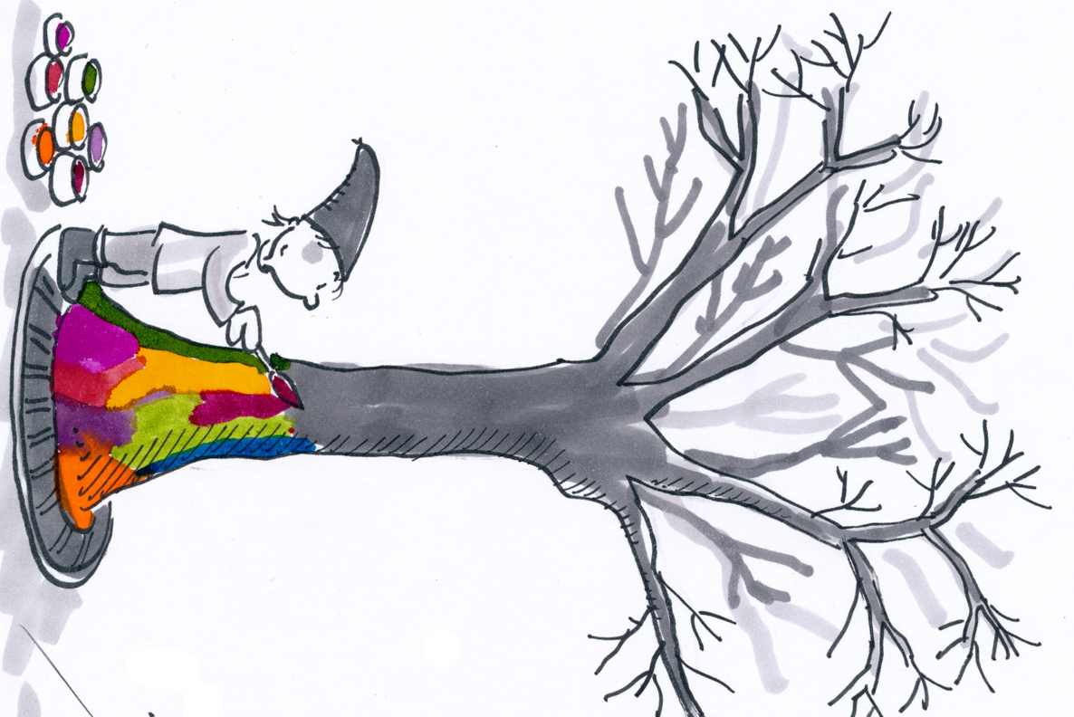WALID

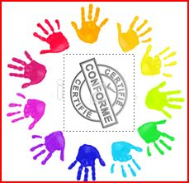
CELIA

KYLIAN
LOUANN
NINA

DYLAN

HYLLAN
LIAM

LUCAS

ADAM

MI
CKAËL

WAHIB

SALMA

CLOE

EMRANE
YUNA

YOUSSEF

HANNA

LENA

TYLER

ALICIA
ALONSO
MAËLLE
RAYAN

CAMEL
IA

MAILYS
ALYNA

ALYNA

ALYNA

ALYNA

