MKU – Biskra Level: 2nd year Licence
Faculty of Letters and Languages Course: Civilization of the Language
English Language Division Instructor: Dr. Salim Kerboua
Semester II

LECTURE 4: PRE-COLONIAL NORTH AMERICA: THE NATIVE AMERICANS

Pre-history Migrations
According to anthropological studies, Native Americans probably originated from Asia. From Siberia, they crossed the Bering Strait which was during the Ice Age a kind of icy bridge. They moved to Alaska, and then, further south. This was approximately 30,000 years ago.
Groups of Indians wandered southward and next eastward. Gradually, throughout a period of thousands of years, they adapted to the different geographic and climatic region they settled.

Native American Tribes
The Indians living in different places had different ways of life. This included food, shelter, clothes, religious beliefs, and social organizations. They were living in different cultural areas.
- Native American of the Eastern Woodlands
The Eastern Region, including the Atlantic Coast and the Midwest, was covered with dense forests, many lakes and rivers. the Indians living that area were Iroquoian and Algonquin tribes. They had a semi-nomadic life.
In the Northeast, the Natives depended on the forest. They hunted its animals for their skins and their meat. They used their bones too. They cut trees and used the branches to build their houses and made their weapons. They also fished. Some Natives practiced agriculture: they cultivated corn, pumpkin, beans, etc…
In the Midwest, the Indian tribes based their life on trade, agriculture, and mining. They exchanged goods with neighbouring tribes, grew corn and sunflowers. They mined copper and other minerals. They also built large towns.
Among the Native Americans that lived the Northeast Woodlands were the Iroquois, the
Delaware, and Narragansett. In the Midwest lived the Illinois, Sioux, and Cheyenne tribes.
The Natives lived in groups called tribes that constituted a socio-economic unit. The tribe included sub-groups called clans.
European settlement began in the 1600s. Those tribes attempted to resist white settlement but epidemics spread among them. By the end of the 17th century, they were either exterminated or forced to retreat west. Midwestern civilizations also disappeared due to spreading epidemics.

- Native Americans living in the Southeast, large tribes of American Indians lived by practicing agriculture. they also gathered wild fruits and hunted animals. Most of the Southeastern Native tribes were speaking the Muskogee language. They included the Cherokee, the Choctaw, the Chickasaw, the Creek, and the Seminole. These were known as the “five civilized tribes.” They organized themselves in a confederacy and had highly developed political institutions.
Another highly developed tribe was the Natchez. They had a highly civilized social structure too. Because of European conquest, the Natchez disappeared by the 18th century.

- Natives of the Great Plains
The region was a land of grass and abundant bison or buffalo on which the natives depended. The buffalo provided them with all the necessities of life: meat for food, skin for clothes and dwelling (called “tepees”), boats (canoes), bones for weapons, etc… Most of the plain tribes lived in small nomadic groups. They constantly moved, following the buffalo. Until the 1880s, it was the most important source of life. But it was exterminated for profit and because it constituted an obstacle to development of the railroad.
Among the early tribes living n the plains were the Blackfoot. However, as white settlers occupied the Eastern woodlands, different tribes such as the Dakota (Sioux) and Cheyenne moved to the plains.
Tribes from the south moved north and traded horses with the Plains tribes. Consequently, the horse entered the culture of Plain Indians and became instrumental in hunting the bison and warfare.

- Natives of the Southwest
That cultural area included Arizona, New Mexico, Utah, part of Colorado (the south), and Texas. (These states did not exist at that time because there was no country called “the United States.”)
The Pueblo Indians (Zuni and Hopi tribes) built large and complex dwellings from stone and clay. They were highly developed agricultural communities. The grew corn, squash, chili pepper, and beans. They introduced a complex system of irrigation.
In 1540, the Spanish conquered the area and imposed their rule. Since then, the region has been dominated successively by the Spanish, the Mexican, and finally, the United States of America.
- The Rockies
The area was a land of great demographic and linguistic diversity. There was a great variety of Natives tribes speaking distinct languages. Agriculture was practiced in the valleys. Near the Pacific Coast, people traded and fished.
- The Desert
The Natives were nomadic tribes such as the Apaches and the Navajo. They were initially hunters and raiders. They raided the Pueblo villages for food and later for slaves. They used to sell slaves to the Spanish.
Gradually, they adapted to the environment; they borrowed from the neighboring cultures and learnt to farm. They also raised sheep and horses.

(Adapted from Lectures in American History by Maameri F. OPU)

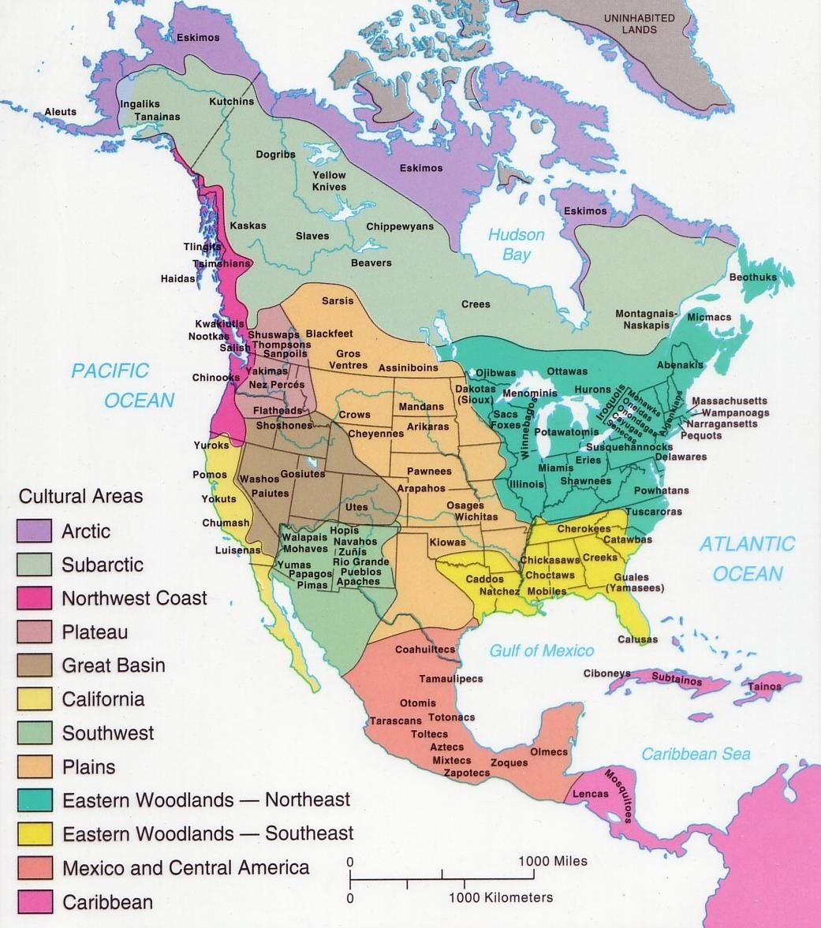

Native American Cultural Areas
At the time of the first European contact, an estimated 90 million Native Americans lived in the Americas. Much of the Native American population in the present-day United States was decimated by war, famine, and disease with the encroachment of the Europeans.

