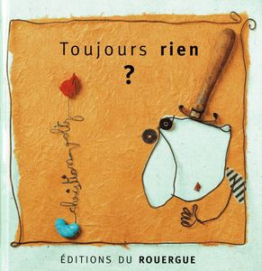**MON LEXIQUE**

|  |  |  |  |  |  |  |  |  |  |  |  |
| --- | --- | --- | --- | --- | --- | --- | --- | --- | --- | --- | --- |
| |  | | --- | |  | | Arrosoir  **Arrosoir**  **ARROSOIR** | | |  | | --- | |  | | L’oiseau  **L’oiseau**  **L’OISEAU** | | |  | | --- | |  | | Monsieur Louis  **Monsieur Louis**  **MONSIEUR LOUIS** | | |  | | --- | |  | | Fleur  **Fleur**  **FLEUR** | |