ENGLISH TEST

1- Introduce yourself :
Se présenter

What's your name ? ____________________________________________________

How old are you ? _____________________________________________________

Where do you live ? ____________________________________________________

2- Read and match :
Connaître les nombres

five | 7 |  | fifty | 15
seven | 8 |  | fifteen | 50
eight | 20 |  | thirty | 40
twenty | 5 |  | twenty-three | 30
twelve | 12 |  | forty | 23

3- Read and draw :
Connaître différentes humeurs

He is happy. |  |  | He is angry.
He is sad. |  |  | He is tired.

4- Choose some food and write two sentences.
Connaître le vocabulaire lié à la nourriture
Savoir dire ce qu'on aime ou pas
  a banana |   coffee | 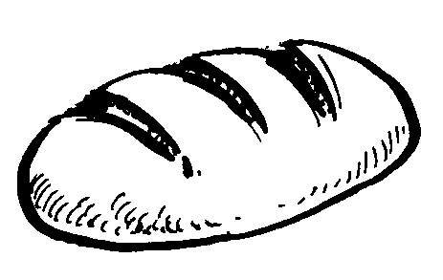  bread |   french fries | 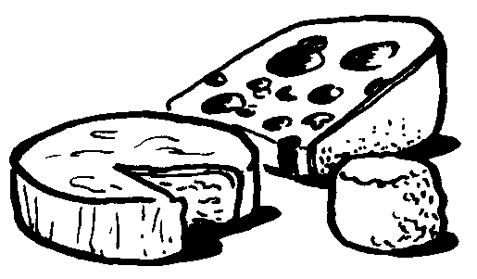  cheese
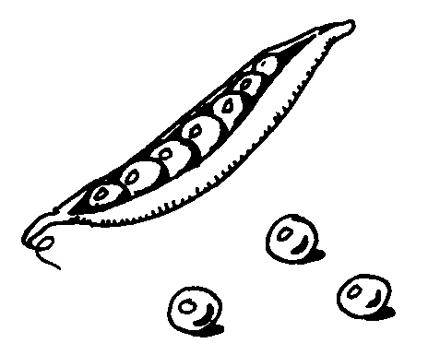  peas |   an apple |   meat | 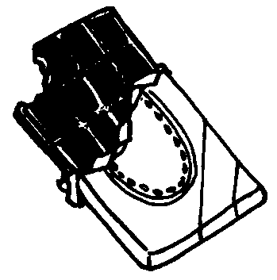  chocolate |   jam
I like … but I don't like...
____________________________________________________________

____________________________________________________________

5- Read and colour.
Connaître le vocabulaire lié aux vêtements
Connaître les couleurs

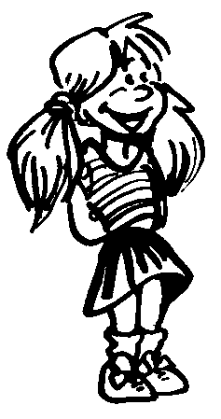 | 
She's wearing a blue skirt ans a pink  t-shirt. She's got black shoes. | He's wearing a green shirt ans grey jeans. He's got a yellow hat and brown shoes.

6- Choose one of your school-mates and describe him or her.
Produire de l'écrit en anglais en réinvestissant ce qui a été vu

