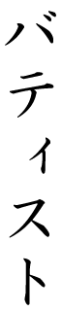

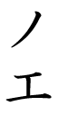

Abygaëlle

Kimie

Winfiheir

Maëna

Perle

Kevine

Nathan

Samuel

Loup

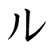

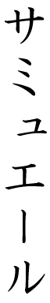



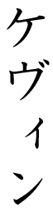

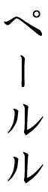

http://www.japanophone.com/Common/kana-pic.php?katakana=AABIGAEE--RU&dir=V&alpha=K&size=32&font=0

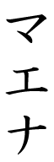

http://www.japanophone.com/Common/kana-pic.php?katakana=UUIINNHUXAIIAA--&dir=V&alpha=K&size=32&font=0



Baptiste

Noé



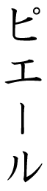



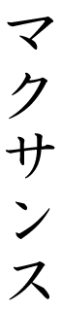

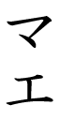



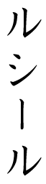

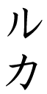



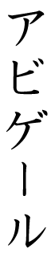

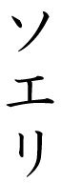

Valérie

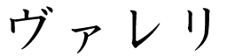

Pierre

Jordan

Maxence

Mahé

Maë

Océane

Lucile

Lucas

Ambroise

Abigail

Soélie