1

Reproduction sur quadrillage

|  |  |  |  |  |  |  |  |  |  |  |  |  |  |  |  |  |  |  |  |  |  |
| --- | --- | --- | --- | --- | --- | --- | --- | --- | --- | --- | --- | --- | --- | --- | --- | --- | --- | --- | --- | --- | --- |
|  |  |  |  |  |  |  |  |  |  |  |  |  |  |  |  |  |  |  |  |  |  |

|  |  |  |  |  |  |  |  |  |  |  |  |  |  |  |  |  |  |  |  |  |  |
| --- | --- | --- | --- | --- | --- | --- | --- | --- | --- | --- | --- | --- | --- | --- | --- | --- | --- | --- | --- | --- | --- |
|  |  |  |  |  |  |  |  |  |  |  |  |  |  |  |  |  |  |  |  |  |  |

Tracés à la règle

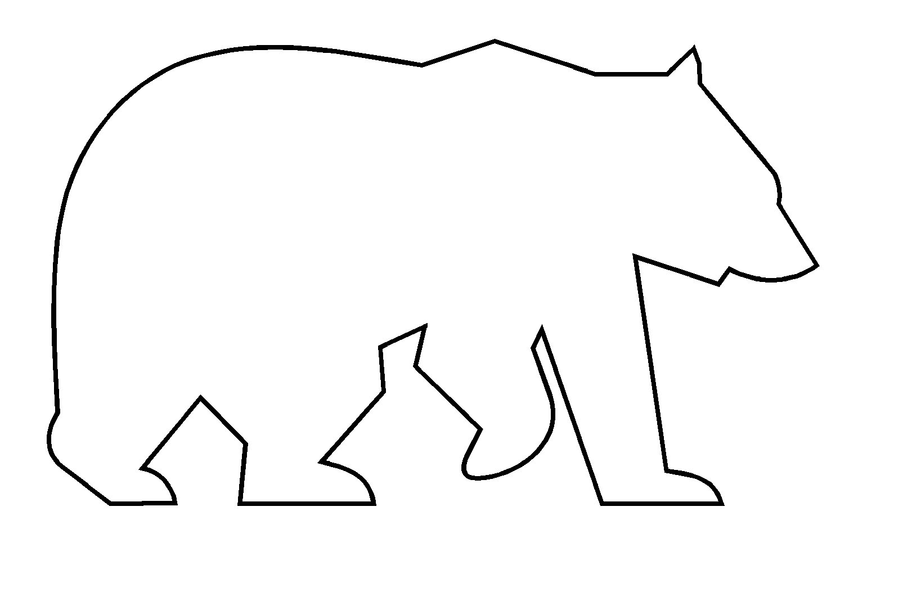

2

Reproduction sur quadrillage

|  |  |  |  |  |  |  |  |  |  |  |  |  |  |  |  |  |  |  |  |  |  |
| --- | --- | --- | --- | --- | --- | --- | --- | --- | --- | --- | --- | --- | --- | --- | --- | --- | --- | --- | --- | --- | --- |
|  |  |  |  |  |  |  |  |  |  |  |  |  |  |  |  |  |  |  |  |  |  |

|  |  |  |  |  |  |  |  |  |  |  |  |  |  |  |  |  |  |  |  |  |  |
| --- | --- | --- | --- | --- | --- | --- | --- | --- | --- | --- | --- | --- | --- | --- | --- | --- | --- | --- | --- | --- | --- |
|  |  |  |  |  |  |  |  |  |  |  |  |  |  |  |  |  |  |  |  |  |  |

Tracés à la règle

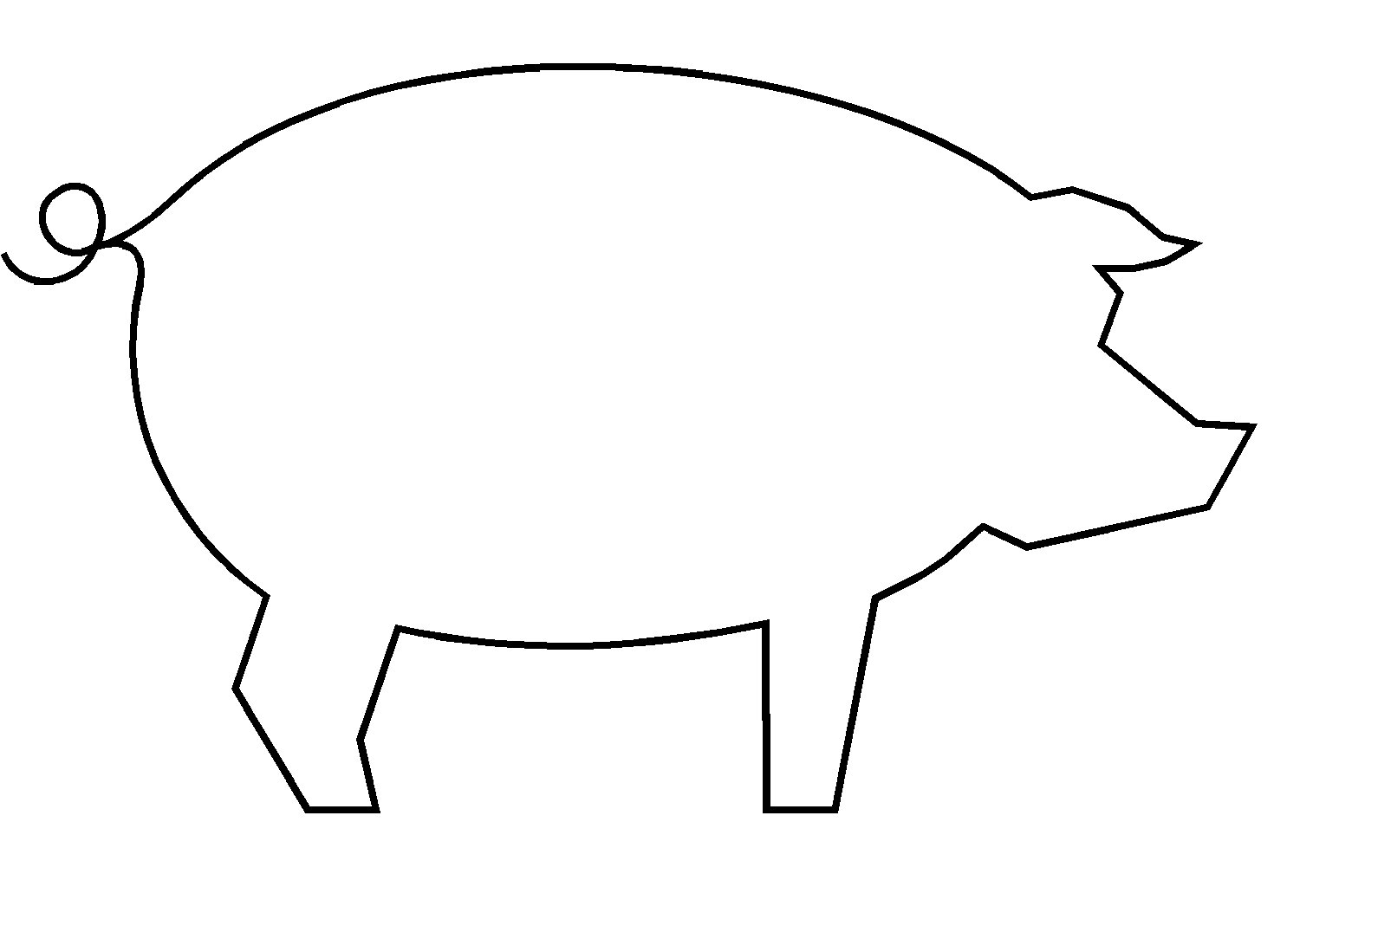

3

Reproduction sur quadrillage

|  |  |  |  |  |  |  |  |  |  |  |  |  |  |  |  |  |  |  |  |  |  |
| --- | --- | --- | --- | --- | --- | --- | --- | --- | --- | --- | --- | --- | --- | --- | --- | --- | --- | --- | --- | --- | --- |
|  |  |  |  |  |  |  |  |  |  |  |  |  |  |  |  |  |  |  |  |  |  |

|  |  |  |  |  |  |  |  |  |  |  |  |  |  |  |  |  |  |  |  |  |  |
| --- | --- | --- | --- | --- | --- | --- | --- | --- | --- | --- | --- | --- | --- | --- | --- | --- | --- | --- | --- | --- | --- |
|  |  |  |  |  |  |  |  |  |  |  |  |  |  |  |  |  |  |  |  |  |  |

Tracés à la règle

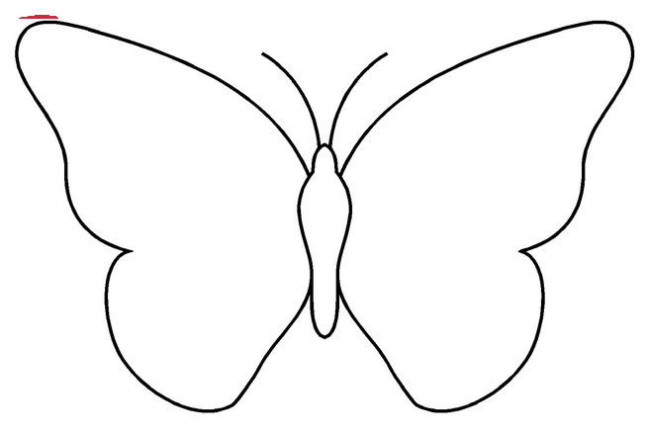

4

Reproduction sur quadrillage

|  |  |  |  |  |  |  |  |  |  |  |  |  |  |  |  |  |  |  |  |  |  |
| --- | --- | --- | --- | --- | --- | --- | --- | --- | --- | --- | --- | --- | --- | --- | --- | --- | --- | --- | --- | --- | --- |
|  |  |  |  |  |  |  |  |  |  |  |  |  |  |  |  |  |  |  |  |  |  |

|  |  |  |  |  |  |  |  |  |  |  |  |  |  |  |  |  |  |  |  |  |  |
| --- | --- | --- | --- | --- | --- | --- | --- | --- | --- | --- | --- | --- | --- | --- | --- | --- | --- | --- | --- | --- | --- |
|  |  |  |  |  |  |  |  |  |  |  |  |  |  |  |  |  |  |  |  |  |  |

Tracés à la règle

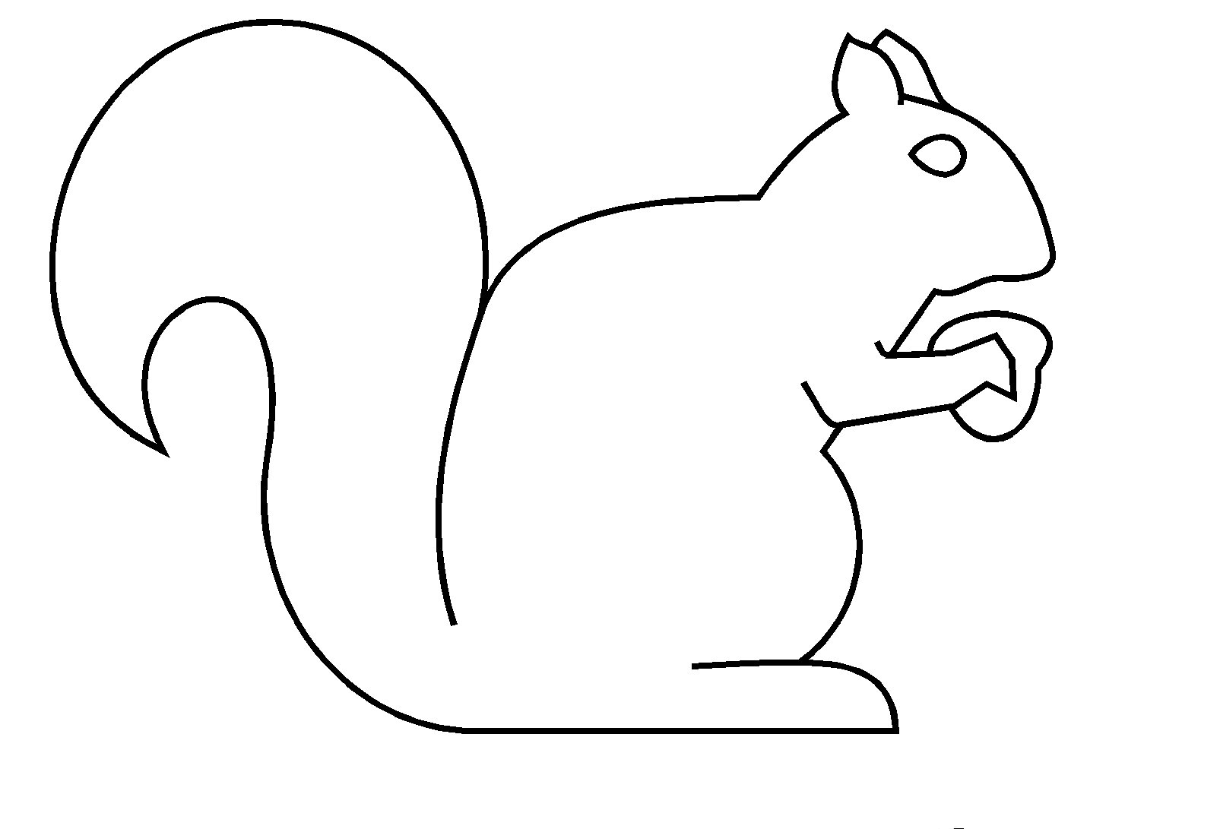

Ajouter les points de couleur pour faire les segments

5

Reproduction sur quadrillage

|  |  |  |  |  |  |  |  |  |  |  |  |  |  |  |  |  |  |  |  |  |  |
| --- | --- | --- | --- | --- | --- | --- | --- | --- | --- | --- | --- | --- | --- | --- | --- | --- | --- | --- | --- | --- | --- |
|  |  |  |  |  |  |  |  |  |  |  |  |  |  |  |  |  |  |  |  |  |  |
|  |  |  |  |  |  |  |  |  |  |  |  |  |  |  |  |  |  |  |  |  |  |

|  |  |  |  |  |  |  |  |  |  |  |  |  |  |  |  |  |  |  |  |  |  |
| --- | --- | --- | --- | --- | --- | --- | --- | --- | --- | --- | --- | --- | --- | --- | --- | --- | --- | --- | --- | --- | --- |
|  |  |  |  |  |  |  |  |  |  |  |  |  |  |  |  |  |  |  |  |  |  |
|  |  |  |  |  |  |  |  |  |  |  |  |  |  |  |  |  |  |  |  |  |  |

Tracés à la règle

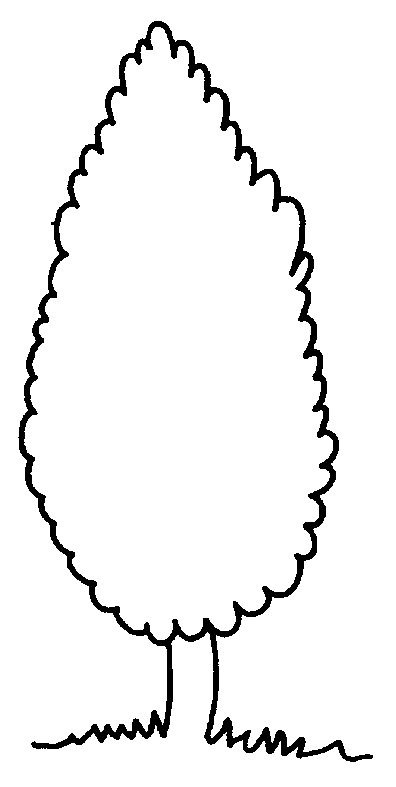

Ajouter les points de couleur pour faire les segments

6

Reproduction sur quadrillage

|  |  |  |  |  |  |  |  |  |  |  |  |  |  |  |  |  |  |  |  |  |  |
| --- | --- | --- | --- | --- | --- | --- | --- | --- | --- | --- | --- | --- | --- | --- | --- | --- | --- | --- | --- | --- | --- |
|  |  |  |  |  |  |  |  |  |  |  |  |  |  |  |  |  |  |  |  |  |  |
|  |  |  |  |  |  |  |  |  |  |  |  |  |  |  |  |  |  |  |  |  |  |

|  |  |  |  |  |  |  |  |  |  |  |  |  |  |  |  |  |  |  |  |  |  |
| --- | --- | --- | --- | --- | --- | --- | --- | --- | --- | --- | --- | --- | --- | --- | --- | --- | --- | --- | --- | --- | --- |
|  |  |  |  |  |  |  |  |  |  |  |  |  |  |  |  |  |  |  |  |  |  |
|  |  |  |  |  |  |  |  |  |  |  |  |  |  |  |  |  |  |  |  |  |  |

Tracés à la règle

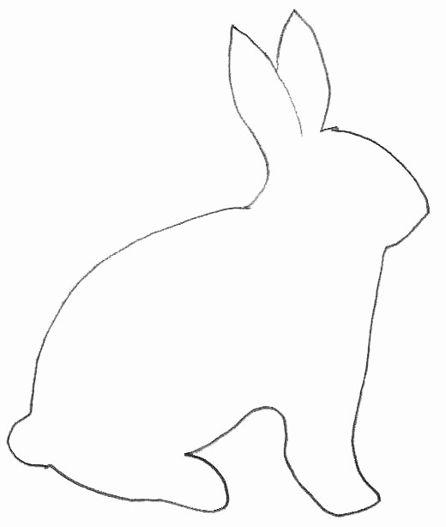

Ajouter les points de couleur pour faire les segments

7

Reproduction sur quadrillage

|  |  |  |  |  |  |  |  |  |  |  |  |  |  |  |  |  |  |  |  |  |  |
| --- | --- | --- | --- | --- | --- | --- | --- | --- | --- | --- | --- | --- | --- | --- | --- | --- | --- | --- | --- | --- | --- |
|  |  |  |  |  |  |  |  |  |  |  |  |  |  |  |  |  |  |  |  |  |  |
|  |  |  |  |  |  |  |  |  |  |  |  |  |  |  |  |  |  |  |  |  |  |

|  |  |  |  |  |  |  |  |  |  |  |  |  |  |  |  |  |  |  |  |  |  |
| --- | --- | --- | --- | --- | --- | --- | --- | --- | --- | --- | --- | --- | --- | --- | --- | --- | --- | --- | --- | --- | --- |
|  |  |  |  |  |  |  |  |  |  |  |  |  |  |  |  |  |  |  |  |  |  |
|  |  |  |  |  |  |  |  |  |  |  |  |  |  |  |  |  |  |  |  |  |  |

Tracés à la règle

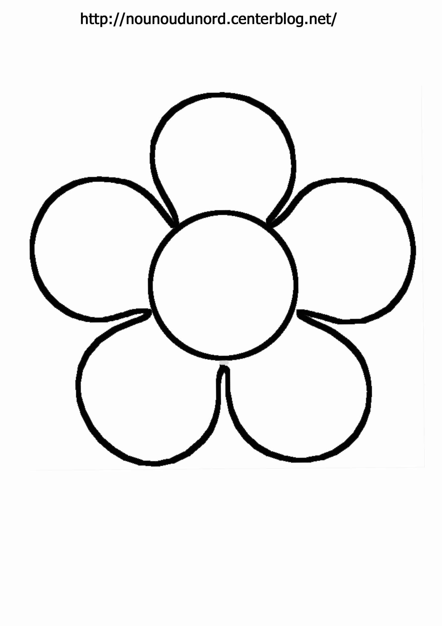

Ajouter les points de couleur pour faire les segments

8

Reproduction sur quadrillage

|  |  |  |  |  |  |  |  |  |  |  |  |  |  |  |  |  |  |  |  |  |  |
| --- | --- | --- | --- | --- | --- | --- | --- | --- | --- | --- | --- | --- | --- | --- | --- | --- | --- | --- | --- | --- | --- |
|  |  |  |  |  |  |  |  |  |  |  |  |  |  |  |  |  |  |  |  |  |  |
|  |  |  |  |  |  |  |  |  |  |  |  |  |  |  |  |  |  |  |  |  |  |

|  |  |  |  |  |  |  |  |  |  |  |  |  |  |  |  |  |  |  |  |  |  |
| --- | --- | --- | --- | --- | --- | --- | --- | --- | --- | --- | --- | --- | --- | --- | --- | --- | --- | --- | --- | --- | --- |
|  |  |  |  |  |  |  |  |  |  |  |  |  |  |  |  |  |  |  |  |  |  |
|  |  |  |  |  |  |  |  |  |  |  |  |  |  |  |  |  |  |  |  |  |  |

Tracés à la règle

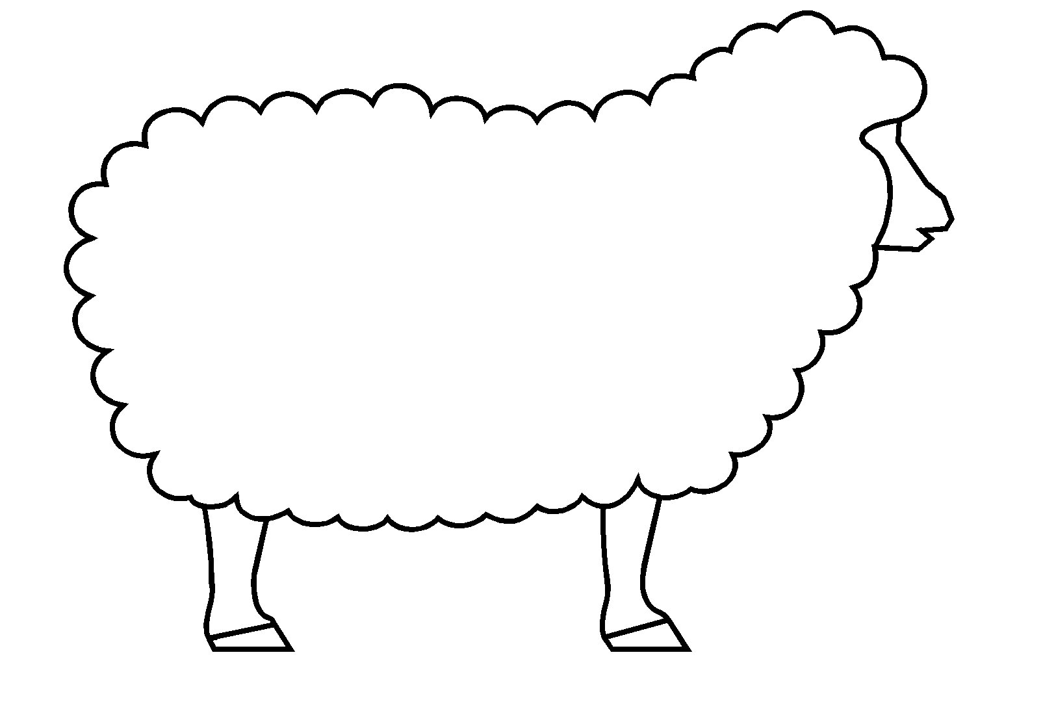

Ajouter les points de couleur pour faire les segments

9

Reproduction sur quadrillage

|  |  |  |  |  |  |  |  |  |  |  |  |  |  |  |  |  |  |  |  |  |
| --- | --- | --- | --- | --- | --- | --- | --- | --- | --- | --- | --- | --- | --- | --- | --- | --- | --- | --- | --- | --- |
|  |  |  |  |  |  |  |  |  |  |  |  |  |  |  |  |  |  |  |  |  |
|  |  |  |  |  |  |  |  |  |  |  |  |  |  |  |  |  |  |  |  |  |

|  |  |  |  |  |  |  |  |  |  |  |  |  |  |  |  |  |  |  |  |  |
| --- | --- | --- | --- | --- | --- | --- | --- | --- | --- | --- | --- | --- | --- | --- | --- | --- | --- | --- | --- | --- |
|  |  |  |  |  |  |  |  |  |  |  |  |  |  |  |  |  |  |  |  |  |
|  |  |  |  |  |  |  |  |  |  |  |  |  |  |  |  |  |  |  |  |  |

Tracés à la règle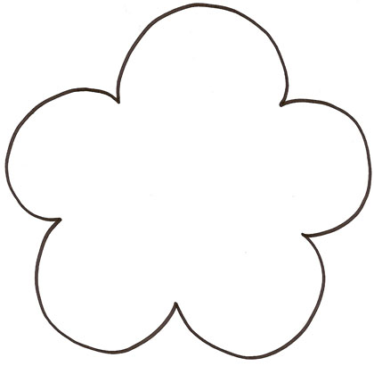

Ajouter les points de couleur pour faire les segments

10

Reproduction sur quadrillage

|  |  |  |  |  |  |  |  |  |  |  |  |  |  |  |  |  |  |  |  |  |  |
| --- | --- | --- | --- | --- | --- | --- | --- | --- | --- | --- | --- | --- | --- | --- | --- | --- | --- | --- | --- | --- | --- |
|  |  |  |  |  |  |  |  |  |  |  |  |  |  |  |  |  |  |  |  |  |  |
|  |  |  |  |  |  |  |  |  |  |  |  |  |  |  |  |  |  |  |  |  |  |

|  |  |  |  |  |  |  |  |  |  |  |  |  |  |  |  |  |  |  |  |  |  |
| --- | --- | --- | --- | --- | --- | --- | --- | --- | --- | --- | --- | --- | --- | --- | --- | --- | --- | --- | --- | --- | --- |
|  |  |  |  |  |  |  |  |  |  |  |  |  |  |  |  |  |  |  |  |  |  |
|  |  |  |  |  |  |  |  |  |  |  |  |  |  |  |  |  |  |  |  |  |  |

Tracés à la règle

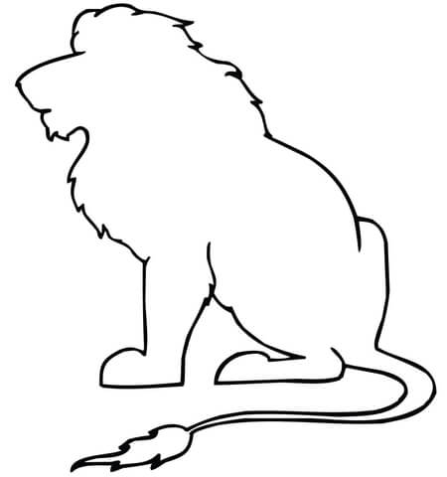

Ajouter les points de couleur pour faire les segments

11

Reproduction sur quadrillage

|  |  |  |  |  |  |  |  |  |  |  |  |  |  |  |  |  |  |  |  |  |
| --- | --- | --- | --- | --- | --- | --- | --- | --- | --- | --- | --- | --- | --- | --- | --- | --- | --- | --- | --- | --- |
|  |  |  |  |  |  |  |  |  |  |  |  |  |  |  |  |  |  |  |  |  |
|  |  |  |  |  |  |  |  |  |  |  |  |  |  |  |  |  |  |  |  |  |

|  |  |  |  |  |  |  |  |  |  |  |  |  |  |  |  |  |  |  |  |  |
| --- | --- | --- | --- | --- | --- | --- | --- | --- | --- | --- | --- | --- | --- | --- | --- | --- | --- | --- | --- | --- |
|  |  |  |  |  |  |  |  |  |  |  |  |  |  |  |  |  |  |  |  |  |
|  |  |  |  |  |  |  |  |  |  |  |  |  |  |  |  |  |  |  |  |  |

Tracés à la règle



Ajouter les points de couleur pour faire les segments

12

Reproduction sur quadrillage

|  |  |  |  |  |  |  |  |  |  |  |  |  |  |  |  |  |  |  |  |  |
| --- | --- | --- | --- | --- | --- | --- | --- | --- | --- | --- | --- | --- | --- | --- | --- | --- | --- | --- | --- | --- |
|  |  |  |  |  |  |  |  |  |  |  |  |  |  |  |  |  |  |  |  |  |
|  |  |  |  |  |  |  |  |  |  |  |  |  |  |  |  |  |  |  |  |  |

|  |  |  |  |  |  |  |  |  |  |  |  |  |  |  |  |  |  |  |  |  |
| --- | --- | --- | --- | --- | --- | --- | --- | --- | --- | --- | --- | --- | --- | --- | --- | --- | --- | --- | --- | --- |
|  |  |  |  |  |  |  |  |  |  |  |  |  |  |  |  |  |  |  |  |  |
|  |  |  |  |  |  |  |  |  |  |  |  |  |  |  |  |  |  |  |  |  |

Tracés à la règle

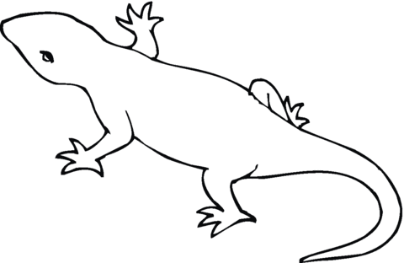

Ajouter les points de couleur pour faire les segments

13

Reproduction sur quadrillage

|  |  |  |  |  |  |  |  |  |  |  |  |  |  |  |  |  |  |  |  |
| --- | --- | --- | --- | --- | --- | --- | --- | --- | --- | --- | --- | --- | --- | --- | --- | --- | --- | --- | --- |
|  |  |  |  |  |  |  |  |  |  |  |  |  |  |  |  |  |  |  |  |
|  |  |  |  |  |  |  |  |  |  |  |  |  |  |  |  |  |  |  |  |

|  |  |  |  |  |  |  |  |  |  |  |  |  |  |  |  |  |  |  |  |
| --- | --- | --- | --- | --- | --- | --- | --- | --- | --- | --- | --- | --- | --- | --- | --- | --- | --- | --- | --- |
|  |  |  |  |  |  |  |  |  |  |  |  |  |  |  |  |  |  |  |  |
|  |  |  |  |  |  |  |  |  |  |  |  |  |  |  |  |  |  |  |  |

Tracés à la règle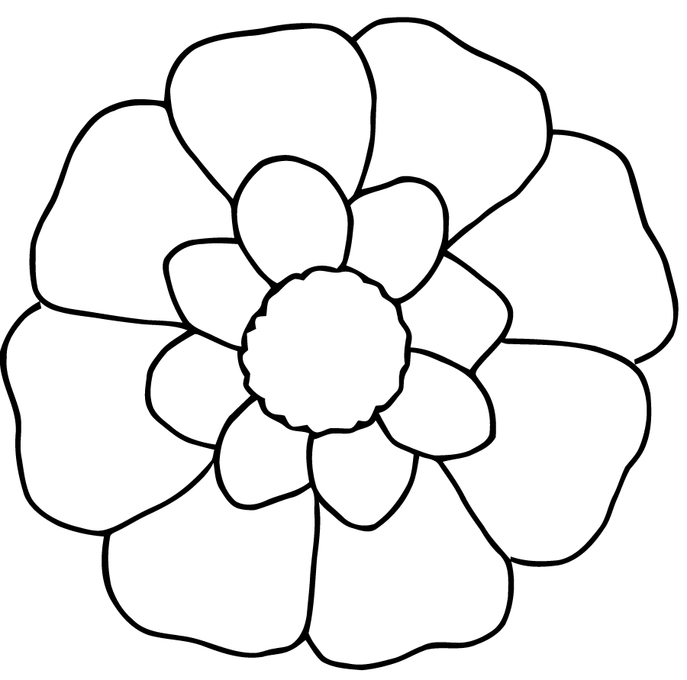

Ajouter les points de couleur pour faire les segments

14

Reproduction sur quadrillage

|  |  |  |  |  |  |  |  |  |  |  |  |  |  |  |  |  |  |  |  |  |
| --- | --- | --- | --- | --- | --- | --- | --- | --- | --- | --- | --- | --- | --- | --- | --- | --- | --- | --- | --- | --- |
|  |  |  |  |  |  |  |  |  |  |  |  |  |  |  |  |  |  |  |  |  |
|  |  |  |  |  |  |  |  |  |  |  |  |  |  |  |  |  |  |  |  |  |

|  |  |  |  |  |  |  |  |  |  |  |  |  |  |  |  |  |  |  |  |  |
| --- | --- | --- | --- | --- | --- | --- | --- | --- | --- | --- | --- | --- | --- | --- | --- | --- | --- | --- | --- | --- |
|  |  |  |  |  |  |  |  |  |  |  |  |  |  |  |  |  |  |  |  |  |
|  |  |  |  |  |  |  |  |  |  |  |  |  |  |  |  |  |  |  |  |  |

Tracés à la règle

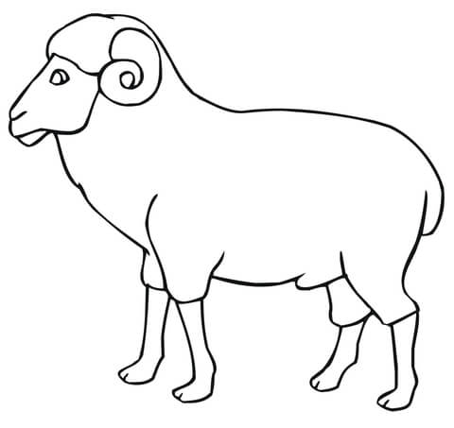 Ajouter les points de couleur pour faire les segments

15

Reproduction sur quadrillage

|  |  |  |  |  |  |  |  |  |  |  |  |  |  |  |  |  |  |  |  |  |
| --- | --- | --- | --- | --- | --- | --- | --- | --- | --- | --- | --- | --- | --- | --- | --- | --- | --- | --- | --- | --- |
|  |  |  |  |  |  |  |  |  |  |  |  |  |  |  |  |  |  |  |  |  |
|  |  |  |  |  |  |  |  |  |  |  |  |  |  |  |  |  |  |  |  |  |
|  |  |  |  |  |  |  |  |  |  |  |  |  |  |  |  |  |  |  |  |  |

|  |  |  |  |  |  |  |  |  |  |  |  |  |  |  |  |  |  |  |  |  |
| --- | --- | --- | --- | --- | --- | --- | --- | --- | --- | --- | --- | --- | --- | --- | --- | --- | --- | --- | --- | --- |
|  |  |  |  |  |  |  |  |  |  |  |  |  |  |  |  |  |  |  |  |  |
|  |  |  |  |  |  |  |  |  |  |  |  |  |  |  |  |  |  |  |  |  |
|  |  |  |  |  |  |  |  |  |  |  |  |  |  |  |  |  |  |  |  |  |

Tracés à la règle

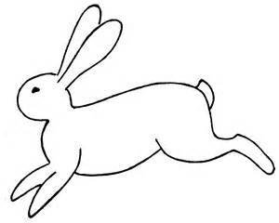

Ajouter les points de couleur pour faire les segments

16

Reproduction sur quadrillage

|  |  |  |  |  |  |  |  |  |  |  |  |  |  |  |  |  |  |  |  |  |
| --- | --- | --- | --- | --- | --- | --- | --- | --- | --- | --- | --- | --- | --- | --- | --- | --- | --- | --- | --- | --- |
|  |  |  |  |  |  |  |  |  |  |  |  |  |  |  |  |  |  |  |  |  |
|  |  |  |  |  |  |  |  |  |  |  |  |  |  |  |  |  |  |  |  |  |
|  |  |  |  |  |  |  |  |  |  |  |  |  |  |  |  |  |  |  |  |  |

|  |  |  |  |  |  |  |  |  |  |  |  |  |  |  |  |  |  |  |  |  |
| --- | --- | --- | --- | --- | --- | --- | --- | --- | --- | --- | --- | --- | --- | --- | --- | --- | --- | --- | --- | --- |
|  |  |  |  |  |  |  |  |  |  |  |  |  |  |  |  |  |  |  |  |  |
|  |  |  |  |  |  |  |  |  |  |  |  |  |  |  |  |  |  |  |  |  |
|  |  |  |  |  |  |  |  |  |  |  |  |  |  |  |  |  |  |  |  |  |

Tracés à la règle

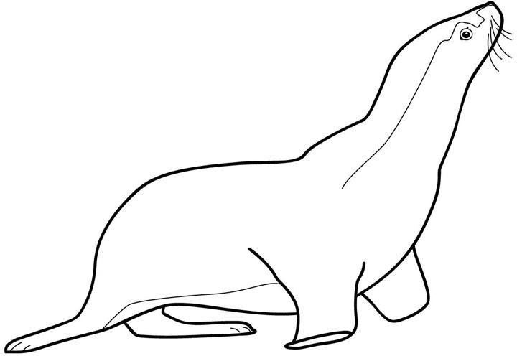

Ajouter les points de couleur pour faire les segments

17

Reproduction sur quadrillage

|  |  |  |  |  |  |  |  |  |  |  |  |  |  |  |  |  |  |  |  |  |
| --- | --- | --- | --- | --- | --- | --- | --- | --- | --- | --- | --- | --- | --- | --- | --- | --- | --- | --- | --- | --- |
|  |  |  |  |  |  |  |  |  |  |  |  |  |  |  |  |  |  |  |  |  |
|  |  |  |  |  |  |  |  |  |  |  |  |  |  |  |  |  |  |  |  |  |
|  |  |  |  |  |  |  |  |  |  |  |  |  |  |  |  |  |  |  |  |  |

|  |  |  |  |  |  |  |  |  |  |  |  |  |  |  |  |  |  |  |  |  |
| --- | --- | --- | --- | --- | --- | --- | --- | --- | --- | --- | --- | --- | --- | --- | --- | --- | --- | --- | --- | --- |
|  |  |  |  |  |  |  |  |  |  |  |  |  |  |  |  |  |  |  |  |  |
|  |  |  |  |  |  |  |  |  |  |  |  |  |  |  |  |  |  |  |  |  |
|  |  |  |  |  |  |  |  |  |  |  |  |  |  |  |  |  |  |  |  |  |

Tracés à la règle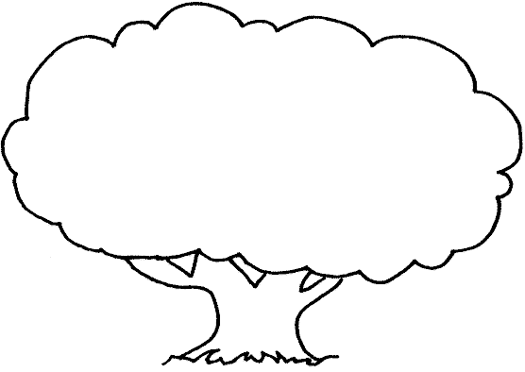

Ajouter les points de couleur pour faire les segments

18

Reproduction sur quadrillage

|  |  |  |  |  |  |  |  |  |  |  |  |  |  |  |  |  |  |  |  |
| --- | --- | --- | --- | --- | --- | --- | --- | --- | --- | --- | --- | --- | --- | --- | --- | --- | --- | --- | --- |
|  |  |  |  |  |  |  |  |  |  |  |  |  |  |  |  |  |  |  |  |
|  |  |  |  |  |  |  |  |  |  |  |  |  |  |  |  |  |  |  |  |
|  |  |  |  |  |  |  |  |  |  |  |  |  |  |  |  |  |  |  |  |

|  |  |  |  |  |  |  |  |  |  |  |  |  |  |  |  |  |  |  |  |
| --- | --- | --- | --- | --- | --- | --- | --- | --- | --- | --- | --- | --- | --- | --- | --- | --- | --- | --- | --- |
|  |  |  |  |  |  |  |  |  |  |  |  |  |  |  |  |  |  |  |  |
|  |  |  |  |  |  |  |  |  |  |  |  |  |  |  |  |  |  |  |  |
|  |  |  |  |  |  |  |  |  |  |  |  |  |  |  |  |  |  |  |  |

Tracés à la règle

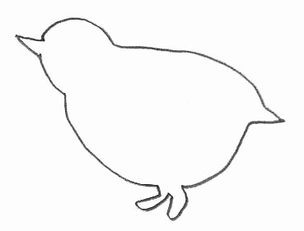

Ajouter les points de couleur pour faire les segments

19

Reproduction sur quadrillage

|  |  |  |  |  |  |  |  |  |  |  |  |  |  |  |  |  |
| --- | --- | --- | --- | --- | --- | --- | --- | --- | --- | --- | --- | --- | --- | --- | --- | --- |
|  |  |  |  |  |  |  |  |  |  |  |  |  |  |  |  |  |
|  |  |  |  |  |  |  |  |  |  |  |  |  |  |  |  |  |
|  |  |  |  |  |  |  |  |  |  |  |  |  |  |  |  |  |

|  |  |  |  |  |  |  |  |  |  |  |  |  |  |  |  |  |
| --- | --- | --- | --- | --- | --- | --- | --- | --- | --- | --- | --- | --- | --- | --- | --- | --- |
|  |  |  |  |  |  |  |  |  |  |  |  |  |  |  |  |  |
|  |  |  |  |  |  |  |  |  |  |  |  |  |  |  |  |  |
|  |  |  |  |  |  |  |  |  |  |  |  |  |  |  |  |  |

Tracés à la règle

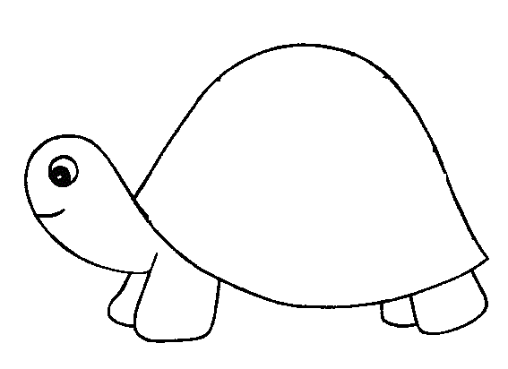

Ajouter les points de couleur pour faire les segments

20

Reproduction sur quadrillage

|  |  |  |  |  |  |  |  |  |  |  |  |  |  |  |  |  |  |  |  |
| --- | --- | --- | --- | --- | --- | --- | --- | --- | --- | --- | --- | --- | --- | --- | --- | --- | --- | --- | --- |
|  |  |  |  |  |  |  |  |  |  |  |  |  |  |  |  |  |  |  |  |
|  |  |  |  |  |  |  |  |  |  |  |  |  |  |  |  |  |  |  |  |
|  |  |  |  |  |  |  |  |  |  |  |  |  |  |  |  |  |  |  |  |

|  |  |  |  |  |  |  |  |  |  |  |  |  |  |  |  |  |  |  |  |
| --- | --- | --- | --- | --- | --- | --- | --- | --- | --- | --- | --- | --- | --- | --- | --- | --- | --- | --- | --- |
|  |  |  |  |  |  |  |  |  |  |  |  |  |  |  |  |  |  |  |  |
|  |  |  |  |  |  |  |  |  |  |  |  |  |  |  |  |  |  |  |  |
|  |  |  |  |  |  |  |  |  |  |  |  |  |  |  |  |  |  |  |  |

Tracés à la règle

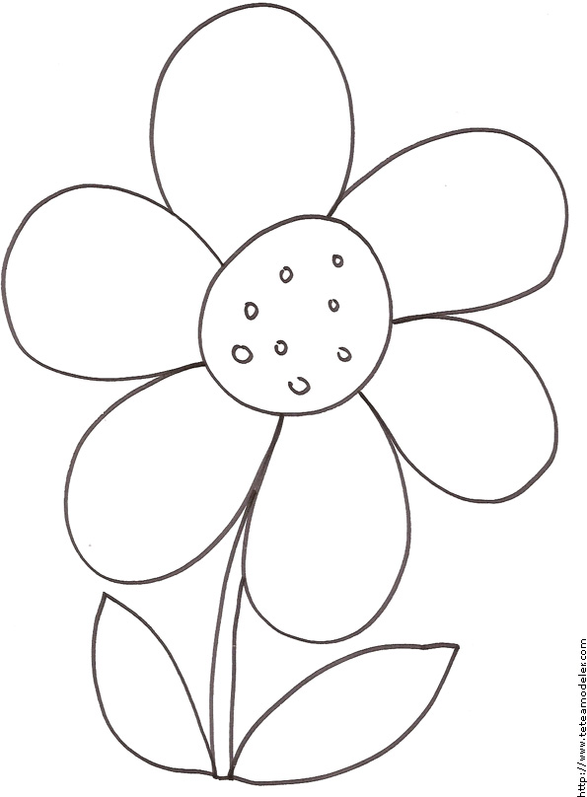

Ajouter les points de couleur pour faire les segments

21

Reproduction sur quadrillage

|  |  |  |  |  |  |  |  |  |  |  |  |  |  |  |  |  |  |  |  |
| --- | --- | --- | --- | --- | --- | --- | --- | --- | --- | --- | --- | --- | --- | --- | --- | --- | --- | --- | --- |
|  |  |  |  |  |  |  |  |  |  |  |  |  |  |  |  |  |  |  |  |
|  |  |  |  |  |  |  |  |  |  |  |  |  |  |  |  |  |  |  |  |
|  |  |  |  |  |  |  |  |  |  |  |  |  |  |  |  |  |  |  |  |

|  |  |  |  |  |  |  |  |  |  |  |  |  |  |  |  |  |  |  |  |
| --- | --- | --- | --- | --- | --- | --- | --- | --- | --- | --- | --- | --- | --- | --- | --- | --- | --- | --- | --- |
|  |  |  |  |  |  |  |  |  |  |  |  |  |  |  |  |  |  |  |  |
|  |  |  |  |  |  |  |  |  |  |  |  |  |  |  |  |  |  |  |  |
|  |  |  |  |  |  |  |  |  |  |  |  |  |  |  |  |  |  |  |  |

Tracés à la règle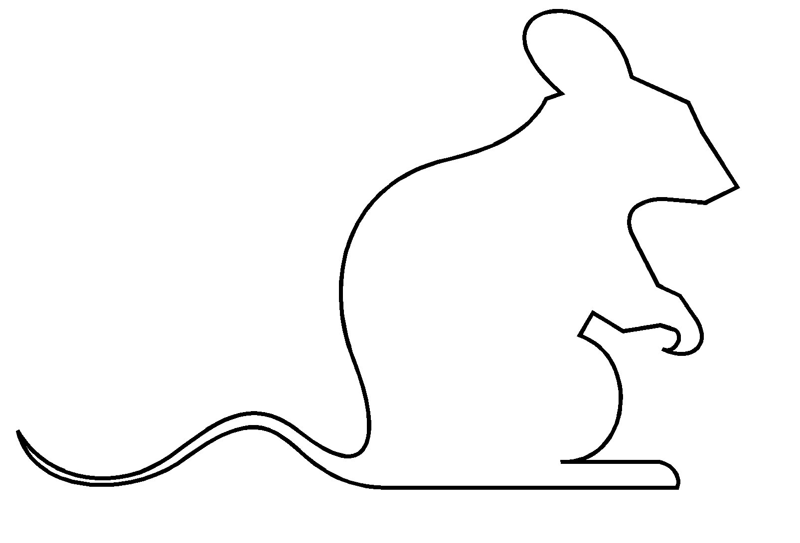

Ajouter les points de couleur pour faire les segments

22

Reproduction sur quadrillage

|  |  |  |  |  |  |  |  |  |  |  |  |  |  |  |  |  |  |  |  |
| --- | --- | --- | --- | --- | --- | --- | --- | --- | --- | --- | --- | --- | --- | --- | --- | --- | --- | --- | --- |
|  |  |  |  |  |  |  |  |  |  |  |  |  |  |  |  |  |  |  |  |
|  |  |  |  |  |  |  |  |  |  |  |  |  |  |  |  |  |  |  |  |
|  |  |  |  |  |  |  |  |  |  |  |  |  |  |  |  |  |  |  |  |

|  |  |  |  |  |  |  |  |  |  |  |  |  |  |  |  |  |  |  |  |
| --- | --- | --- | --- | --- | --- | --- | --- | --- | --- | --- | --- | --- | --- | --- | --- | --- | --- | --- | --- |
|  |  |  |  |  |  |  |  |  |  |  |  |  |  |  |  |  |  |  |  |
|  |  |  |  |  |  |  |  |  |  |  |  |  |  |  |  |  |  |  |  |
|  |  |  |  |  |  |  |  |  |  |  |  |  |  |  |  |  |  |  |  |

Tracés à la règle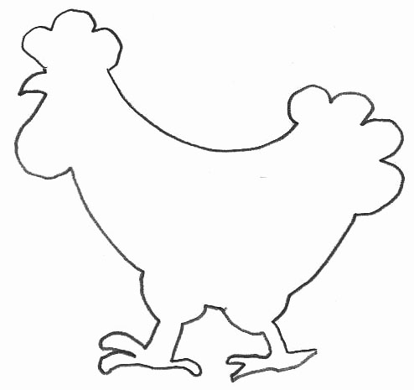

Ajouter les points de couleur pour faire les segments

23

Reproduction sur quadrillage

|  |  |  |  |  |  |  |  |  |  |  |  |  |  |  |  |  |  |  |  |
| --- | --- | --- | --- | --- | --- | --- | --- | --- | --- | --- | --- | --- | --- | --- | --- | --- | --- | --- | --- |
|  |  |  |  |  |  |  |  |  |  |  |  |  |  |  |  |  |  |  |  |
|  |  |  |  |  |  |  |  |  |  |  |  |  |  |  |  |  |  |  |  |
|  |  |  |  |  |  |  |  |  |  |  |  |  |  |  |  |  |  |  |  |

|  |  |  |  |  |  |  |  |  |  |  |  |  |  |  |  |  |  |  |  |
| --- | --- | --- | --- | --- | --- | --- | --- | --- | --- | --- | --- | --- | --- | --- | --- | --- | --- | --- | --- |
|  |  |  |  |  |  |  |  |  |  |  |  |  |  |  |  |  |  |  |  |
|  |  |  |  |  |  |  |  |  |  |  |  |  |  |  |  |  |  |  |  |
|  |  |  |  |  |  |  |  |  |  |  |  |  |  |  |  |  |  |  |  |

Tracés à la règle

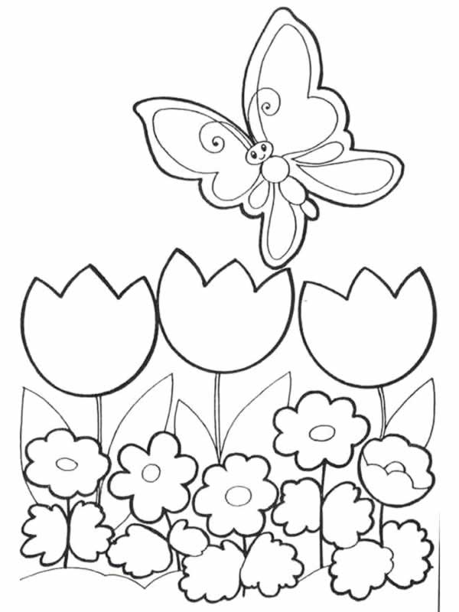

Ajouter les points de couleur pour faire les segments

24

Reproduction sur quadrillage

|  |  |  |  |  |  |  |  |  |  |  |  |  |  |  |  |  |  |  |  |
| --- | --- | --- | --- | --- | --- | --- | --- | --- | --- | --- | --- | --- | --- | --- | --- | --- | --- | --- | --- |
|  |  |  |  |  |  |  |  |  |  |  |  |  |  |  |  |  |  |  |  |
|  |  |  |  |  |  |  |  |  |  |  |  |  |  |  |  |  |  |  |  |
|  |  |  |  |  |  |  |  |  |  |  |  |  |  |  |  |  |  |  |  |

|  |  |  |  |  |  |  |  |  |  |  |  |  |  |  |  |  |  |  |  |
| --- | --- | --- | --- | --- | --- | --- | --- | --- | --- | --- | --- | --- | --- | --- | --- | --- | --- | --- | --- |
|  |  |  |  |  |  |  |  |  |  |  |  |  |  |  |  |  |  |  |  |
|  |  |  |  |  |  |  |  |  |  |  |  |  |  |  |  |  |  |  |  |
|  |  |  |  |  |  |  |  |  |  |  |  |  |  |  |  |  |  |  |  |

Tracés à la règle

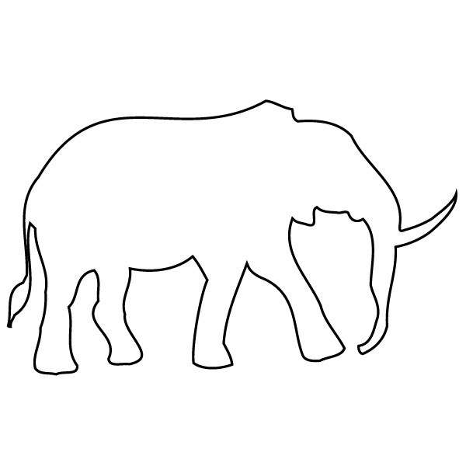

Ajouter les points de couleur pour faire les segments

25

Reproduction sur quadrillage

|  |  |  |  |  |  |  |  |  |  |  |  |  |  |  |  |  |  |  |  |
| --- | --- | --- | --- | --- | --- | --- | --- | --- | --- | --- | --- | --- | --- | --- | --- | --- | --- | --- | --- |
|  |  |  |  |  |  |  |  |  |  |  |  |  |  |  |  |  |  |  |  |
|  |  |  |  |  |  |  |  |  |  |  |  |  |  |  |  |  |  |  |  |
|  |  |  |  |  |  |  |  |  |  |  |  |  |  |  |  |  |  |  |  |

|  |  |  |  |  |  |  |  |  |  |  |  |  |  |  |  |  |  |  |  |
| --- | --- | --- | --- | --- | --- | --- | --- | --- | --- | --- | --- | --- | --- | --- | --- | --- | --- | --- | --- |
|  |  |  |  |  |  |  |  |  |  |  |  |  |  |  |  |  |  |  |  |
|  |  |  |  |  |  |  |  |  |  |  |  |  |  |  |  |  |  |  |  |
|  |  |  |  |  |  |  |  |  |  |  |  |  |  |  |  |  |  |  |  |

Tracés à la règle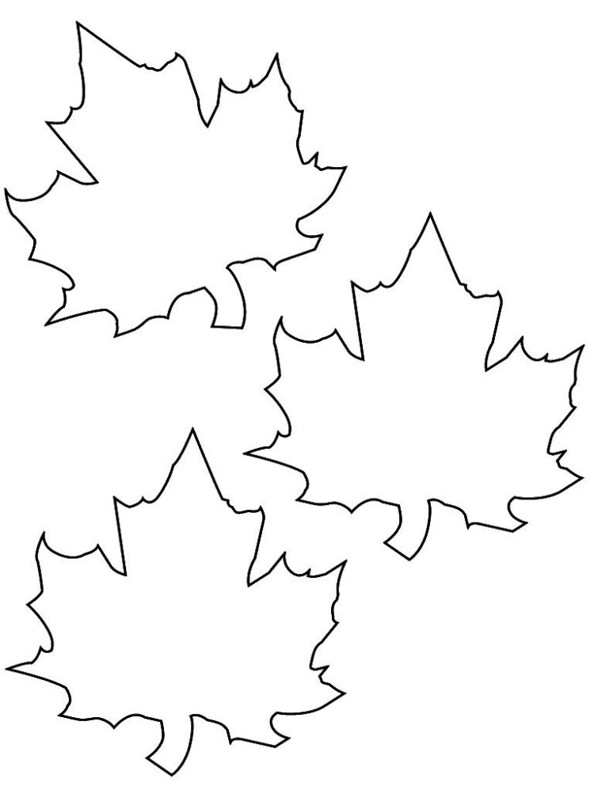

Ajouter les points de couleur pour faire les segments

26

Reproduction sur quadrillage

|  |  |  |  |  |  |  |  |  |  |  |  |  |  |  |  |  |  |  |
| --- | --- | --- | --- | --- | --- | --- | --- | --- | --- | --- | --- | --- | --- | --- | --- | --- | --- | --- |
|  |  |  |  |  |  |  |  |  |  |  |  |  |  |  |  |  |  |  |
|  |  |  |  |  |  |  |  |  |  |  |  |  |  |  |  |  |  |  |
|  |  |  |  |  |  |  |  |  |  |  |  |  |  |  |  |  |  |  |

|  |  |  |  |  |  |  |  |  |  |  |  |  |  |  |  |  |  |  |
| --- | --- | --- | --- | --- | --- | --- | --- | --- | --- | --- | --- | --- | --- | --- | --- | --- | --- | --- |
|  |  |  |  |  |  |  |  |  |  |  |  |  |  |  |  |  |  |  |
|  |  |  |  |  |  |  |  |  |  |  |  |  |  |  |  |  |  |  |
|  |  |  |  |  |  |  |  |  |  |  |  |  |  |  |  |  |  |  |

Tracés à la règle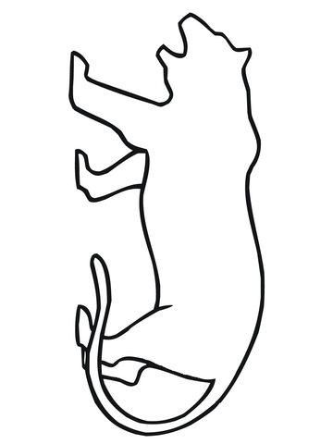

Ajouter les points de couleur pour faire les segments

27

Reproduction sur quadrillage

|  |  |  |  |  |  |  |  |  |  |  |  |  |  |  |  |  |  |  |  |
| --- | --- | --- | --- | --- | --- | --- | --- | --- | --- | --- | --- | --- | --- | --- | --- | --- | --- | --- | --- |
|  |  |  |  |  |  |  |  |  |  |  |  |  |  |  |  |  |  |  |  |
|  |  |  |  |  |  |  |  |  |  |  |  |  |  |  |  |  |  |  |  |
|  |  |  |  |  |  |  |  |  |  |  |  |  |  |  |  |  |  |  |  |

|  |  |  |  |  |  |  |  |  |  |  |  |  |  |  |  |  |  |  |  |
| --- | --- | --- | --- | --- | --- | --- | --- | --- | --- | --- | --- | --- | --- | --- | --- | --- | --- | --- | --- |
|  |  |  |  |  |  |  |  |  |  |  |  |  |  |  |  |  |  |  |  |
|  |  |  |  |  |  |  |  |  |  |  |  |  |  |  |  |  |  |  |  |
|  |  |  |  |  |  |  |  |  |  |  |  |  |  |  |  |  |  |  |  |

Tracés à la règle

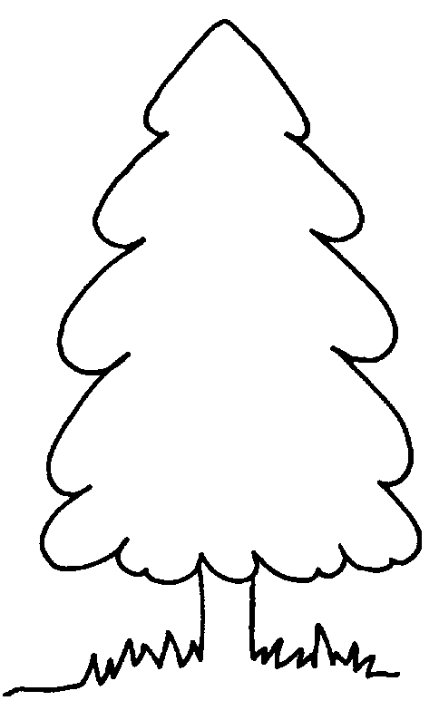

Ajouter les points de couleur pour faire les segments

28

Reproduction sur quadrillage

|  |  |  |  |  |  |  |  |  |  |  |  |  |  |  |  |  |  |  |  |
| --- | --- | --- | --- | --- | --- | --- | --- | --- | --- | --- | --- | --- | --- | --- | --- | --- | --- | --- | --- |
|  |  |  |  |  |  |  |  |  |  |  |  |  |  |  |  |  |  |  |  |
|  |  |  |  |  |  |  |  |  |  |  |  |  |  |  |  |  |  |  |  |
|  |  |  |  |  |  |  |  |  |  |  |  |  |  |  |  |  |  |  |  |

|  |  |  |  |  |  |  |  |  |  |  |  |  |  |  |  |  |  |  |  |
| --- | --- | --- | --- | --- | --- | --- | --- | --- | --- | --- | --- | --- | --- | --- | --- | --- | --- | --- | --- |
|  |  |  |  |  |  |  |  |  |  |  |  |  |  |  |  |  |  |  |  |
|  |  |  |  |  |  |  |  |  |  |  |  |  |  |  |  |  |  |  |  |
|  |  |  |  |  |  |  |  |  |  |  |  |  |  |  |  |  |  |  |  |

Tracés à la règle

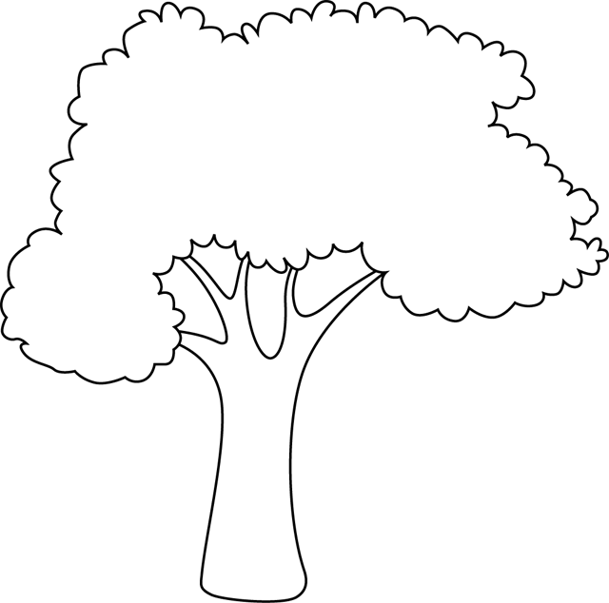

Ajouter les points de couleur pour faire les segments

29

Reproduction sur quadrillage

|  |  |  |  |  |  |  |  |  |  |  |  |  |  |  |  |  |  |  |
| --- | --- | --- | --- | --- | --- | --- | --- | --- | --- | --- | --- | --- | --- | --- | --- | --- | --- | --- |
|  |  |  |  |  |  |  |  |  |  |  |  |  |  |  |  |  |  |  |
|  |  |  |  |  |  |  |  |  |  |  |  |  |  |  |  |  |  |  |
|  |  |  |  |  |  |  |  |  |  |  |  |  |  |  |  |  |  |  |

|  |  |  |  |  |  |  |  |  |  |  |  |  |  |  |  |  |  |  |
| --- | --- | --- | --- | --- | --- | --- | --- | --- | --- | --- | --- | --- | --- | --- | --- | --- | --- | --- |
|  |  |  |  |  |  |  |  |  |  |  |  |  |  |  |  |  |  |  |
|  |  |  |  |  |  |  |  |  |  |  |  |  |  |  |  |  |  |  |
|  |  |  |  |  |  |  |  |  |  |  |  |  |  |  |  |  |  |  |

Tracés à la règle

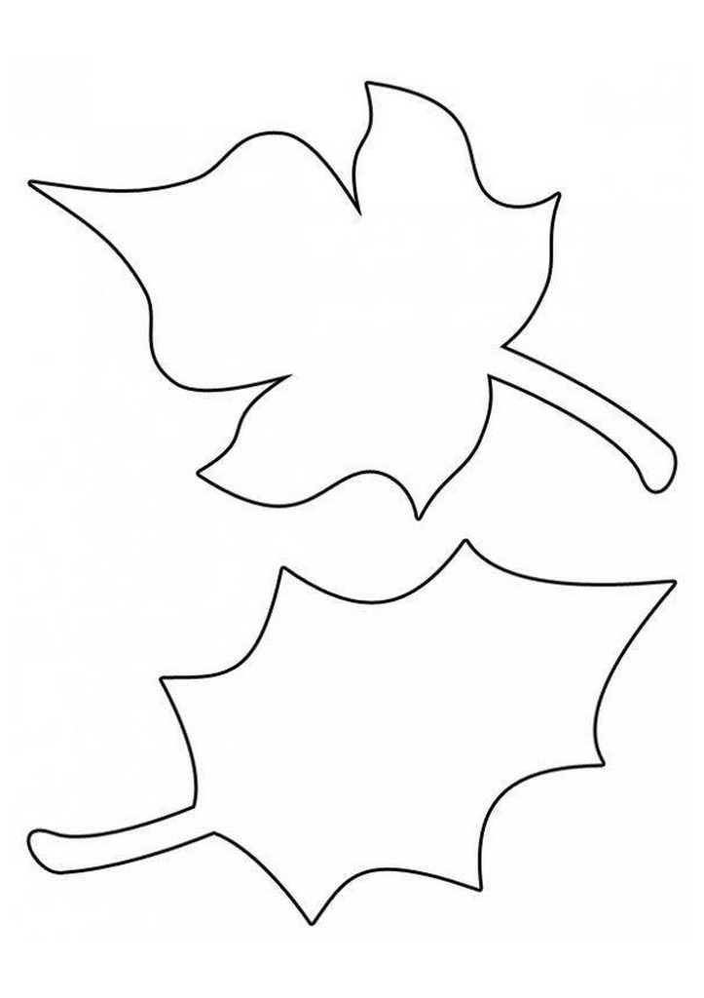

Ajouter les points de couleur pour faire les segments

30

Reproduction sur quadrillage

|  |  |  |  |  |  |  |  |  |  |  |  |  |  |  |  |  |  |  |  |
| --- | --- | --- | --- | --- | --- | --- | --- | --- | --- | --- | --- | --- | --- | --- | --- | --- | --- | --- | --- |
|  |  |  |  |  |  |  |  |  |  |  |  |  |  |  |  |  |  |  |  |
|  |  |  |  |  |  |  |  |  |  |  |  |  |  |  |  |  |  |  |  |
|  |  |  |  |  |  |  |  |  |  |  |  |  |  |  |  |  |  |  |  |

|  |  |  |  |  |  |  |  |  |  |  |  |  |  |  |  |  |  |  |  |
| --- | --- | --- | --- | --- | --- | --- | --- | --- | --- | --- | --- | --- | --- | --- | --- | --- | --- | --- | --- |
|  |  |  |  |  |  |  |  |  |  |  |  |  |  |  |  |  |  |  |  |
|  |  |  |  |  |  |  |  |  |  |  |  |  |  |  |  |  |  |  |  |
|  |  |  |  |  |  |  |  |  |  |  |  |  |  |  |  |  |  |  |  |

Tracés à la règle

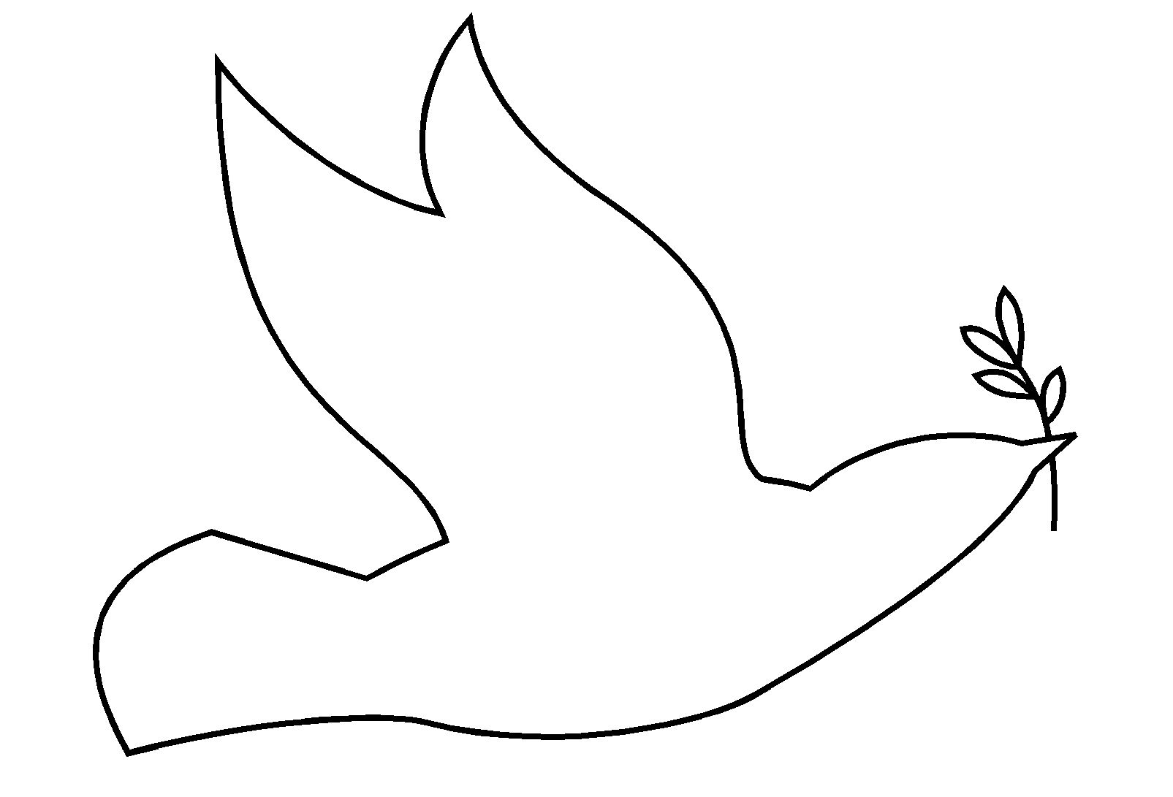

Ajouter les points de couleur pour faire les segments