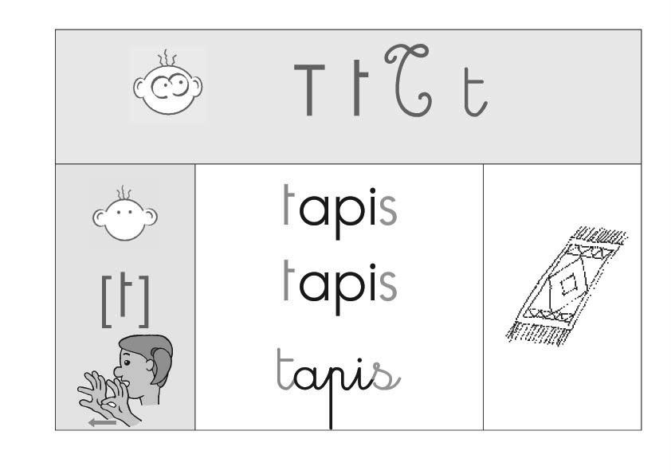

|  |  |  |  |
| --- | --- | --- | --- |
|  | **Je lis des sons.** | | |
| to | ti | te | ta |
| ATI | OTO | ATU | ITA |
| ti | te | ta | tu |

|  |  |
| --- | --- |
|  | **Je lis des mots.** |
|  | TATI  tata  pâte |