BINGO
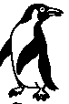 | 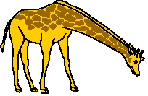 | 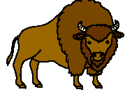
 | FROM HEAD TO TOE | 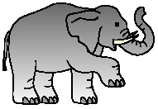
 |  | 

BINGO
FROM HEAD TO TOE


BINGO
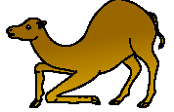 | FROM HEAD TO TOE

BINGO
FROM HEAD TO TOE

BINGO
FROM HEAD TO TOE

BINGO
FROM HEAD TO TOE

BINGO
FROM HEAD TO TOE

BINGO
FROM HEAD TO TOE

BINGO
FROM HEAD TO TOE

An elephant | A crocodile | A giraffe | A camel
A gorilla | A cat | A monkey | A seal
A penguin | A buffalo

