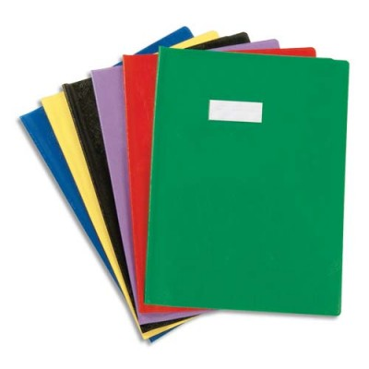

**Inventaire de la classe :**

**cahiers et livres**

|  |  |  |
| --- | --- | --- |
| **Matériel :** | **Stock :** | **A commander :** |
|  |  |  |
|  |  |  |
|  |  |  |
|  |  |  |
|  |  |  |
|  |  |  |
|  |  |  |
|  |  |  |
|  |  |  |
|  |  |  |
|  |  |  |
|  |  |  |
|  |  |  |
|  |  |  |
|  |  |  |
|  |  |  |
|  |  |  |
|  |  |  |
|  |  |  |
|  |  |  |
|  |  |  |
|  |  |  |
|  |  |  |
|  |  |  |
|  |  |  |
|  |  |  |
|  |  |  |
|  |  |  |
|  |  |  |
|  |  |  |
|  |  |  |
|  |  |  |
|  |  |  |
|  |  |  |
|  |  |  |
|  |  |  |
|  |  |  |
|  |  |  |
|  |  |  |
|  |  |  |



**Inventaire de la classe :**

**fournitures**

|  |  |  |
| --- | --- | --- |
| **Matériel :** | **Stock :** | **A commander :** |
|  |  |  |
|  |  |  |
|  |  |  |
|  |  |  |
|  |  |  |
|  |  |  |
|  |  |  |
|  |  |  |
|  |  |  |
|  |  |  |
|  |  |  |
|  |  |  |
|  |  |  |
|  |  |  |
|  |  |  |
|  |  |  |
|  |  |  |
|  |  |  |
|  |  |  |
|  |  |  |
|  |  |  |
|  |  |  |
|  |  |  |
|  |  |  |
|  |  |  |
|  |  |  |
|  |  |  |
|  |  |  |
|  |  |  |
|  |  |  |
|  |  |  |
|  |  |  |
|  |  |  |
|  |  |  |
|  |  |  |
|  |  |  |
|  |  |  |
|  |  |  |
|  |  |  |
|  |  |  |



**Inventaire de la classe :**

**art visuel**

|  |  |  |
| --- | --- | --- |
| **Matériel :** | **Stock :** | **A commander :** |
|  |  |  |
|  |  |  |
|  |  |  |
|  |  |  |
|  |  |  |
|  |  |  |
|  |  |  |
|  |  |  |
|  |  |  |
|  |  |  |
|  |  |  |
|  |  |  |
|  |  |  |
|  |  |  |
|  |  |  |
|  |  |  |
|  |  |  |
|  |  |  |
|  |  |  |
|  |  |  |
|  |  |  |
|  |  |  |
|  |  |  |
|  |  |  |
|  |  |  |
|  |  |  |
|  |  |  |
|  |  |  |
|  |  |  |
|  |  |  |
|  |  |  |
|  |  |  |
|  |  |  |
|  |  |  |
|  |  |  |
|  |  |  |
|  |  |  |
|  |  |  |
|  |  |  |
|  |  |  |