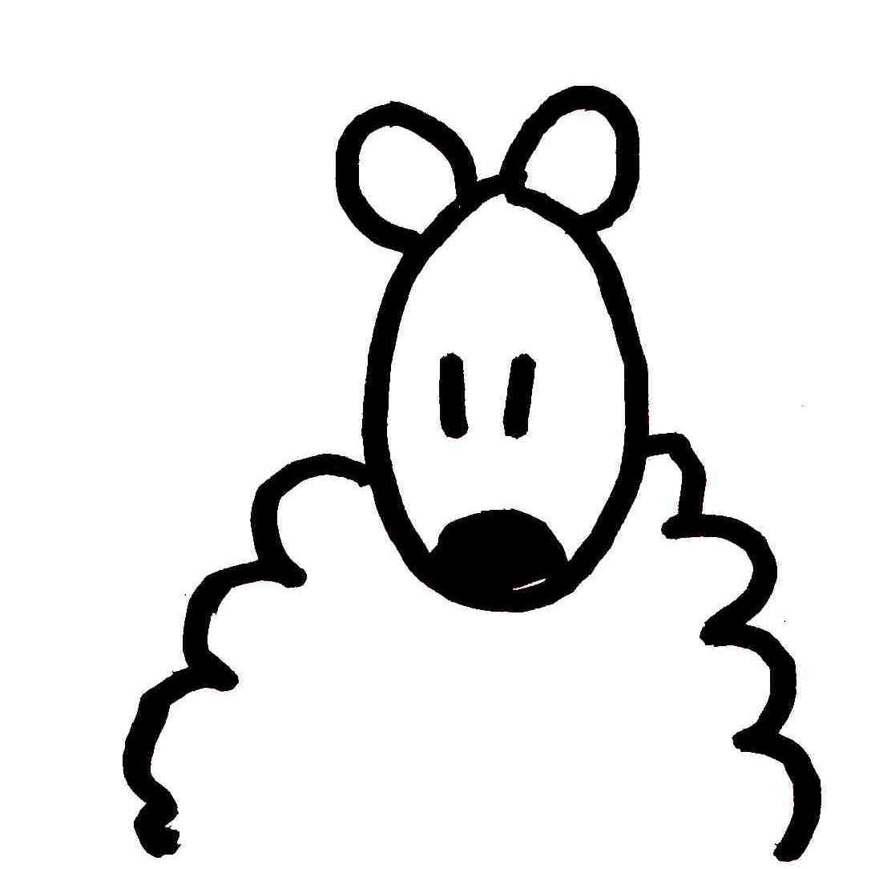 |  | 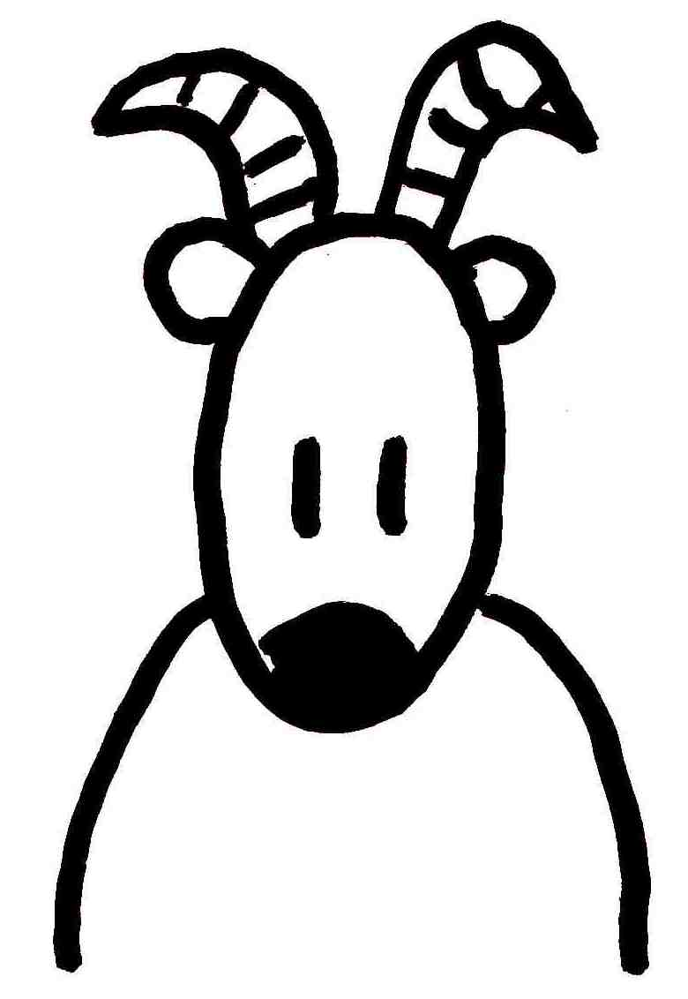
 | 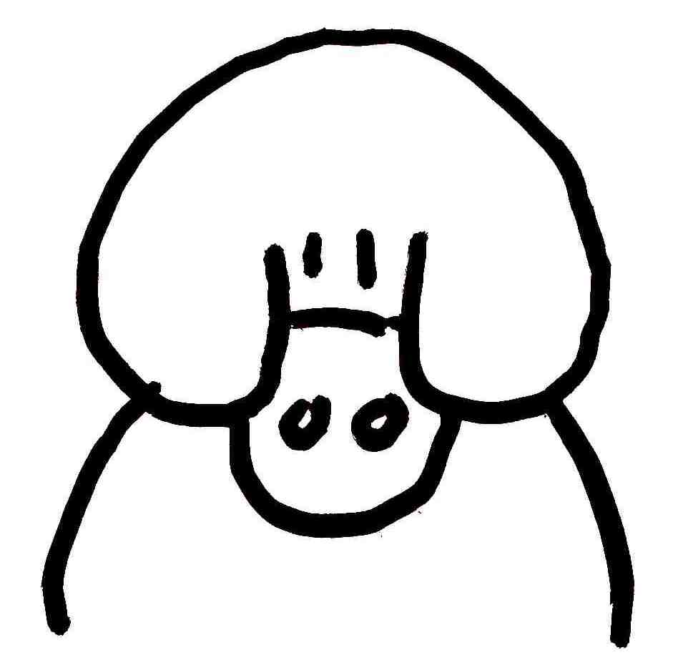

☺ 😐 ☹

MOUTON |  | COCHON |  | CHEVRE

MOUTON |  | COCHON |  | CHEVRE

COCHON |  | CHEVRE |  | MOUTON

