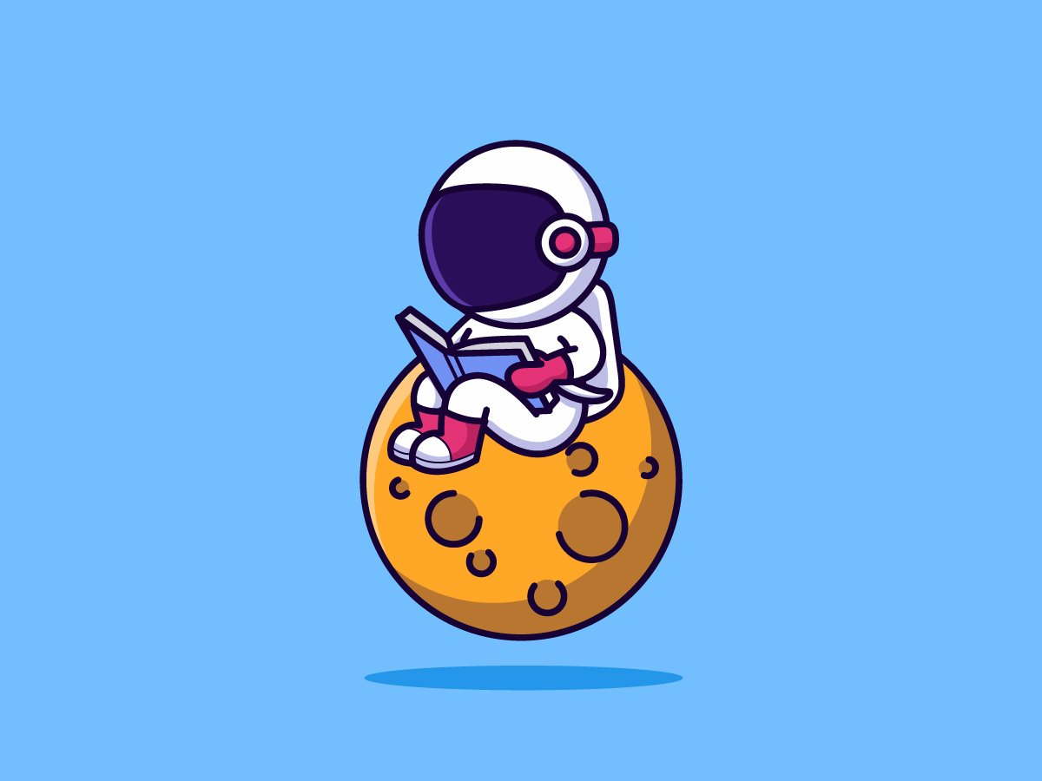

mühsin

rania



ethan

aylin



léo

maude



maxim

emy



loucas

iris



martin

louise



eden

zola



aaron

myriem



tidiane

zina



maël



