Stages in the History of Communication

The following account of history is largely based on the discussions in Chramm(1998) and De Fleur and Ball-Rokeah (1989).

The stages in human communication are associated with the development of speaking, writing, printing, and the mass media( such as news papers, radio and television). The most recent stage is the age of computers. One of the most important consequences of the development of computer is that it has turned us into what has come to be known as the ‘‘information society’’. Because of the radical changes each stage brought about, these stages in the history of communication have also been termed ‘‘revolutions’’

The beginning of human communication

The story of human communication begins some half a million years ago with small groups of prehistoric hunters who lived in caves. These people did not walk upright and were physically incapable of producing speech. Although we have no records, scientists assume that their communication was similar to animal communication. That is, prehistoric people received and exchanged information about the environment (for instance, the presence of danger, or food) through their senses: sight, smell, taste, touch and hearing. They also communicate with each other through gestures, posture, and facial expressions, and expressed a limited number of sounds such as grunts and cries. The inability to speak put limits on the ability of these early people to think and be creative.

Over time, climatic changes caused people to move out of the caves and settle in small communities. The need to communicate played an increasingly important role in their ability to participate in community life. The development of speech and language was the first major revolution in the means of communication available to human beings.

The age of speech and language

Scientists estimate that speech and language originated between 35000 and 40000 years ago among people who had evolved to physically resemble human beings today. Not much is known about the origins of speech. One view is that it was a divine gift. Another view assumes that, as the human speech organs developed, recognizable words gradually developed from the basic sounds emitted by prehistoric people, and speech and language evolved. What is important is that speech gave people the ability to think and plan, to hunt and defend themselves more effectively, to invent ways of preserving their food and keeping warm in winter, and to learn to cultivate the land. Over time they developed techniques for using various metals, and learned to weave and use the wool. It was during this era that people began expressing their creativity in the form of art and cave paintings that have been discovered in different parts of the world. The development of speech and language thus had consequences for both individuals and society. While the ability to use language did not cause great changes, it made possible the transition from a hunting way of life to an agricultural way of life.

The first agricultural communities settled along the fertile bank of the Tigris and Euphrates Rivers, the shores of the Mediterranean, and the banks of the Nile River. As these agricultural areas grew and developed over the centuries, people needed to find ways to record such matters as boundaries and land ownership. As their towns grew in size and commercial activities and trading increased, they also needed to keep records of buying and selling, and other transactions. It was needs such as these that prompted the invention of writing in about 3500BC.

The age of writing

Writing had its beginning in the pictures and drawings that represented animals and people in prehistoric cave paintings. People gradually started combining pictures to convey more complex ideas, such as the sequence of a hunt. Later, the drawings of such pictures becomes associated with sounds. For example, the drawing of an ox becomes associated with the sound ox.

The first writing system using such pictures , called cuneiform, was invented by the Sumerians in Mesopotamia round about 3500BC. A great advancement was made when they realized that it was not necessary to use pictures to represent ideas. Instead, they began producing wedge-shaped characters on clay tablets. Each character was assigned a meaning. Later, they let each character stand for a particular sound rather than an idea. The advantage was that instead of thousands of characters that represent ideas-one for each thing and idea- only about a hundred were needed to represent the syllables that made up the words of a language. The cuneiform characters were refined into the letters of an alphabet. Each letter or sign stood for a consonant or vowel, rather than a syllable, and made it possible for a whole language to be written down using a limited number of signs. Today, we manage very well with an alphabet of 26 letters.

About 400 years after the Sumerians, the Egyptians embarked on a similar path producing a system of writing known as hieroglyphics, a series of pictures carved in stone, which told a story. Because they considered writing as an art form, they never reached the stage of developing an alphabet. As a result, their writing disappeared while that of the Sumerians developed and spread.

While the invention of writing allowed people to record and store information, the problem with hieroglyphics and the clay tablets of cuneiform was that they were difficult to transport. The first advances toward a more portable writing medium were made by the Egyptians who discovered the papyrus-making process in about 2500BC. Later, animal skins and parchment replaced papyrus, and paper was finally invented by the Chinese in about 100AD.

The importance of light and portable media, together with a system of meaningful written signs, is that it provided the conditions for far reaching social and cultural changes. Of prime importance is that it was no longer necessary to rely on the human memory to convey information and to pass the culture of a society by word of mouth. In Egypt, for example, papyrus was used to record the affairs of government and to write legal, literary, scientific, medical, and religious ideas. Libraries were opened, and schools were established to teach a class of clerks, known as scribes, to write. In fact, it was not until the invention of printing in the 15th century AD that literacy started to spread.

The age of print

The printing process is traditionally attributed to the invention of portable metal type by Johann Gutenberg of Mainz in Germany in 1450. Prior to this time, manuscripts and books were produced by craftsman and monks who copied and recopied them by hand- a slow laborious and expensive process. Gutenberg’s invention revolutionized book production. His techniques spread rapidly throughout the world and by the beginning of the sixteenth century, thousands of books were being produced. Newspapers also began to flourish and their circulation increased rapidly. While the early newspapers of the 17th and 18th century were aimed at the educated elite, the newspapers of the 19th and 20th centuries were designed to appeal to the growing numbers of literate artisans and merchants in the rapidly developing urban-industrial cities of England, Europe and America. The first newspaper to be published in South Africa was the bilingual Capetown Gazett and African Advertiser, which appeared in 1800.

The social significance of printing is that with the spread of books, more and more people learned to read and write, and their thinking was freed from the restrictions of church and government. New political and religious ideas began to circulate in society, and throughout Europe and America revolutionary movements emerged, disseminating their ideas to increasingly receptive publics. Particularly, with the spread of newspapers, public opinion became something that political leaders had to take into account. Although it came after book production, the great success and wide distribution of newspapers made it the first true mass communication medium.

The age of the electronic mass media

After the appearance and acceptance of the mass press, changes in the means of human communication occurred rapidly. Scientific discoveries and technological inventions during the 19th century( such as electricity and the telegraph) lead the foundation that would eventually lead to electronic mass media.

Towards the end of the 19th century, people were able to send telegrams and talk to each other on the telephone. Marconi invented the first ‘wireless telegraph’ which permitted signals to be transmitted without the use of electric wires. The 20th century is characterized by the invention of satellites, radio, television, and VCR.

Later, computers were invented. Initially, they were used for calculating and computing. Soon, satellites, telephony, and computers were brought together to form a network connecting people all over the world.
This international network or INTERNET with its world wide web has finally turned the world into a global village in the real sense.

Today, we use technological means to exchange, record, recover and disseminate information. What is of interest to communication scholars is how techniques and technology that made modern communication possible developed over the ages—in other words, the story of human communication.

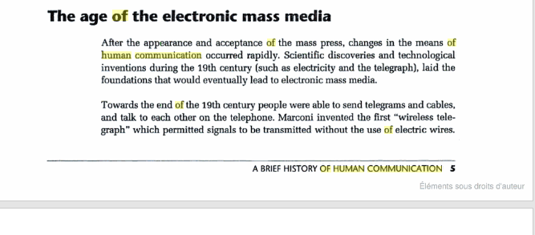
Towards the end of the 19th century, people were able to send telegrams and talk to each other on the telephone. Marconi invented the first ‘wireless telegraph’ which permitted signals to be transmitted without the use of electric wires. The 20th century is characterized by the invention of satellites, radio, television, and VCR.

Later, computers were invented. Initially, they were used for calculating and computing. Soon, satellites, telephony, and computers were brought together to form a network connecting people all over the world.
This international network or INTERNET with its world wide web has finally turned the world into a global village in the real sense.

Today, we use technological means to exchange, record, recover and disseminate information. What is of interest to communication scholars is how techniques and technology that made modern communication possible developed over the ages—in other words, the story of human communication.

Today, we use technological means to exchange, record, recover and disseminate information. What is of interest to communication scholars is how techniques and technology that made modern communication possible developed over the ages—in other words, the story of human communication.
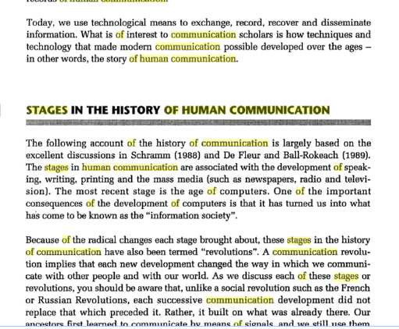

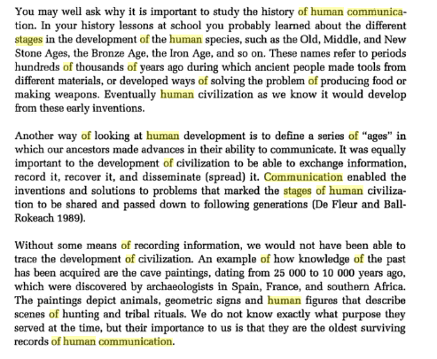

The oldest forms of human communication
Some of the oldest forms of human communication include talking or making sounds, drawing or painting, dancing, acting, and using symbols.
From sounds and symbols to written communication and language
Making sounds such as grunting or guttural sounds at a low pitch or high pitch would indicate either social communication or be a warning sign. Body language was also used as communication at this time. Later written communication came about when humans realised the need to record their daily life activities. Further down the line this progressed to meeting the needs of bartering and exchanging of goods. The ancient Egyptians were amongst the first people to use symbols as a form of written communication which later developed into the alphabet system that we know today.
Language, symbols, songs, art and dance
Cave drawings were murals that people painted onto the walls of caves and canyons to tell the story of their culture. They would tell stories of battles, hunts and culture.
Storytelling was used to tell stories, both fiction and nonfiction, before there were books. It was a way for families and communities to pass on information about their past.
This infographic highlights all forms of communication through ages, click here to view
Drums were one way to send signals to neighbouring tribes and groups. The sound of the drumming patterns would tell them of concerns and events they needed to know.
Smoke signals were another way to send messages to people who were not close enough to use words with. Can you imagine living without your telephone? We sure have come a long way!
SAHO is still developing content for this section. If you have any content to send us or suggestions please click on 'contribute'.
Rock art For some great rock art images. Visit: www.kimberleycoastalcamp.com.au To download PowerPoint presentations on early man with great pictures and drawings. Visit: earlyhumans.mrdonn.org. The site also includes interesting ideas for games in the classroom.
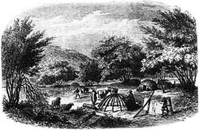
San hunter-gatherers and the Khoi-Khoi herder
For many years it was widely believed that the only reliable form of knowledge was the written word. Books, diaries, documents, and newspapers.These commanded respect because their words could be preserved. But the printed word can be misleading. For example, certain history books taught, inaccurately, that Africans arrived in Southern Africa at more or less the same time as European settlers landed in the Cape. Some books emphasised differences amongst people. And while most textbooks acknowledged that the Khoisan had lived in South Africa for a very long time, the writers saw them as 'primitive', and paid very little respect to their history.
Their dance was after this fashion: on uttering the word 'hottentot!' they two of their fingers and clicked with tongue and feet, all in time ”Jan Olafsson, a visitor from Holland to the Cape".
When European settlers arrived in South Africa, most of them could read and write. They valued the written word as a precious form of knowledge. But European scholars made the mistake of thinking that writing was the only way that knowledge could be passed on. Where they did not find books in Africa, they simply assumed that Africa had no history.
”The Broken String” shows how wrong they were! Adapted from the school textbook by Emilia Potenza, this feature provides a taste of Africa's rich heritage, long before colonial times. South Africa's distant past may be learned not only through the written word, but through many other forms of evidence from human remains, pottery, tools, rock paintings and buildings, as well as from cultural traditions and the stories and memories passed on by the elders.
”The Broken String” presents this wealth of knowledge in a richly visual, well-informed and challenging way. Giving voice to the stories and experiences of the people themselves encourages more sensitivity to those people of the past, and to understanding their lives, needs and problems. “The Broken String” also approaches the learning of history in a fresh way, encouraging independent and creative exploration of ideas, people and events.
The content for San hunter-gatherers and the Khoi-Khoi herders, was adapted from a book titled 'The Broken String' was developed for the SAHO classroom by Emilia Potenza

LThe history of communication is concerned with the ways in which information, understanding and knowledge have been communicated from individual to individual, and from community to community, through both space and time. It is not only interested in the physical form of the message, but also in its material mode of transmission.

Until the nineteenth century most of this communication was achieved by the transmission of written or printed text and pictures. Thus a history of communication can include books, but can also embrace everything from the clay tablets which were moved along the Tigris and Euphrates in ancient Sumeria, Babylonia and Assyria; through private letters written on paper carried by postboys on early modern European roads; printed newspapers and scientific journals delivered by mail coaches and railway trains; and developments in cinemaphotography and the wireless transmission of radio and television. It can even include the more recent development of the Web; the growth of emails, videoconferencing and social media; and the emergence of print-on-demand and rise of on-line publishing.

In other words, the subject is concerned not just with the transport of goods (such as books) and people as physical vectors of communication; but also with the transmission of encoded information through signal fires, the telegraph, the telephone, and broadcasting; and with the transfer of economic value through coins, bills of exchange, cheques, and PayPal.

The Institute of English Studies (IES) has pioneered the exploration of this field by running a sequence of research seminars on various aspects of the subject. It felt, however, that a major study in the history of communications was needed in order to establish new research methodologies. The most striking subject for such a research programme was on our own doorstep or, more precisely and literally, within our doors. Indeed the IES offices in the University of London’s Senate House were amongst those taken over by the Ministry of Information (MOI) at the beginning of the Second World War. Senate House would serve as the MOI’s headquarters until 1946, and would later be immortalised by George Orwell as the ‘Ministry of Truth’ in his novel Nineteen-Eighty Four.

The MOI was responsible for many aspects of the way in which the UK government communicated news and information to its own people, and to large parts of the rest of the world. It used all modes of communication open to it: pamphlets and books, posters, travelling exhibitions, peripatetic lecturers, loudspeaker vans, films, radio broadcasts and, abroad, printed information dropped from planes. The MOI, in one building and over just seven years, encapsulated a host of ways in which human beings – both successfully and unsuccessfully, intentionally and unintentionally, openly and circumspectly – attempt to communicate to each other.

Communication in Ancient Times

The first means of communication was, of course, the human voice but about 3,200 BC writing was invented in Iraq and Egypt> It was invented about 1,500 BC in China. However the only American civilization to invent a true system of writing were the Mayans.

The next big step was the invention of the alphabet in what is now Israel and Lebanon about 1,600 BC.

In the Ancient World many civilizations including Egypt, Assyria, Persia, Rome and China had efficient postal systems to deliver messages to parts of their empires using relays of horses.

In the ancient world people wrote on papyrus or parchment. However the Chinese invented paper about 200 BC. The knowledge of how to make paper passed to the Arabs and in the Middle Ages it reached Europe.

Communication 1500-1800

The next major improvement in communication was the invention of printing. The Chinese invented printing with blocks in the 6th century AD but the first known printed book was the Diamond Sutra of 686. In Europe in the mid-15th century Johannes Gutenburg invented the printing press, which made books much cheaper and allowed newspapers to be invented. William Caxton introduced the printing press into England in 1476.

The first newspapers were printed in the 17th century. The first newspaper in England was printed in 1641. (However the word newspaper was not recorded until 1670). The first successful daily newspaper in Britain was printed in 1702.

Meanwhile European monarchs set up postal services to carry their messages. In France Louis XI founded one in 1477 and in England Henry VIII created the Royal Mail in 1512. In 1635 to raise money Charles I allowed private citizens to send messages by Royal Mail, for a fee.

Meanwhile the pencil was invented. It was first described in 1565.

Communication in the 19th Century

Communication became far more efficient in the 19th century. In the early 19th century the recipient of a letter had to pay the postage, not the sender. Then in 1840 Rowland Hill invented the Penny Post. From then on the sender of a letter paid. Cheap mail made it much easier for people to keep in touch with loved ones who lived a long way off.

Meanwhile Ralph Wedgwood invented carbon paper in 1806.

The telegraph was invented in 1837. A cable was laid across the Channel in 1850 and after 1866 it was possible to send messages across the Atlantic.

Meanwhile the first fax machine was invented in 1843. A Scot, Alexander Graham Bell, invented the telephone in 1876. The first telephone exchange in Britain opened in 1879. The first telephone directory in London was published in 1880. The first telephone line from London to Paris opened in 1891. The first transatlantic telephone line opened in 1927.

Meanwhile the first successful typewriter went on sale in 1874 and the first successful fountain pen was made in 1884.

In 1829 Louis Braille invented an embossed typeface for the blind and in 1837 Isaac Pitman invented shorthand.

Communication in The 20th Century

Communication continued to improve in the 20th century. In 1901 Marconi sent a radio message across the Atlantic. Radio broadcasting began in Britain in 1922 when the BBC was formed. By 1933 half the households in Britain had a radio. Following the 1972 Sound Broadcasting Act independent radio stations were formed. In the 1990s new radio stations included Radio 5 Live (1990) and Classic FM (1991).

Television was invented in 1925 by John Logie Baird and the BBC began regular, high definition broadcasting in 1936. TV was suspended in Britain during World War II but it began again in 1946. TV first became common in the 1950s. A lot of people bought a TV set to watch the coronation of Elizabeth II and a survey at the end of the that year showed that about one quarter of households had one. By 1959 about two thirds of homes had a TV. By 1964 the figure had reached 90% and TV had become the main form of entertainment - at the expense of cinema, which declined in popularity.

At first there was only one TV channel in Britain but between 1955 and 1957 the ITV companies began broadcasting. BBC2 began in 1964 and Channel 4 began in 1982. Channel 5 began in 1997. In Britain BBC 2 began broadcasting in color in 1967, BBC 1 and ITV followed in 1969. Satellite television began in Britain in 1989.

Meanwhile commercial TV began in the USA in 1941. TV began in Australia in 1956 and in New Zealand in 1960.

Meanwhile in 1960 the first communications satellite, Echo was launched. The laser printer was invented by Gary Starkweather in 1969.

Meanwhile in Britain telephones became common in peoples homes in the 1970s. In 1969 only 40% of British households had a phone but by 1979 the figure had reached 69%. Dr Martin Cooper made the first cell phone call in the USA in 1973. The first mobile phone call in Britain was made in 1985. The first commercial text was sent in 1992. In Britain smartphones were introduced in 1996.

Communication in The 21st Century

In the early 21st century the internet became an important form of communication. Today email has become one of the most popular methods of communication. In the 2010s ebook readers became common.

A timeline of communications and media

A history of education

A history of transport

A history of newspapers

A history of English society

A history of Inventions

Home

Last revised 2017

astThe amount of technological change that takes place in a set number of years almost doubles. For example, from 1850 to 1950, the United States experienced tremendous growth in the area of communications, factory production, medicine, and almost every other technology-based industries. Since 1950, we have matched that amount of technological growth in less than half as many years! And predictions are that the 20-year period from 1990 to 2010 will bring another doubling of technological change!

Clearly, we live in an era of human history where huge changes take place from one generation to the next. We take granted the fact that hwe use technologies our grandparents didn't have, and that our children will use technologies that don't yet exist. Yet the pace of change was not always this fast. It was often hundreds of years and many generations between technological advancements. The following timeline presents some of the highlights in the development of communications technologies:

History of Communication
Tens of thousands of years ago: Speech

4000 B.C.: Pictographic Writing (Hieroglypics)

1500 B.C.:Alphabetic writing

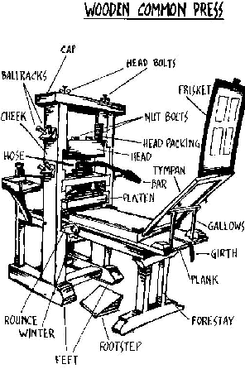 1450 A.D.:Printing Press

1835: Photography

1844: Telegraph

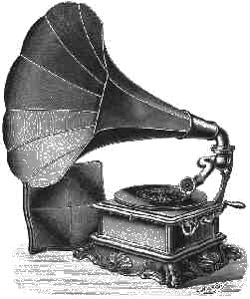 1876: Telephone, phonograph

1894: Wireless telegraph

1895: Silent Movies

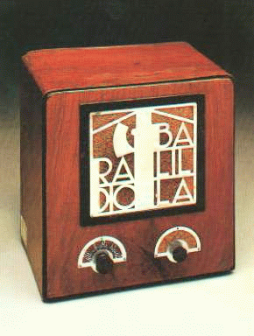 1922: Radio broadcasts

1927: Sound movies

1930: Magnetic recording tape, full colour printing

1935: Colour movies

1939: Pocket paper back books

1940: Black and White TV broadcasts
updated : 08-Feb-2017
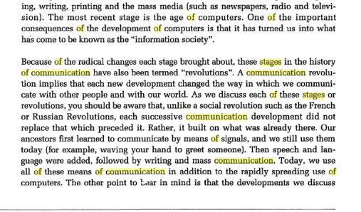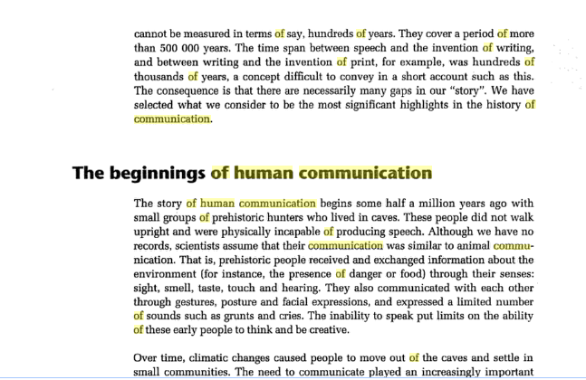

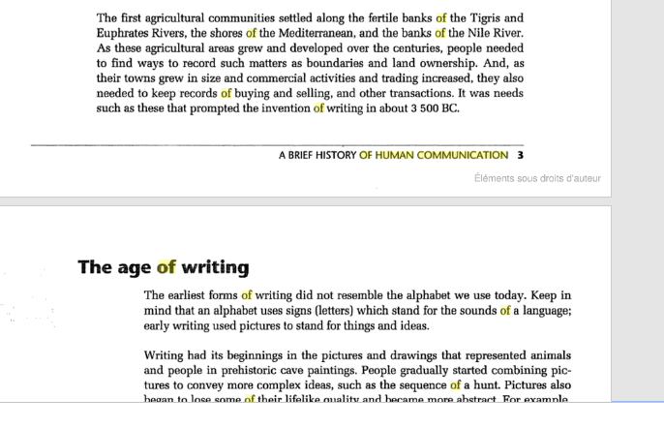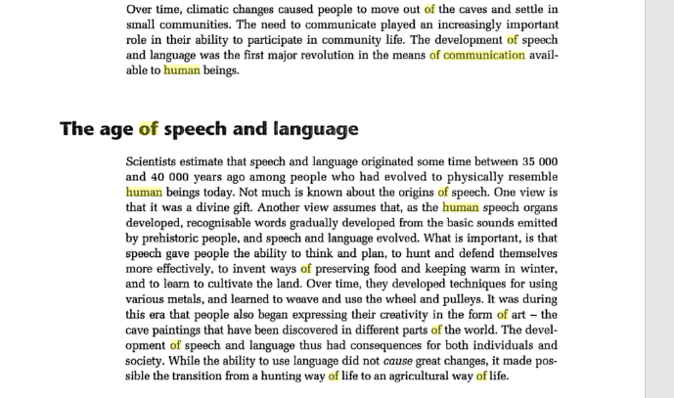

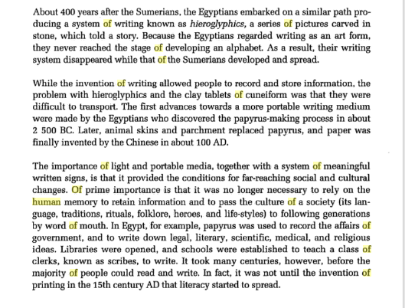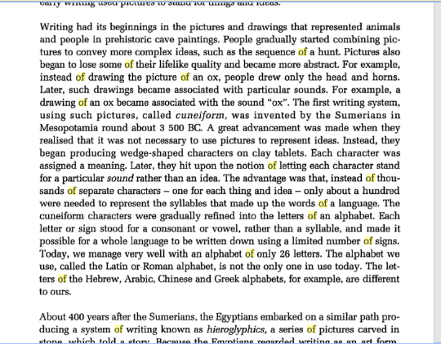
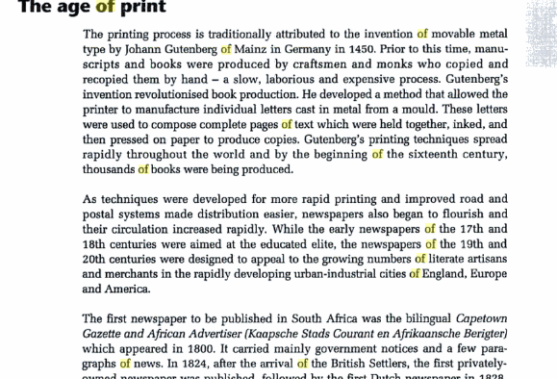
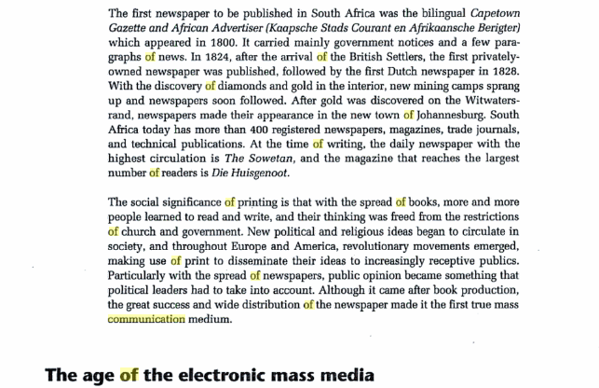
It is estimated that speech and language originated about 40 000 years ago. The origin of speech is not very clear. Some believe that as the human speech organs developed, recognisable words gradually developed from the basic sounds emitted by prehistoric people, and speech and language evolved. Speech gave people the ability to think and plan, to hunt and defend themselves, to learn and express themselves.
Age of writing
In prehistoric eras pictures and drawings of animals and people and cuneiform were used to communicate. The cave paintings provided people with a way of recording customs, traditions, and ceremonies. The Egyptians invented papyrus (a kind of paper made from water plants) in about 2 500 BC. Later, animal skins and parchment (a kind of paper made from animal skins) replaced papyrus, and paper from wood pulp was invented by the Chinese in about AD 100.
Age of print
The fastest way to spread information to many people was by means of printing and it should be noted that printed material was a supplement to oral communication. In 1438, German printer Johann Gutenberg invented a mould for casting individual letters in metal and published the first book in the 1450s. These letters which were held together, inked, and then pressed on paper to produce copies, were used to compose complete pages of text.
Electronic mass media
Mass media is the term used to describe newspapers, television, radio and the Internet simply because it can be used to reach large numbers of people at the same time. It enabled people to transmit and receive information with ease. Radio, television and film have contributed hugely to the development of communication.
Information age
Communication technologies such as computers, satellite communication, videotext, facsimile and the cellular telephone are changing the way people communicate. The information age has seen an increase in the volume of communication and information. This is also called the computer age, or the digital age. E.g. internet, email, chatrooms etc

