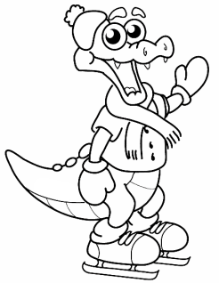
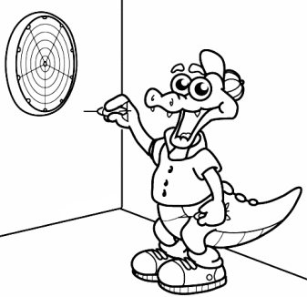
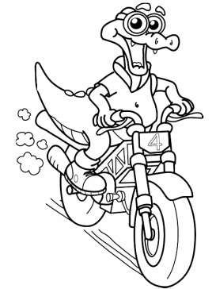
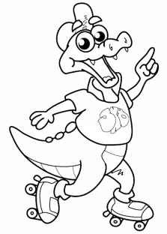
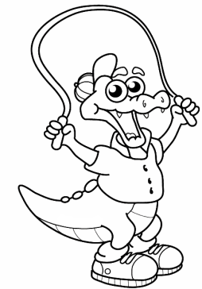
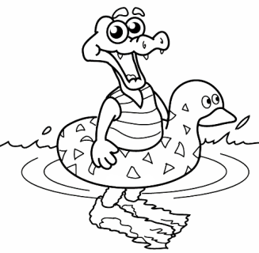
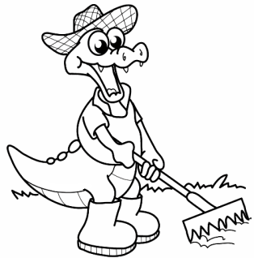
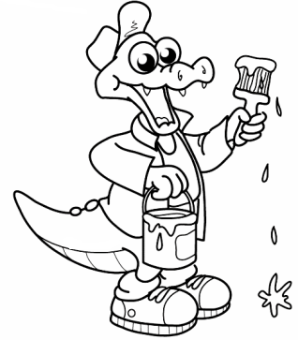
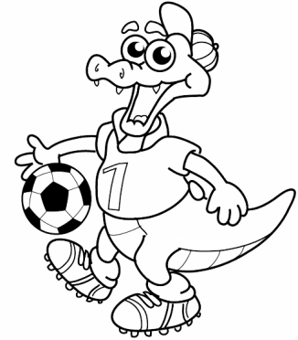
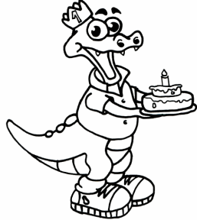

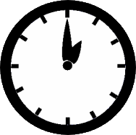
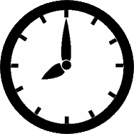
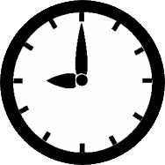
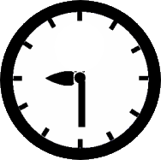
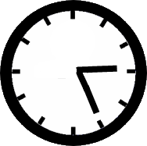
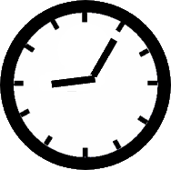
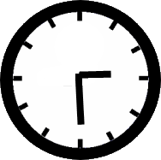
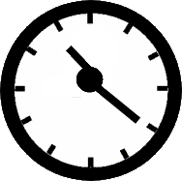
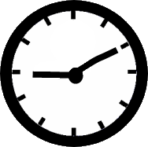
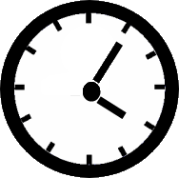
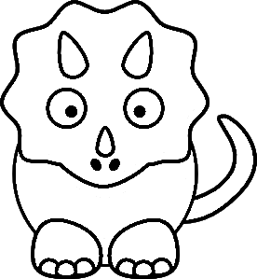
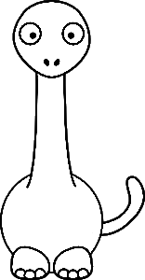


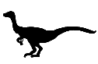
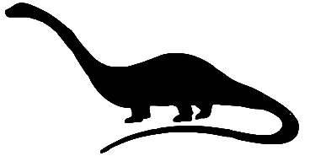
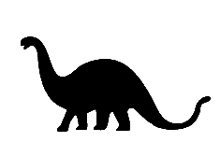

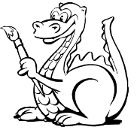

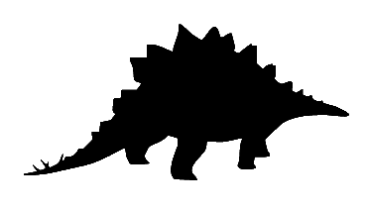
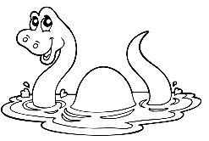

1
2
3
4
a-Mr. Dino skates at half past three. b-He paints his house at half past nine. c-He skips the rope at ten past four. d-He does the gardening at twenty-five past three. e-He plays football at five past nine. f-He rides his bike at twenty past eleven. g-He swims at one o’clock. h-He plays darts at ten past nine. i-He ice skates at eight o’clock. j-He cooks at nine o’clock.
a-What time does he play football? ______________________________ b-Does he do the gardening? ______________________________ c-Can he bake cakes? ______________________________ d-Does he skate at ten o’clock? ______________________________ e-What does he do at half past nine? _____________________________ f-Can he swim?_________________ g-Does he play darts at quarter past four?_______________________
Mr. Dino cooks at nine o’clock._____ He paints at half past three._______ He does the gardening at twenty five past three._______ He skates at half past three._______ He plays football at five past eight._______
a-He plays darts at ten past nine.______________ _________________________________________ b-He paints his house at half past nine._________ _________________________________________ c-He skates at half past three. ________________ _________________________________________ d-He rides his bike at twenty past eleven.________ __________________________________________

