[_Mon_immeuble_des__]

[additions_en_colonnes]

[_Mon_immeuble_des__]

[additions_en_colonnes]

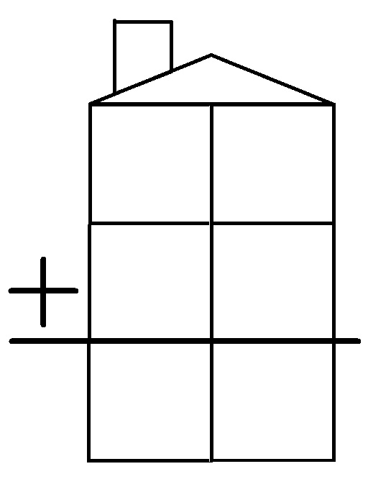

[_Mon_immeuble_des__]

[additions_en_colonnes]

[_Mon_immeuble_des__]

[additions_en_colonnes]

