Universal gyro constant of Saros

Pierre Jones-Savard

[Add affiliation]

Abstract
I provide a gyroscopic constant that makes the connection between the period of variation of the obliquity of the axis of rotation O and the period of precession of the equinoxes E.
This gyroscopic constant N is also the period of rotation of the line of the nodes of the orbit of the Moon, which is 18.6 years, and it is very close to the period of Saros of the Moon, which is 18.03 years (see references herein); for this reason and reasons of convenience, I call this constant N, the universal gyroscopic constant of Saros.
For experimentation with a small gyroscope, the unit of time chosen was milliseconds, and the constant N was therefore 18.6 milliseconds for this gyroscope.
The theoretical angle of variation of the rod or of the axis of rotation is known and we can compare this theoretical angle of variation with that given by a photo taken at the equinoxes after a video freeze of the moving gyroscope towards the equinoxes (then, the precessional motion of the equinoxes was not there).
In doing so, we can see coherence between the theory and experimental results.

In the video that I present to you on YouTube, the variability of the obliquity O of the axis represented by a rod, which is a skewer 15 cm long, is very difficult to see on a small screen. However, on a big screen or with a projector, we can see the vibrated stem very well. It is this vibration that contributes to the variability of the obliquity O of the axis of rotation of the cork disc 17.2 cm in diameter and 1 cm thick; the maximum angle of inclination of the disc is 26.83 degrees, the tangent is 0.52 or 44 mm/85 mm, and the disc touches the table when this angle is reached.

For a cycle or period of variability of the obliquity O and a cycle or period of precession E of the disk, the universal gyro constant of Saros S or N is as follows:

S = N = [O2]/E. (1)

Here, the unit of time for N or S is the same unit of time for E, S refers to the Saros cycle of the Moon’s orbit, N refers to the displacement of the nodes of the Moon’s orbit, O refers to the obliquity of the axis of rotation of the gyroscope, and E refers to the precession of the equinoxes.

The average angular velocity of the variability of the obliquity O must be proportional to the average angular velocity of precession E, and the proportionality constant is equal to 1/2 or 0.5. S = N for the Moon in the cycle or precession period of Saros, and it is about 18.6 years, as shown here in the video (Multimedia file; Universel gyro constant of Saros).

Edition 1, March 4, 2018

With the analysis of this video and a photo taken at a time when we can see very well the jamming of the O obliquity variation, I can confirm that this experiment is consistent with the theory that informs us that the average speed of the variation of the obliquity of the axis of rotation is proportional to the average speed of precession, the constant of proportion being 1/2 or 0.5. We can write this as follows:

(absolute average velocity due to variation of obliquity O) = (1/2) (absolute average speed of a precession E). (2)

In the photo, I show that the shadow of the jamming of the vibration O was about 3.25 inches for 17.49 inches, and the length of this shadow was 12 inches, but with the estimated length under the disk, this gives a length of 17.49 inches. The relevant equation is as follows:

arctan [(3.25)/(17.49)] = arctan (0.1858) = 10.5267 degrees. (3)

The variation estimate angle was 10.9059 degrees, and the error is therefore about

(10.9059)/(10.5267) = 1.036, so it is 3.6 % (10.9059) / (10.5267) = 1.036, or 3.6%. (4)

According to the video, E = ~1266.7 milliseconds, and so I have enough of these two values to prove the theory described above. I commented on my video to give details of the calculations, like the general equation of a conventional gyroscope used in normal conditions for non-uniform movement with variability of obliquity:

(angle variation) = (90 degrees) (O/E), (5)

with the universal gyro constant of Saros, which here is N = 18.6 milliseconds; for O I obtained:

(O2)/E = 18.6 milliseconds, (6)

O = [(18.6 milliseconds) (1266.7 milliseconds)](1/2) = 153.49469 milliseconds. (7)

Here is a picture showing the shadow of the jamming caused by the vibration of the axis of rotation or the variability of the obliquity O. I did not turn off my flash, and it is difficult to see in the photo; thus, I suggest looking at the picture in the dark if possible (Fig. 1 (Multimedia view)).

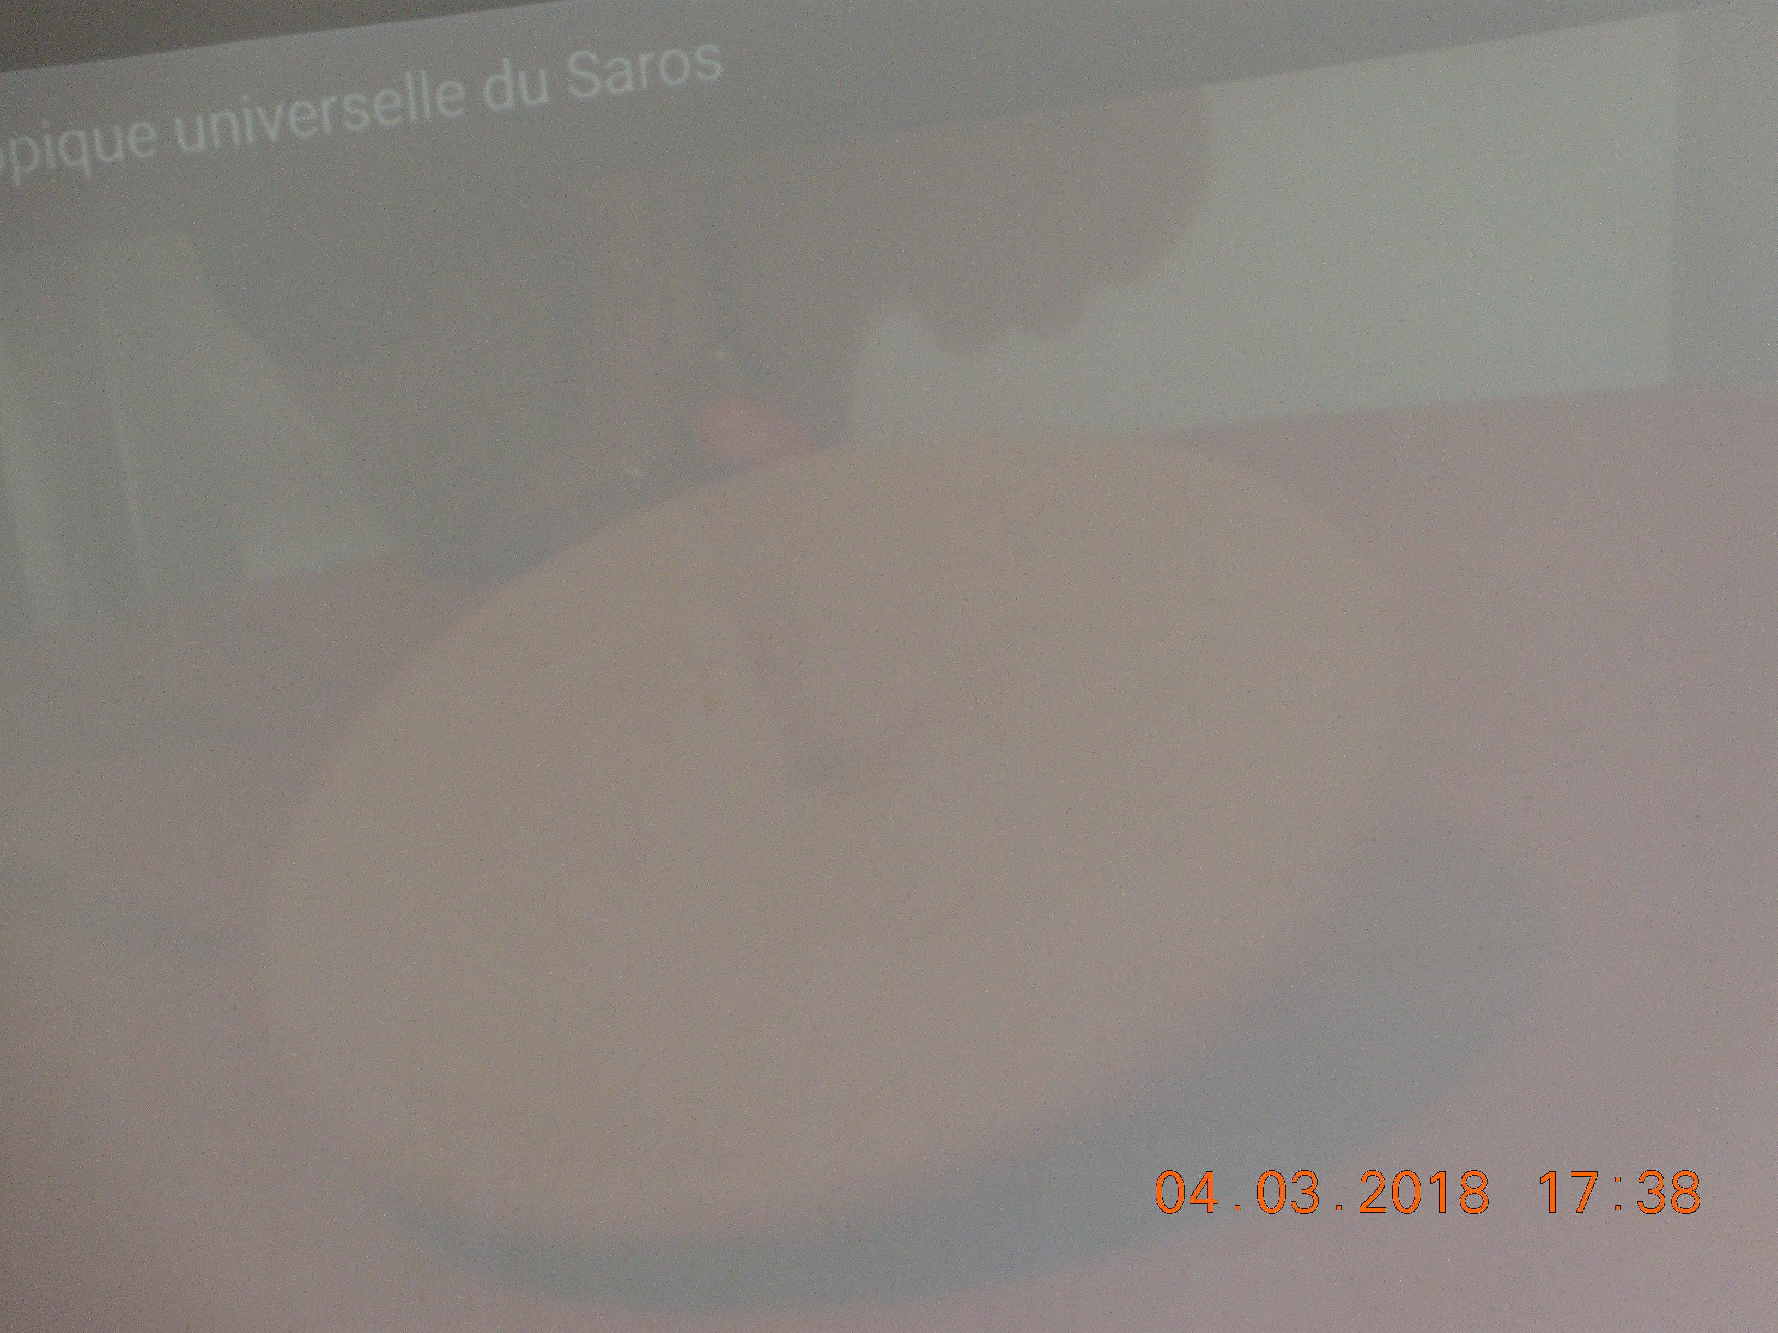
Fig. 1

Here is another very successful photo (Fig. 2 (Multimedia view)).

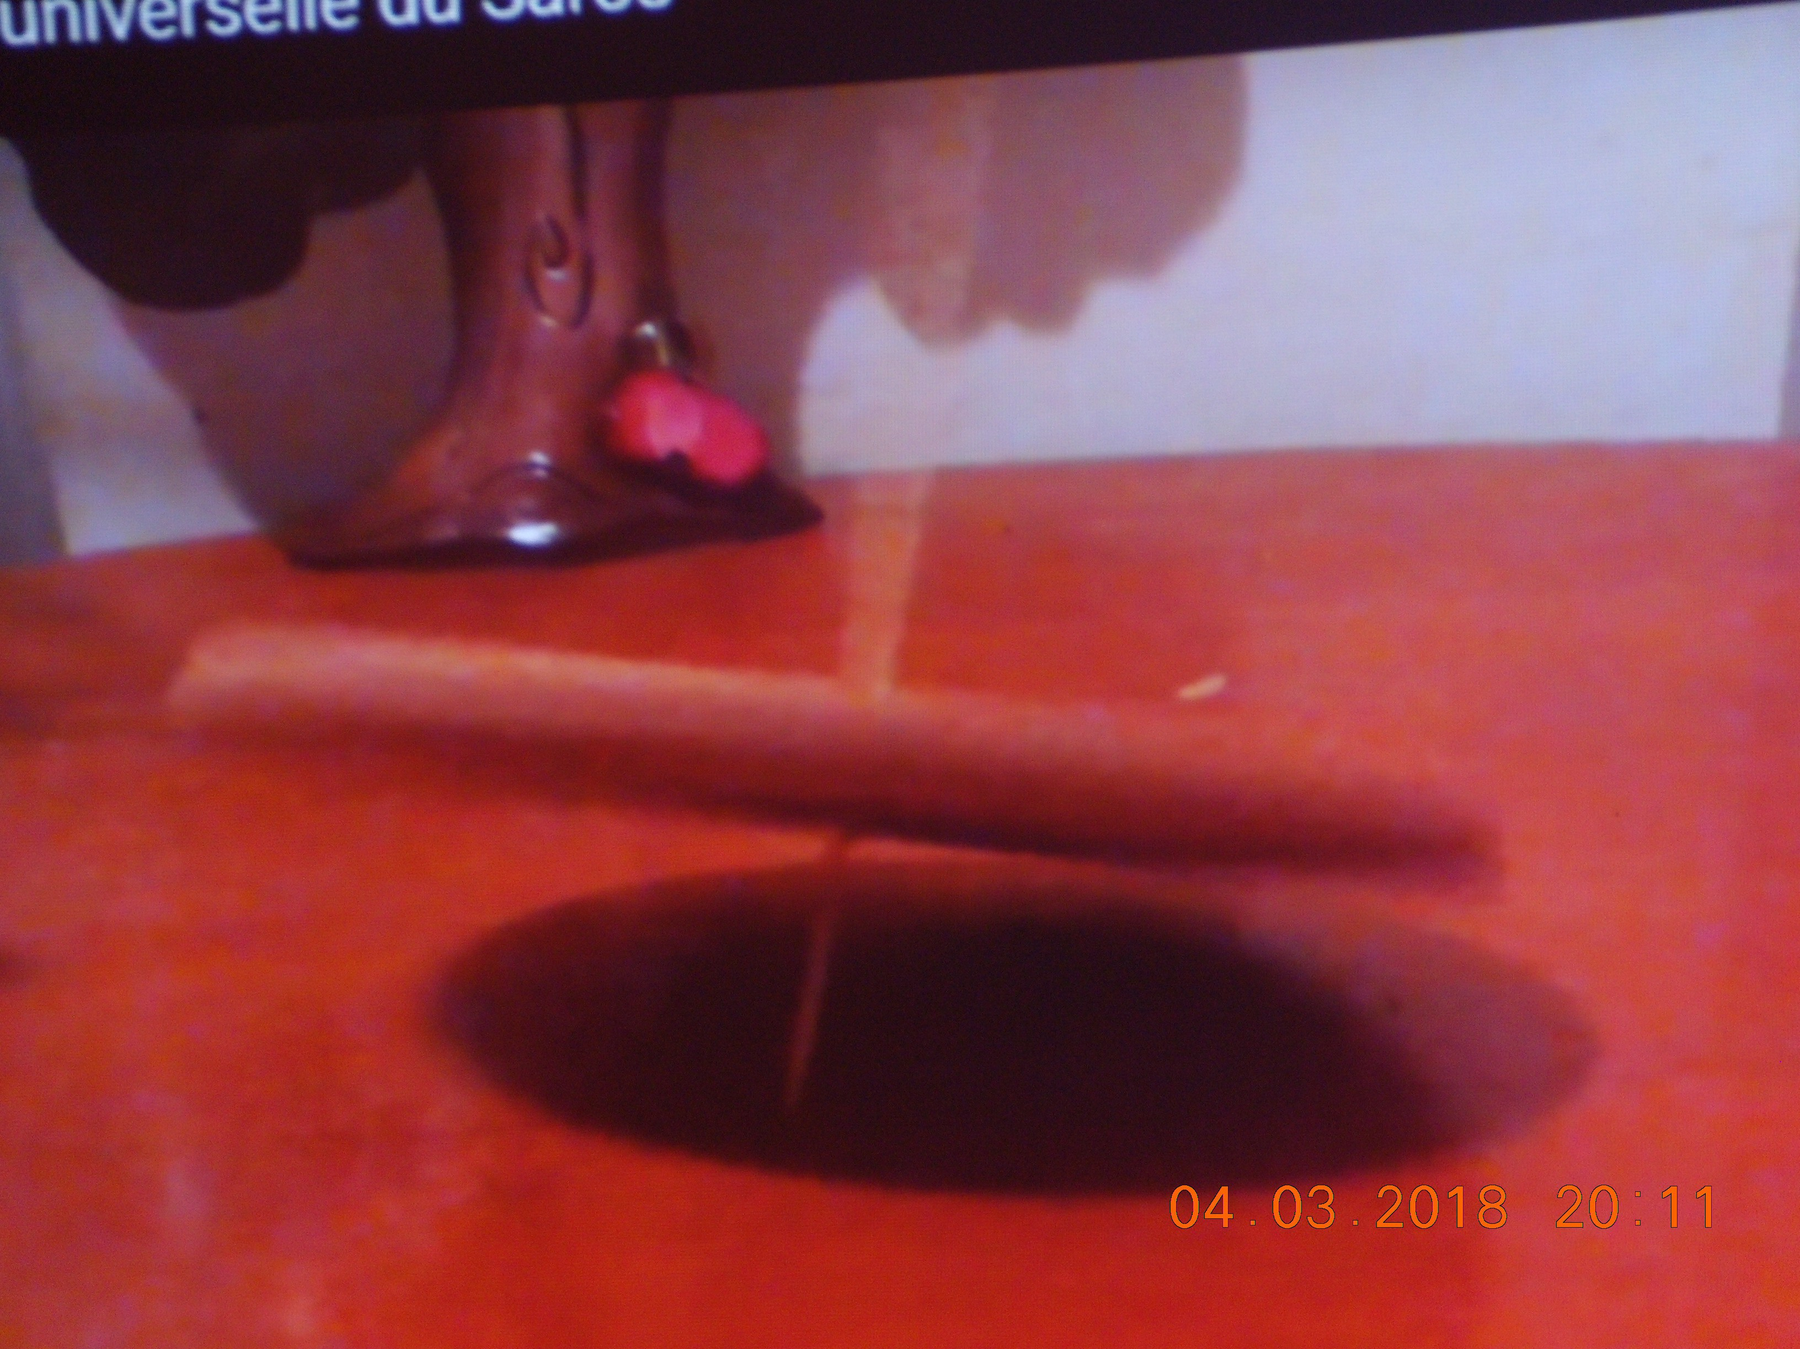
Fig. 2

I noted 3.5 inches wide for 30 inches long;

arctan (3.5)/(30) = arctan (0.11667) = 6.6546 degrees, and the error is (10.9059)/(6.6546) = 1.6388 or 63.88%. (8)

Edition 2, March 10, 2018

The first picture was not taken at the equinoxes, and I should not consider it for the estimation of the variability of obliquity. I took this photo on March 8, 2018, and it is even closer to the equinoxes than the second photo; here is this picture (Fig. 3 (Multimedia view)).

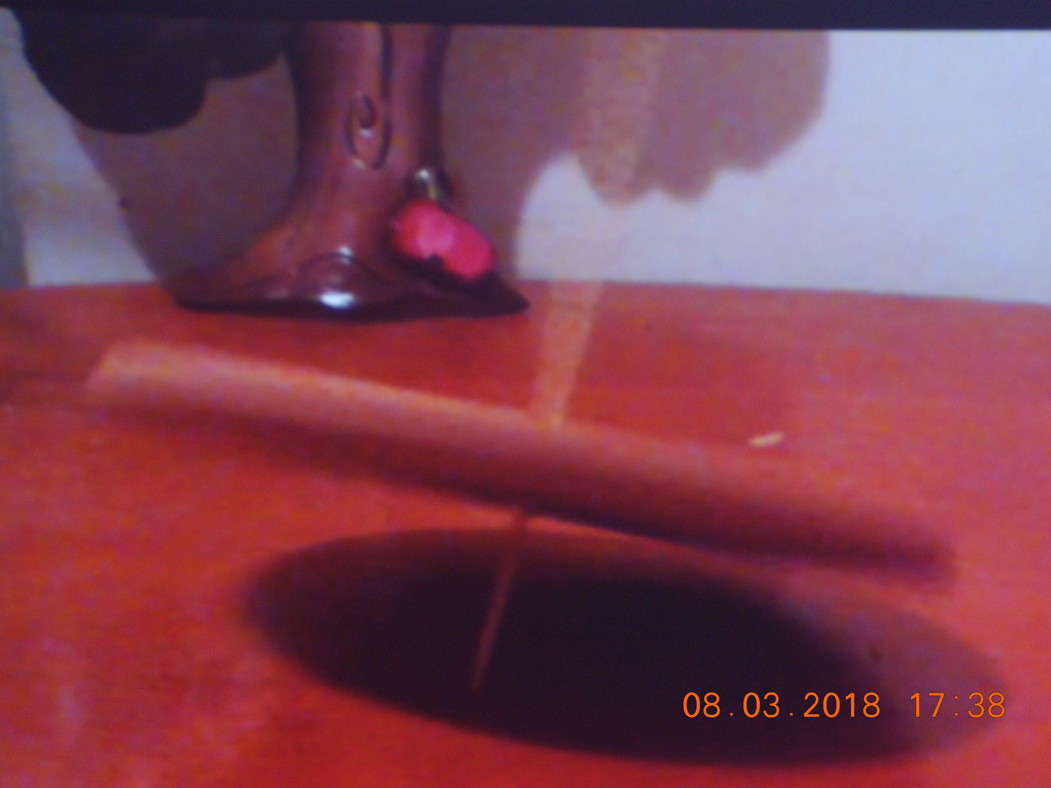
Fig. 3

I noted 4.5 inches for 29.5 inches.

arctan [(4.5 inches)/(29.5 inches)] = arctan (0.1525423) = 8.673174 degrees, (9)
the error is (10.91 degrees)/(8.67 degrees) = 1.258 or about 26%. (10)

These two photos (the second and the third) are very similar; on that of March 8, we can see that the visible angle of the disc is more to the equinoxes, so the jamming of the vibration of the stem is more uniform and important towards the top of the photo, which facilitates the estimation.

The closer to the equinoxes, the greater the accuracy of the experimental estimate, and so when the angle of variation of the obliquity is small, the estimate is precise, in which case the obliquity period O is much smaller compared to the E precession period and the gyro constant is more accurate.

Multimedia metadata
Caption/description:
Type: Video
Format: MPEG-4
This video shows non-unsteady gyroscopic movement (for the second try), with variation of the axis of rotation; it is the only example that I need for the movement.

Acknowledgements
I thank the IOP team at Editage.

References
Pierre Causeret,
A propos du Saros, de la rotation de la ligne des nœuds et du cycle de Méton,

http://clea.astro.eu/archives/cahiers-clairaut/CLEA_CahiersClairaut_122_12.pdf (in French).

