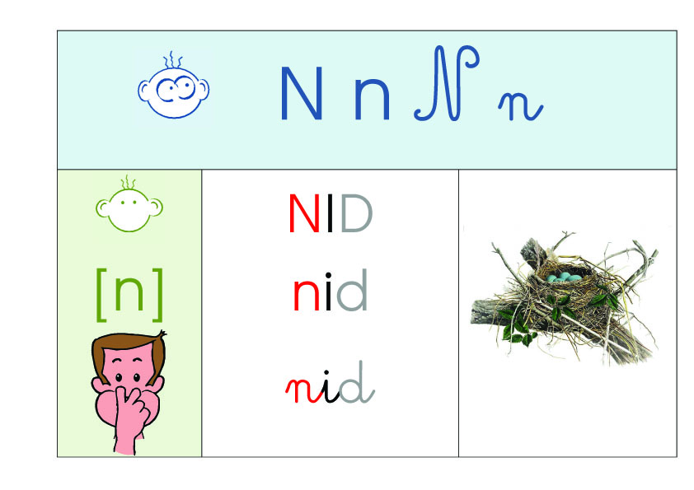

|  |  |  |  |
| --- | --- | --- | --- |
|  | **Je lis des sons.** | | |
| na | mina | noli | pune |
| nété | riné | moni | nalu |
| vino | nina | nonu | tini |

|  |  |  |  |
| --- | --- | --- | --- |
|  | **Je lis des mots.** | | |
|  | âne | punir | tourner |
| menu | nuit | nappe |
|  | panne | tartine | animal |