TEACHER
Langue | Phonologie – Comprendre l’oral - Comprendre l’écrit - Ecrire – Civilisation – Parler en interaction – Parler
Thème | Se présenter : saluer, dire son nom, dire au revoir.
Niveau | 2
Compétences B2i associées | 1.3 – 1.4 – 3.4 - 3.5 – 4.1 – 4.3 – 5.1
PUPIL
1) Complete
Name(s) : Date :
School : Class level :
2) Activities
Go to | http://www.angles365.com/classroom/brown/b1u1d1.swf
Web activity | Complete the comic strip below.
Computer activity
(with help)
Assessment | - Save the document on your computer.  - Send this document to your teacher or print it.
Hi ! Good
What’s
My name’s
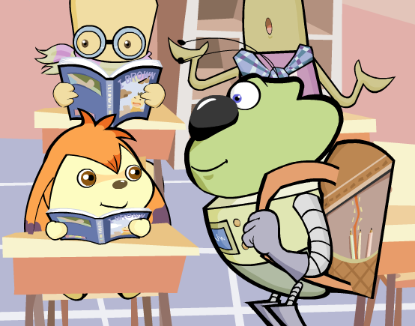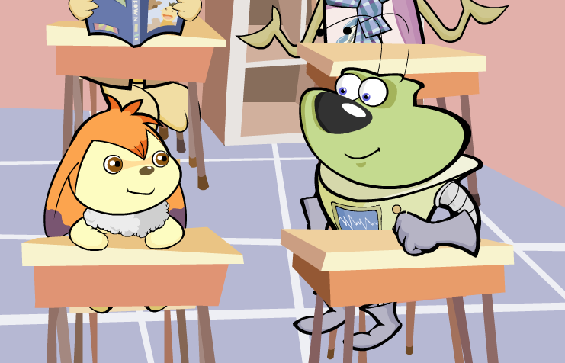
Bye ! See you later !
Good
