**100**

**10**

**20**

**30**

**40**

**50**

**60**

**70**

**80**

**90**

**0**

**1**

**2**

**3**

**4**

**5**

**6**

**7**

**8**

**9**

Le boulier

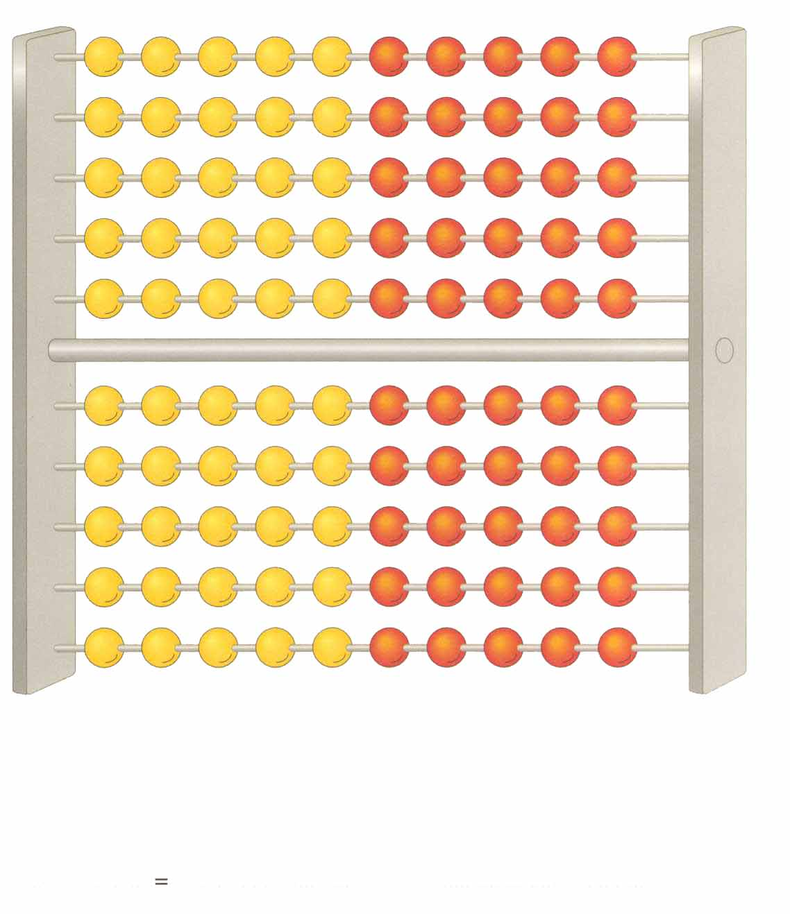

L’abaque

|  |  |  |  |  |  |  |  |  |
| --- | --- | --- | --- | --- | --- | --- | --- | --- |
|  |  |  | |  |  | |  |  |
| **c** | | | **d** | | | **u** | | |