|  |  |  |
| --- | --- | --- |
| *[A Palestinian worshiper prays outside the Dome of the Rock during a snowstorm](http://www.haaretz.com/news/national/.premium-1.563057)* | PEACE LINES  MESSAGERIES  DE LA PAIX  www.peacelines.net  [peacelines@gmail.com](mailto:peacelines@free.fr)  Newsletter n°79  15 December 2013 | [An Ultra-Orthodox Jewish man prays at the Western Wall in Jerusalem's Old City during a snowstorm](http://www.haaretz.com/news/national/.premium-1.563057) |

416 Members of the European Parliament support the **Open the Doors Campaign** (a 54.3% majority)

When we launched this campaign, in 2008, with a handful of MEPs and Nobel laureates, we had precisely 8 objectives :

1. the end of the Gaza blockade
2. *the end of all killings (in particular of targeted killings)*
3. *the end of rocket firing from Gaza*
4. *the release of Corporal Shalit*
5. *the release of “a significant number of women prisoners,*
6. and of the sick Palestnian detainees”
7. *the release of “the eldest and longest-serving” among Palestinian prisoners (the “forgotten prisoners of Oslo”)*
8. and the release of arbitrarily detained prisoners (among them, Palestinian Members of Parliament)

To this day we may consider that we have reached *practically* half of these objectives (2, 3, 4, 5) although there is still occasional firing from isolated radicals in Gaza, with their symbolic lot of Israeli reprisals, and we presently count 6 Palestinian women behind bars (as opposed to 27, who were all released at the end of 2011). Eventually, Israel has accepted to release the eldest and longest-serving (Point 7), in 4 stages. The third of these stages is announced for December 29.

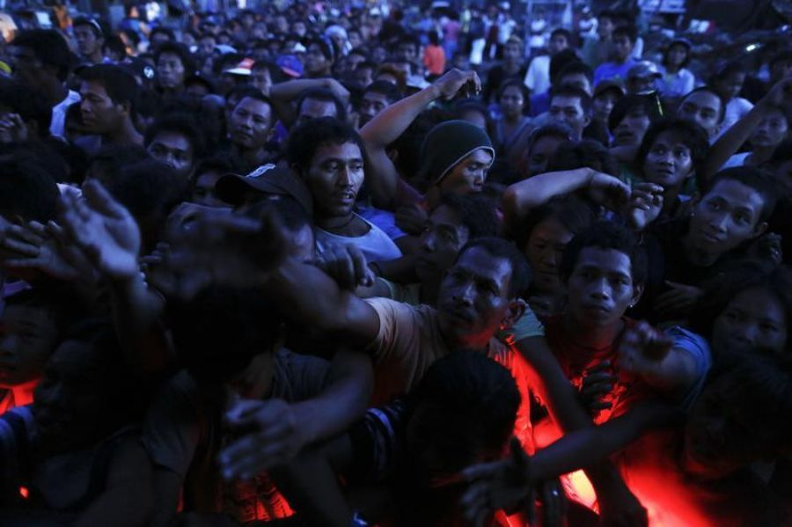From Haiyan to Alexa : Gaza "Disaster Area"

In early November, in the Philippines, Typhoon Haiyan, with winds above 130 mph, devastated part of the archipelago, destroying houses and infrastructures, leaving some 6,000 casualties. Worldwide mobilization was immediate. British and American warships took part in the rescue operations, with some 13,000 US troops. Thirty countries instantly contributed to the tune of 300 million euros in cash.



The Storm Alexa,which has been rampaging across the Middle-East since December 13, cannot be compared to Typhoon Haiyan, fortunately. Still, it is the first time that such quantities of snow have disrupted daily life since the creation of Israel. Here are a few images selected from the Israeli media (*Haaretz, Jerusalem Post*), all taken in Jerusalem.

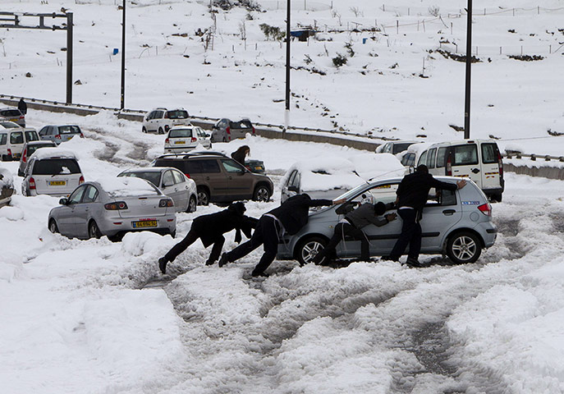

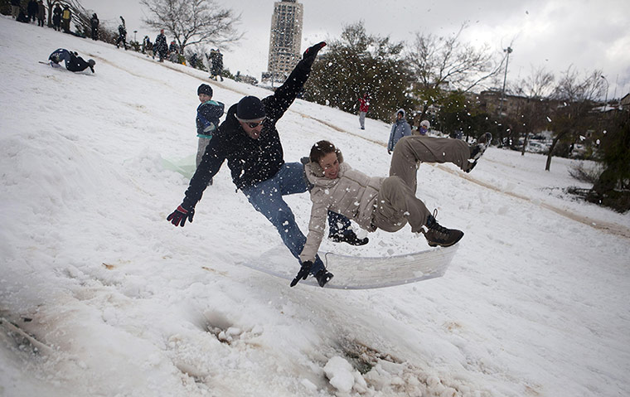

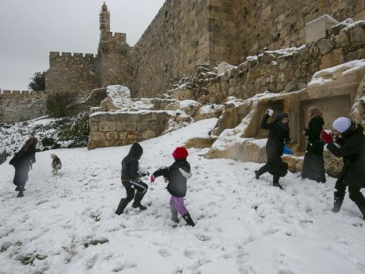

Further South, in Gaza, it is another story altogether, after four days of torrential rains.

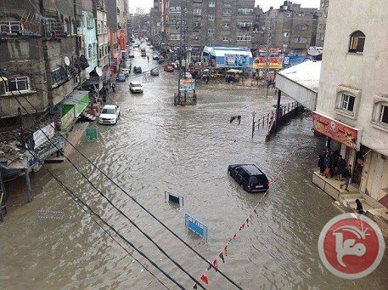

“Widespread flooding in Gaza forces thousands to flee homes”

*Ma'an News, December 13, 2013*

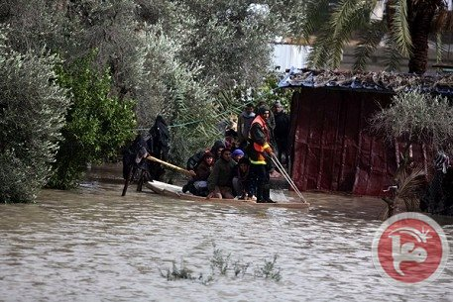

Facing such an emergency, we are sending you images from 3 agencies : *Ma'an News, Reuters* and *UPI,* and from the *New York Times*. Interestingly enough, no such news could be found in French-speaking media. Even the Israeli media are more informative on this topic.

Would there be an embargo on all news from Gaza in the French media ? Within Europe itself ?

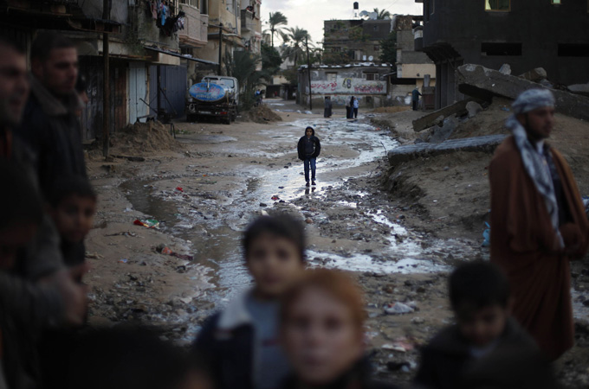

“United Nations calls northern Strip ‘disaster area’; water reported to be two meter high in some places.”

*Reuters, 14 December 2013*

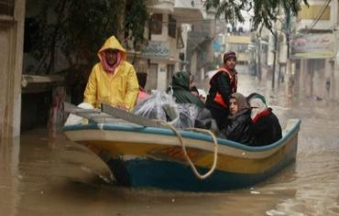

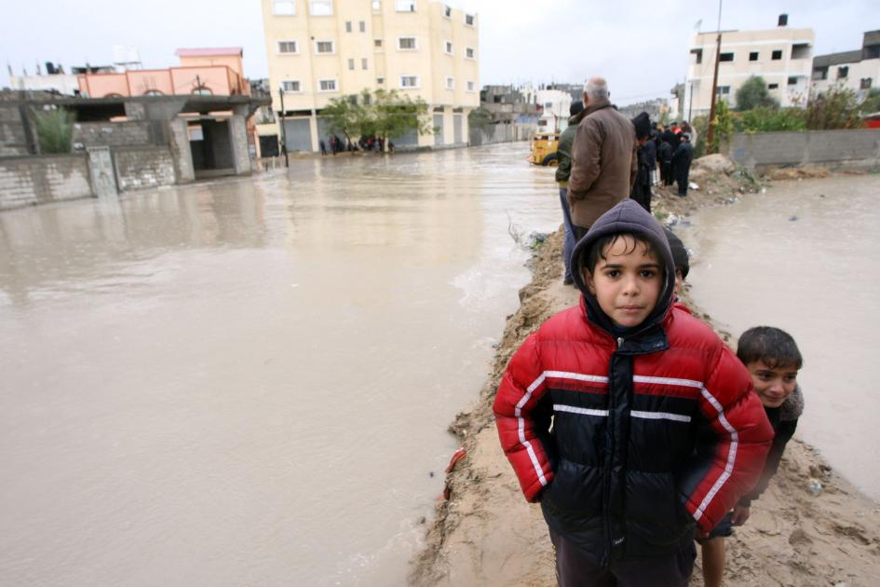“Flooding in Gaza”

*UPI, 14 December 2013*

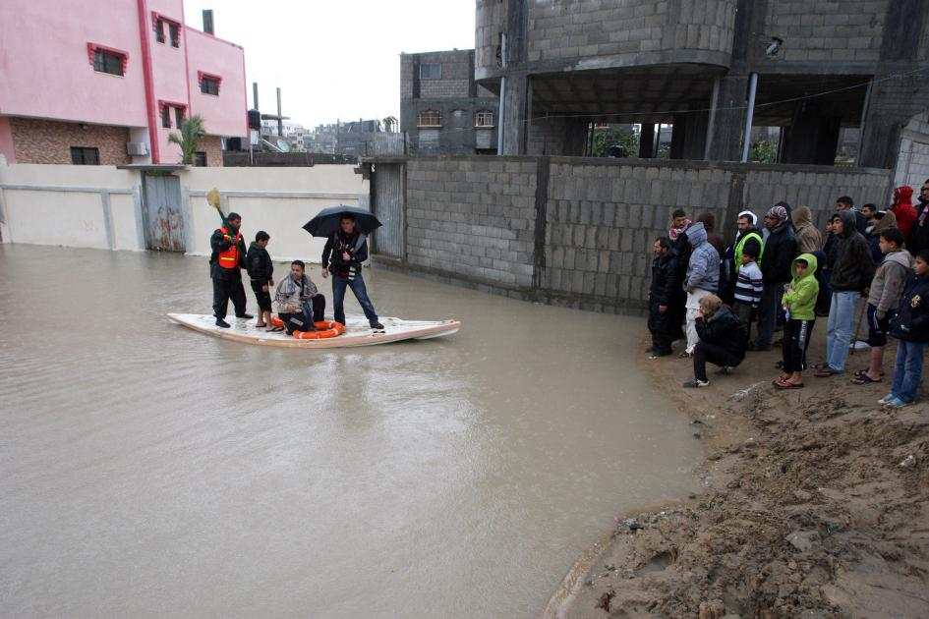The northern part of the Gaza Strip, the Jabaliya Camp in particular, is under water. Thousands of people have had to be displaced and relocated in schools. Distribution of bread and water, for those who could stay in their besieged homes, has been organized with small barks and kayaks. However, it would be misleading to attribute this catastrophe to the storm Alexa alone. There is more to it, and the news was broken by *EuroNews* first, as early as mid-November.

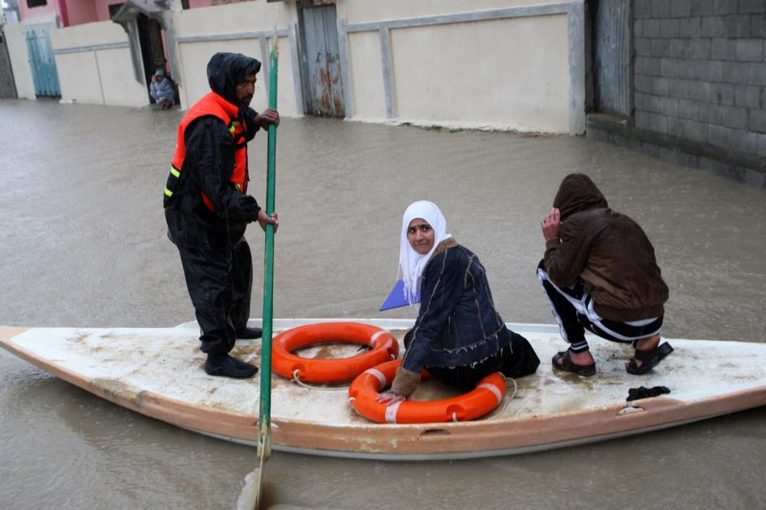

“[Gaza ‘faces disaster’ after power cuts cause sewage floods](http://www.euronews.com/2013/11/14/gaza-faces-disaster-after-power-cuts-cause-sewage-floods/)”

*EuroNews, 14 November 2013*

“There are warnings of a humanitarian disaster in Gaza caused by the floodwater submerging the streets: not the aftermath of heavy rain, but raw sewage.

One of the Palestinian enclave’s largest waste water treatment plants has stopped working because of power cuts caused by fuel shortages.

Residents are forced to pass by or through the filthy muck that overflows into the streets each time the plant goes idle and the waste goes untreated.

‘This is the start of a catastrophe and unless the world listens to our cries, a real disaster may hit Gaza and its people,’ said Sa’ad El-Deen Al-Tbash of the Gaza City wastewater department. ‘This is a humanitarian, not a political issue.’

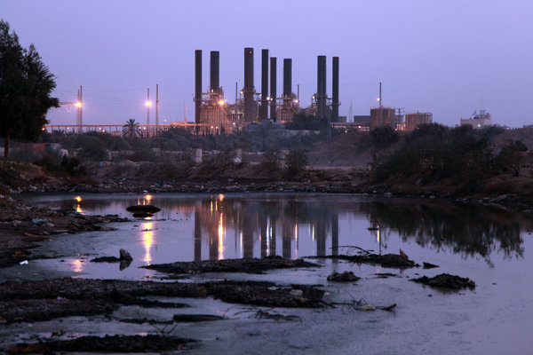Lack of fuel has disrupted the territory’s only power plant, causing daily 12-hour blackouts.

‘It’s one of two things, either they give us continuous electricity to this area, or they somehow come up with diesel so the power plant can work. The power plant needs to work for 12 hours straight and if it stops for one hour the whole area is flooded,’ said Gaza resident Maher Salim.

The fuel shortages follow Egypt’s closure of most of the estimated 1,200 cross-border tunnels that used to bring in cheap fuel.

(…) Gazan officials said the affected treatment plant served 120,000 residents, and warned that other waste water plants may soon run out of fuel for generators.

Gaza economist Maher Al-Tabbaa’ said the shortages of fuel and power meant that many businesses could not afford to run a generator.

‘The continuing stoppage of the Gaza power plant… foreshadows a real catastrophe that might affect the basic food security of the people as well as the health and education sectors.’”

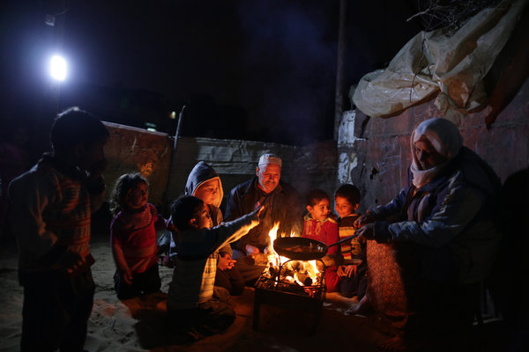

“Raw sewage and anger flood Gaza streets as electricity runs low”

*New York Times, 20 November 2013*

The *New York Times* picked up on *Euronews* in its November 20 issue, and *Asia Times* took a relay on the 27th.

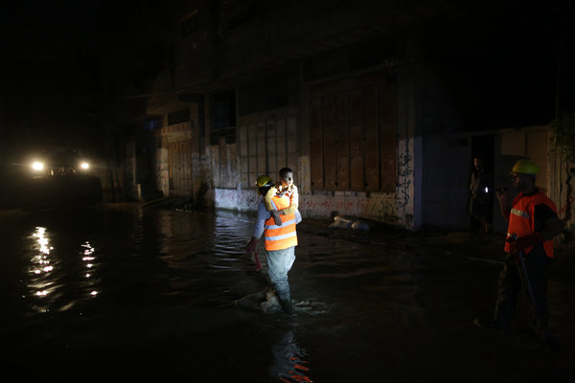“Three more sewage stations in Gaza City and 10 others elsewhere in the Gaza Strip are close to overflowing, sanitation officials here said, and 3.5 million cubic feet of raw sewage is seeping into the Mediterranean Sea daily. The sanitation department may soon no longer be able to pump drinking water to Gaza homes.”

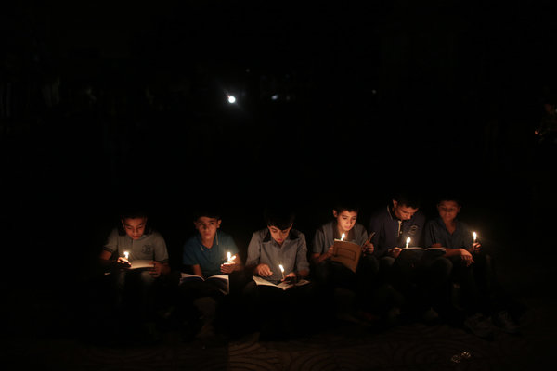

In December, power cuts cover up to 16 hours a day, and temperature is going down, closer to 0°C. When the night falls from the sky, kids read by candle-light. To take advantage of night-time electricity, students are deprived of normal sleep patterns...