☺ 😐 ☹

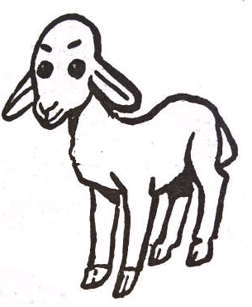 |  |  |  | 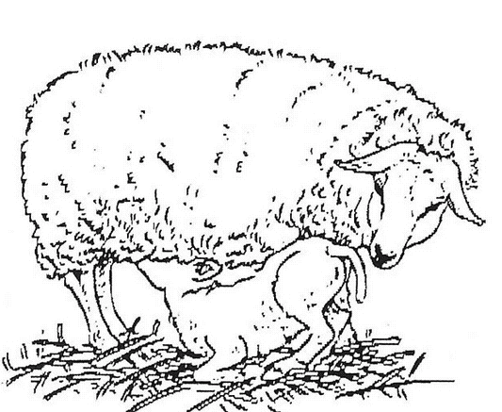
agneau |  | bélier |  | brebis

AGNEAU | BREBIS | BELIER | agneau
brebis | bélier

