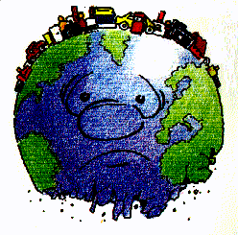  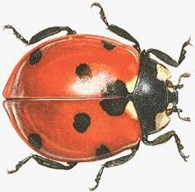

**Sciences CE2**

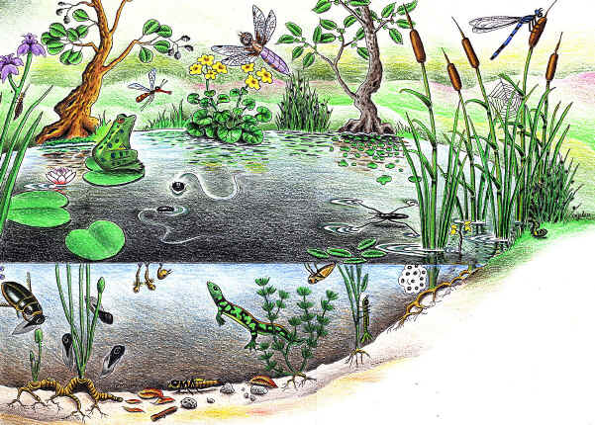

C:\Documents and Settings\Administrateur\Local Settings\Temporary Internet Files\Content.IE5\2UHAQGGG\MCj03468910000[1].wmfC:\Documents and Settings\Administrateur\Local Settings\Temporary Internet Files\Content.IE5\2UHAQGGG\MCj03468910000[1].wmfC:\Documents and Settings\Administrateur\Local Settings\Temporary Internet Files\Content.IE5\2UHAQGGG\MCj03468910000[1].wmfC:\Documents and Settings\Administrateur\Local Settings\Temporary Internet Files\Content.IE5\2UHAQGGG\MCj03468910000[1].wmf**C:\Documents and Settings\Administrateur\Local Settings\Temporary Internet Files\Content.IE5\2UHAQGGG\MCj03468910000[1].wmf**

C:\Documents and Settings\Administrateur\Local Settings\Temporary Internet Files\Content.IE5\IQCQKZDH\MCj04382210000[1].wmf

Année scolaire 2012-2013