[♪|•óÁ–♥_♫á]

\ Cahier de la maitresse \

\ Année 2016-2017 \

\ CP/CE1 \



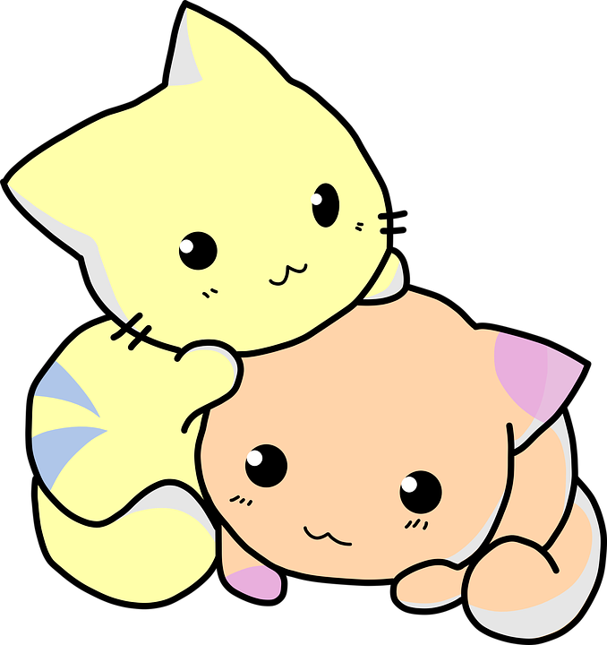

[♪|•óÁ–♥_♫á]

Administration

\ La circonscription \

IEN : ____________________________________________________________________________

Secrétaire de l’IEN : ______________________________________________________________

Adresse : ________________________________________________________________________

Téléphone : ______________________________________________________________________

Mail : ____________________________________________________________________________

\ L’inspection académique \

IA : _____________________________________________________________________________

Adresse : ________________________________________________________________________

\ Le Rased \

Maitre E : _______________________________________________________________________

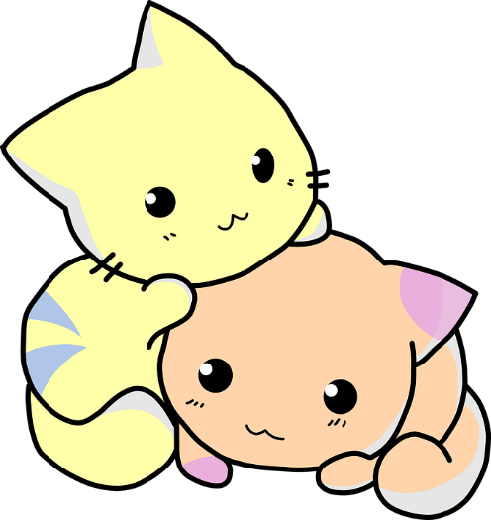Maitre G : _______________________________________________________________________

Psychologue scolaire : ____________________________________________________________

Maitre supplémentaire : __________________________________________________________

Autres professionnels : ___________________________________________________________

[♪|•óÁ–♥_♫á]

Les Voirons Gaillard

Adresse : ________________________________________________________________________

Téléphone : ______________________________________________________________________

Mail : ____________________________________________________________________________

\ Les collègues \

|  |  |  |  |
| --- | --- | --- | --- |
| Classe | Nom | Téléphone | Mail |
|  |  |  |  |
|  |  |  |  |
|  |  |  |  |
|  |  |  |  |
|  |  |  |  |
|  |  |  |  |
|  |  |  |  |
|  |  |  |  |
|  |  |  | Chatons, Dessin Animé, Snuggle, Chats, Mignon, Adorable |

|  |  |  |  |  |  |  |  |  |  |  |  |  |  |
| --- | --- | --- | --- | --- | --- | --- | --- | --- | --- | --- | --- | --- | --- |
| 2016 / 2017  *Classe de CP/CE1* | Date de naissance  [♪|•óÁ–♥_♫á] | F. Renseignement | F. Urgence | Assurance | Droit à l‘image | Coop. Scolaire | Autorisation activité piscine | Problèmes médicaux | Parents séparés | Suivi particulier | Remarques | Cantine | Etude |
|  |  |  |  |  |  |  |  |  |  |  | 1 | L M M J V | L M M J V |
|  |  |  |  |  |  |  |  |  |  |  | 2 | L M M J V | L M M J V |
|  |  |  |  |  |  |  |  |  |  |  | 3 | L M M J V | L M M J V |
|  |  |  |  |  |  |  |  |  |  |  | 4 | L M M J V | L M M J V |
|  |  |  |  |  |  |  |  |  |  |  | 5 | L M M J V | L M M J V |
|  |  |  |  |  |  |  |  |  |  |  | 6 | L M M J V | L M M J V |
|  |  |  |  |  |  |  |  |  |  |  | 7 | L M M J V | L M M J V |
|  |  |  |  |  |  |  |  |  |  |  | 8 | L M M J V | L M M J V |
|  |  |  |  |  |  |  |  |  |  |  | 9 | L M M J V | L M M J V |
|  |  |  |  |  |  |  |  |  |  |  | 10 | L M M J V | L M M J V |
|  |  |  |  |  |  |  |  |  |  |  | 11 | L M M J V | L M M J V |
|  |  |  |  |  |  |  |  |  |  |  | 12 | L M M J V | L M M J V |
|  |  |  |  |  |  |  |  |  |  |  | 13 | L M M J V | L M M J V |
|  |  |  |  |  |  |  |  |  |  |  | 14 | L M M J V | L M M J V |
|  |  |  |  |  |  |  |  |  |  |  | 15 | L M M J V | L M M J V |
|  |  |  |  |  |  |  |  |  |  |  | 16 | L M M J V | L M M J V |
|  |  |  |  |  |  |  |  |  |  |  | 17 | L M M J V | L M M J V |
|  |  |  |  |  |  |  |  |  |  |  | 18 | L M M J V | L M M J V |
|  |  |  |  |  |  |  |  |  |  |  | 19 | L M M J V | L M M J V |
|  |  |  |  |  |  |  |  |  |  |  | 20 | L M M J V | L M M J V |
|  |  |  |  |  |  |  |  |  |  |  | 21 | L M M J V | L M M J V |
|  |  |  |  |  |  |  |  |  |  |  | 22 | L M M J V | L M M J V |
|  |  |  |  |  |  |  |  |  |  |  | 23 | L M M J V | L M M J V |
|  |  |  |  |  |  |  |  |  |  |  | 24 | L M M J V | L M M J V |
|  |  |  |  |  |  |  |  |  |  |  | 25 | L M M J V | L M M J V |

[♪|•óÁ–♥_♫á]

|  |  |  |  |  |  |  |
| --- | --- | --- | --- | --- | --- | --- |
| \ Tableau des prises en charges \ | | | | | | |
|  | Lundi | Mardi | Mercredi | Jeudi | Vendredi | Autre |
| Matin |  |  |  |  |  |  |
| Périscolaire  /  midi |  |  |  |  |  |  |
| Après-midi |  |  |  |  |  |  |
| Hors temps scolaire |  |  |  |  |  | Chatons, Dessin Animé, Snuggle, Chats, Mignon, Adorable |



[♪|•óÁ–♥_♫á]

\ Emploi du temps – Classe de CP/CE1 \

\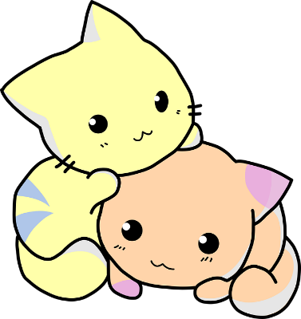 Horaires officiels, cycle 2 \

|  |  |  |  |
| --- | --- | --- | --- |
| Domaines disciplinaires | Durée annuelle des enseignements | Durée hebdomadaire des enseignements sur 24h | Durée effective sur 22h (2h de récréations par semaine) |
| Français | 360 h | 10 h | 550 min = 9h10 |
| Mathématiques | 180 h | 5 h | 275 min = 4h35 |
| EPS | 108 h | 3 h | 165 min = 2h45 |
| Langue vivante | 54 h | 1h30 | 82,5 min = 1h20 |
| Pratiques artistiques et HDA | 72 h | 2 h | 110 min = 1h50 |
| Questionner le monde, ECM | 90 h | 2 h 30 | 137,5 min = 2h20 |
| Total | 864 h | 24 h | 22h |

[♪|•óÁ–♥_♫á]

\ Liste des élèves \

|  |  |  |  |
| --- | --- | --- | --- |
| N° | Nom / Prénom | Date de naissance | Sexe |
| 1 |  |  |  |
| 2 |  |  |  |
| 3 |  |  |  |
| 4 |  |  |  |
| 5 |  |  |  |
| 6 |  |  |  |
| 7 |  |  |  |
| 8 |  |  |  |
| 9 |  |  |  |
| 10 |  |  |  |
| 11 |  |  |  |
| 12 |  |  |  |
| 13 |  |  |  |
| 14 |  |  |  |
| 15 |  |  |  |
| 16 |  |  |  |
| 17 |  |  |  |
| 18 |  |  |  |
| 19 |  |  |  |
| 20 |  |  |  |
| 21 |  |  |  |
| 22 |  |  |  |
| 23 |  |  |  |
| 24 |  |  |  |
| 25 |  |  |  |
| 26 |  |  |  |
| 27 |  |  |  |
| 28 |  |  |  |
| 29 |  |  |  |
| 30 |  |  |  |

[♪|•óÁ–♥_♫á]

\ Services de récréation \

|  |  |  |  |  |  |
| --- | --- | --- | --- | --- | --- |
|  | Lundi | Mardi | Mercredi | Jeudi | Vendredi |
| Accueil matin |  |  |  |  |  |
| Récré matin |  |  |  |  |  |
| Accueil après-midi |  |  |  |  |  |
| Récré après-midi |  |  |  |  |  |

\ Horaires d’accueil matin : 8h20-8h30

\ Heures des récréations : 10h15-10h30 (15h30-15h40 si besoin l’après-midi)

\ Horaires d’accueil après-midi : 14h05-14h15

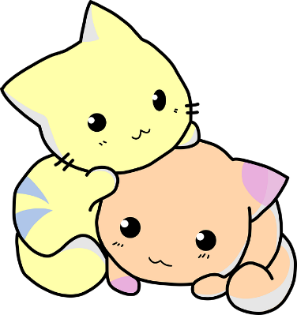

[♪|•óÁ–♥_♫á]

\ Occupation des salles \

|  |  |  |  |  |  |  |
| --- | --- | --- | --- | --- | --- | --- |
|  | Espace Louis Simon | BCD | Cour des petits | Cour des grands |  |  |
| Période 1 |  |  |  |  |  |  |
| Période 2 |  |  |  |  |  |  |
| Période 3 |  |  |  |  |  |  |
| Période 4 |  |  |  |  |  |  |
| Période 5 |  |  |  |  |  |  |

\ Remarques \

----------------------------------------------------------------------------------------------------------------------------------------------------

[♪|•óÁ–♥_♫á]



| Juillet \ |  | Août \ |
| --- | --- | --- |
| |  |  |  | | --- | --- | --- | | 1 |  |  | | 2 |  |  | | 3 |  |  | | 4 |  |  | | 5 |  |  | | 6 |  |  | | 7 |  |  | | 8 |  |  | | 9 |  |  | | 10 |  |  | | 11 |  |  | | 12 |  |  | | 13 |  |  | | 14 |  |  | | 15 |  |  | | 16 |  |  | | 17 |  |  | | 18 |  |  | | 19 |  |  | | 20 |  |  | | 21 |  |  | | 22 |  |  | | 23 |  |  | | 24 |  |  | | 25 |  |  | | 26 |  |  | | 27 |  |  | | 28 |  |  | | 29 |  |  | | 30 |  |  | | 31 |  |  | |  | |  |  |  | | --- | --- | --- | | 1 |  |  | | 2 |  |  | | 3 |  |  | | 4 |  |  | | 5 |  |  | | 6 |  |  | | 7 |  |  | | 8 |  |  | | 9 |  |  | | 10 |  |  | | 11 |  |  | | 12 |  |  | | 13 |  |  | | 14 |  |  | | 15 |  |  | | 16 |  |  | | 17 |  |  | | 18 |  |  | | 19 |  |  | | 20 |  |  | | 21 |  |  | | 22 |  |  | | 23 |  |  | | 24 |  |  | | 25 |  |  | | 26 |  |  | | 27 |  |  | | 28 |  |  | | 29 |  |  | | 30 |  |  | | 31 |  |  | |

[♪|•óÁ–♥_♫á]



| Septembre \ |  | Octobre \ |
| --- | --- | --- |
| |  |  |  | | --- | --- | --- | | 1 |  |  | | 2 |  |  | | 3 |  |  | | 4 |  |  | | 5 |  |  | | 6 |  |  | | 7 |  |  | | 8 |  |  | | 9 |  |  | | 10 |  |  | | 11 |  |  | | 12 |  |  | | 13 |  |  | | 14 |  |  | | 15 |  |  | | 16 |  |  | | 17 |  |  | | 18 |  |  | | 19 |  |  | | 20 |  |  | | 21 |  |  | | 22 |  |  | | 23 |  |  | | 24 |  |  | | 25 |  |  | | 26 |  |  | | 27 |  |  | | 28 |  |  | | 29 |  |  | | 30 |  |  | | 1 |  |  | |  | |  |  |  |  | | --- | --- | --- | --- | | 1 |  |  |  | | 2 |  |  |  | | 3 |  |  |  | | 4 |  |  |  | | 5 |  |  |  | | 6 |  |  |  | | 7 |  |  |  | | 8 |  |  |  | | 9 |  |  |  | | 10 |  |  |  | | 11 |  |  |  | | 12 |  |  |  | | 13 |  |  |  | | 14 |  |  |  | | 15 |  |  |  | | 16 |  |  |  | | 17 |  |  |  | | 18 |  |  |  | | 19 |  |  |  | | 20 |  |  |  | | 21 |  |  |  | | 22 |  |  |  | | 23 |  |  |  | | 24 |  |  |  | | 25 |  |  |  | | 26 |  |  |  | | 27 |  |  |  | | 28 |  |  |  | | 29 |  |  |  | | 30 |  |  |  | | 31 |  |  |  | |

[♪|•óÁ–♥_♫á]



| Novembre \ |  | Décembre \ |
| --- | --- | --- |
| |  |  |  | | --- | --- | --- | | 1 |  |  | | 2 |  |  | | 3 |  |  | | 4 |  |  | | 5 |  |  | | 6 |  |  | | 7 |  |  | | 8 |  |  | | 9 |  |  | | 10 |  |  | | 11 |  |  | | 12 |  |  | | 13 |  |  | | 14 |  |  | | 15 |  |  | | 16 |  |  | | 17 |  |  | | 18 |  |  | | 19 |  |  | | 20 |  |  | | 21 |  |  | | 22 |  |  | | 23 |  |  | | 24 |  |  | | 25 |  |  | | 26 |  |  | | 27 |  |  | | 28 |  |  | | 29 |  |  | | 30 |  |  | | 1 |  |  | |  | |  |  |  | | --- | --- | --- | | 1 |  |  | | 2 |  |  | | 3 |  |  | | 4 |  |  | | 5 |  |  | | 6 |  |  | | 7 |  |  | | 8 |  |  | | 9 |  |  | | 10 |  |  | | 11 |  |  | | 12 |  |  | | 13 |  |  | | 14 |  |  | | 15 |  |  | | 16 |  |  | | 17 |  |  | | 18 |  |  | | 19 |  |  | | 20 |  |  | | 21 |  |  | | 22 |  |  | | 23 |  |  | | 24 |  |  | | 25 |  |  | | 26 |  |  | | 27 |  |  | | 28 |  |  | | 29 |  |  | | 30 |  |  | | 31 |  |  | |

[♪|•óÁ–♥_♫á]



| Janvier \ |  | Février \ |
| --- | --- | --- |
| |  |  |  | | --- | --- | --- | | 1 |  |  | | 2 |  |  | | 3 |  |  | | 4 |  |  | | 5 |  |  | | 6 |  |  | | 7 |  |  | | 8 |  |  | | 9 |  |  | | 10 |  |  | | 11 |  |  | | 12 |  |  | | 13 |  |  | | 14 |  |  | | 15 |  |  | | 16 |  |  | | 17 |  |  | | 18 |  |  | | 19 |  |  | | 20 |  |  | | 21 |  |  | | 22 |  |  | | 23 |  |  | | 24 |  |  | | 25 |  |  | | 26 |  |  | | 27 |  |  | | 28 |  |  | | 29 |  |  | | 30 |  |  | | 31 |  |  | |  | |  |  |  | | --- | --- | --- | | 1 |  |  | | 2 |  |  | | 3 |  |  | | 4 |  |  | | 5 |  |  | | 6 |  |  | | 7 |  |  | | 8 |  |  | | 9 |  |  | | 10 |  |  | | 11 |  |  | | 12 |  |  | | 13 |  |  | | 14 |  |  | | 15 |  |  | | 16 |  |  | | 17 |  |  | | 18 |  |  | | 19 |  |  | | 20 |  |  | | 21 |  |  | | 22 |  |  | | 23 |  |  | | 24 |  |  | | 25 |  |  | | 26 |  |  | | 27 |  |  | | 28 |  |  | | 1 |  |  | | 2 |  |  | | 3 |  |  | |

[♪|•óÁ–♥_♫á]

| Mars \ |  | Avril \ |
| --- | --- | --- |
| |  |  |  | | --- | --- | --- | | 1 |  |  | | 2 |  |  | | 3 |  |  | | 4 |  |  | | 5 |  |  | | 6 |  |  | | 7 |  |  | | 8 |  |  | | 9 |  |  | | 10 |  |  | | 11 |  |  | | 12 |  |  | | 13 |  |  | | 14 |  |  | | 15 |  |  | | 16 |  |  | | 17 |  |  | | 18 |  |  | | 19 |  |  | | 20 |  |  | | 21 |  |  | | 22 |  |  | | 23 |  |  | | 24 |  |  | | 25 |  |  | | 26 |  |  | | 27 |  |  | | 28 |  |  | | 29 |  |  | | 30 |  |  | | 31 |  |  | |  | |  |  |  | | --- | --- | --- | | 1 |  |  | | 2 |  |  | | 3 |  |  | | 4 |  |  | | 5 |  |  | | 6 |  |  | | 7 |  |  | | 8 |  |  | | 9 |  |  | | 10 |  |  | | 11 |  |  | | 12 |  |  | | 13 |  |  | | 14 |  |  | | 15 |  |  | | 16 |  |  | | 17 |  |  | | 18 |  |  | | 19 |  |  | | 20 |  |  | | 21 |  |  | | 22 |  |  | | 23 |  |  | | 24 |  |  | | 25 |  |  | | 26 |  |  | | 27 |  |  | | 28 |  |  | | 29 |  |  | | 30 |  |  | | 1 |  |  |   Chatons, Dessin Animé, Snuggle, Chats, Mignon, Adorable |

[♪|•óÁ–♥_♫á]



| Mai \ |  | Juin \ |
| --- | --- | --- |
| |  |  |  | | --- | --- | --- | | 1 |  |  | | 2 |  |  | | 3 |  |  | | 4 |  |  | | 5 |  |  | | 6 |  |  | | 7 |  |  | | 8 |  |  | | 9 |  |  | | 10 |  |  | | 11 |  |  | | 12 |  |  | | 13 |  |  | | 14 |  |  | | 15 |  |  | | 16 |  |  | | 17 |  |  | | 18 |  |  | | 19 |  |  | | 20 |  |  | | 21 |  |  | | 22 |  |  | | 23 |  |  | | 24 |  |  | | 25 |  |  | | 26 |  |  | | 27 |  |  | | 28 |  |  | | 29 |  |  | | 30 |  |  | | 31 |  |  | |  | |  |  |  | | --- | --- | --- | | 1 |  |  | | 2 |  |  | | 3 |  |  | | 4 |  |  | | 5 |  |  | | 6 |  |  | | 7 |  |  | | 8 |  |  | | 9 |  |  | | 10 |  |  | | 11 |  |  | | 12 |  |  | | 13 |  |  | | 14 |  |  | | 15 |  |  | | 16 |  |  | | 17 |  |  | | 18 |  |  | | 19 |  |  | | 20 |  |  | | 21 |  |  | | 22 |  |  | | 23 |  |  | | 24 |  |  | | 25 |  |  | | 26 |  |  | | 27 |  |  | | 28 |  |  | | 29 |  |  | | 30 |  |  | | 1 |  |  | |

[♪|•óÁ–♥_♫á]

| Juillet \ |  | Août \ |
| --- | --- | --- |
| |  |  |  | | --- | --- | --- | | 1 |  |  | | 2 |  |  | | 3 |  |  | | 4 |  |  | | 5 |  |  | | 6 |  |  | | 7 |  |  | | 8 |  |  | | 9 |  |  | | 10 |  |  | | 11 |  |  | | 12 |  |  | | 13 |  |  | | 14 |  |  | | 15 |  |  | | 16 |  |  | | 17 |  |  | | 18 |  |  | | 19 |  |  | | 20 |  |  | | 21 |  |  | | 22 |  |  | | 23 |  |  | | 24 |  |  | | 25 |  |  | | 26 |  |  | | 27 |  |  | | 28 |  |  | | 29 |  |  | | 30 |  |  | | 31 |  |  | |  | |  |  |  | | --- | --- | --- | | 1 |  |  | | 2 |  |  | | 3 |  |  | | 4 |  |  | | 5 |  |  | | 6 |  |  | | 7 |  |  | | 8 |  |  | | 9 |  |  | | 10 |  |  | | 11 |  |  | | 12 |  |  | | 13 |  |  | | 14 |  |  | | 15 |  |  | | 16 |  |  | | 17 |  |  | | 18 |  |  | | 19 |  |  | | 20 |  |  | | 21 |  |  | | 22 |  |  | | 23 |  |  | | 24 |  |  | | 25 |  |  | | 26 |  |  | | 27 |  |  | | 28 |  |  | | 29 |  |  | | 30 |  |  | | 31 |  |  |   Chatons, Dessin Animé, Snuggle, Chats, Mignon, Adorable |

[♪|•óÁ–♥_♫á]

# \ Dispositif \

# « Plus de maitres que de classes »

\ Période 1 \

|  |  |  |
| --- | --- | --- |
|  |  |  |

\ Période 2 \

|  |  |  |
| --- | --- | --- |
|  |  |  |



\ Période 3 \

|  |  |  |
| --- | --- | --- |
|  |  |  |

\ Période 4 \

|  |  |  |
| --- | --- | --- |
|  |  |  |

\ Période 5 \

|  |  |  |
| --- | --- | --- |
|  |  |  |

[♪|•óÁ–♥_♫á]

# \ APC \

\ Période 1 \

|  |  |  |
| --- | --- | --- |
| Dates et jours | Objectifs | Élèves |
|  |  |  |

\ Période 2 \

|  |  |  |
| --- | --- | --- |
| Dates et jours | Objectifs | Élèves |
|  |  |  |



\ Période 3 \

|  |  |  |
| --- | --- | --- |
| Dates et jours | Objectifs | Élèves |
|  |  |  |

\ Période 4 \

|  |  |  |
| --- | --- | --- |
| Dates et jours | Objectifs | Élèves |
|  |  |  |

\ Période 5 \

|  |  |  |
| --- | --- | --- |
| Dates et jours | Objectifs | Élèves |
|  |  |  |

[♪|•óÁ–♥_♫á]

Elève : ___________________________________

Date du rendez-vous : ________________________________

Personne rencontrée : _____________________________________

□ A la demande de l’enseignant □ A la demande du parent

Objet du rendez-vous : ____________________________________________

Compte rendu de la rencontre :

________________________________________________________________________________________________________________________________________________________________________________________________________________________________________________________________________________________________________________________________________________________________________________________________________________________________________________________________________________________________________________________________________________________________________________________________________________________________________________________________________________________________________________________________________________________________________________

_____________________________________________________________________________________________

_____________________________________________________________________________________________

_____________________________________________________________________________________________

_____________________________________________________________________________________________

_____________________________________________________________________________________________

_____________________________________________________________________________________________

_____________________________________________________________________________________________

____________________________________________________________________________________________

\ Relevés de notes \

|  |  |  |  |  |
| --- | --- | --- | --- | --- |
| Afficher l'image d'originePrénoms |  |  |  |  |
|  |  |  |  |  |
|  |  |  |  |  |
|  |  |  |  |  |
|  |  |  |  |  |
|  |  |  |  |  |
|  |  |  |  |  |
|  |  |  |  |  |
|  |  |  |  |  |
|  |  |  |  |  |
|  |  |  |  |  |
|  |  |  |  |  |
|  |  |  |  |  |
|  |  |  |  |  |
|  |  |  |  |  |
|  |  |  |  |  |
|  |  |  |  |  |
|  |  |  |  |  |
|  |  |  |  |  |
|  |  |  |  |  |
|  |  |  |  |  |
|  |  |  |  |  |
|  |  |  |  |  |
|  |  |  |  |  |
|  |  |  |  |  |
|  |  |  |  |  |
|  |  |  |  |  |
|  |  |  |  |  |

\ Relevés de notes \

|  |  |  |  |  |
| --- | --- | --- | --- | --- |
| Afficher l'image d'originePrénoms |  |  |  |  |
|  |  |  |  |  |
|  |  |  |  |  |
|  |  |  |  |  |
|  |  |  |  |  |
|  |  |  |  |  |
|  |  |  |  |  |
|  |  |  |  |  |
|  |  |  |  |  |
|  |  |  |  |  |
|  |  |  |  |  |
|  |  |  |  |  |
|  |  |  |  |  |
|  |  |  |  |  |
|  |  |  |  |  |
|  |  |  |  |  |
|  |  |  |  |  |
|  |  |  |  |  |
|  |  |  |  |  |
|  |  |  |  |  |
|  |  |  |  |  |
|  |  |  |  |  |
|  |  |  |  |  |
|  |  |  |  |  |
|  |  |  |  |  |
|  |  |  |  |  |
|  |  |  |  |  |
|  |  |  |  |  |

[♪|•óÁ–♥_♫á]

Comptes de la classe



|  |  |  |  |  |
| --- | --- | --- | --- | --- |
| Date | Désignation | Coût | Solde restant | Infos + |
| ____/____/____ |  |  |  |  |
| ____/____/____ |  |  |  |  |
| ____/____/____ |  |  |  |  |
| ____/____/____ |  |  |  |  |
| ____/____/____ |  |  |  |  |
| ____/____/____ |  |  |  |  |
| ____/____/____ |  |  |  |  |
| ____/____/____ |  |  |  |  |
| ____/____/____ |  |  |  |  |
| ____/____/____ |  |  |  |  |
| ____/____/____ |  |  |  |  |
| ____/____/____ |  |  |  |  |
| ____/____/____ |  |  |  |  |
| ____/____/____ |  |  |  |  |
| ____/____/____ |  |  |  |  |
| ____/____/____ |  |  |  |  |

[♪|•óÁ–♥_♫á]

Suivi des 108 heures

Conseils d’école : 6h ; Concertations : 24 h ; APC : 36h ; Animations pédagogiques : 18h ; Vie scolaire (travail équipe, RDV parents…) : 24h

|  |  |  |  |
| --- | --- | --- | --- |
| Date | Désignation | Heures |  |
| ____/____/____ |  |  |  |
| ____/____/____ |  |  |  |
| ____/____/____ |  |  |  |
| ____/____/____ |  |  |  |
| ____/____/____ |  |  |  |
| ____/____/____ |  |  |  |
| ____/____/____ |  |  |  |
| ____/____/____ |  |  |  |
| ____/____/____ |  |  |  |
| ____/____/____ |  |  |  |
| ____/____/____ |  |  |  |
| ____/____/____ |  |  |  |
| ____/____/____ |  |  |  |
| ____/____/____ |  |  |  |
| ____/____/____ |  |  |  |
| ____/____/____ |  |  |  |

[♪|•óÁ–♥_♫á]

\ Cahier de la maitresse \

\ Année 2016-2017 \

\ CP/CE1 \



[♪|•óÁ–♥_♫á]

\ Cahier de la maitresse \

\ Année 2016-2017 \

\ CP/CE1 \



[♪|•óÁ–♥_♫á]

\ Cahier de la maitresse \

\ Année 2016-2017 \

\ CP/CE1 \





[♪|•óÁ–♥_♫á]

\ Cahier de la maitresse \

\ Année 2016-2017 \

\ CP/CE1 \



[♪|•óÁ–♥_♫á]

\ Cahier de la maitresse \

\ Année 2016-2017 \

\ CP/CE1 \



[♪|•óÁ–♥_♫á]

\ Cahier de la maitresse \

\ Année 2016-2017 \

\ CP/CE1 \





[♪|•óÁ–♥_♫á]

\ Cahier de la maitresse \

\ Année 2016-2017 \

\ CP/CE1 \



[♪|•óÁ–♥_♫á]

\ Cahier de la maitresse \

\ Année 2016-2017 \

\ CP/CE1 \



Les pages de garde sont à plastifier pour faire des intercalaires