|  |  |  |  |
| --- | --- | --- | --- |
| 3 paires de chaussettes bleues et 2 paires blanches | **10**  **14**  **5** | 4 paires de chaussettes vertes et 3 paires jaunes | **7**  **14**  **8** |
| 5 paires de chaussettes rouges et 1 paire rose | **10**  **12**  **6** | 6 paires de chaussettes jaunes et 2 paires vertes | **12**  **8**  **16** |
| 8 paires de chaussettes blanches et 4 paires rouges | **16**  **24**  **12** | 3 paires de chaussettes roses et 7 paires bleues | **20**  **14**  **10** |

|  |  |
| --- | --- |
| ___ X ___ = ____  ___ X ___ = ____ | ___ X ___ = ____  ___ X ___ = ____ |
| ___ X ___ = ____  ___ X ___ = ____ | ___ X ___ = ____  ___ X ___ = ____ |
| ___ X ___ = ____  ___ X ___ = ____ | ___ X ___ = ____  ___ X ___ = ____ |

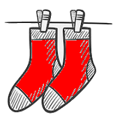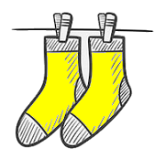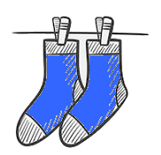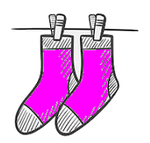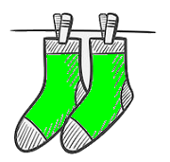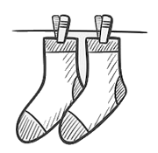



A photocopier 5 fois

|  |  |  |
| --- | --- | --- |
| 1 X |  | = 2 |
| 2 X |  | = 4 |
| 3 X |  | = 6 |
| 4 X |  | = 8 |
| 5 X |  | = 10 |
| 6 X |  | = 12 |
| 7 X |  | = 14 |
| 8 X |  | = 16 |
| 9 X |  | = 18 |
| 10 X |  | = 20 |

|  |  |  |  |
| --- | --- | --- | --- |
| 6 paires de chaussettes bleues et 6 paires blanches | **20**  **24**  **12** | 5 paires de chaussettes vertes et 9 paires jaunes | **28**  **14**  **18** |
| 4 paires de chaussettes rouges et 8 paires roses | **16**  **12**  **24** | 3 paires de chaussettes jaunes et 6 paires vertes | **12**  **6**  **18** |
| 5 paires de chaussettes blanches et 5 paires rouges | **15**  **20**  **10** | 2 paires de chaussettes roses et 9 paires bleues | **22**  **18**  **11** |

|  |  |
| --- | --- |
| ___ X ___ = ____  ___ X ___ = ____ | ___ X ___ = ____  ___ X ___ = ____ |
| ___ X ___ = ____  ___ X ___ = ____ | ___ X ___ = ____  ___ X ___ = ____ |
| ___ X ___ = ____  ___ X ___ = ____ | ___ X ___ = ____  ___ X ___ = ____ |

|  |  |  |  |
| --- | --- | --- | --- |
| 3 paires de chaussettes bleues et 3 paires blanches | **6**  **24**  **12** | 4 paires de chaussettes vertes et 6 paires jaunes | **20**  **14**  **18** |
| 1 paires de chaussettes rouges et 8 paires roses | **16**  **18**  **20** | 10 paires de chaussettes jaunes et 10 paires vertes | **40**  **20**  **18** |
| 10 paires de chaussettes blanches et 7 paires rouges | **17**  **20**  **34** | 9 paires de chaussettes roses et 9 paires bleues | **36**  **18**  **24** |

|  |  |
| --- | --- |
| ___ X ___ = ____  ___ X ___ = ____ | ___ X ___ = ____  ___ X ___ = ____ |
| ___ X ___ = ____  ___ X ___ = ____ | ___ X ___ = ____  ___ X ___ = ____ |
| ___ X ___ = ____  ___ X ___ = ____ | ___ X ___ = ____  ___ X ___ = ____ |

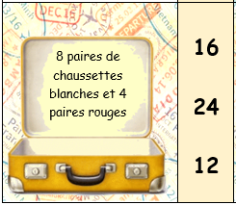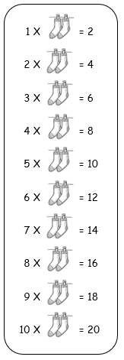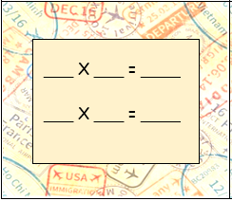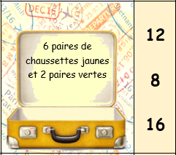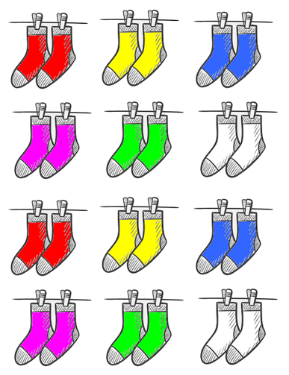

**Fais ta valise !**

