|  |  |  |  |  |  |  |
| --- | --- | --- | --- | --- | --- | --- |
| Lundi | Mardi | Mercredi | Jeudi | Vendredi | Samedi | Dimanche |
|  |  |  |  |  |  | 1 |
| 2  Rentrée | 3 | 4 | 5 | 6 | 7 | 8 |
| 9 | 10 | 11 | 12 | 13 | **14** | 15 |
| 16 | 17 | 18 | 19 | 20 | 21 | 22 |
| 23 | 24 | 25 | 26 | 27 | 28 | 29 |
| 30 |  |  |  |  |  |  |

**Septembre**

**2019**

http://laclassedefanny.eklablog.fr

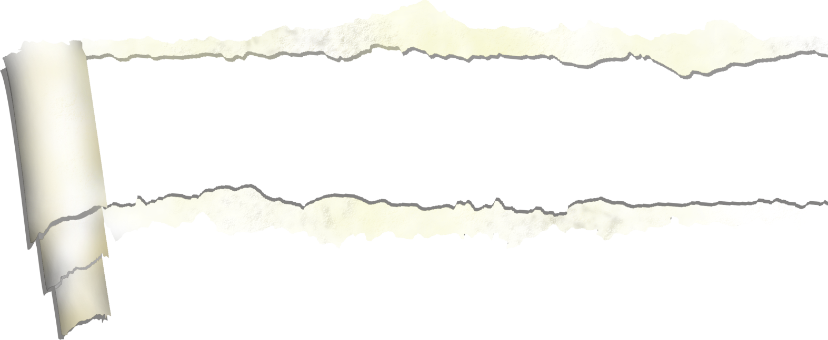



|  |  |  |  |  |  |  |
| --- | --- | --- | --- | --- | --- | --- |
| Lundi | Mardi | Mercredi | Jeudi | Vendredi | Samedi | Dimanche |
|  | 1 | 2 | 3 | 4 | 5 | 6  Fête Papis |
| 7 | 8 | 9 | 10 | 11 | 12 | 13 |
| 14 | 15 | 16 | 17 | 18 | 19 | 20 |
| 21 | 22 | 23 | 24 | 25 | 26 | 27  Heure d’hiver |
| 28 | 29 | 30 | 31  Halloween |  |  |  |

**Octobre**

**2019**

http://laclassedefanny.eklablog.fr



|  |  |  |  |  |  |  |
| --- | --- | --- | --- | --- | --- | --- |
| Lundi | Mardi | Mercredi | Jeudi | Vendredi | Samedi | Dimanche |
|  |  |  |  | 1  Toussaint | 2 | 3 |
| 4 | 5 | 6 | 7 | 8 | 9 | 10 |
| 11  Armistice | 12 | 13 | 14 | 15 | 16 | 17 |
| 18 | 19 | 20 | 21 | 22 | 23 | 24 |
| 25 | 26 | 27 | 28 | 29 | 30 |  |

**Novembre**

**2019**

http://laclassedefanny.eklablog.fr



|  |  |  |  |  |  |  |
| --- | --- | --- | --- | --- | --- | --- |
| Lundi | Mardi | Mercredi | Jeudi | Vendredi | Samedi | Dimanche |
|  |  |  |  |  |  | 1 |
| 2 | 3 | 4  Sainte Barbe | 5 | 6 | 7 | 8 |
| 9 | 10 | 11 | 12 | 13 | 14 | 15 |
| 16 | 17 | 18 | 19 | 20 | 21 | 22 |
| 23 | 24 | 25  Noël | 26 | 27 | 28 | 29 |
| 30 | 31 |  |  |  |  |  |

**Décembre**

**20199**

http://laclassedefanny.eklablog.fr

|  |  |  |  |  |  |  |
| --- | --- | --- | --- | --- | --- | --- |
| Lundi | Mardi | Mercredi | Jeudi | Vendredi | Samedi | Dimanche |
|  |  | 1  Nouvel an | 2 | 3 | 4 | 5 |
| 6  Epiphanie | 7 | 8 | 9 | 10 | 11 | 12 |
| 13 | 14 | 15 | 16 | 17 | 18 | 19 |
| 20 | 21 | 22 | 23 | 24 | 25 | 26 |
| 27 | 28 | 29 | 30 | 31 |  |  |



**Janvier**

http://laclassedefanny.eklablog.fr

**2020**



|  |  |  |  |  |  |  |
| --- | --- | --- | --- | --- | --- | --- |
| Lundi | Mardi | Mercredi | Jeudi | Vendredi | Samedi | Dimanche |
|  |  |  |  |  | 1 | 2  Chandeleur |
| 3 | 4 | 5 | 6 | 7 | 8 | 9 |
| 10 | 11 | 12 | 13 | 14 | 15 | 16 |
| 17 | 18 | 19 | 20 | 21 | 22 | 23 |
| 24 | 25  Mardi gras | 26  Cendres | 27 | 28 | 29 |  |

**Février**

http://laclassedefanny.eklablog.fr

**2020**



|  |  |  |  |  |  |  |
| --- | --- | --- | --- | --- | --- | --- |
| Lundi | Mardi | Mercredi | Jeudi | Vendredi | Samedi | Dimanche |
|  |  |  |  |  |  | 1  Fête Mamies |
| 2 | 3 | 4 | 5 | 6 | 7 | 8 |
| 9 | 10 | 11 | 12 | 13 | 14 | 15 |
| 16 | 17 | 18 | 19 | 20 | 21 | 22 |
| 23 | 24 | 25 | 26 | 27 | 28 | 29  Heure Eté |
| 30 | 31 |  |  |  |  |  |

**Mars**

http://laclassedefanny.eklablog.fr

**2020**



|  |  |  |  |  |  |  |
| --- | --- | --- | --- | --- | --- | --- |
| Lundi | Mardi | Mercredi | Jeudi | Vendredi | Samedi | Dimanche |
|  |  | 1 | 2 | 3 | 4 | 5  Rameaux |
| 6 | 7 | 8 | 9 | 10 | 11 | 12  Pâques |
| 13 | 14 | 15 | 16 | 17 | 18 | 19 |
| 20 | 21 | 22 | 23 | 24 | 25 | 26 |
| 27 | 28 | 29 | 30 |  |  |  |

**Avril**

http://laclassedefanny.eklablog.fr

**2020**



|  |  |  |  |  |  |  |
| --- | --- | --- | --- | --- | --- | --- |
| Lundi | Mardi | Mercredi | Jeudi | Vendredi | Samedi | Dimanche |
|  |  |  |  | 1  Fête Travail | 2 | 3 |
| 4 | 5 | 6 | 7 | 8  Armistice | 9 | 10 |
| 11 | 12 | 13 | 14 | 15 | 16 | 17 |
| 18 | 19 | 20 | 21  Ascension | 22 | 23 | 24 |
| 25 | 26 | 27 | 28 | 29 | 30 | 31  Pentecôte |

**Mai**

http://laclassedefanny.eklablog.fr

**2020**



|  |  |  |  |  |  |  |
| --- | --- | --- | --- | --- | --- | --- |
| Lundi | Mardi | Mercredi | Jeudi | Vendredi | Samedi | Dimanche |
| 1 | 2 | 3 | 4 | 5 | 6 | 7  Fête Mères |
| 8 | 9 | 10 | 11 | 12 | 13 | 14 |
| 15 | 16 | 17 | 18 | 19 | 20 | 21  Fête Pères |
| 22 | 23 | 24 | 25 | 26 | 27 | 28 |
| 29 | 30 |  |  |  |  |  |

**Juin**

http://laclassedefanny.eklablog.fr

**2020**



|  |  |  |  |  |  |  |
| --- | --- | --- | --- | --- | --- | --- |
| Lundi | Mardi | Mercredi | Jeudi | Vendredi | Samedi | Dimanche |
|  |  | 1 | 2 | 3  Fin d’année | 4 | 5 |
| 6 | 7 | 8 | 9 | 10 | 11 | 12 |
| 13 | 14 Fête  Nationale | 15 | 16 | 17 | 18 | 19 |
| 20 | 21 | 22 | 23 | 24 | 25 | 26 |
| 27 | 28 | 29 | 30 | 31 |  |  |

**Juillet**

**2020**

http://laclassedefanny.eklablog.fr



|  |  |  |  |  |  |  |
| --- | --- | --- | --- | --- | --- | --- |
| Lundi | Mardi | Mercredi | Jeudi | Vendredi | Samedi | Dimanche |
|  |  |  |  |  | 1 | 2 |
| 3 | 4 | 5 | 6 | 7 | 8 | 9 |
| 10 | 11 | 12 | 13 | 14 | 15  Assomption | 16 |
| 17 | 18 | 19 | 20 | 21 | 22 | 23 |
| 24 | 25 | 26 | 27 | 28 | 29 | 30 |
| 31 |  |  |  |  |  |  |

**Août**

http://laclassedefanny.eklablog.fr

**2020**