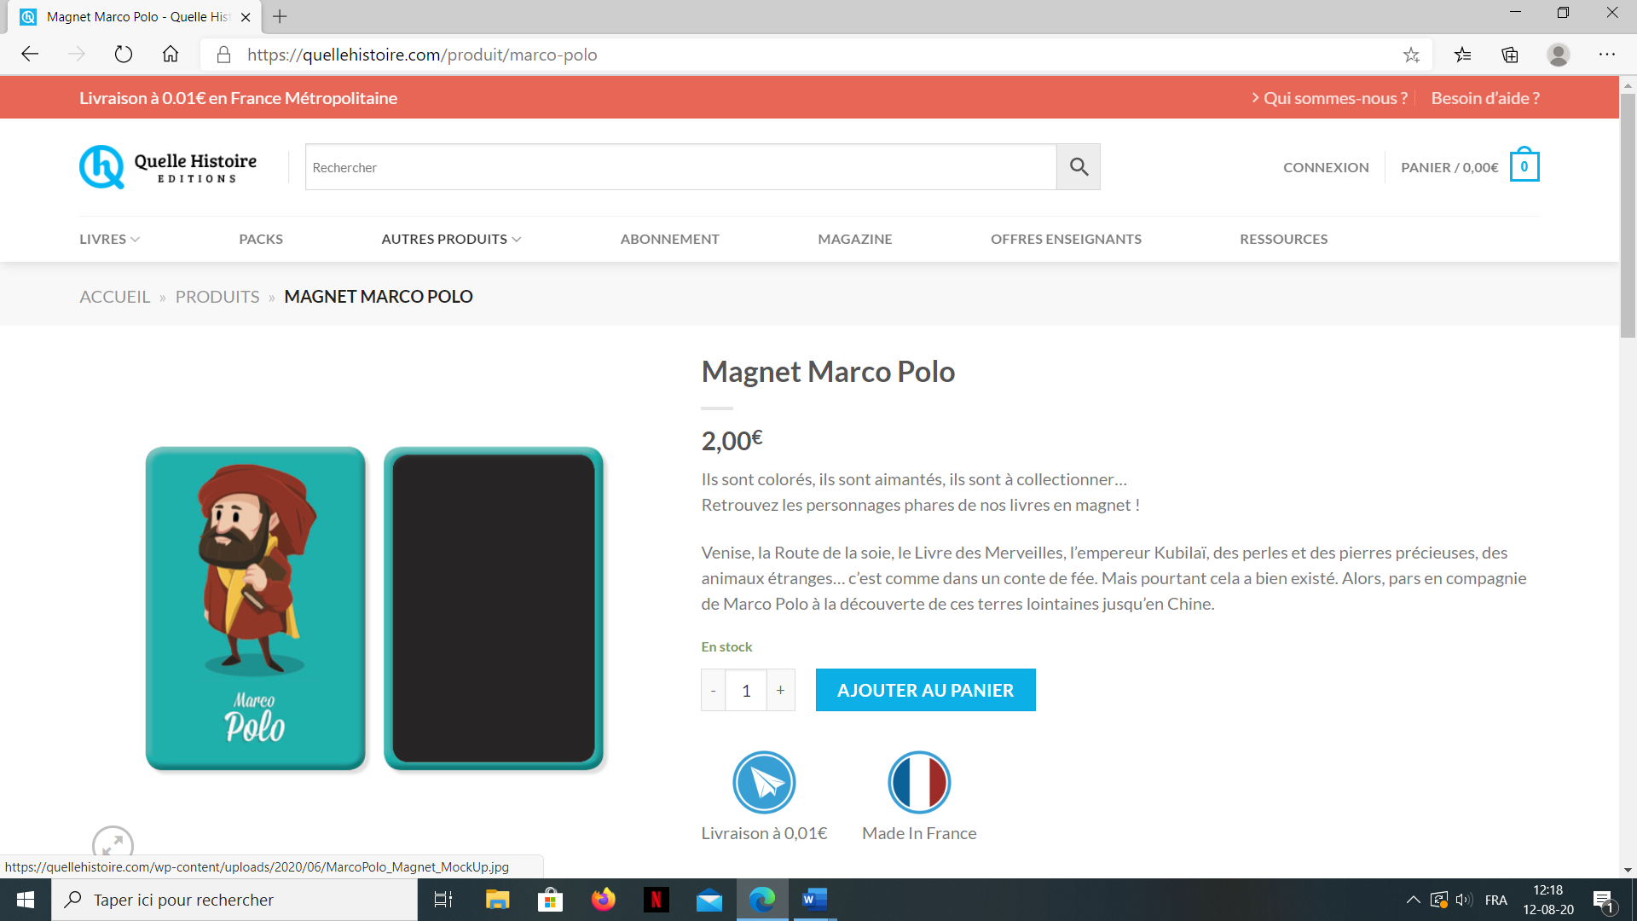

Les grandes explorations de Marco Polo

|  |  |  |  |  |  |
| --- | --- | --- | --- | --- | --- |
| **Les grandes explorations de Cyrian** | | | | | |
| **1** | **2** | **3** | **4** | **5** | **6** |
| **7** | **8** | **9** | **10** | **11** | **12** |

|  |  |  |  |  |  |
| --- | --- | --- | --- | --- | --- |
| **Les grandes explorations de Nolann** | | | | | |
| **1** | **2** | **3** | **4** | **5** | **6** |
| **7** | **8** | **9** | **10** | **11** | **12** |

|  |  |  |  |  |  |
| --- | --- | --- | --- | --- | --- |
| **Les grandes explorations de Romain** | | | | | |
| **1** | **2** | **3** | **4** | **5** | **6** |
| **7** | **8** | **9** | **10** | **11** | **12** |

|  |  |  |  |  |  |
| --- | --- | --- | --- | --- | --- |
| **Les grandes explorations de Maël** | | | | | |
| **1** | **2** | **3** | **4** | **5** | **6** |
| **7** | **8** | **9** | **10** | **11** | **12** |

|  |  |  |  |  |  |
| --- | --- | --- | --- | --- | --- |
| **Les grandes explorations de Hugo** | | | | | |
| **1** | **2** | **3** | **4** | **5** | **6** |
| **7** | **8** | **9** | **10** | **11** | **12** |
| **Les grandes explorations de Luca** | | | | | |
| **1** | **2** | **3** | **4** | **5** | **6** |
| **7** | **8** | **9** | **10** | **11** | **12** |

|  |  |  |  |  |  |
| --- | --- | --- | --- | --- | --- |
| **Les grandes explorations de Constant** | | | | | |
| **1** | **2** | **3** | **4** | **5** | **6** |
| **7** | **8** | **9** | **10** | **11** | **12** |

|  |  |  |  |  |  |
| --- | --- | --- | --- | --- | --- |
| **Les grandes explorations de Léa** | | | | | |
| **1** | **2** | **3** | **4** | **5** | **6** |
| **7** | **8** | **9** | **10** | **11** | **12** |
| **Les grandes explorations de Lucie** | | | | | |
| **1** | **2** | **3** | **4** | **5** | **6** |
| **7** | **8** | **9** | **10** | **11** | **12** |

|  |  |  |  |  |  |
| --- | --- | --- | --- | --- | --- |
| **Les grandes explorations d’Elodie** | | | | | |
| **1** | **2** | **3** | **4** | **5** | **6** |
| **7** | **8** | **9** | **10** | **11** | **12** |

|  |  |  |  |  |  |
| --- | --- | --- | --- | --- | --- |
| **Les grandes explorations d’Aliyah** | | | | | |
| **1** | **2** | **3** | **4** | **5** | **6** |
| **7** | **8** | **9** | **10** | **11** | **12** |
| **Les grandes explorations d’Amélie** | | | | | |
| **1** | **2** | **3** | **4** | **5** | **6** |
| **7** | **8** | **9** | **10** | **11** | **12** |

|  |  |  |  |  |  |
| --- | --- | --- | --- | --- | --- |
| **Les grandes explorations de Sarah** | | | | | |
| **1** | **2** | **3** | **4** | **5** | **6** |
| **7** | **8** | **9** | **10** | **11** | **12** |

|  |  |  |  |  |  |
| --- | --- | --- | --- | --- | --- |
| **Les grandes explorations de Sayana** | | | | | |
| **1** | **2** | **3** | **4** | **5** | **6** |
| **7** | **8** | **9** | **10** | **11** | **12** |