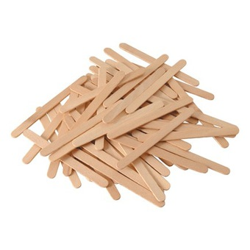
DEFI
Bâtonnets de glace

 | 1 | 2 | 3 | 4 | 5 | 6 | 7 | 8 | 9 | 10 | 11

