Pseudo :
Auto-Contrôle :
Cendrillon : Les personnages et l’histoire
Magic Disney Princesses : l’école
/20

- Complète par le prénom des personnages :
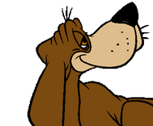
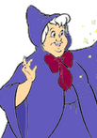
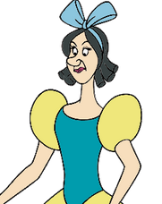
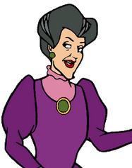
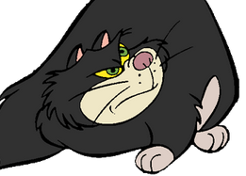
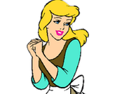

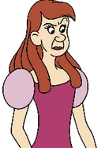

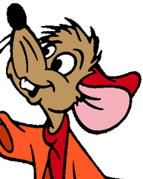
- Relie :
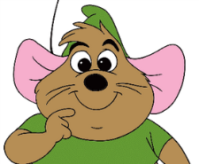
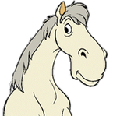
Gus Major Jack
- Fais un résumé de l’histoire de Cendrillon :
______________________________________________________________________________________________________________________________________________________________________________________________________________________________________________________________________________________________________________________________________________________________________________________________________________________________________________________________________________________________________________________________________________________________________________________________________________________________________________________________________________________________________________________________________________________________________________________________________________________________________________________________________________________________________________________________________________

