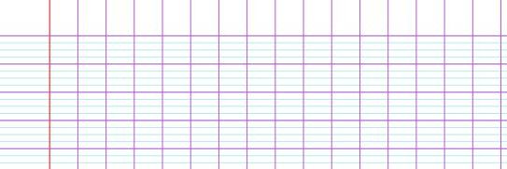**Lundi – Mardi - Mercredi – Jeudi – Vendredi – Samedi – Dimanche**

**Lundi 02 mai 2016**

|  |  |
| --- | --- |
| 1 * janvier | 7 * juillet |
| 2 * février | 8 * août |
| 3 * mars | 9 * septembre |
| 4 * avril | 10 * octobre |
| 5 * mai | 11 * novembre |
| 6 * juin | 12 * décembre |

|  |  |  |  |  |  |  |  |  |  |  |  |  |
| --- | --- | --- | --- | --- | --- | --- | --- | --- | --- | --- | --- | --- |
| A | B | C | D | E | F | G | H | I | J | K | L | M |
| **²a** | **²b** | **²c** | **²d** | **²e** | **²f** | **²g** | **h** | **²i** | **j** | **²k** | **²l** | **m** |
| **A** | **B** | **C** | **D** | **E** | **F** | **G** | **H** | **I** | **J** | **K** | **L** | **M** |
| **a** | **b** | **c** | **d** | **e** | **f** | **g** | **h** | **i** | **j** | **k** | **l** | **m** |

|  |  |  |  |  |  |  |  |  |  |  |
| --- | --- | --- | --- | --- | --- | --- | --- | --- | --- | --- |
| Bleu | Vert | Jaune | Orange | Rouge | Rose | Violet | Marron | Blanc | Gris | Noir |

|  |  |  |  |  |  |  |  |  |
| --- | --- | --- | --- | --- | --- | --- | --- | --- |
| **0**  **1**  **2**  **3**  **4**  **5**  **6** | zéro  un  deux  trois  quatre  cinq  six | **7**  **8**  **9**  **10**  **11**  **12**  **13** | sept  huit  neuf  dix  onze  douze  treize | **14**  **15**  **16**  **17**  **18**  **19**  **20** | Quatorze  quinze  seize  dix-sept  dix-huit  dix-neuf  vingt | **30**  **40**  **50**  **60**  **70**  **80**  **90** | trente  quarante  cinquante  soixante  soixante-dix  quatre-**vingt(s)**  quatre-vingt-dix | 100 |
| **cent(s)** |
| 1 000 |
| mille |
| 1 000 000 |
| **million(s)** |
| 1 000 000 |
| **milliard(s)** |

HAUT

droite

gauche

|  |  |  |  |
| --- | --- | --- | --- |
|  |  |  |  |
| Triangle | Cercle | Carré | Rectangle |

BAS

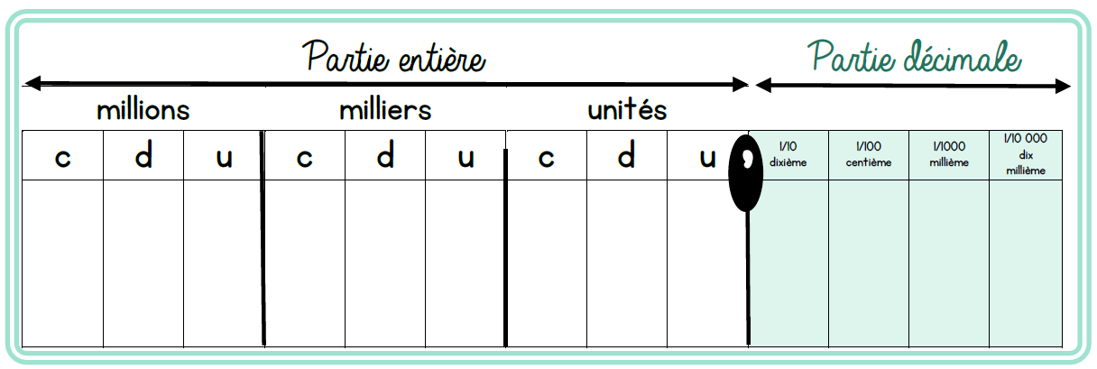

**Tableau de conversions**

**Tableau de numération**

**,**

|  |  |  |  |  |  |  |  |  |  |  |  |  |
| --- | --- | --- | --- | --- | --- | --- | --- | --- | --- | --- | --- | --- |
| N | O | P | Q | R | S | T | U | V | W | X | Y | Z |
| **n** | **²o** | **²p** | **²q** | **²r** | **²s** | **²t** | **u** | **v** | **w** | **x** | **y** | **²z** |
| **N** | **O** | **P** | **Q** | **R** | **S** | **T** | **U** | **V** | **W** | **X** | **Y** | **Z** |
| **n** | **o** | **p** | **q** | **r** | **s** | **t** | **u** | **v** | **w** | **x** | **y** | **z** |

|  |  |  |  |  |  |  |  |  |  |  |  |  |
| --- | --- | --- | --- | --- | --- | --- | --- | --- | --- | --- | --- | --- |
|  |  |  |  |  |  |  |  |  |  |  |  |  |
| écris |  | lis |  | recopie |  | calcule |  | observe |  | colorie |  | découpe |
|  |  |  |  |  |  |  |  |  |  |  |  |  |
|  |  |  |  |  |  |  |  |  |  |  |  |  |
| entoure |  | trace |  | coche |  | dessine |  | barre |  | relie |  | colle |

|  |  |  |  |  |  |  |  |  |  |  |  |  |
| --- | --- | --- | --- | --- | --- | --- | --- | --- | --- | --- | --- | --- |
|  |  |  |  | Afficher l'image d'origine |  | Afficher l'image d'origine |  | Afficher l'image d'origine |  | Afficher l'image d'origine |  | Afficher l'image d'origine |
| Crayon à papier |  | Stylos |  | Crayons de couleur |  | Feutres |  | Gomme |  | Règle |  | Equerre |
|  |  |  |  |  |  |  |  |  |  |  |  |  |
| Afficher l'image d'origine |  | Afficher l'image d'origine |  |  |  | Afficher l'image d'origine |  |  |  |  |  | Afficher l'image d'origine |
| Taille crayons |  | Ciseaux |  | Trousse |  | Chemise |  | Ardoise |  | Porte-vues |  | Cahiers |