My name is Wilbur. I have got a red head, a yellow body, purple legs, a pink tail, blue whiskers.

But my eyes are still green!

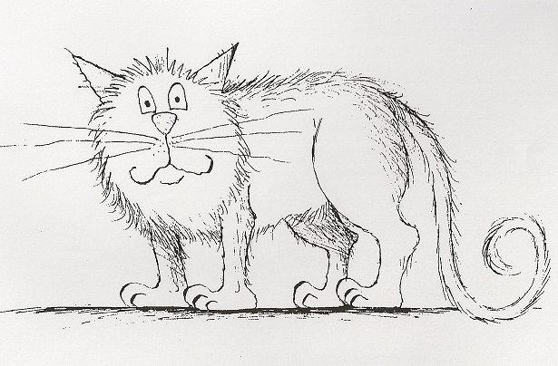

My name is Wilbur. I have got a red head, a yellow body, purple legs, a pink tail, blue whiskers.

But my eyes are still green!

