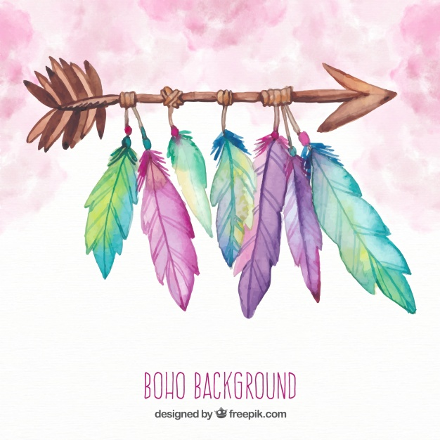

Charlie



Sarah



Sara



Mariana



Naël



Sofia



Léo



Charles-William



Najat



Nayra



Eliza



Rayan



Inaya



Slimane



Maia



Maxine



Emma



Ilyès



Idriss



Nils



Arthur



Alpha



Liora



Sophia



Younes



Omar



Lise



Ludovic



Charlie