My House

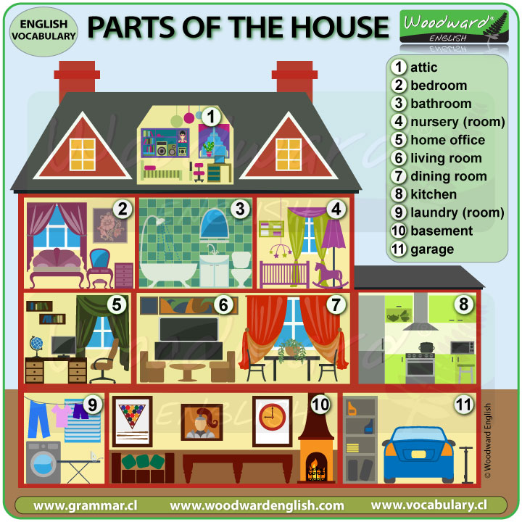

Attic grenier basement sous-sol

Bathroom Salle de Bain garage garage

Bedroom Chambre à coucher garden jardin

Nursery chambre de bébé

Office/study bureau

Living room salon

Dining room salle à manger

Kitchen cuisine

Laundry buanderie

Some verbs :

I cook in the kitchen (cuisine)

I sleep in the bedroom (dors)

I eat in the dining room (mange)

I watch TV in the living room (regarde)

I shower in the bathroom (prends une douche)

I wash the laundry in the laundry room (lave)

I play in the garden (joue)