(=maths=CE2==num10A=)

Mémo 3

Exercice 1 : Relie ces nombres à leur place sur la frise.

\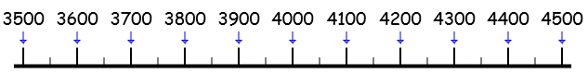

|  |  |  |  |  |  |  |  |  |  |  |
| --- | --- | --- | --- | --- | --- | --- | --- | --- | --- | --- |
| 4102 |  | 3793 |  | 3618 |  | 4119 |  | 3815 |  | 3570 |

\\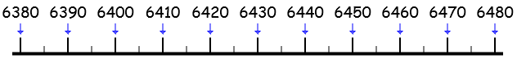

|  |  |  |  |  |  |  |  |  |  |  |  |  |
| --- | --- | --- | --- | --- | --- | --- | --- | --- | --- | --- | --- | --- |
| 6385 |  | 6465 |  | 6402 |  | 6461 |  | 6419 |  | 6386 |  | 6450 |

Exercice 2 : Complète le tableau de numération.

|  |  |  |
| --- | --- | --- |
| 2342 | 2000 + 300 + 40 + 2 |  |
| \  4523 |  |  |
| \\  8271 |  |  |
| \\  9035 |  |  |

(=maths=CE2==num10B=)

Mémo 3

Exercice 1 : Relie ces nombres à leur place sur la frise.

\\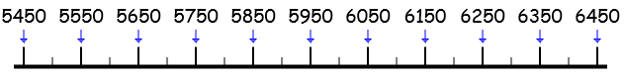

|  |  |  |  |  |  |  |  |  |  |  |  |  |
| --- | --- | --- | --- | --- | --- | --- | --- | --- | --- | --- | --- | --- |
| 6125 |  | 6381 |  | 6394 |  | 6453 |  | 6403 |  | 6317 |  | 6451 |

\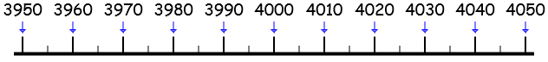

|  |  |  |  |  |  |  |  |  |  |  |  |  |
| --- | --- | --- | --- | --- | --- | --- | --- | --- | --- | --- | --- | --- |
| 4011 |  | 3982 |  | 3993 |  | 4039 |  | 3965 |  | 3957 |  | 4033 |

Exercice 2 : Complète le tableau de numération.

|  |  |  |
| --- | --- | --- |
| 2342 | 2000 + 300 + 40 + 2 |  |
| \  5064 |  |  |
| \\  1425 |  |  |
| \\  9736 |  |  |

(=maths=CE2==num10C=)

Mémo 3

Exercice 1 : Relie ces nombres à leur place sur la frise.

\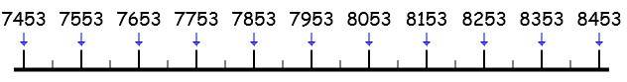

|  |  |  |  |  |  |  |  |  |  |  |  |  |
| --- | --- | --- | --- | --- | --- | --- | --- | --- | --- | --- | --- | --- |
| 8073 |  | 7877 |  | 8103 |  | 8089 |  | 7503 |  | 7741 |  | 7646 |

\\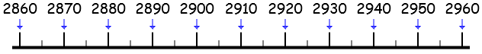

|  |  |  |  |  |  |  |  |  |  |  |  |  |
| --- | --- | --- | --- | --- | --- | --- | --- | --- | --- | --- | --- | --- |
| 2886 |  | 2863 |  | 2918 |  | 2879 |  | 2901 |  | 2914 |  | 2901 |

Exercice 2 : Complète le tableau de numération.

|  |  |  |
| --- | --- | --- |
| 2342 | 2000 + 300 + 40 + 2 |  |
| \  6351 |  |  |
| \\  2725 |  |  |
| \\  3028 |  |  |

(=maths=CE2==num10D=)

Mémo 3

Exercice 1 : Relie ces nombres à leur place sur la frise.

\\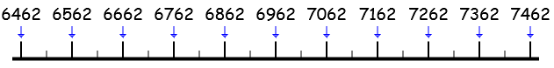

|  |  |  |  |  |  |  |  |  |  |  |  |  |
| --- | --- | --- | --- | --- | --- | --- | --- | --- | --- | --- | --- | --- |
| 6924 |  | 6661 |  | 6949 |  | 7159 |  | 6586 |  | 6564 |  | 7017 |

\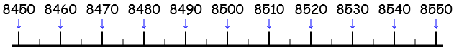

|  |  |  |  |  |  |  |  |  |  |  |  |  |
| --- | --- | --- | --- | --- | --- | --- | --- | --- | --- | --- | --- | --- |
| 8508 |  | 8477 |  | 8543 |  | 8533 |  | 8477 |  | 8597 |  | 8459 |

Exercice 2 : Complète le tableau de numération.

|  |  |  |
| --- | --- | --- |
| 2342 | 2000 + 300 + 40 + 2 |  |
| \  8361 |  |  |
| \\  3512 |  |  |
| \\  3524 |  |  |

(=maths=CE2==num10E=)

Mémo 3

Exercice 1 : Relie ces nombres à leur place sur la frise.

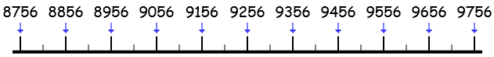

\

|  |  |  |  |  |  |  |  |  |  |  |  |  |
| --- | --- | --- | --- | --- | --- | --- | --- | --- | --- | --- | --- | --- |
| 9363 |  | 9607 |  | 9350 |  | 9730 |  | 9508 |  | 8996 |  | 9725 |

\\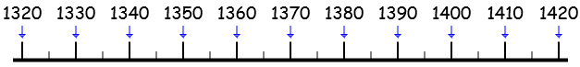

|  |  |  |  |  |  |  |  |  |  |  |  |  |
| --- | --- | --- | --- | --- | --- | --- | --- | --- | --- | --- | --- | --- |
| 1371 |  | 1797 |  | 1324 |  | 1358 |  | 1362 |  | 1383 |  | 1354 |

Exercice 2 : Complète le tableau de numération.

|  |  |  |
| --- | --- | --- |
| 2342 | 2000 + 300 + 40 + 2 |  |
| \  8364 |  |  |
| \\  3624 |  |  |
| \\  7397 |  |  |

(=maths=CE2==num10F=)

Mémo 3

Exercice 1 : Relie ces nombres à leur place sur la frise.

\\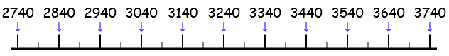

|  |  |  |  |  |  |  |  |  |  |  |  |  |
| --- | --- | --- | --- | --- | --- | --- | --- | --- | --- | --- | --- | --- |
| 3001 |  | 3115 |  | 3728 |  | 3499 |  | 3521 |  | 3571 |  | 3477 |

\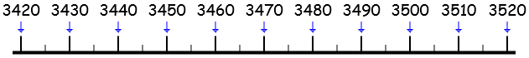

|  |  |  |  |  |  |  |  |  |  |  |  |  |
| --- | --- | --- | --- | --- | --- | --- | --- | --- | --- | --- | --- | --- |
| 3431 |  | 3424 |  | 3472 |  | 3511 |  | 3508 |  | 3435 |  | 3497 |

Exercice 2 : Complète le tableau de numération.

|  |  |  |
| --- | --- | --- |
| 2342 | 2000 + 300 + 40 + 2 |  |
| \  7646 |  |  |
| \\  9852 |  |  |
| \\  4043 |  |  |

(=maths=CE2==num10G=)

Mémo 3

Exercice 1 : Relie ces nombres à leur place sur la frise.

\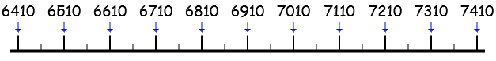

|  |  |  |  |  |  |  |  |  |  |  |  |  |
| --- | --- | --- | --- | --- | --- | --- | --- | --- | --- | --- | --- | --- |
| 6988 |  | 6617 |  | 7272 |  | 6720 |  | 7162 |  | 6946 |  | 6632 |

\\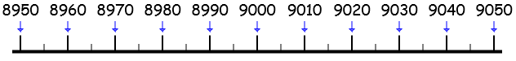

|  |  |  |  |  |  |  |  |  |  |  |  |  |
| --- | --- | --- | --- | --- | --- | --- | --- | --- | --- | --- | --- | --- |
| 8984 |  | 8998 |  | 9015 |  | 9033 |  | 9041 |  | 8965 |  | 8922 |

Exercice 2 : Complète le tableau de numération.

|  |  |  |
| --- | --- | --- |
| 2342 | 2000 + 300 + 40 + 2 |  |
| \  7643 |  |  |
| \\  1432 |  |  |
| \\  2058 |  |  |

(=maths=CE2==num10H=)

Mémo 3

Exercice 1 : Relie ces nombres à leur place sur la frise.

\\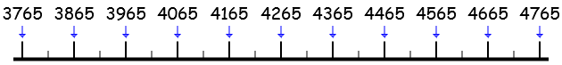

|  |  |  |  |  |  |  |  |  |  |  |  |  |
| --- | --- | --- | --- | --- | --- | --- | --- | --- | --- | --- | --- | --- |
| 4693 |  | 4224 |  | 4058 |  | 4439 |  | 3906 |  | 4018 |  | 4700 |

\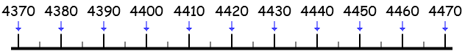

|  |  |  |  |  |  |  |  |  |  |  |  |  |
| --- | --- | --- | --- | --- | --- | --- | --- | --- | --- | --- | --- | --- |
| 4421 |  | 4404 |  | 4383 |  | 4416 |  | 4399 |  | 4425 |  | 4397 |

Exercice 2 : Complète le tableau de numération.

|  |  |  |
| --- | --- | --- |
| 2342 | 2000 + 300 + 40 + 2 |  |
| \  9864 |  |  |
| \\  4241 |  |  |
| \\  7574 |  |  |

(évaluation=CE2=num10)

Compétence : Décomposer les nombres jusqu’à 10 000 + Situer les nombres jusqu’à 10 000 sur une file numérique

Exercice 1 : Relie ces nombres à leur place sur la frise.

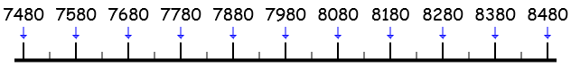

|  |  |  |  |  |  |  |  |  |  |  |  |  |
| --- | --- | --- | --- | --- | --- | --- | --- | --- | --- | --- | --- | --- |
| 4468 |  | 4443 |  | 4396 |  | 4465 |  | 4385 |  | 4459 |  | 4403 |

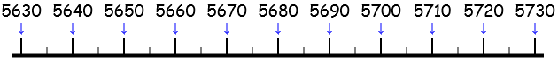

|  |  |  |  |  |  |  |  |  |  |  |  |  |
| --- | --- | --- | --- | --- | --- | --- | --- | --- | --- | --- | --- | --- |
| 5718 |  | 5681 |  | 5652 |  | 5663 |  | 5679 |  | 5648 |  | 5635 |

Exercice 2 : Complète le tableau de numération.

|  |  |  |
| --- | --- | --- |
| 2342 | 2000 + 300 + 40 + 2 |  |
| 8754 |  |  |
| 6053 |  |  |
| 7642 |  |  |