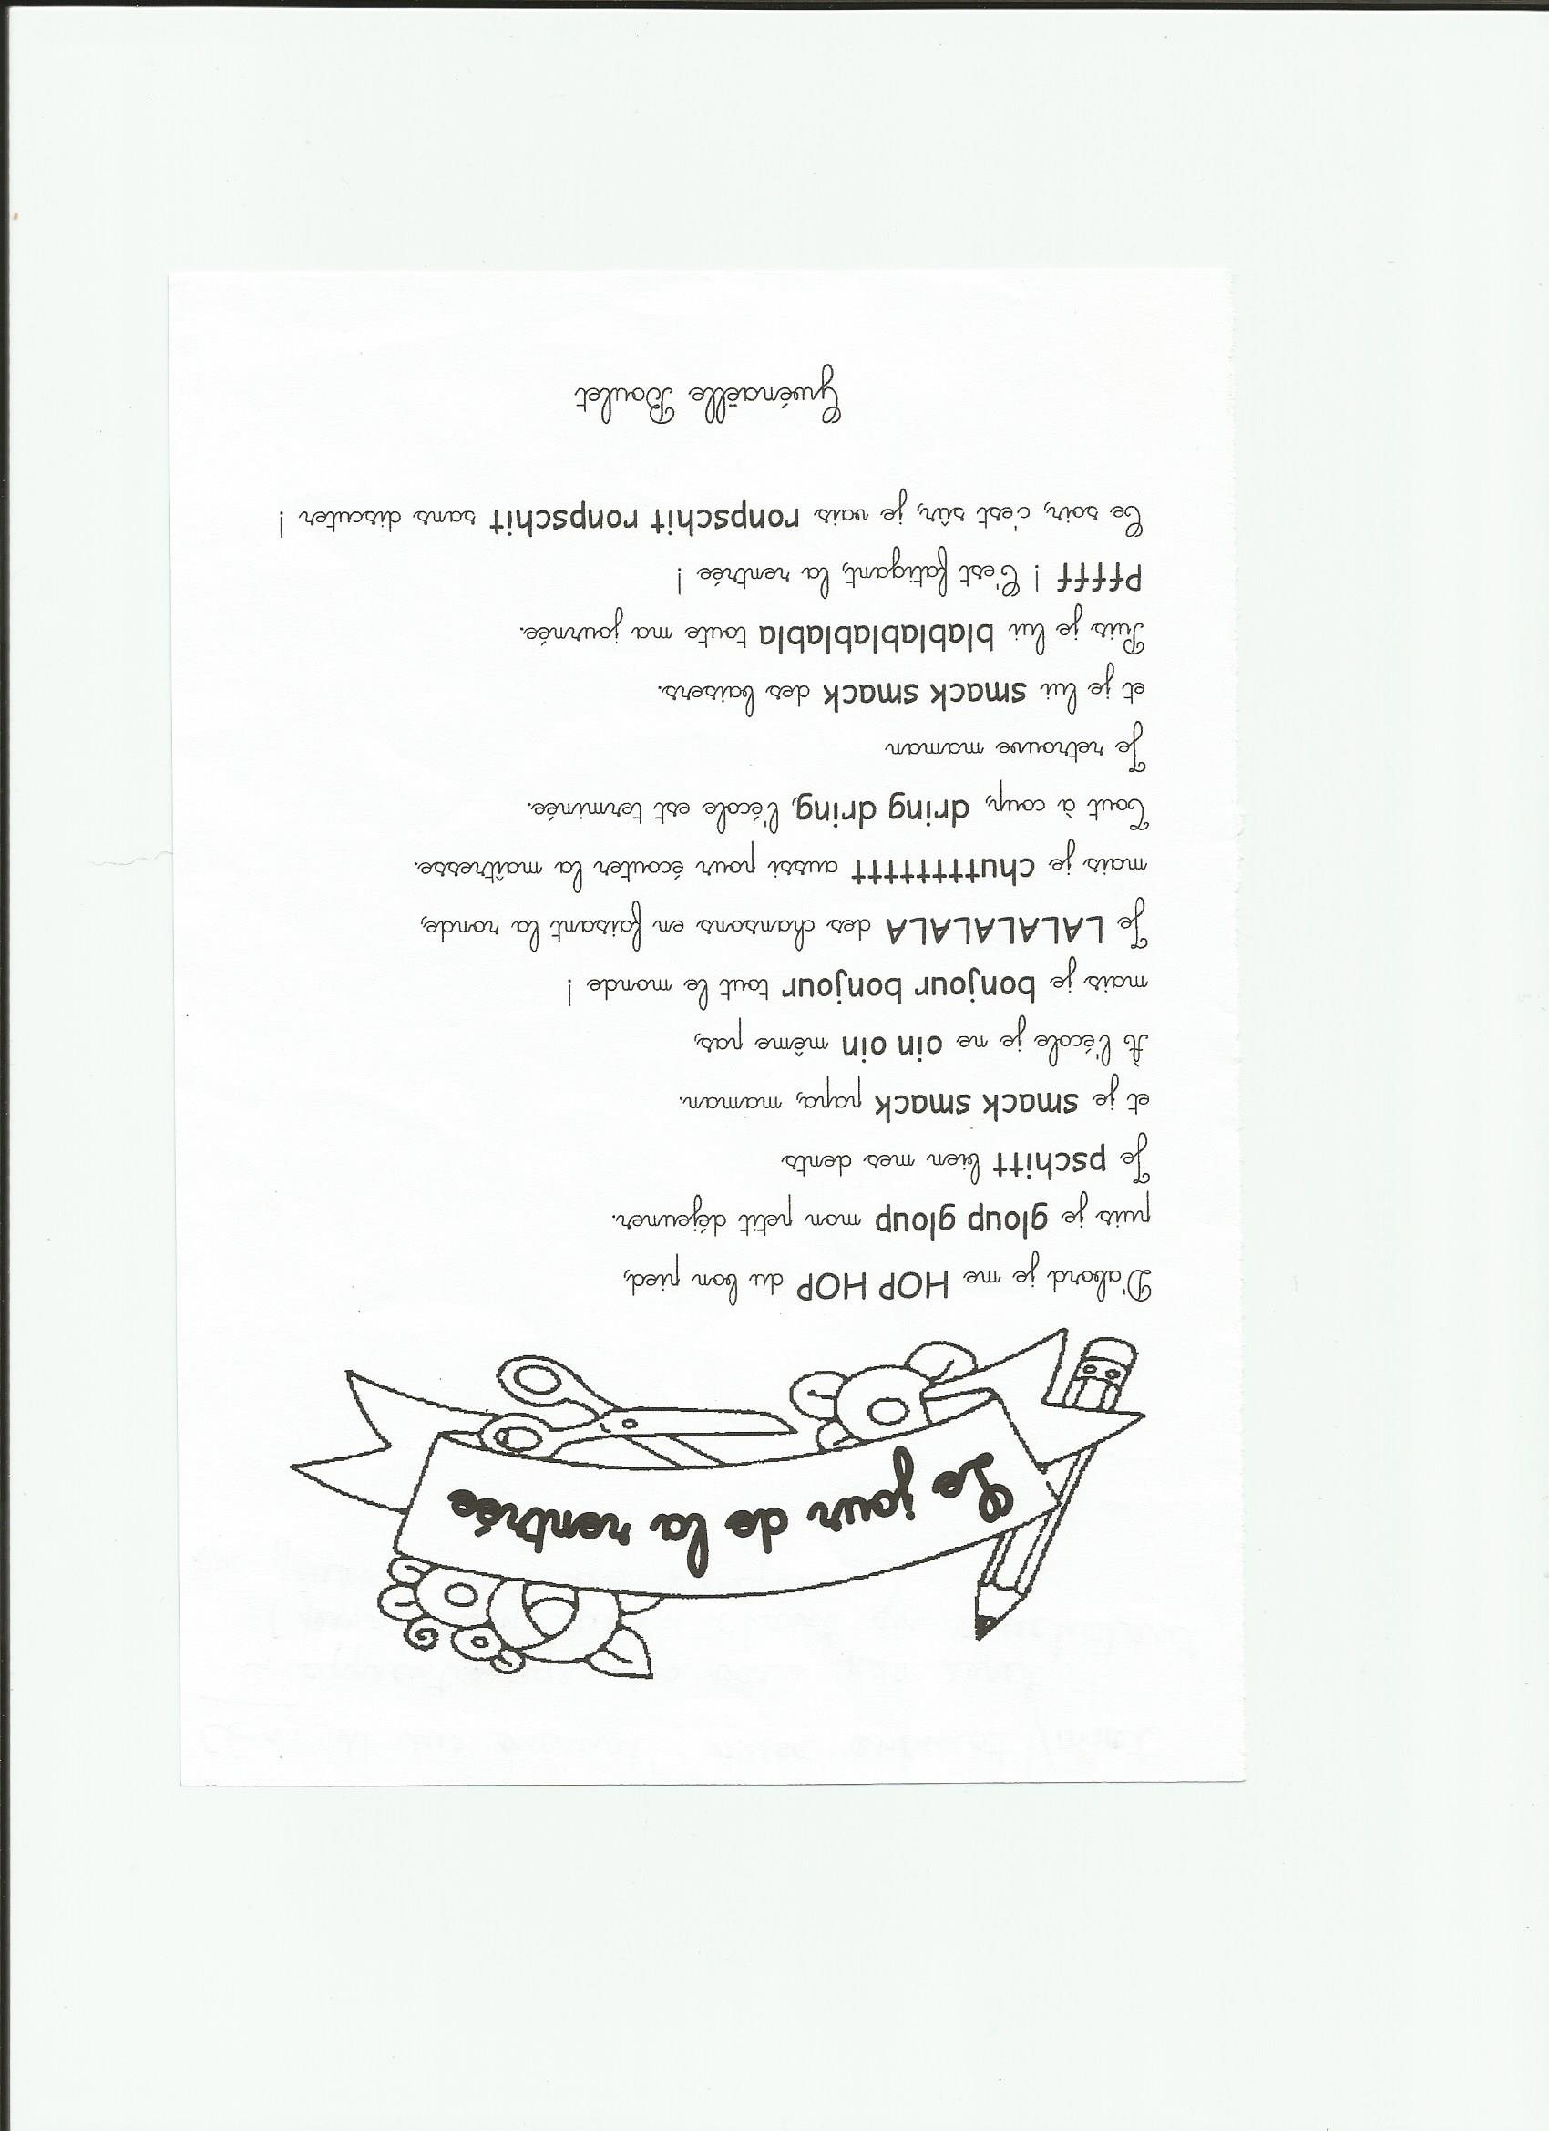

|  |
| --- |
| HOP HOP |
| gloup gloup |
| pschitt |
| smack smack |
| oin oin.jpgoin oin |

|  |
| --- |
| bonjour bonjour |
| LALALALALA |
| chutttttttt chut_petit_.jpg |
| dring dring |
| smack smack |

|  |
| --- |
| blablablablabla |
| Pffff |
| ronpschit ronpschit |