# The Royal Family

[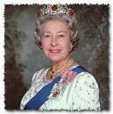](http://fr.wrs.yahoo.com/_ylt=A9ibyjpqpYZEqmgBFUJlAQx./SIG=1gbj4mj5i/EXP=1149761258/**http%3a/fr.search.yahoo.com/search/images/view%3fback=http%253A%252F%252Ffr.search.yahoo.com%252Fsearch%252Fimages%253Ffr%253DFP-tab-img-t%2526ei%253DISO-8859-1%2526p%253Delizabeth%252Bii%26w=200%26h=201%26imgurl=www.education.mcgill.ca%252Fedee-382b-01%252Fmccoll%252Fhudsonbay%252FElizabeth.jpg%26rurl=http%253A%252F%252Fwww.education.mcgill.ca%252Fedee-382b-01%252Fmccoll%252Fhudsonbay%252Fmove.html%26size=8.2kB%26name=Elizabeth.jpg%26p=elizabeth%2bii%26type=jpeg%26no=2%26tt=42%20533%26ei=ISO-8859-1) 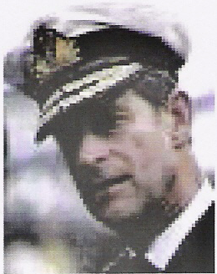

[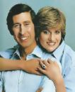](http://fr.wrs.yahoo.com/_ylt=A9iby4yDpoZEnkQBTfVlAQx./SIG=1gdoogjss/EXP=1149761539/**http%3a/fr.search.yahoo.com/search/images/view%3fback=http%253A%252F%252Ffr.search.yahoo.com%252Fsearch%252Fimages%253Fp%253Dprince%252Bcharles%2526ei%253DUTF-8%2526fr%253Dsfp%2526x%253Dwrt%26w=250%26h=305%26imgurl=www.famous-couple.com%252Fpics%252Fprince_charles-lady_diana_spencer.jpg%26rurl=http%253A%252F%252Fforum.aceboard.net%252F5397-1337-56705-0-Mariage-Charles-Camilla.htm%26size=22.6kB%26name=prince_charles-lady_diana_spencer.jpg%26p=prince%2bcharles%26type=jpeg%26no=1%26tt=47%20277%26ei=UTF-8)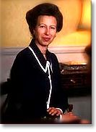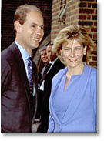[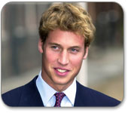](http://fr.wrs.yahoo.com/_ylt=A9htdaB1qYZEJrgAkopuAQx./SIG=12qk7ioov/EXP=1149762293/**http%3a/www.cbc.ca/tvarts/britishweek/howtobeaprince/images/william.jpg)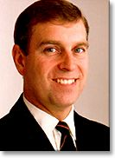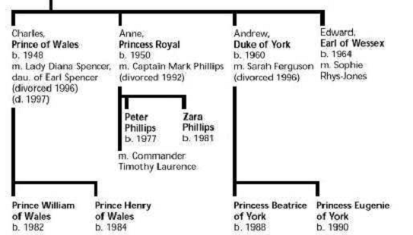



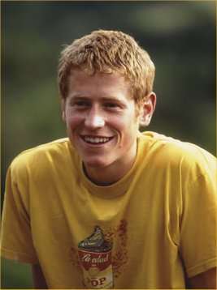

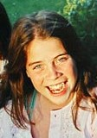

**b. (born) : né(e) en *Queen : reine***

**m. (married) : marié à *Duke : duc***

**divorced : divorcés *Prince : prince***

**d. (died) : morte en *Princess : princesse***

***Earl : comte***

***Captain : capitaine***

## *Commander : commandant*

*CM2- English lesson ………………….. The royal family*

**?1**

I have got two brothers and one sister.

I have got two children .

My mother is a queen and I am a prince .

My name is ……………………………….

**?2**

I have got one brother.

I haven’t got any sisters.

My grand-mother is a queen.

I am 26 years old.

My name is ……………………………….

**?3**

I have four children

I have six grand-children.

I am a queen.

My name is ……………………………….

**?4**

I have got three brothers and one sister.

I haven’t got any children .

My mother is a queen and I am an earl.

My name is ……………………………….

|  |  |
| --- | --- |
| ***QUESTION*** | ***SENTENCE*** |
| **Do you have …………. ?** | **I have got …………**  **I haven’t got …………** |