|  |
| --- |
| **ANGLAIS**  Prénom :  **évaluation** |

|  |  |  |  |  |  |
| --- | --- | --- | --- | --- | --- |
| Q. |  | | | | |
| 1 | Connaître le vocabulaire de la famille | 1 | 2 | 3 | 4 |

1. Ecris ces mots au bon endroit: sister, mother, grand father, aunt, father, brother, uncle, grand mother

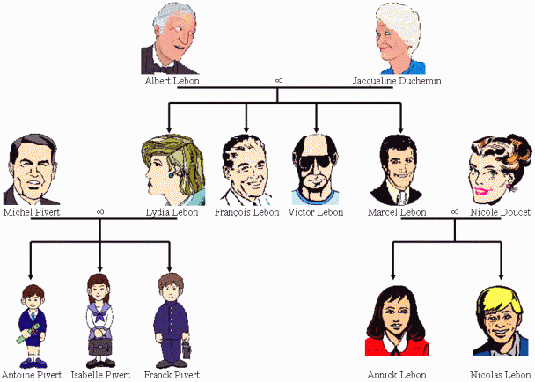

Who is Nicolas’s mother? .....................................................................................................

Who is Annick's brother? …...................................................................................................

Who is Isabelle’s father?..........................................................................................

Who are Franck's sisters? …....................................................................................

Who is Isabelle's grand father? …....................................................................................

Who are Jacqueline’s daughters? …....................................................................................

Who are Michel's son? …..................................................................................................

Who are Annick's grand mother? …................................................................................

Who are Franck's cousins ? …..............................................................................................

Who are Antoine's aunt ? …...............................................................................................

Who are Nicolas's uncle ? ….....................................................................................

|  |
| --- |
| **ANGLAIS**  Prénom :  **évaluation** |

|  |  |  |  |  |  |
| --- | --- | --- | --- | --- | --- |
| Q. |  | | | | |
| 1 | Connaître l’alphabet/ savoir épeler un mot | 1 | 2 | 3 | 4 |
| 2 | connaitre le nom des couleurs | 1 | 2 | 3 | 4 |
| 3 | Connaître le vocabulaire des affaires scolaires | 1 | 2 | 3 | 4 |
| 4 | connaître les nombres | 1 | 2 | 3 | 4 |

1. Ecris les lettres  dictées:

|  |  |  |  |  |
| --- | --- | --- | --- | --- |
|  |  |  |  |  |
|  |  |  |  |  |
|  |  |  |  |  |
|  |  |  |  |  |

1. Dictée de couleurs:

|  |  |  |  |  |
| --- | --- | --- | --- | --- |
| b  a | c | d |  | f |
| f  e | g | h |  | k |

1. Numérote les affaires scolaires dans l’ordre de la dictée :

|  |  |  |  |  |
| --- | --- | --- | --- | --- |
|  |  |  |  |  |
|  |  |  |  |  |

1. Dictée de nombres :

|  |  |  |  |  |  |  |  |  |  |
| --- | --- | --- | --- | --- | --- | --- | --- | --- | --- |
|  |  |  |  |  |  |  |  |  |  |
|  |  |  |  |  |  |  |  |  |  |