CRÉATION
__________________________________________________
DIEU
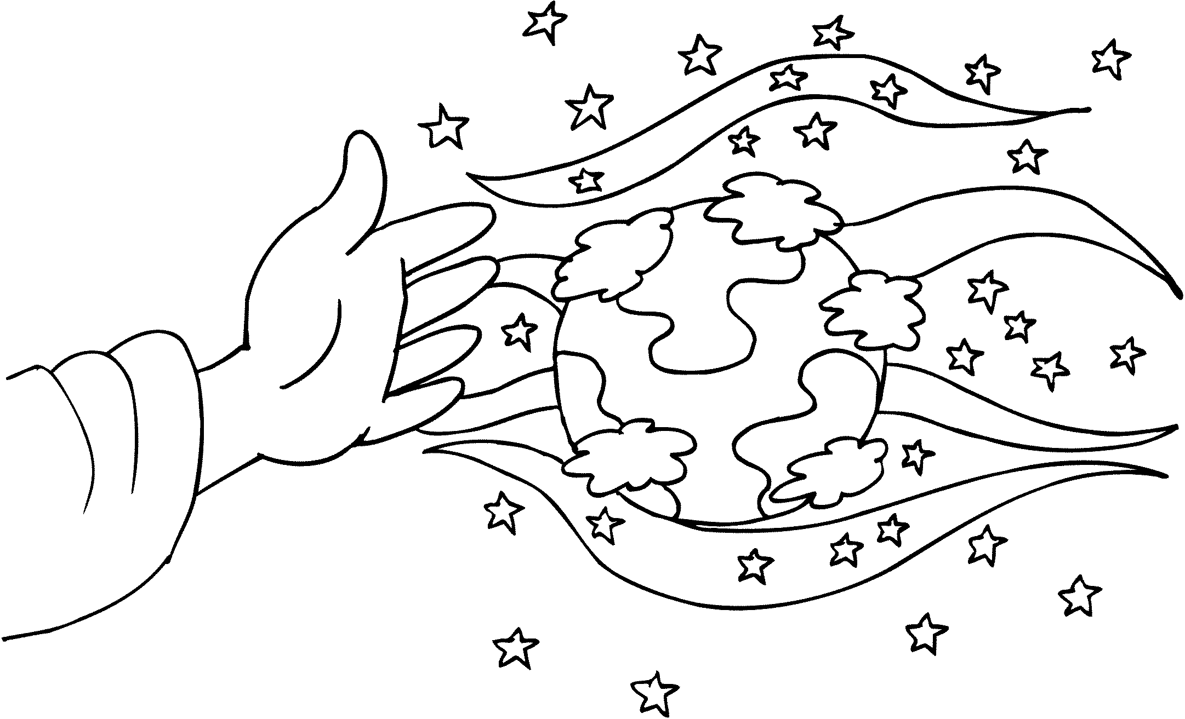

________________________________________________

PLAN PARFAIT

ORIGINE
__________________________________________________
ADAM / EVE
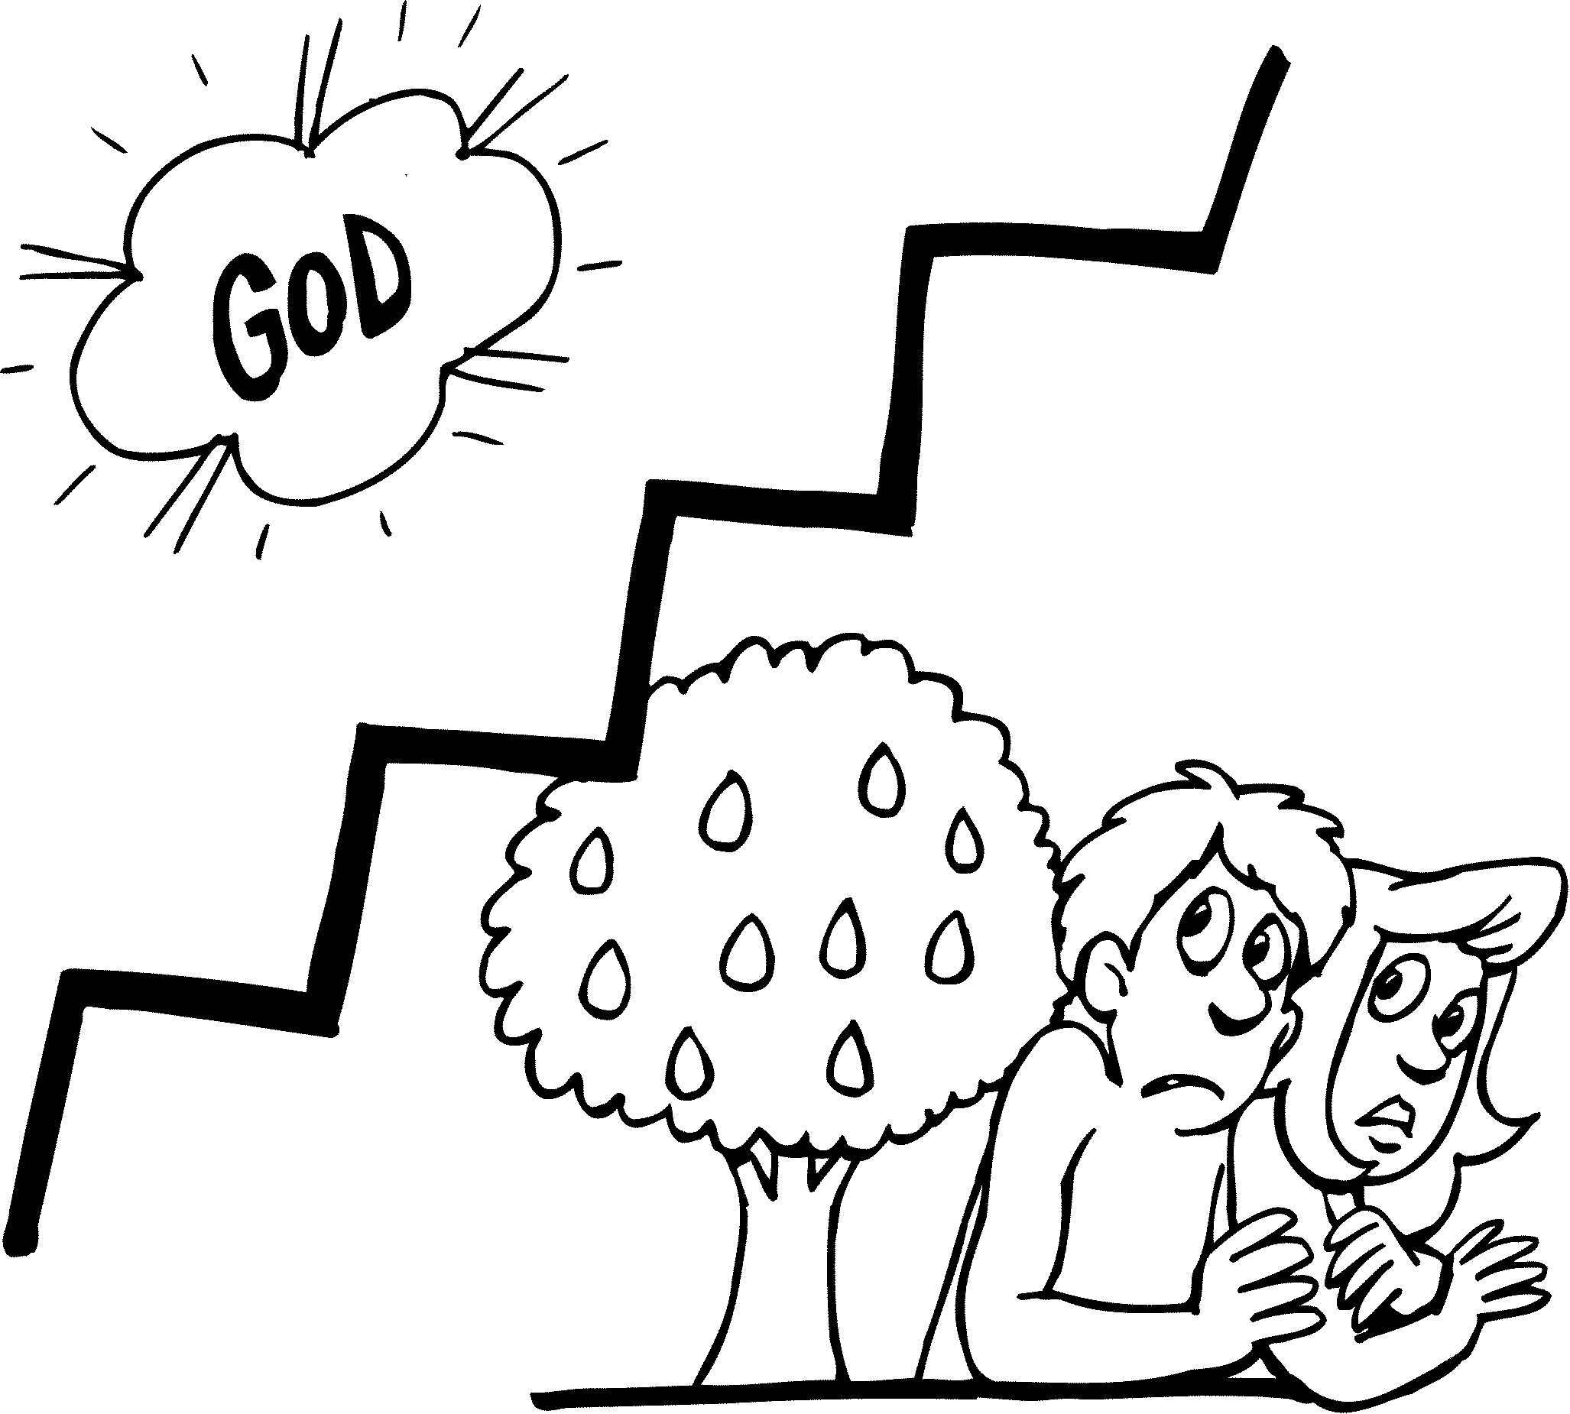

__________________________________________________
PROBLÈME / PROMESSE
ORIGINE
__________________________________________________
NOÉ
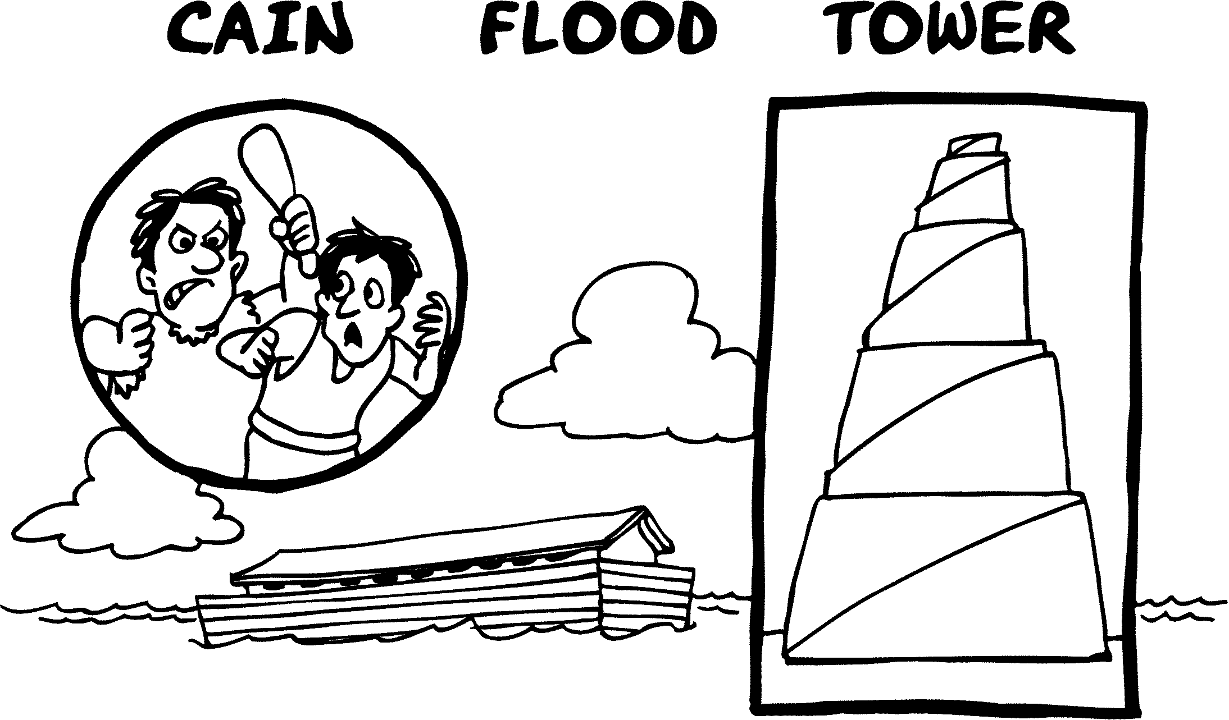

__________________________________________________
RÉSULTATS DU PÉCHÉ
FAMILLE
__________________________________________________
ABRAHAM
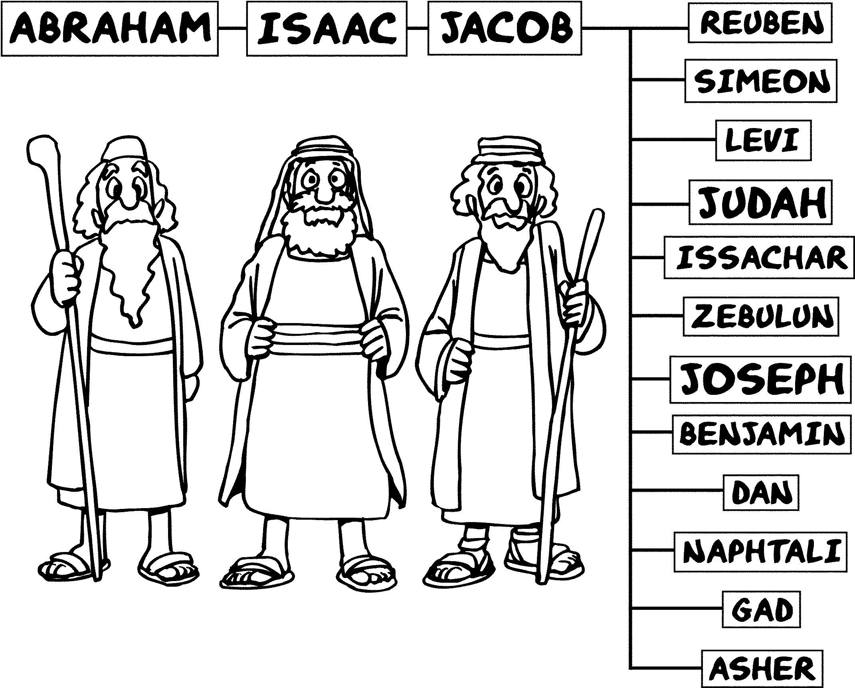

__________________________________________________
3 PROMESSES DONNÉES
EXODE
__________________________________________________
JOSEPH / MOÏSE
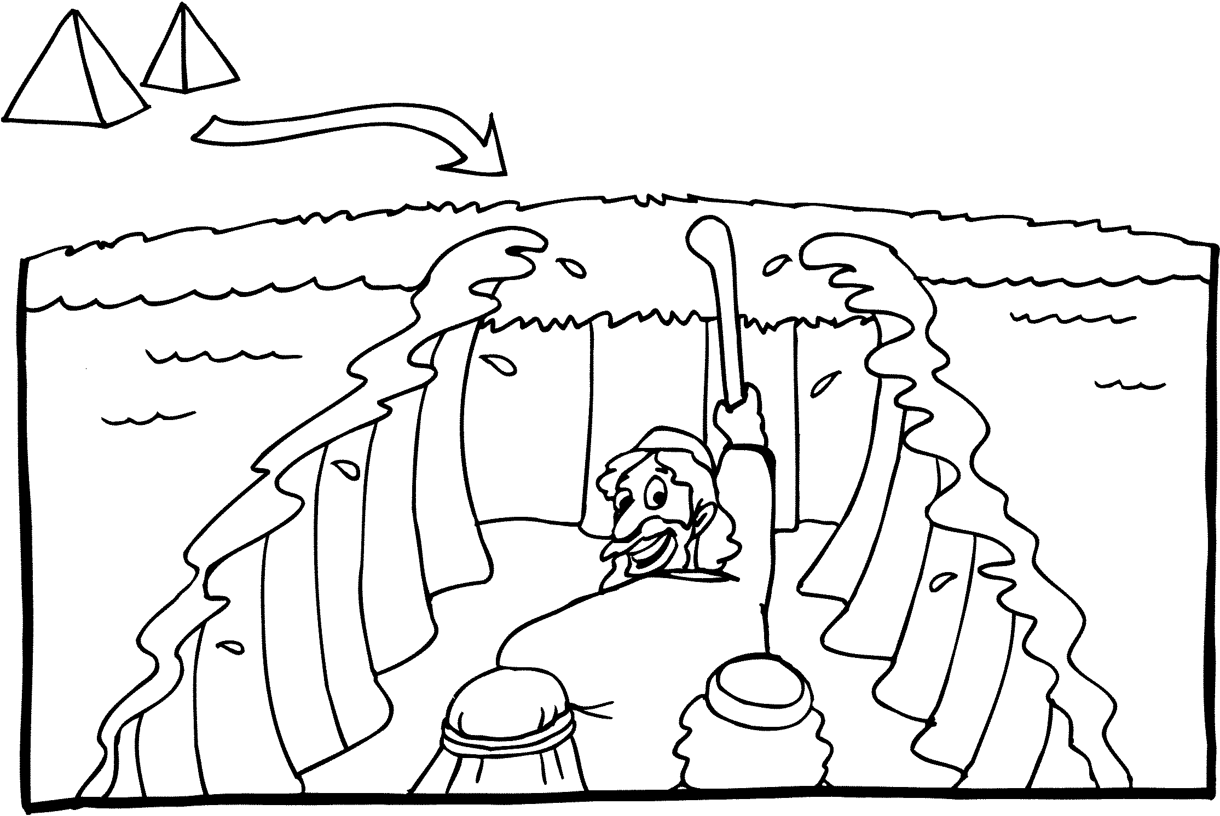

__________________________________________________
ESCLAVES DE PHARAON

EXODE
__________________________________________________
MOÏSE
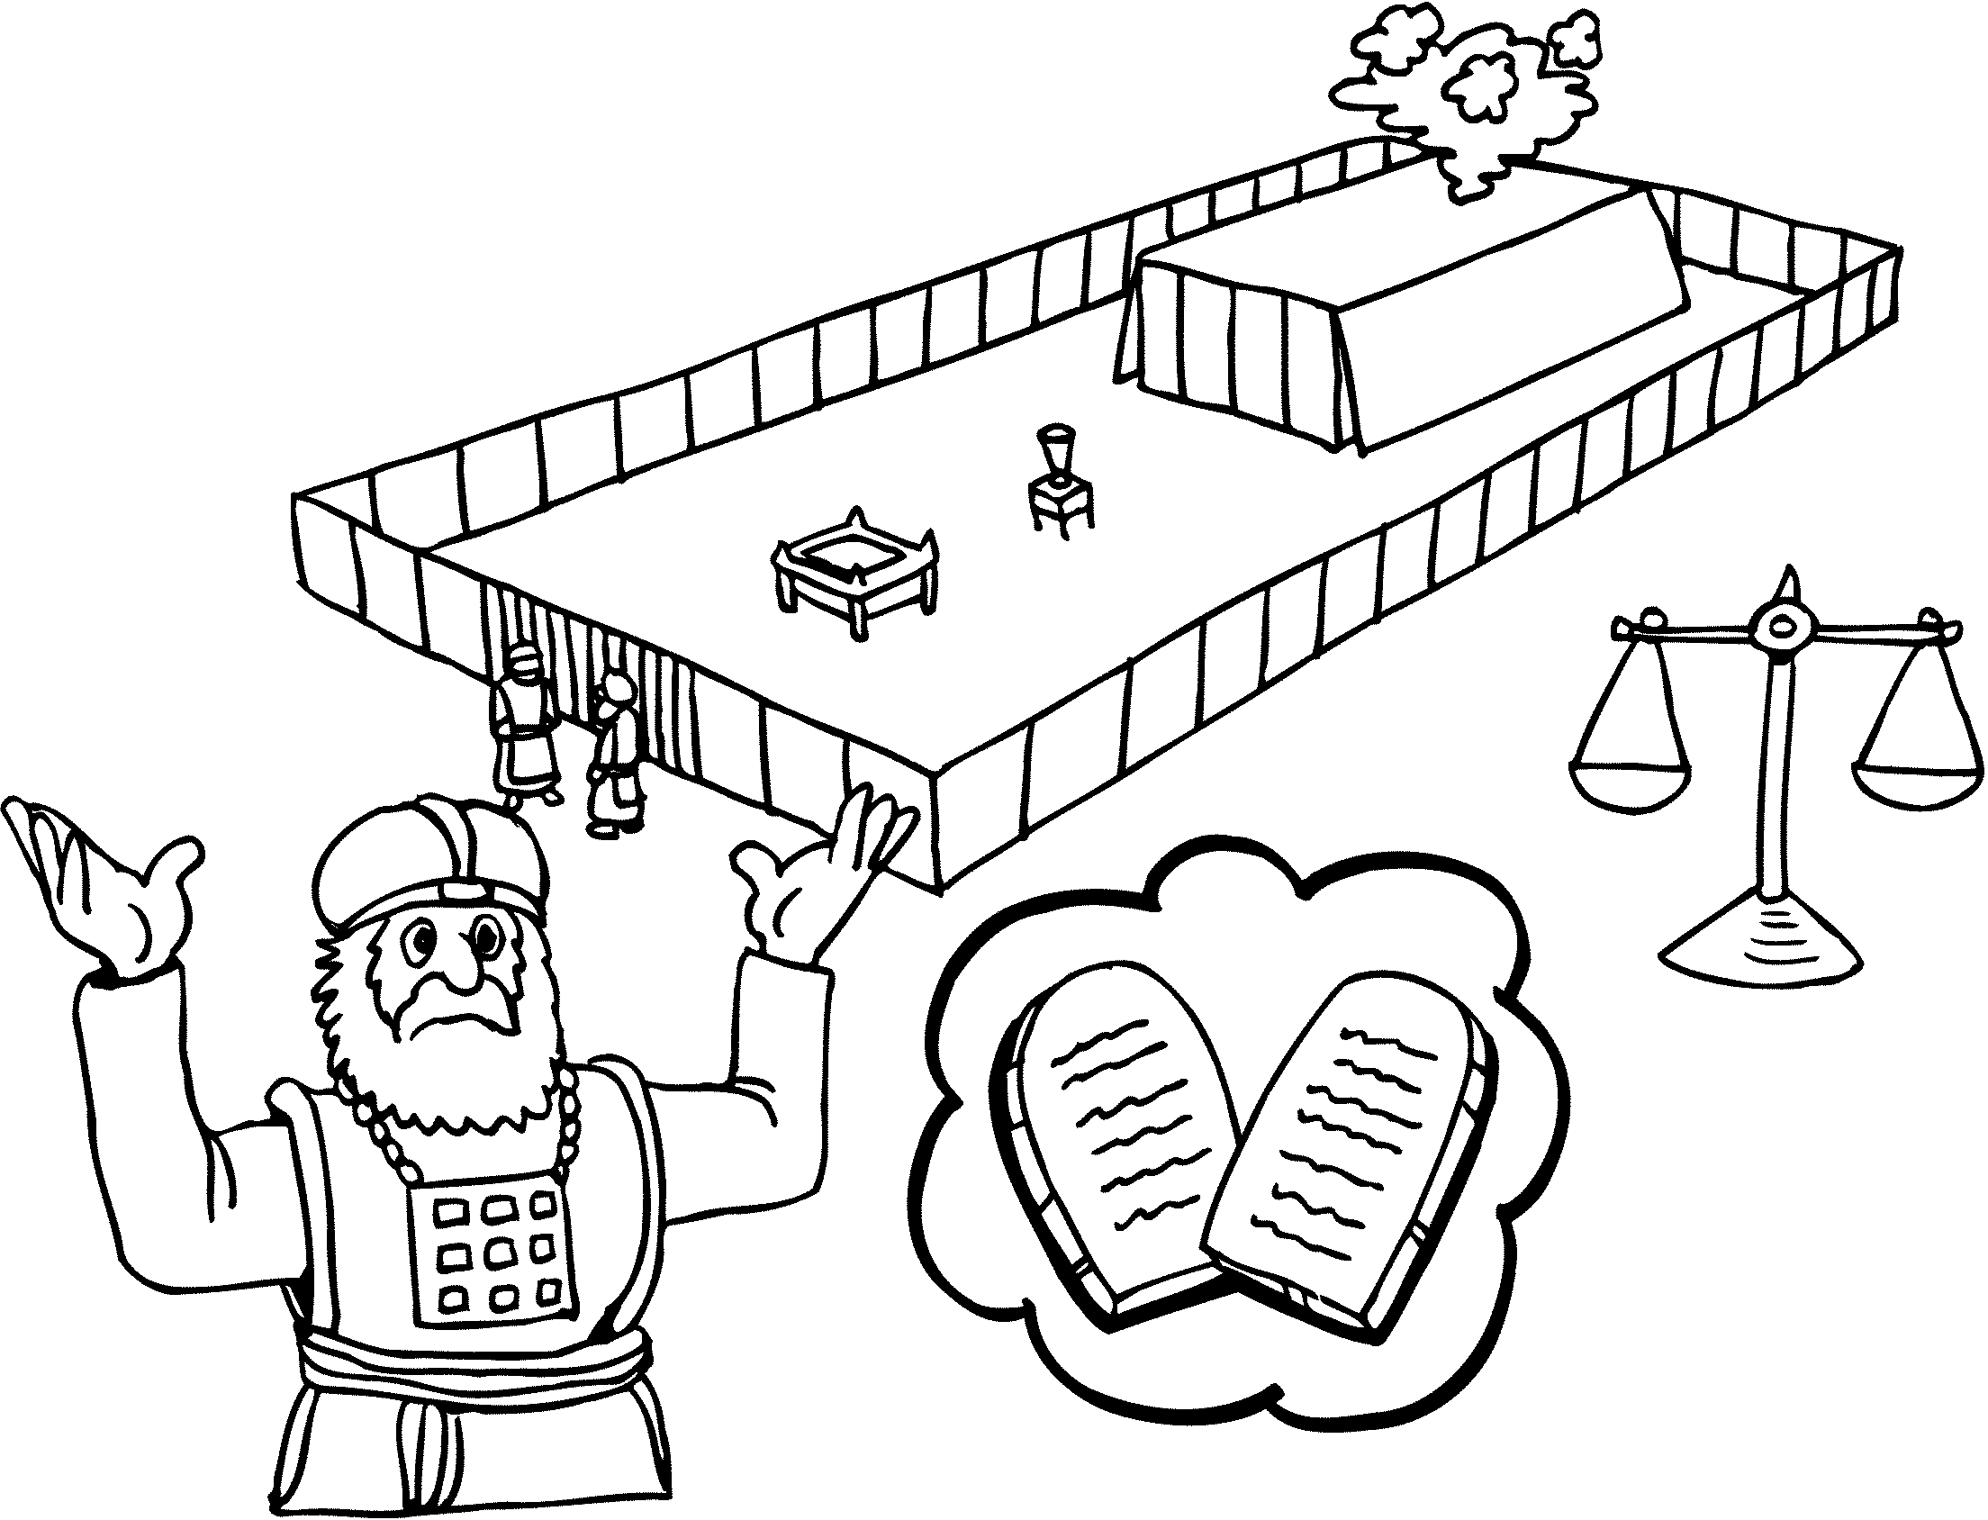

__________________________________________________
NATION PROMISE (1)
EXODE
__________________________________________________MOÏSE / AARON
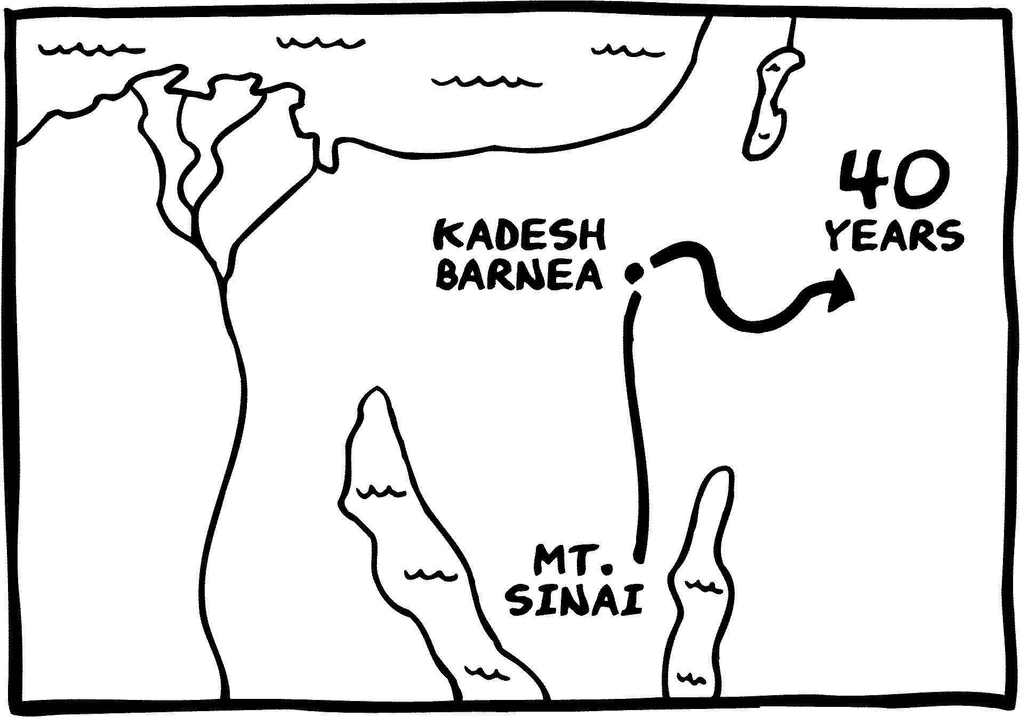

__________________________________________________
MORT DANS LE DÉSERT
CONQUÊTE
__________________________________________________
JOSUÉ
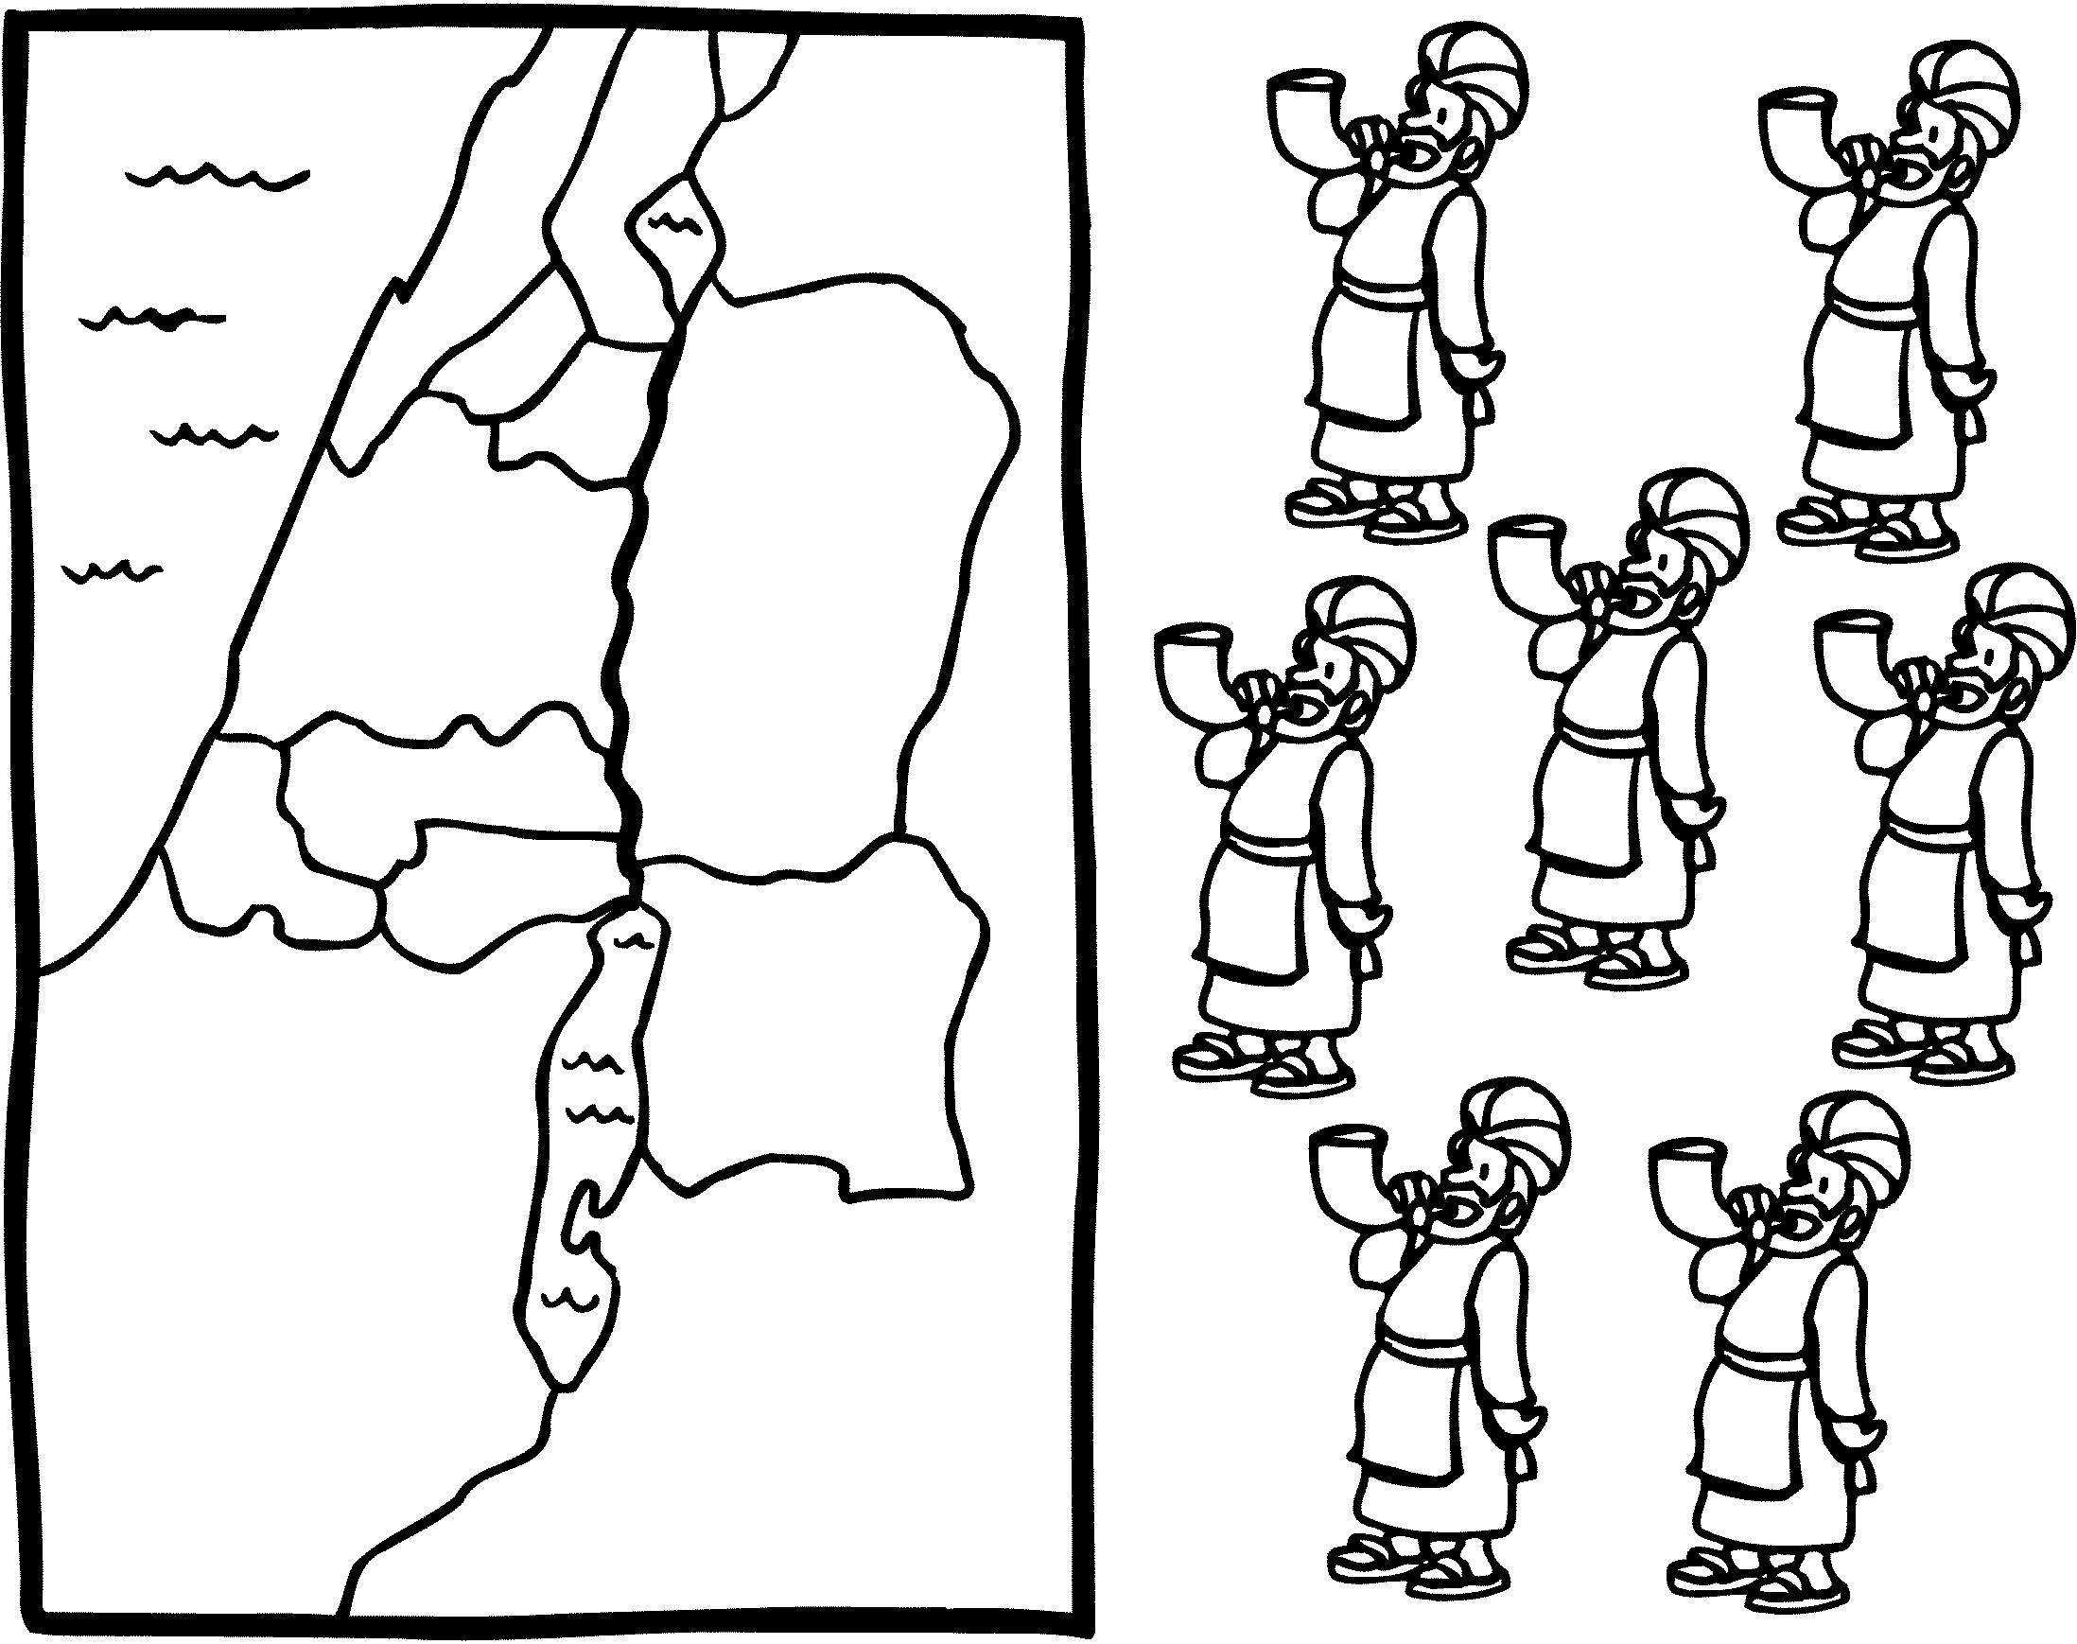

__________________________________________________
TERRE PROMISE (2)
JUGES
__________________________________________________
SAMUEL
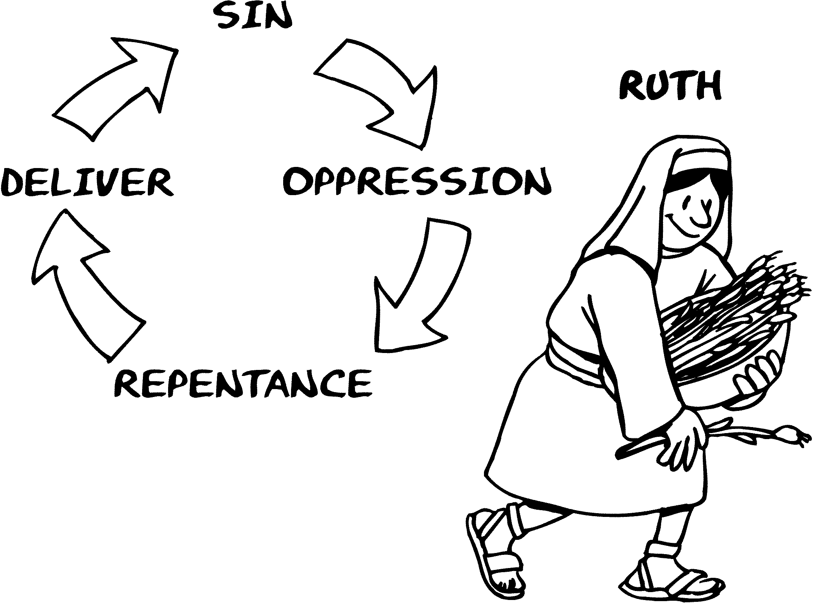

__________________________________________________
CYCLE - PÉCHÉ
ROYAUME
__________________________________________________
DAVID
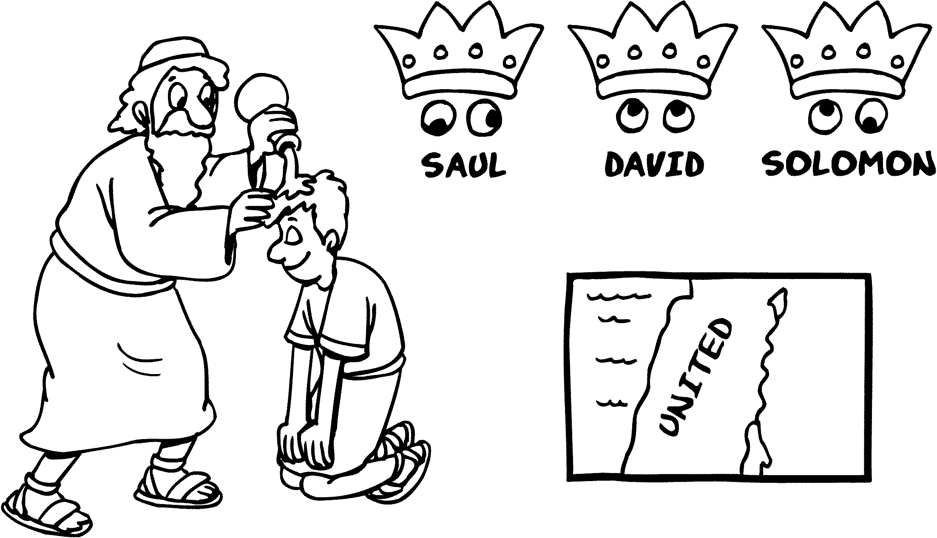

__________________________________________________
PALAIS
ROYAUME __________________________________________________
REHOBOAM
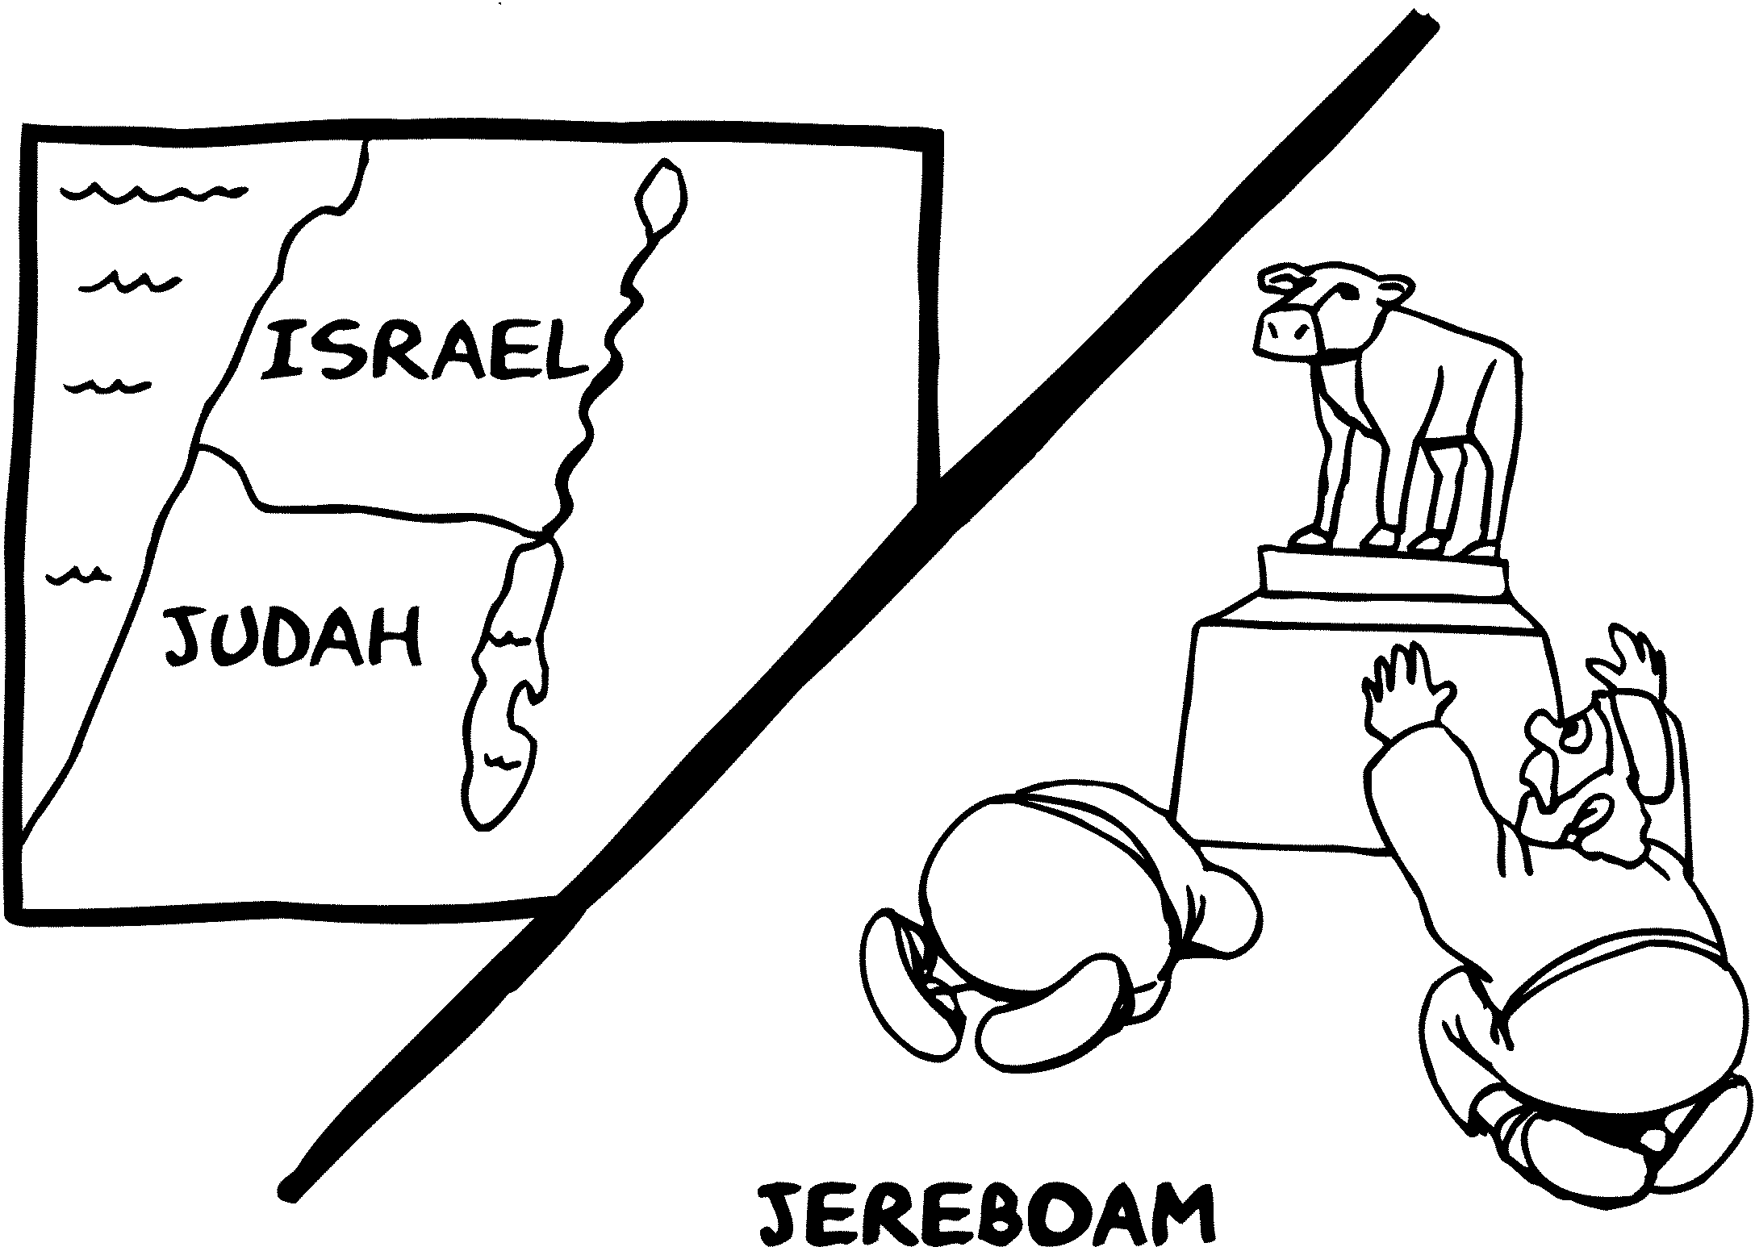

__________________________________________________
IDOLES PAÏENNES
ROYAUME __________________________________________________
JOSIAS
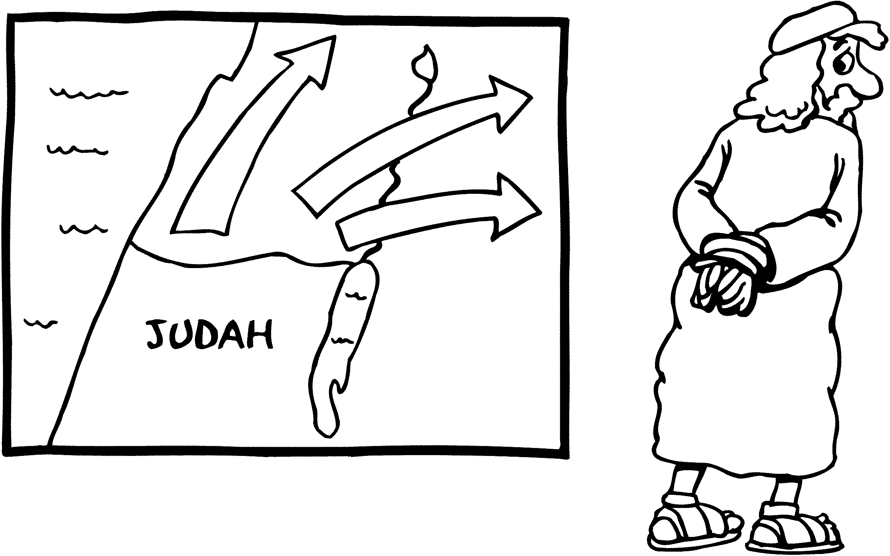

__________________________________________________
PUNITION PROCHE
ROYAUME
__________________________________________________
JOB / ESAÏE
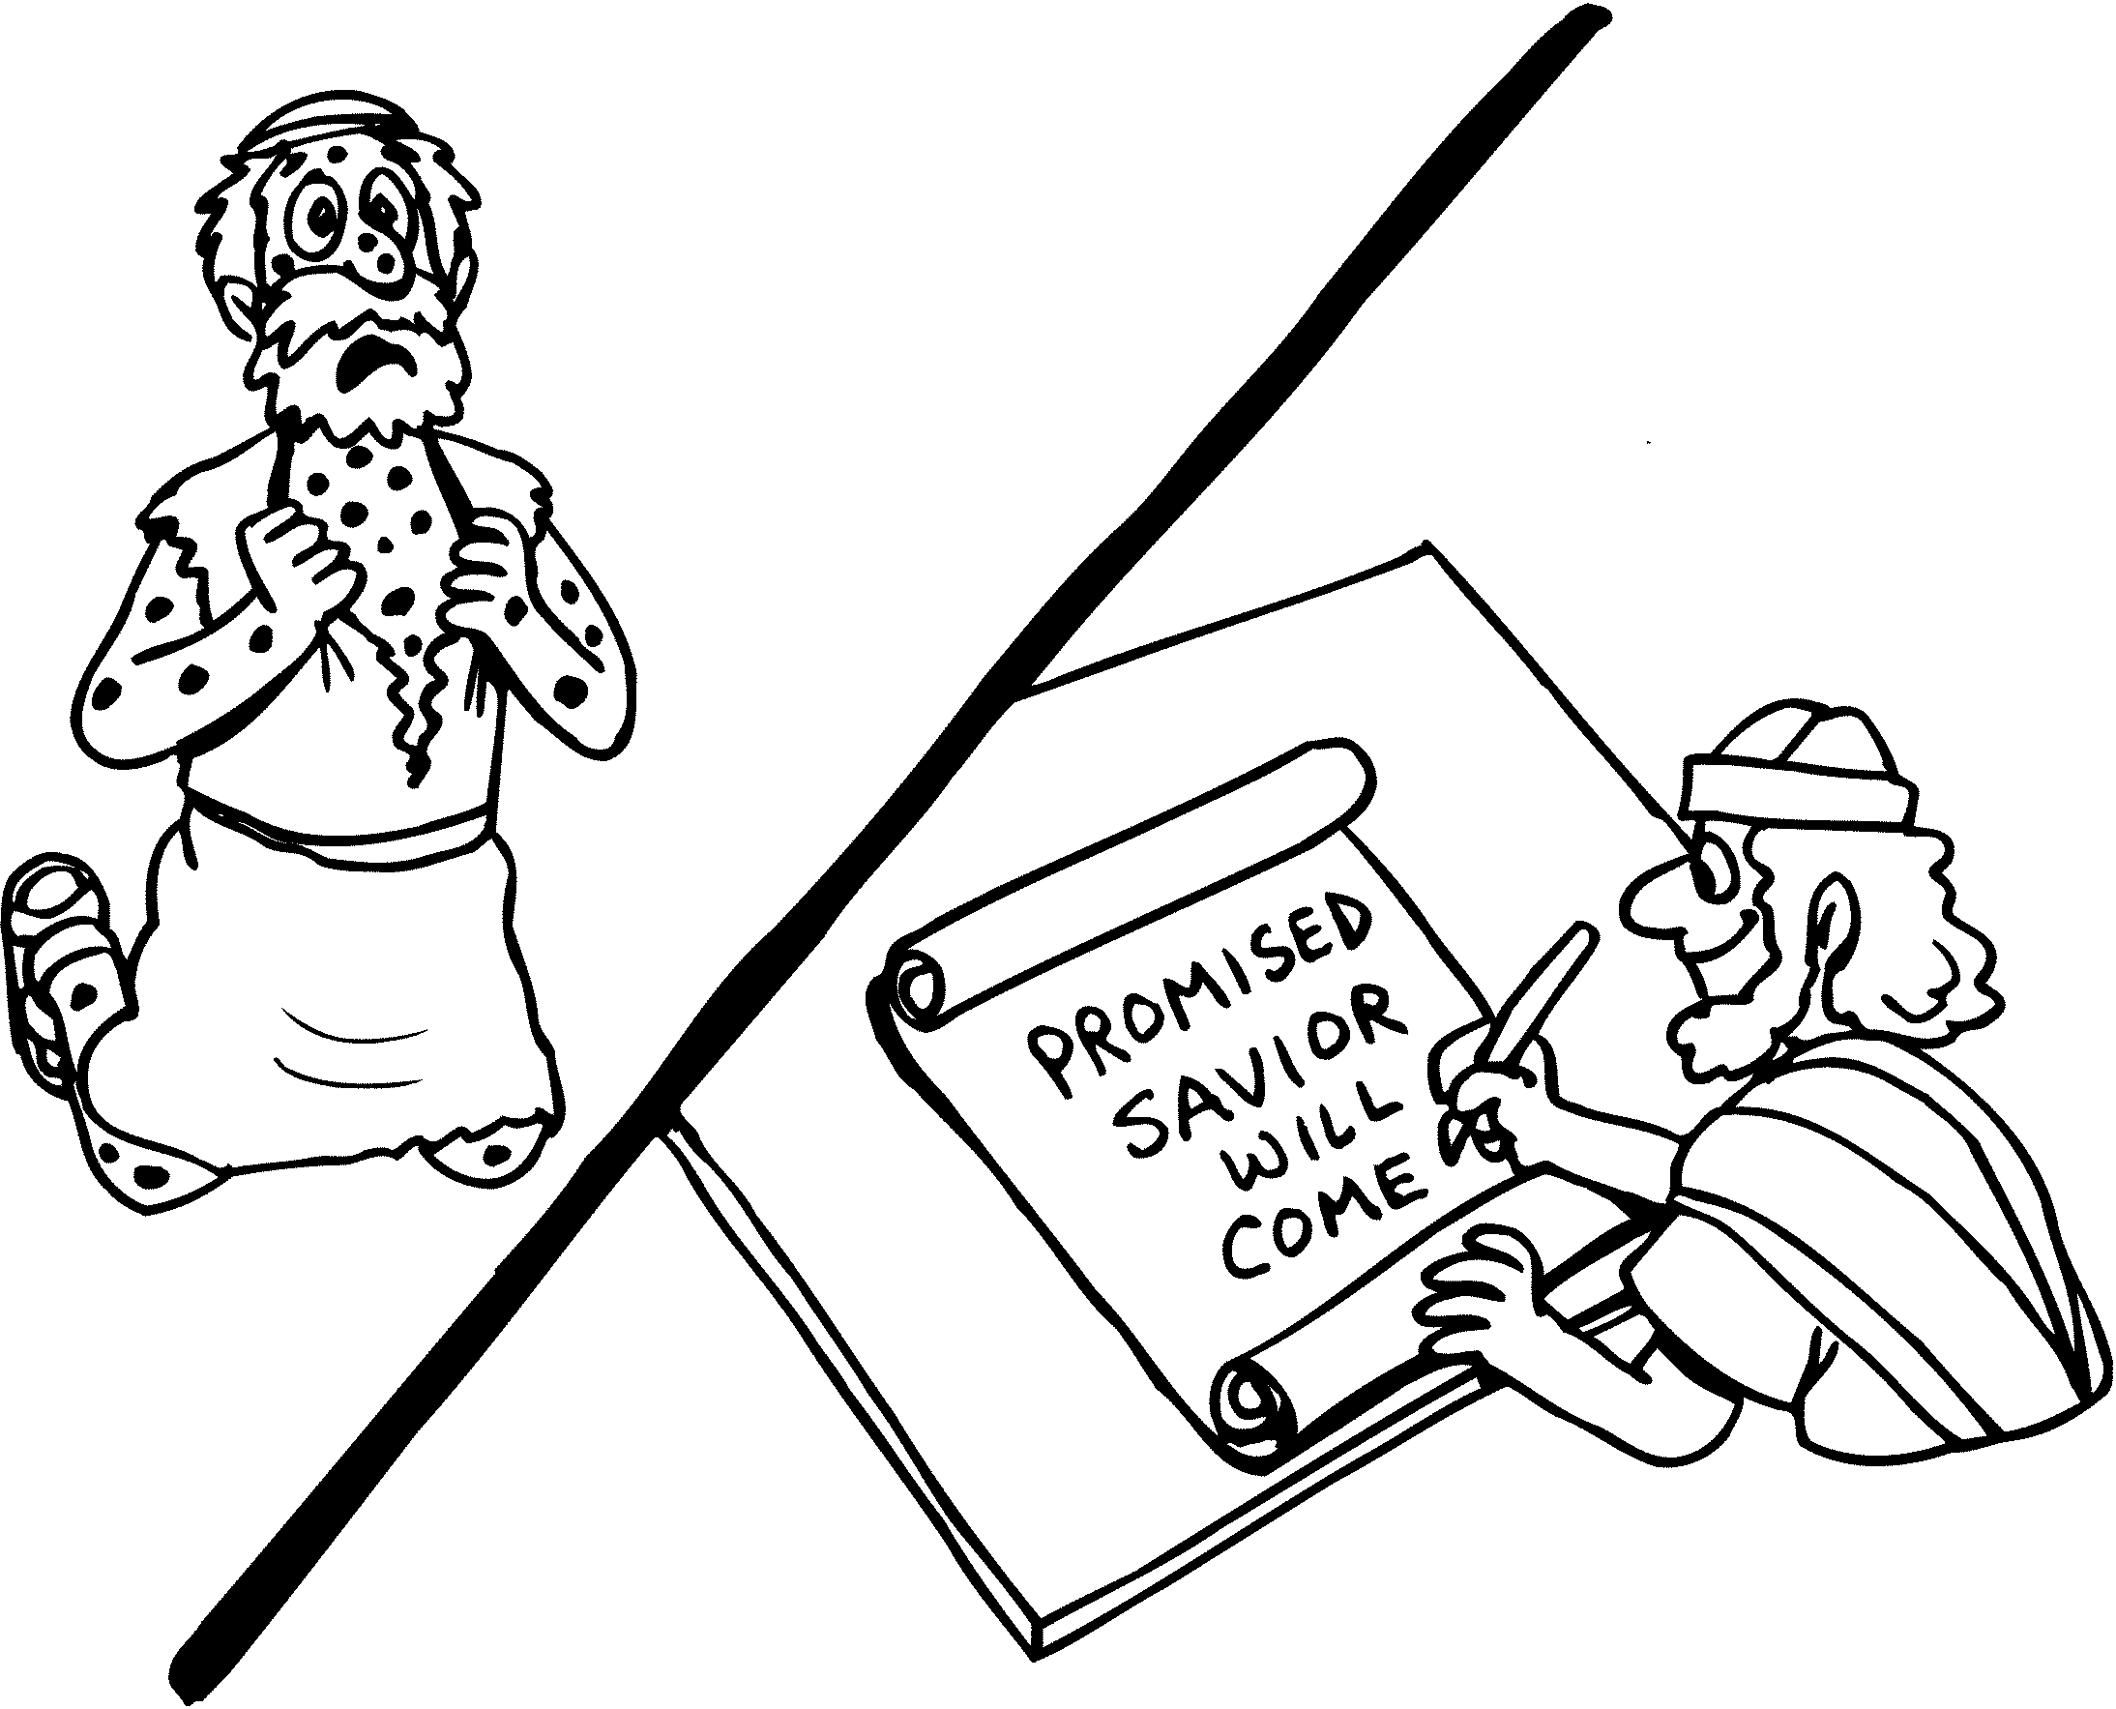

__________________________________________________
POÈTES / PROPHÈTES
EXIL
__________________________________________________
DANIEL
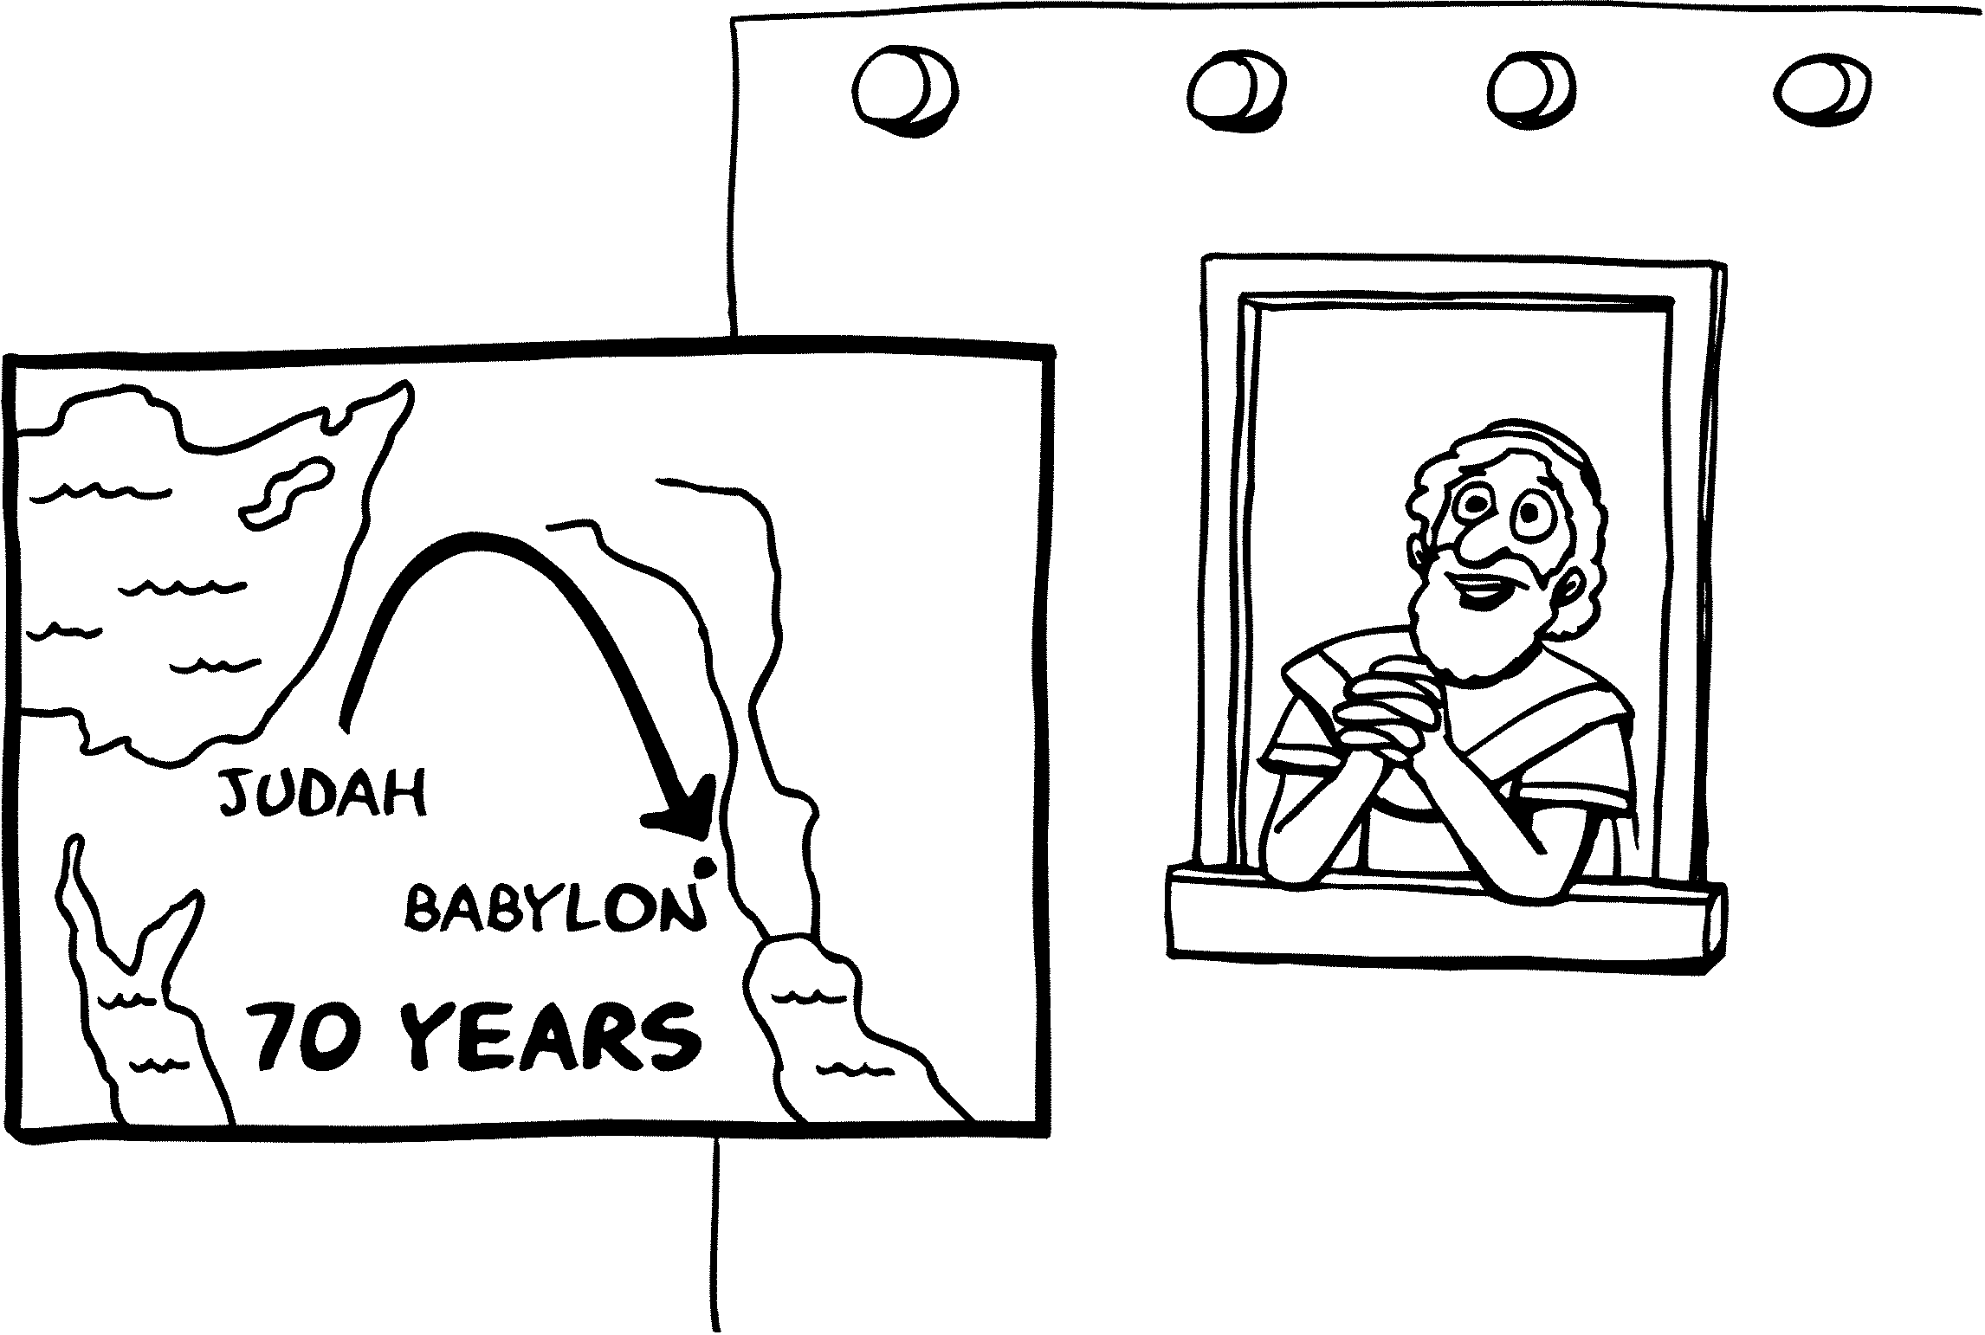

__________________________________________________
INTERCESSEUR
RETOUR
__________________________________________________
ESDRAS
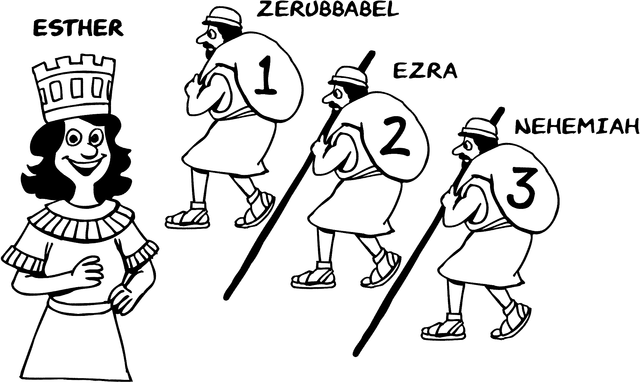

__________________________________________________

PRÉSERVATION

SILENCE
__________________________________________________
HÉRODE
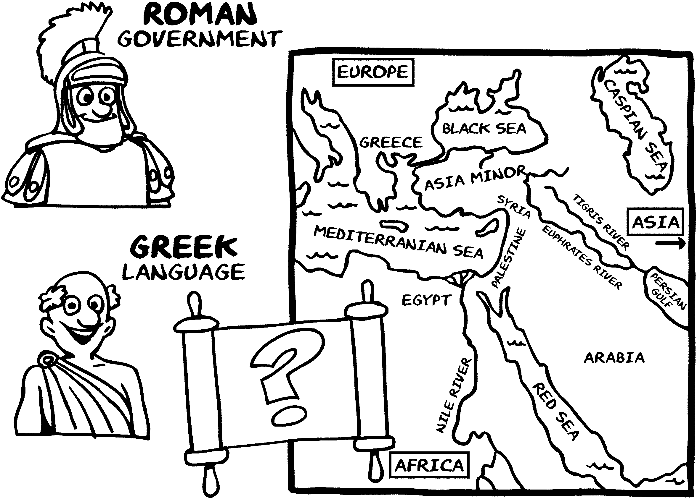

__________________________________________________
PRÉPARATION

ÉVANGILE
__________________________________________________
JÉSUS
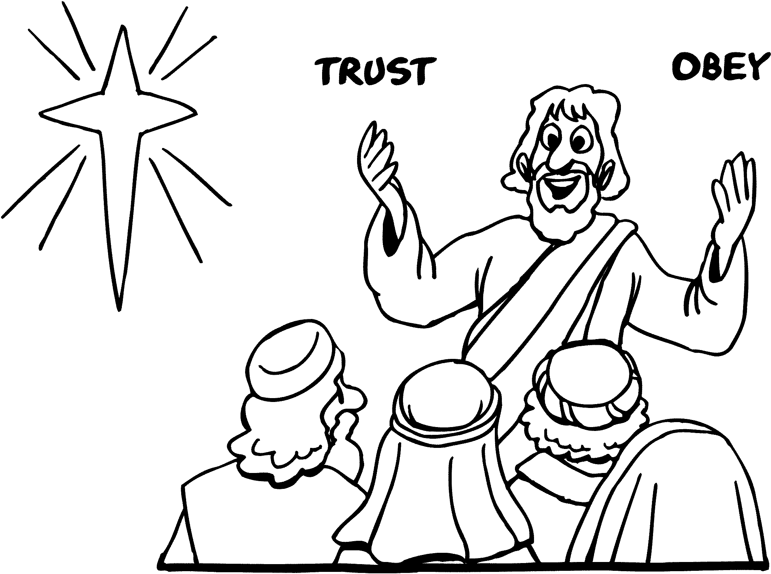

__________________________________________________
PROPHÉTIES - VÉRITÉ
ÉVANGILE
__________________________________________________
JÉSUS
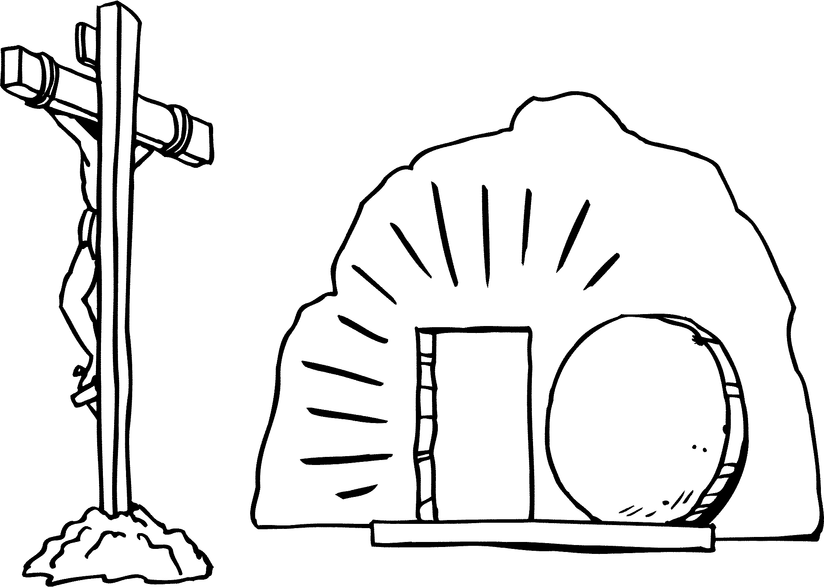

__________________________________________________
SAUVEUR PROMIS (3)
ÉGLISE
__________________________________________________
PIERRE/PAUL
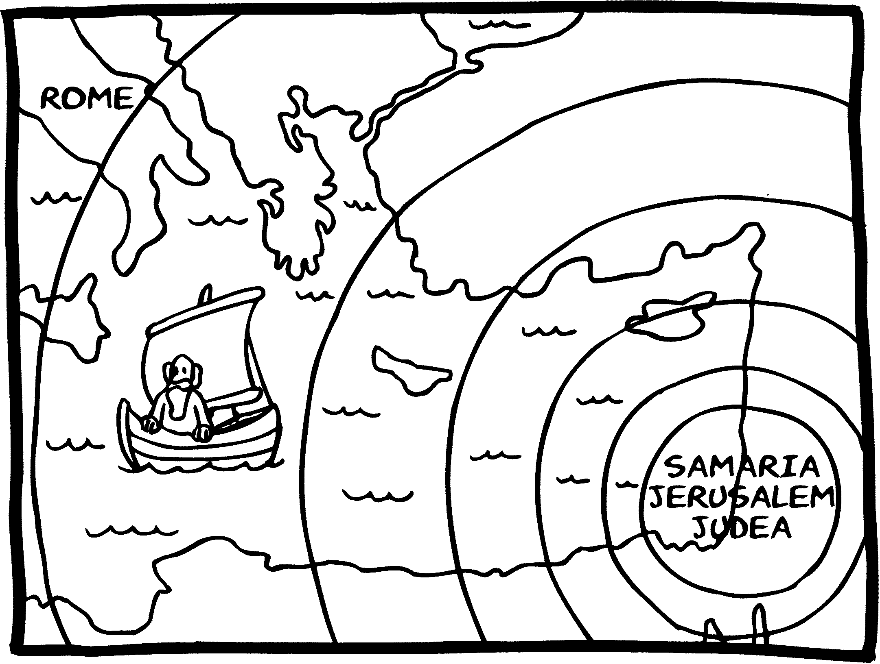

__________________________________________________
PROCLAMATION
MISSIONS
__________________________________________________
PAUL
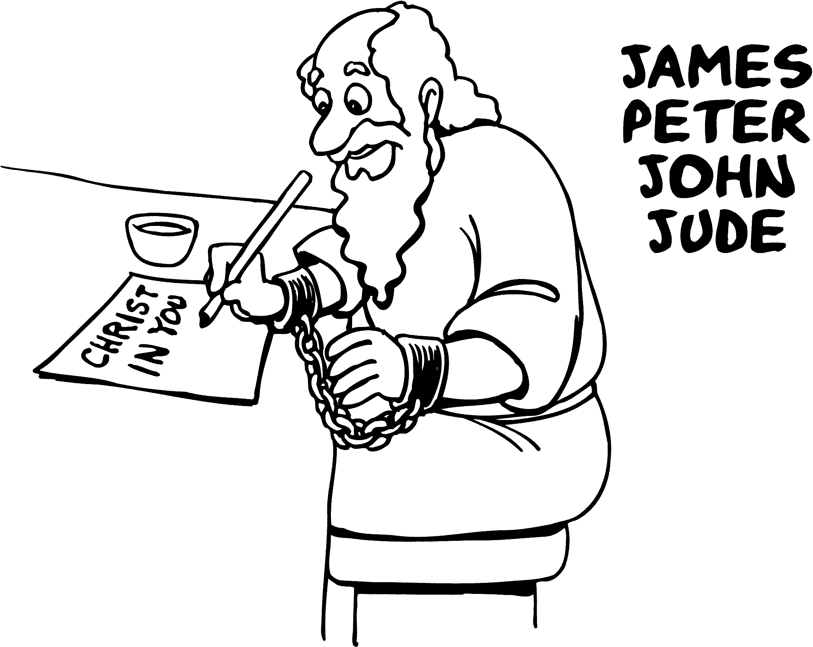

__________________________________________________
POSITION / BUT

MARIAGE
__________________________________________________
DIEU TOI
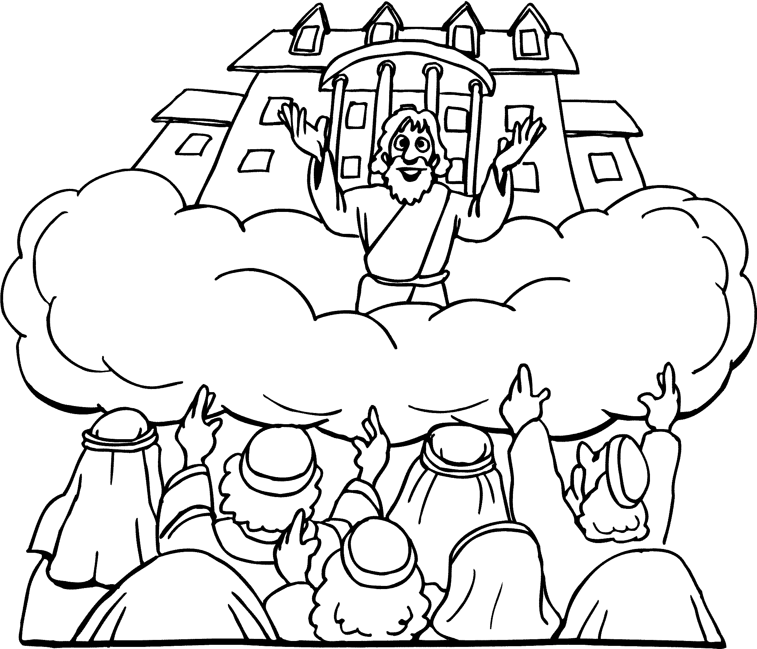

__

_______________________________________________
PARADIS

