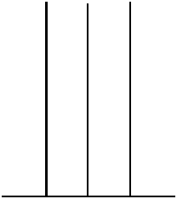
0 |  |  |  |  |  |  |  |  |  | 10

