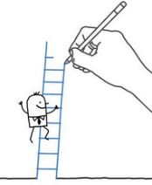Mon échelle de mots

ami

 Un mot par semaine…

ami

ami

Ami

mini

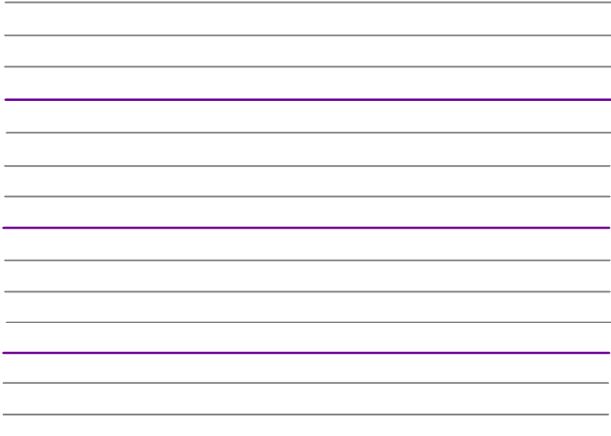__________

ami

année

 ami

mai

mari

|  |  |  |  |  |  |
| --- | --- | --- | --- | --- | --- |
| B | R | T | U | O | A |
| S | A | M | I | F | D |
| M | N | V | C | O | U |
| J | I | R | E | A | B |
| L | K | A | T | G | H |



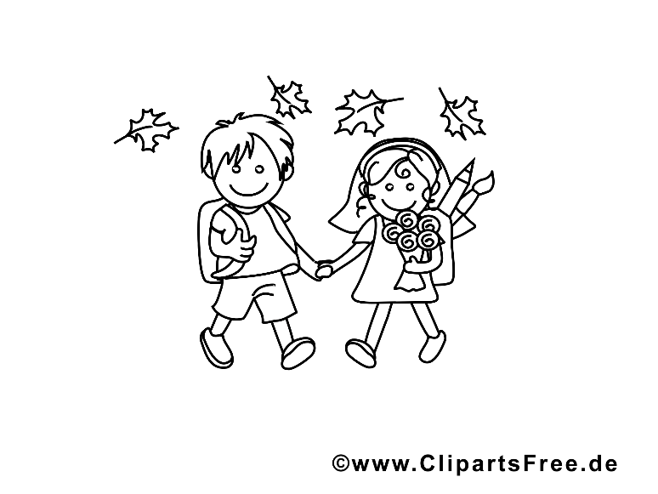

Sarah et Tom sont amis.

________________

|  |  |  |  |  |  |
| --- | --- | --- | --- | --- | --- |
| sont | Amis. | Sarah | Tom | et | Image associée |