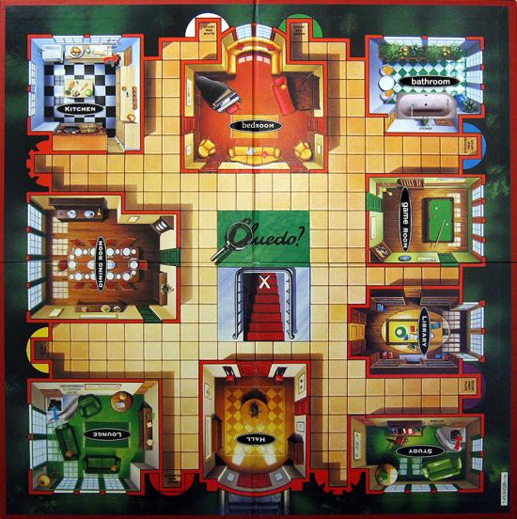

**Let’s play cluedo**

**(parties jouées entre**

**deux classes)**

**grille de jeu**

|  |  |  |  |  |
| --- | --- | --- | --- | --- |
|  |  |  |  |  |
|  |  |  |  |  |

|  |  |  |  |  |  |
| --- | --- | --- | --- | --- | --- |
|  |  |  |  |  |  |
|  |  |  |  |  |  |

