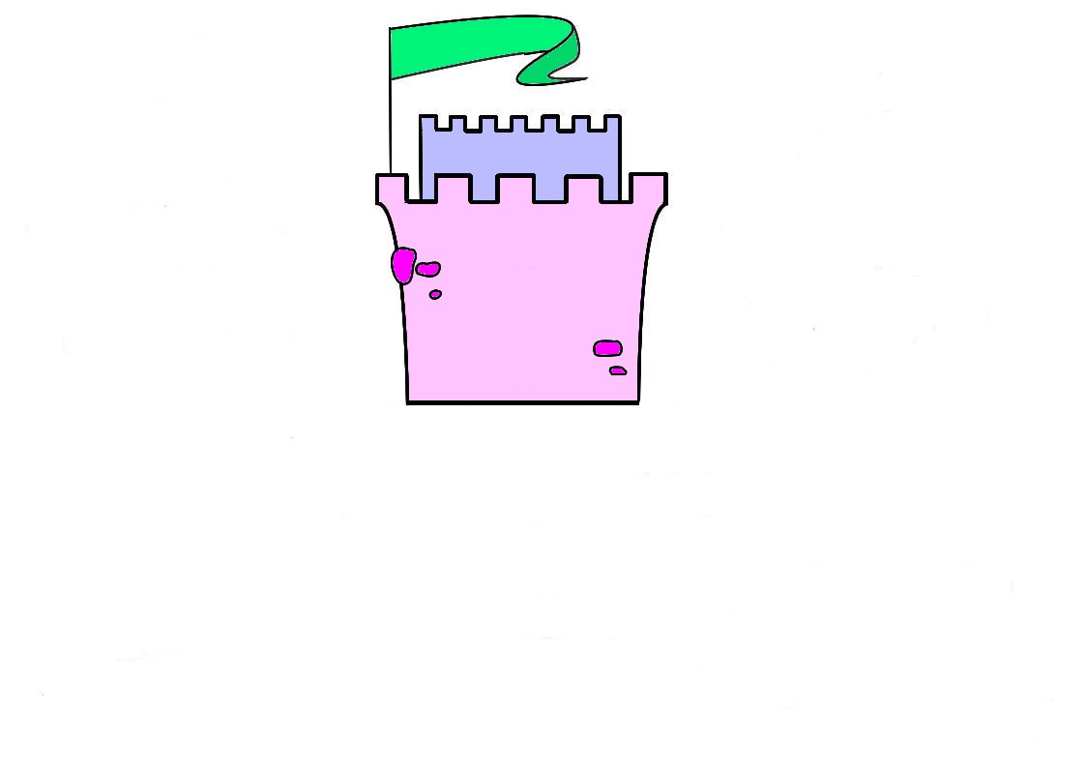

|  |
| --- |
|  |
| Jade |
| Vincent |
| Sacha |
| Jahel |

**Le château des p’tits services**

|  |
| --- |
| Coralie |
| Nolan |
| Léa |
| Nathan |
| Nora |
| Osanne |
| Irina |
| Laeyna |
| Lou-Ann |
| Nathan |
| Anaïs |
| Lambert |
| Julia |

|  |
| --- |
| Lucas |
| Elona |
| Julien |
| Wissem |
| Kylian |
| Chahinez |
| Quentin |
|  |
|  |
|  |
|  |

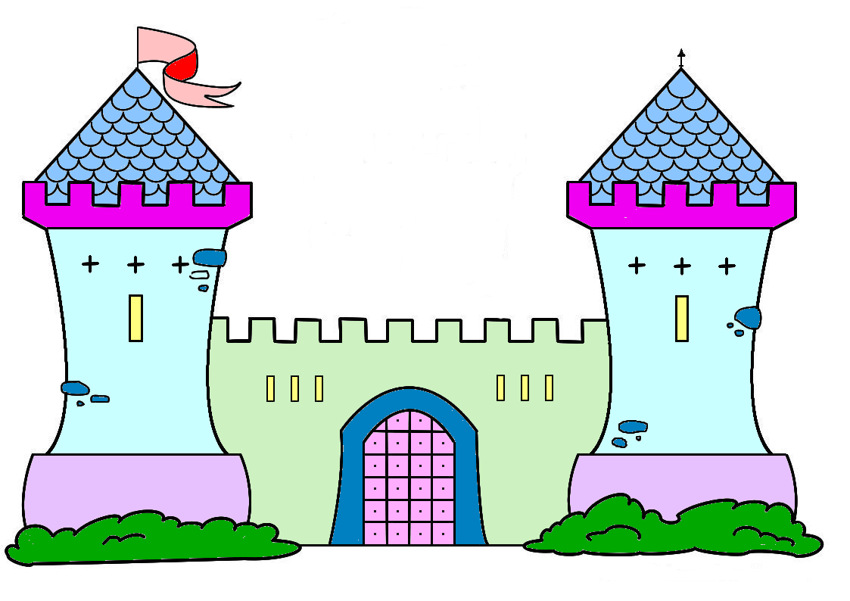

|  |
| --- |
|  |

Etiquettes à coller sur des pinces à linge

|  |  |  |  |
| --- | --- | --- | --- |
| Girl Classroom Calendar Job date School Kid Calendar Classroom Job | Girl Classroom Calendar Job date School Kid Calendar Classroom Job | Boy Boy Classroom Weather Jobmétéo Classroom Weather Job | Boy Boy Classroom Weather Jobmétéo Classroom Weather Job |
| Girl Line Leaderchef de rang | Girl Line Leaderchef de rang | Boy Classroom Sweeper propreté Girl Girl Classroom Trash Helper | Boy Classroom Sweeper propreté Girl Girl Classroom Trash Helper |
| Girl Girl Classroom Paper Collector matériel Boy Supply Monitor | Girl Girl Classroom Paper Collector matériel Boy Supply Monitor | Classroom Errand Runner facteur Girl Classroom Errand Runner | Classroom Errand Runner facteur Girl Classroom Errand Runner |
| Boy Door Holder porte Door Holder Classroom Job | Boy Door Holder porte Door Holder Classroom Job | Line Counter appel | Line Counter appel |