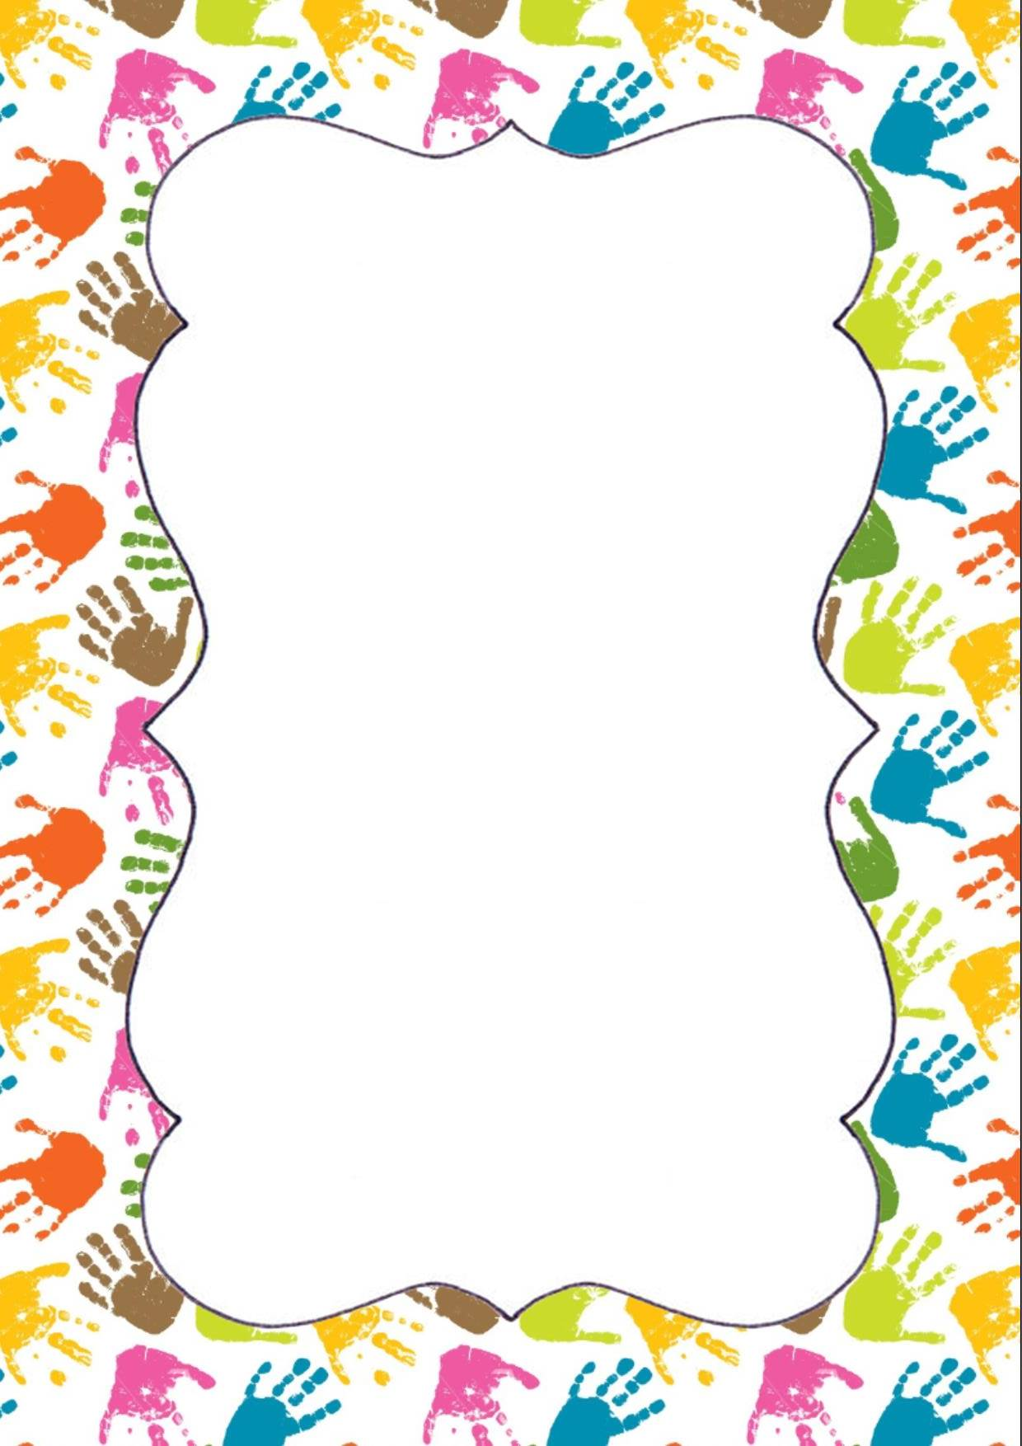  Noé  Pochette documents | Mathias B  Pochette documents | Jawed  Pochette documents | Soukaïna  Pochette documents
Yéléna  Pochette documents | Kylian  Pochette documents | Lisandro  Pochette documents | Malely  Pochette documents
Thomas G  Pochette documents  Angie  Pochette documents |  | Lucas  Pochette documents | Célia  Pochette documents

Lenzo  Pochette documents | Matias MP  Pochette documents | Margaux  Pochette documents | Elie  Pochette documents
Louise  Pochette documents |  | Méline  Pochette documents | Nolan  Pochette documents | Carla  Pochette documents
Thomas S  Pochette documents |  | Timéo  Pochette documents | Noa  Pochette documents | Jean-Baptiste  Pochette documents

