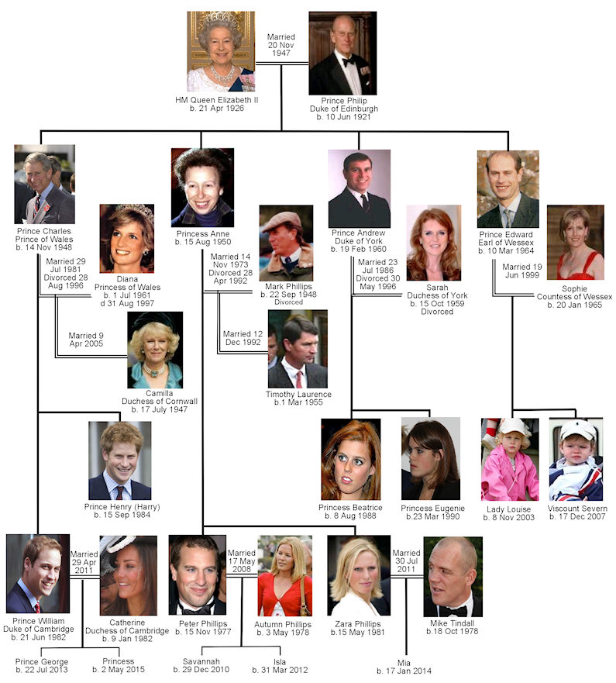

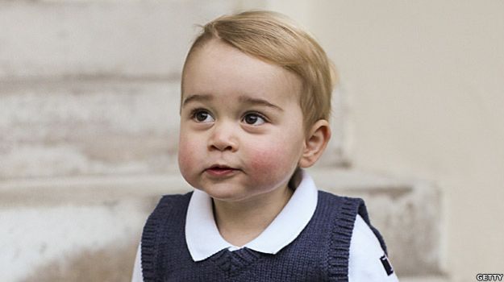  PRINCE GEORGE OF CAMBRIDGE  Born 22 July, 2013 | 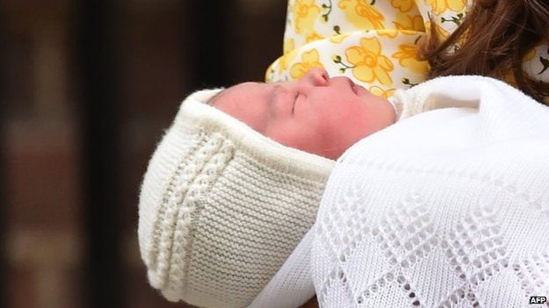  PRINCESS  Born MAY 2^{nd,} 2015 | 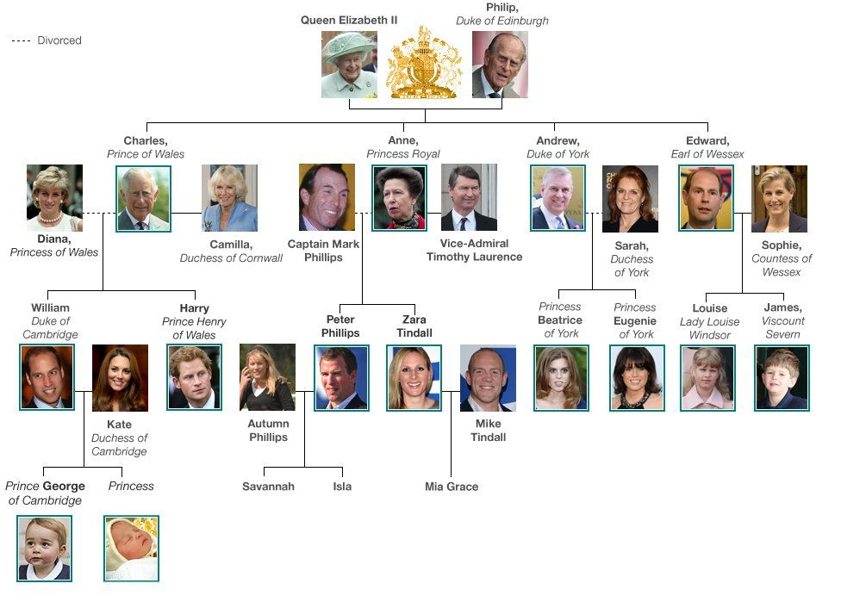
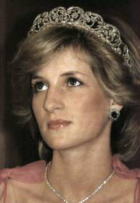  DIANA, PRINCESS OF WALES  1961-1996 | 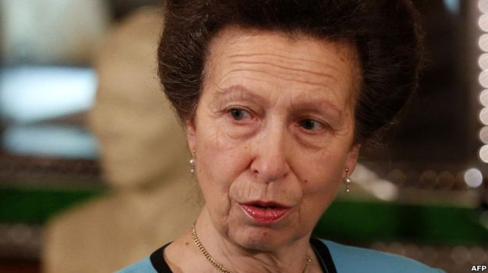  ANNE, PRINCESS ROYAL

