Porte-vues sciences histoire géographie





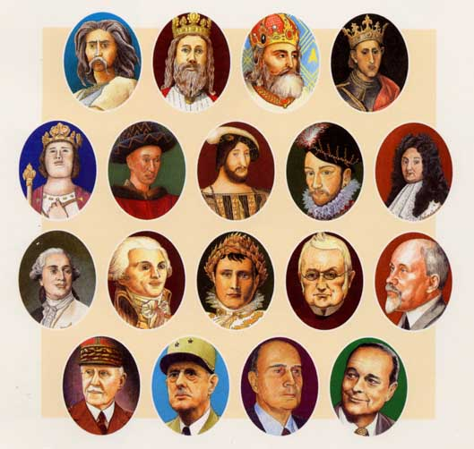

SCIENCES HISTOIRE GEOGRAPHIE

_______________________________________________________________________________________________________________________________________________________________________________________________________________________________________________________________________________________________________________________________________________________________________________________________________________________________________________________________________________________________________________________________________________________________________________________________________________________________________________________________________________________________________________________________________________________________________________________________________________________________________________________________________________________________________________________________________________________________________________________________________________________________________________________________

_______________________________________________________________________________________________________________________________________________________________________________________________________________________________________________________________________________________________________________________________________________________________________________________________________________________________________________________________________________________________________________________________________________________________________________________________________________________________________________________________________________________________________________________________________________________________________________________________________________________________________________________________________________________________________________________________________________________________________________________________________________________________________________________________

_______________________________________________________________________________________________________________________________________________________________________________________________________________________________________________________________________________________________________________________________________________________________________________________________________________________________________________________________________________________________________________________________________________________________________________________________________________________________________________________________________________________________________________________________________________________________________________________________________________________________________________________________________________________________________________________________________________________________________________________________________________________________________________________________