Prénom : …………………………. Date (in english) :………………………………….…..(1point) Note : ………………/10

EVALUATION D’ANGLAIS – CM1 – février 2009
Connaître le vocabulaire de position (prépositions) | A | B | C
COMPREHENSION DE L ORAL

Exercice 1 : Dessine ce que l’on te dicte au bon endroit (6 points)
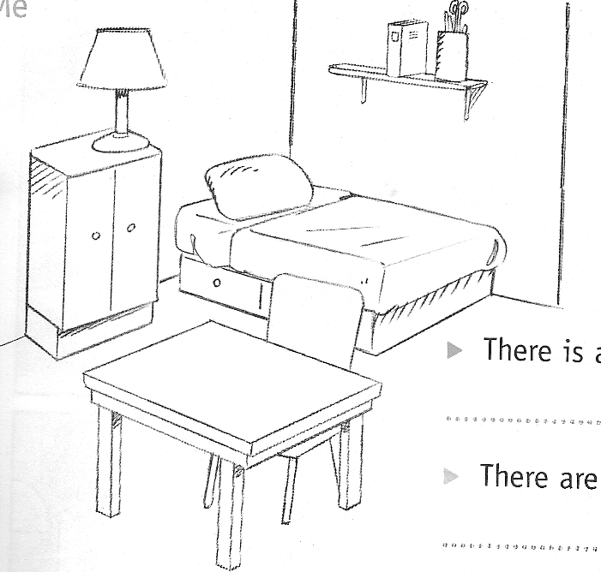
vocabulaire : / 3
Prépositions : /2
Couleurs : / 1

COMPREHENSION DE L ECRIT
Connaitre le nom des pièces de la maison | A | B | C
Exercice 1 : Draw the bubbles. (3,5 points)

There are fifteen bubbles in the living-room. There are seven bubbles in the kitchen.
There is one bubble in the bedroom. There are eleven bubbles in the bathroom.
There are four bubbles in the garage. There are eight bubbles in the dining-room.
There is no bubble in the toilet.

EXPRESSION ECRITE
Savoir employer there is / there are | A | B | C

Leçon : Quand utilise-t-on there is ? there are ? (0,5 points)
…………………………………………………………………………………………………………………………

Exercice 1 : Complete with « there is » or « there are ». (6 points)
………………………… bubbles in the bathroom.
…………………………………… pencils in the pot.
 …………………………… a star in the Christmas tree.
……………………………… three dogs in the garden.
…………………………… a cat in the living-room.
……………………………… a car in the garage.

Exercice 2 : Réponds aux questions( 3,5 points)
Écrire des phrases avec there is / there are | A | B | C
A box


  1. | Where is the ball ?

  2. | Where is the ball ?

  3. | Where is the ball ?

  4. | Where is the ball ?

  5. | Where is the ball ?

  6. | Where is the ball ?

