Le nombre 11

**Colorie**

**Colorie**

**Ecris le nombre en chiffres**

 

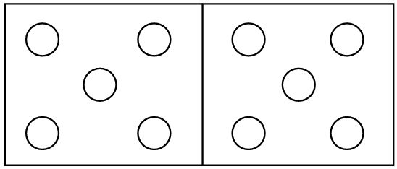





**Ecris le nombre en lettres**

**Entoure le nombre**

|  |  |  |  |  |  |  |  |  |  |  |  |  |  |  |  |  |  |  |  |  |
| --- | --- | --- | --- | --- | --- | --- | --- | --- | --- | --- | --- | --- | --- | --- | --- | --- | --- | --- | --- | --- |
| 1 | 2 | 3 | 4 | 5 | 6 | 7 | 8 | 9 | 10 | 11 | 12 | 13 | 14 | 15 | 16 | 17 | 18 | 19 | 20 | 21 |

@p.hugerot

Le nombre 11





**1100**

@p.hugerot