[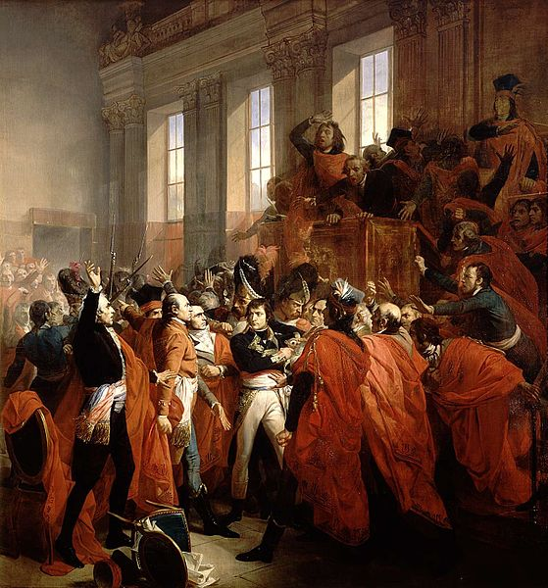](http://upload.wikimedia.org/wikipedia/commons/4/44/Bouchot_-_Le_general_Bonaparte_au_Conseil_des_Cinq-Cents.jpg)