teN Little Indians

One little, two little, three little Indians
Four little, five little, six little Indians
Seven little, eight little, nine little Indians
Ten little Indian boys.

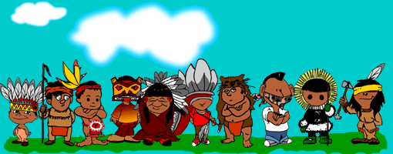

teN Little Indians

One little, two little, three little Indians
Four little, five little, six little Indians
Seven little, eight little, nine little Indians
Ten little Indian boys.

