Fichier de géométrie et de réinvestissement

* Prénom : ______________________

**Dans ce fichier, tu trouveras :**

* Des activités de géométrie : tracés à la règle et reproduction sur quadrillage
* Des petits jeux de numération et de calcul.
* Des coloriages magiques qui te permettront de t’entrainer à poser des additions, et à calculer mentalement.

**Tu peux réaliser les activités dans l’ordre que tu veux.**

Les activités de géométrie : reproductions sur quadrillage

|  |  |  |  |  |  |  |  |  |  |  |  |  |  |  |  |  |  |  |  |  |
| --- | --- | --- | --- | --- | --- | --- | --- | --- | --- | --- | --- | --- | --- | --- | --- | --- | --- | --- | --- | --- |
|  |  |  |  |  |  |  |  |  |  |  |  |  |  |  |  |  |  |  |  |  |
|  |  |  |  |  |  |  |  |  |  |  |  |  |  |  |  |  |  |  |  |  |
|  |  |  |  |  |  |  |  |  |  |  |  |  |  |  |  |  |  |  |  |  |
|  |  |  |  |  |  |  |  |  |  |  |  |  |  |  |  |  |  |  |  |  |
|  |  |  |  |  |  |  |  |  |  |  |  |  |  |  |  |  |  |  |  |  |
|  |  |  |  |  |  |  |  |  |  |  |  |  |  |  |  |  |  |  |  |  |
|  |  |  |  |  |  |  |  |  |  |  |  |  |  |  |  |  |  |  |  |  |
|  |  |  |  |  |  |  |  |  |  |  |  |  |  |  |  |  |  |  |  |  |

|  |  |  |  |  |  |  |  |  |  |  |  |  |  |  |  |  |  |  |  |  |
| --- | --- | --- | --- | --- | --- | --- | --- | --- | --- | --- | --- | --- | --- | --- | --- | --- | --- | --- | --- | --- |
|  |  |  |  |  |  |  |  |  |  |  |  |  |  |  |  |  |  |  |  |  |
|  |  |  |  |  |  |  |  |  |  |  |  |  |  |  |  |  |  |  |  |  |
|  |  |  |  |  |  |  |  |  |  |  |  |  |  |  |  |  |  |  |  |  |
|  |  |  |  |  |  |  |  |  |  |  |  |  |  |  |  |  |  |  |  |  |
|  |  |  |  |  |  |  |  |  |  |  |  |  |  |  |  |  |  |  |  |  |
|  |  |  |  |  |  |  |  |  |  |  |  |  |  |  |  |  |  |  |  |  |
|  |  |  |  |  |  |  |  |  |  |  |  |  |  |  |  |  |  |  |  |  |
|  |  |  |  |  |  |  |  |  |  |  |  |  |  |  |  |  |  |  |  |  |

|  |  |  |  |  |  |  |  |  |  |  |  |  |  |  |  |  |  |  |  |  |
| --- | --- | --- | --- | --- | --- | --- | --- | --- | --- | --- | --- | --- | --- | --- | --- | --- | --- | --- | --- | --- |
|  |  |  |  |  |  |  |  |  |  |  |  |  |  |  |  |  |  |  |  |  |
|  |  |  |  |  |  |  |  |  |  |  |  |  |  |  |  |  |  |  |  |  |
|  |  |  |  |  |  |  |  |  |  |  |  |  |  |  |  |  |  |  |  |  |
|  |  |  |  |  |  |  |  |  |  |  |  |  |  |  |  |  |  |  |  |  |
|  |  |  |  |  |  |  |  |  |  |  |  |  |  |  |  |  |  |  |  |  |
|  |  |  |  |  |  |  |  |  |  |  |  |  |  |  |  |  |  |  |  |  |
|  |  |  |  |  |  |  |  |  |  |  |  |  |  |  |  |  |  |  |  |  |
|  |  |  |  |  |  |  |  |  |  |  |  |  |  |  |  |  |  |  |  |  |

Les activités de géométrie : reproductions sur quadrillage

|  |  |  |  |  |  |  |  |  |  |  |  |  |  |  |  |  |  |  |  |  |
| --- | --- | --- | --- | --- | --- | --- | --- | --- | --- | --- | --- | --- | --- | --- | --- | --- | --- | --- | --- | --- |
|  |  |  |  |  |  |  |  |  |  |  |  |  |  |  |  |  |  |  |  |  |
|  |  |  |  |  |  |  |  |  |  |  |  |  |  |  |  |  |  |  |  |  |
|  |  |  |  |  |  |  |  |  |  |  |  |  |  |  |  |  |  |  |  |  |
|  |  |  |  |  |  |  |  |  |  |  |  |  |  |  |  |  |  |  |  |  |
|  |  |  |  |  |  |  |  |  |  |  |  |  |  |  |  |  |  |  |  |  |
|  |  |  |  |  |  |  |  |  |  |  |  |  |  |  |  |  |  |  |  |  |
|  |  |  |  |  |  |  |  |  |  |  |  |  |  |  |  |  |  |  |  |  |
|  |  |  |  |  |  |  |  |  |  |  |  |  |  |  |  |  |  |  |  |  |

|  |  |  |  |  |  |  |  |  |  |  |  |  |  |  |  |  |  |  |  |  |
| --- | --- | --- | --- | --- | --- | --- | --- | --- | --- | --- | --- | --- | --- | --- | --- | --- | --- | --- | --- | --- |
|  |  |  |  |  |  |  |  |  |  |  |  |  |  |  |  |  |  |  |  |  |
|  |  |  |  |  |  |  |  |  |  |  |  |  |  |  |  |  |  |  |  |  |
|  |  |  |  |  |  |  |  |  |  |  |  |  |  |  |  |  |  |  |  |  |
|  |  |  |  |  |  |  |  |  |  |  |  |  |  |  |  |  |  |  |  |  |
|  |  |  |  |  |  |  |  |  |  |  |  |  |  |  |  |  |  |  |  |  |
|  |  |  |  |  |  |  |  |  |  |  |  |  |  |  |  |  |  |  |  |  |
|  |  |  |  |  |  |  |  |  |  |  |  |  |  |  |  |  |  |  |  |  |
|  |  |  |  |  |  |  |  |  |  |  |  |  |  |  |  |  |  |  |  |  |

|  |  |  |  |  |  |  |  |  |  |  |  |  |  |  |  |  |  |  |  |  |
| --- | --- | --- | --- | --- | --- | --- | --- | --- | --- | --- | --- | --- | --- | --- | --- | --- | --- | --- | --- | --- |
|  |  |  |  |  |  |  |  |  |  |  |  |  |  |  |  |  |  |  |  |  |
|  |  |  |  |  |  |  |  |  |  |  |  |  |  |  |  |  |  |  |  |  |
|  |  |  |  |  |  |  |  |  |  |  |  |  |  |  |  |  |  |  |  |  |
|  |  |  |  |  |  |  |  |  |  |  |  |  |  |  |  |  |  |  |  |  |
|  |  |  |  |  |  |  |  |  |  |  |  |  |  |  |  |  |  |  |  |  |
|  |  |  |  |  |  |  |  |  |  |  |  |  |  |  |  |  |  |  |  |  |
|  |  |  |  |  |  |  |  |  |  |  |  |  |  |  |  |  |  |  |  |  |
|  |  |  |  |  |  |  |  |  |  |  |  |  |  |  |  |  |  |  |  |  |

Les activités de géométrie : reproductions sur quadrillage

|  |  |  |  |  |  |  |  |  |  |  |  |  |  |  |  |  |  |  |  |  |
| --- | --- | --- | --- | --- | --- | --- | --- | --- | --- | --- | --- | --- | --- | --- | --- | --- | --- | --- | --- | --- |
|  |  |  |  |  |  |  |  |  |  |  |  |  |  |  |  |  |  |  |  |  |
|  |  |  |  |  |  |  |  |  |  |  |  |  |  |  |  |  |  |  |  |  |
|  |  |  |  |  |  |  |  |  |  |  |  |  |  |  |  |  |  |  |  |  |
|  |  |  |  |  |  |  |  |  |  |  |  |  |  |  |  |  |  |  |  |  |
|  |  |  |  |  |  |  |  |  |  |  |  |  |  |  |  |  |  |  |  |  |
|  |  |  |  |  |  |  |  |  |  |  |  |  |  |  |  |  |  |  |  |  |
|  |  |  |  |  |  |  |  |  |  |  |  |  |  |  |  |  |  |  |  |  |
|  |  |  |  |  |  |  |  |  |  |  |  |  |  |  |  |  |  |  |  |  |

|  |  |  |  |  |  |  |  |  |  |  |  |  |  |  |  |  |  |  |  |  |
| --- | --- | --- | --- | --- | --- | --- | --- | --- | --- | --- | --- | --- | --- | --- | --- | --- | --- | --- | --- | --- |
|  |  |  |  |  |  |  |  |  |  |  |  |  |  |  |  |  |  |  |  |  |
|  |  |  |  |  |  |  |  |  |  |  |  |  |  |  |  |  |  |  |  |  |
|  |  |  |  |  |  |  |  |  |  |  |  |  |  |  |  |  |  |  |  |  |
|  |  |  |  |  |  |  |  |  |  |  |  |  |  |  |  |  |  |  |  |  |
|  |  |  |  |  |  |  |  |  |  |  |  |  |  |  |  |  |  |  |  |  |
|  |  |  |  |  |  |  |  |  |  |  |  |  |  |  |  |  |  |  |  |  |
|  |  |  |  |  |  |  |  |  |  |  |  |  |  |  |  |  |  |  |  |  |
|  |  |  |  |  |  |  |  |  |  |  |  |  |  |  |  |  |  |  |  |  |

|  |  |  |  |  |  |  |  |  |  |  |  |  |  |  |  |  |  |  |  |  |
| --- | --- | --- | --- | --- | --- | --- | --- | --- | --- | --- | --- | --- | --- | --- | --- | --- | --- | --- | --- | --- |
|  |  |  |  |  |  |  |  |  |  |  |  |  |  |  |  |  |  |  |  |  |
|  |  |  |  |  |  |  |  |  |  |  |  |  |  |  |  |  |  |  |  |  |
|  |  |  |  |  |  |  |  |  |  |  |  |  |  |  |  |  |  |  |  |  |
|  |  |  |  |  |  |  |  |  |  |  |  |  |  |  |  |  |  |  |  |  |
|  |  |  |  |  |  |  |  |  |  |  |  |  |  |  |  |  |  |  |  |  |
|  |  |  |  |  |  |  |  |  |  |  |  |  |  |  |  |  |  |  |  |  |
|  |  |  |  |  |  |  |  |  |  |  |  |  |  |  |  |  |  |  |  |  |
|  |  |  |  |  |  |  |  |  |  |  |  |  |  |  |  |  |  |  |  |  |

Les activités de géométrie : reproductions sur quadrillage

|  |  |  |  |  |  |  |  |  |  |  |  |  |  |  |  |  |  |  |  |  |
| --- | --- | --- | --- | --- | --- | --- | --- | --- | --- | --- | --- | --- | --- | --- | --- | --- | --- | --- | --- | --- |
|  |  |  |  |  |  |  |  |  |  |  |  |  |  |  |  |  |  |  |  |  |
|  |  |  |  |  |  |  |  |  |  |  |  |  |  |  |  |  |  |  |  |  |
|  |  |  |  |  |  |  |  |  |  |  |  |  |  |  |  |  |  |  |  |  |
|  |  |  |  |  |  |  |  |  |  |  |  |  |  |  |  |  |  |  |  |  |
|  |  |  |  |  |  |  |  |  |  |  |  |  |  |  |  |  |  |  |  |  |
|  |  |  |  |  |  |  |  |  |  |  |  |  |  |  |  |  |  |  |  |  |
|  |  |  |  |  |  |  |  |  |  |  |  |  |  |  |  |  |  |  |  |  |
|  |  |  |  |  |  |  |  |  |  |  |  |  |  |  |  |  |  |  |  |  |

|  |  |  |  |  |  |  |  |  |  |  |  |  |  |  |  |  |  |  |  |  |
| --- | --- | --- | --- | --- | --- | --- | --- | --- | --- | --- | --- | --- | --- | --- | --- | --- | --- | --- | --- | --- |
|  |  |  |  |  |  |  |  |  |  |  |  |  |  |  |  |  |  |  |  |  |
|  |  |  |  |  |  |  |  |  |  |  |  |  |  |  |  |  |  |  |  |  |
|  |  |  |  |  |  |  |  |  |  |  |  |  |  |  |  |  |  |  |  |  |
|  |  |  |  |  |  |  |  |  |  |  |  |  |  |  |  |  |  |  |  |  |
|  |  |  |  |  |  |  |  |  |  |  |  |  |  |  |  |  |  |  |  |  |
|  |  |  |  |  |  |  |  |  |  |  |  |  |  |  |  |  |  |  |  |  |
|  |  |  |  |  |  |  |  |  |  |  |  |  |  |  |  |  |  |  |  |  |
|  |  |  |  |  |  |  |  |  |  |  |  |  |  |  |  |  |  |  |  |  |

|  |  |  |  |  |  |  |  |  |  |  |  |  |  |  |  |  |  |  |  |  |
| --- | --- | --- | --- | --- | --- | --- | --- | --- | --- | --- | --- | --- | --- | --- | --- | --- | --- | --- | --- | --- |
|  |  |  |  |  |  |  |  |  |  |  |  |  |  |  |  |  |  |  |  |  |
|  |  |  |  |  |  |  |  |  |  |  |  |  |  |  |  |  |  |  |  |  |
|  |  |  |  |  |  |  |  |  |  |  |  |  |  |  |  |  |  |  |  |  |
|  |  |  |  |  |  |  |  |  |  |  |  |  |  |  |  |  |  |  |  |  |
|  |  |  |  |  |  |  |  |  |  |  |  |  |  |  |  |  |  |  |  |  |
|  |  |  |  |  |  |  |  |  |  |  |  |  |  |  |  |  |  |  |  |  |
|  |  |  |  |  |  |  |  |  |  |  |  |  |  |  |  |  |  |  |  |  |
|  |  |  |  |  |  |  |  |  |  |  |  |  |  |  |  |  |  |  |  |  |

Les activités de géométrie : reproductions sur quadrillage

|  |  |  |  |  |  |  |  |  |  |  |  |  |  |  |  |  |  |  |  |  |
| --- | --- | --- | --- | --- | --- | --- | --- | --- | --- | --- | --- | --- | --- | --- | --- | --- | --- | --- | --- | --- |
|  |  |  |  |  |  |  |  |  |  |  |  |  |  |  |  |  |  |  |  |  |
|  |  |  |  |  |  |  |  |  |  |  |  |  |  |  |  |  |  |  |  |  |
|  |  |  |  |  |  |  |  |  |  |  |  |  |  |  |  |  |  |  |  |  |
|  |  |  |  |  |  |  |  |  |  |  |  |  |  |  |  |  |  |  |  |  |
|  |  |  |  |  |  |  |  |  |  |  |  |  |  |  |  |  |  |  |  |  |
|  |  |  |  |  |  |  |  |  |  |  |  |  |  |  |  |  |  |  |  |  |
|  |  |  |  |  |  |  |  |  |  |  |  |  |  |  |  |  |  |  |  |  |
|  |  |  |  |  |  |  |  |  |  |  |  |  |  |  |  |  |  |  |  |  |

|  |  |  |  |  |  |  |  |  |  |  |  |  |  |  |  |  |  |  |  |  |
| --- | --- | --- | --- | --- | --- | --- | --- | --- | --- | --- | --- | --- | --- | --- | --- | --- | --- | --- | --- | --- |
|  |  |  |  |  |  |  |  |  |  |  |  |  |  |  |  |  |  |  |  |  |
|  |  |  |  |  |  |  |  |  |  |  |  |  |  |  |  |  |  |  |  |  |
|  |  |  |  |  |  |  |  |  |  |  |  |  |  |  |  |  |  |  |  |  |
|  |  |  |  |  |  |  |  |  |  |  |  |  |  |  |  |  |  |  |  |  |
|  |  |  |  |  |  |  |  |  |  |  |  |  |  |  |  |  |  |  |  |  |
|  |  |  |  |  |  |  |  |  |  |  |  |  |  |  |  |  |  |  |  |  |
|  |  |  |  |  |  |  |  |  |  |  |  |  |  |  |  |  |  |  |  |  |
|  |  |  |  |  |  |  |  |  |  |  |  |  |  |  |  |  |  |  |  |  |

|  |  |  |  |  |  |  |  |  |  |  |  |  |  |  |  |  |  |  |  |  |
| --- | --- | --- | --- | --- | --- | --- | --- | --- | --- | --- | --- | --- | --- | --- | --- | --- | --- | --- | --- | --- |
|  |  |  |  |  |  |  |  |  |  |  |  |  |  |  |  |  |  |  |  |  |
|  |  |  |  |  |  |  |  |  |  |  |  |  |  |  |  |  |  |  |  |  |
|  |  |  |  |  |  |  |  |  |  |  |  |  |  |  |  |  |  |  |  |  |
|  |  |  |  |  |  |  |  |  |  |  |  |  |  |  |  |  |  |  |  |  |
|  |  |  |  |  |  |  |  |  |  |  |  |  |  |  |  |  |  |  |  |  |
|  |  |  |  |  |  |  |  |  |  |  |  |  |  |  |  |  |  |  |  |  |
|  |  |  |  |  |  |  |  |  |  |  |  |  |  |  |  |  |  |  |  |  |
|  |  |  |  |  |  |  |  |  |  |  |  |  |  |  |  |  |  |  |  |  |

Les activités de géométrie : reproductions sur quadrillage

|  |  |  |  |  |  |  |  |  |  |  |  |  |  |  |  |  |  |  |  |  |
| --- | --- | --- | --- | --- | --- | --- | --- | --- | --- | --- | --- | --- | --- | --- | --- | --- | --- | --- | --- | --- |
|  |  |  |  |  |  |  |  |  |  |  |  |  |  |  |  |  |  |  |  |  |
|  |  |  |  |  |  |  |  |  |  |  |  |  |  |  |  |  |  |  |  |  |
|  |  |  |  |  |  |  |  |  |  |  |  |  |  |  |  |  |  |  |  |  |
|  |  |  |  |  |  |  |  |  |  |  |  |  |  |  |  |  |  |  |  |  |
|  |  |  |  |  |  |  |  |  |  |  |  |  |  |  |  |  |  |  |  |  |
|  |  |  |  |  |  |  |  |  |  |  |  |  |  |  |  |  |  |  |  |  |
|  |  |  |  |  |  |  |  |  |  |  |  |  |  |  |  |  |  |  |  |  |
|  |  |  |  |  |  |  |  |  |  |  |  |  |  |  |  |  |  |  |  |  |

|  |  |  |  |  |  |  |  |  |  |  |  |  |  |  |  |  |  |  |  |  |
| --- | --- | --- | --- | --- | --- | --- | --- | --- | --- | --- | --- | --- | --- | --- | --- | --- | --- | --- | --- | --- |
|  |  |  |  |  |  |  |  |  |  |  |  |  |  |  |  |  |  |  |  |  |
|  |  |  |  |  |  |  |  |  |  |  |  |  |  |  |  |  |  |  |  |  |
|  |  |  |  |  |  |  |  |  |  |  |  |  |  |  |  |  |  |  |  |  |
|  |  |  |  |  |  |  |  |  |  |  |  |  |  |  |  |  |  |  |  |  |
|  |  |  |  |  |  |  |  |  |  |  |  |  |  |  |  |  |  |  |  |  |
|  |  |  |  |  |  |  |  |  |  |  |  |  |  |  |  |  |  |  |  |  |
|  |  |  |  |  |  |  |  |  |  |  |  |  |  |  |  |  |  |  |  |  |
|  |  |  |  |  |  |  |  |  |  |  |  |  |  |  |  |  |  |  |  |  |

|  |  |  |  |  |  |  |  |  |  |  |  |  |  |  |  |  |  |  |  |  |
| --- | --- | --- | --- | --- | --- | --- | --- | --- | --- | --- | --- | --- | --- | --- | --- | --- | --- | --- | --- | --- |
|  |  |  |  |  |  |  |  |  |  |  |  |  |  |  |  |  |  |  |  |  |
|  |  |  |  |  |  |  |  |  |  |  |  |  |  |  |  |  |  |  |  |  |
|  |  |  |  |  |  |  |  |  |  |  |  |  |  |  |  |  |  |  |  |  |
|  |  |  |  |  |  |  |  |  |  |  |  |  |  |  |  |  |  |  |  |  |
|  |  |  |  |  |  |  |  |  |  |  |  |  |  |  |  |  |  |  |  |  |
|  |  |  |  |  |  |  |  |  |  |  |  |  |  |  |  |  |  |  |  |  |
|  |  |  |  |  |  |  |  |  |  |  |  |  |  |  |  |  |  |  |  |  |
|  |  |  |  |  |  |  |  |  |  |  |  |  |  |  |  |  |  |  |  |  |

Les activités de géométrie : reproductions sur quadrillage

|  |  |  |  |  |  |  |  |  |  |  |  |  |  |  |  |  |  |  |  |  |
| --- | --- | --- | --- | --- | --- | --- | --- | --- | --- | --- | --- | --- | --- | --- | --- | --- | --- | --- | --- | --- |
|  |  |  |  |  |  |  |  |  |  |  |  |  |  |  |  |  |  |  |  |  |
|  |  |  |  |  |  |  |  |  |  |  |  |  |  |  |  |  |  |  |  |  |
|  |  |  |  |  |  |  |  |  |  |  |  |  |  |  |  |  |  |  |  |  |
|  |  |  |  |  |  |  |  |  |  |  |  |  |  |  |  |  |  |  |  |  |
|  |  |  |  |  |  |  |  |  |  |  |  |  |  |  |  |  |  |  |  |  |
|  |  |  |  |  |  |  |  |  |  |  |  |  |  |  |  |  |  |  |  |  |
|  |  |  |  |  |  |  |  |  |  |  |  |  |  |  |  |  |  |  |  |  |
|  |  |  |  |  |  |  |  |  |  |  |  |  |  |  |  |  |  |  |  |  |

|  |  |  |  |  |  |  |  |  |  |  |  |  |  |  |  |  |  |  |  |  |
| --- | --- | --- | --- | --- | --- | --- | --- | --- | --- | --- | --- | --- | --- | --- | --- | --- | --- | --- | --- | --- |
|  |  |  |  |  |  |  |  |  |  |  |  |  |  |  |  |  |  |  |  |  |
|  |  |  |  |  |  |  |  |  |  |  |  |  |  |  |  |  |  |  |  |  |
|  |  |  |  |  |  |  |  |  |  |  |  |  |  |  |  |  |  |  |  |  |
|  |  |  |  |  |  |  |  |  |  |  |  |  |  |  |  |  |  |  |  |  |
|  |  |  |  |  |  |  |  |  |  |  |  |  |  |  |  |  |  |  |  |  |
|  |  |  |  |  |  |  |  |  |  |  |  |  |  |  |  |  |  |  |  |  |
|  |  |  |  |  |  |  |  |  |  |  |  |  |  |  |  |  |  |  |  |  |
|  |  |  |  |  |  |  |  |  |  |  |  |  |  |  |  |  |  |  |  |  |

|  |  |  |  |  |  |  |  |  |  |  |  |  |  |  |  |  |  |  |  |  |
| --- | --- | --- | --- | --- | --- | --- | --- | --- | --- | --- | --- | --- | --- | --- | --- | --- | --- | --- | --- | --- |
|  |  |  |  |  |  |  |  |  |  |  |  |  |  |  |  |  |  |  |  |  |
|  |  |  |  |  |  |  |  |  |  |  |  |  |  |  |  |  |  |  |  |  |
|  |  |  |  |  |  |  |  |  |  |  |  |  |  |  |  |  |  |  |  |  |
|  |  |  |  |  |  |  |  |  |  |  |  |  |  |  |  |  |  |  |  |  |
|  |  |  |  |  |  |  |  |  |  |  |  |  |  |  |  |  |  |  |  |  |
|  |  |  |  |  |  |  |  |  |  |  |  |  |  |  |  |  |  |  |  |  |
|  |  |  |  |  |  |  |  |  |  |  |  |  |  |  |  |  |  |  |  |  |
|  |  |  |  |  |  |  |  |  |  |  |  |  |  |  |  |  |  |  |  |  |

Les activités de géométrie : reproductions sur quadrillage

|  |  |  |  |  |  |  |  |  |  |  |  |  |  |  |  |  |  |  |  |  |
| --- | --- | --- | --- | --- | --- | --- | --- | --- | --- | --- | --- | --- | --- | --- | --- | --- | --- | --- | --- | --- |
|  |  |  |  |  |  |  |  |  |  |  |  |  |  |  |  |  |  |  |  |  |
|  |  |  |  |  |  |  |  |  |  |  |  |  |  |  |  |  |  |  |  |  |
|  |  |  |  |  |  |  |  |  |  |  |  |  |  |  |  |  |  |  |  |  |
|  |  |  |  |  |  |  |  |  |  |  |  |  |  |  |  |  |  |  |  |  |
|  |  |  |  |  |  |  |  |  |  |  |  |  |  |  |  |  |  |  |  |  |
|  |  |  |  |  |  |  |  |  |  |  |  |  |  |  |  |  |  |  |  |  |
|  |  |  |  |  |  |  |  |  |  |  |  |  |  |  |  |  |  |  |  |  |
|  |  |  |  |  |  |  |  |  |  |  |  |  |  |  |  |  |  |  |  |  |

|  |  |  |  |  |  |  |  |  |  |  |  |  |  |  |  |  |  |  |  |  |
| --- | --- | --- | --- | --- | --- | --- | --- | --- | --- | --- | --- | --- | --- | --- | --- | --- | --- | --- | --- | --- |
|  |  |  |  |  |  |  |  |  |  |  |  |  |  |  |  |  |  |  |  |  |
|  |  |  |  |  |  |  |  |  |  |  |  |  |  |  |  |  |  |  |  |  |
|  |  |  |  |  |  |  |  |  |  |  |  |  |  |  |  |  |  |  |  |  |
|  |  |  |  |  |  |  |  |  |  |  |  |  |  |  |  |  |  |  |  |  |
|  |  |  |  |  |  |  |  |  |  |  |  |  |  |  |  |  |  |  |  |  |
|  |  |  |  |  |  |  |  |  |  |  |  |  |  |  |  |  |  |  |  |  |
|  |  |  |  |  |  |  |  |  |  |  |  |  |  |  |  |  |  |  |  |  |
|  |  |  |  |  |  |  |  |  |  |  |  |  |  |  |  |  |  |  |  |  |

Les activités de géométrie : reproductions sur quadrillage

|  |  |  |  |  |  |  |  |  |  |  |  |  |  |  |  |  |  |  |  |  |
| --- | --- | --- | --- | --- | --- | --- | --- | --- | --- | --- | --- | --- | --- | --- | --- | --- | --- | --- | --- | --- |
|  |  |  |  |  |  |  |  |  |  |  |  |  |  |  |  |  |  |  |  |  |
|  |  |  |  |  |  |  |  |  |  |  |  |  |  |  |  |  |  |  |  |  |
|  |  |  |  |  |  |  |  |  |  |  |  |  |  |  |  |  |  |  |  |  |
|  |  |  |  |  |  |  |  |  |  |  |  |  |  |  |  |  |  |  |  |  |
|  |  |  |  |  |  |  |  |  |  |  |  |  |  |  |  |  |  |  |  |  |
|  |  |  |  |  |  |  |  |  |  |  |  |  |  |  |  |  |  |  |  |  |
|  |  |  |  |  |  |  |  |  |  |  |  |  |  |  |  |  |  |  |  |  |
|  |  |  |  |  |  |  |  |  |  |  |  |  |  |  |  |  |  |  |  |  |

|  |  |  |  |  |  |  |  |  |  |  |  |  |  |  |  |  |  |  |  |  |
| --- | --- | --- | --- | --- | --- | --- | --- | --- | --- | --- | --- | --- | --- | --- | --- | --- | --- | --- | --- | --- |
|  |  |  |  |  |  |  |  |  |  |  |  |  |  |  |  |  |  |  |  |  |
|  |  |  |  |  |  |  |  |  |  |  |  |  |  |  |  |  |  |  |  |  |
|  |  |  |  |  |  |  |  |  |  |  |  |  |  |  |  |  |  |  |  |  |
|  |  |  |  |  |  |  |  |  |  |  |  |  |  |  |  |  |  |  |  |  |
|  |  |  |  |  |  |  |  |  |  |  |  |  |  |  |  |  |  |  |  |  |
|  |  |  |  |  |  |  |  |  |  |  |  |  |  |  |  |  |  |  |  |  |
|  |  |  |  |  |  |  |  |  |  |  |  |  |  |  |  |  |  |  |  |  |
|  |  |  |  |  |  |  |  |  |  |  |  |  |  |  |  |  |  |  |  |  |

|  |  |  |  |  |  |  |  |  |  |  |  |  |  |  |  |  |  |  |  |  |
| --- | --- | --- | --- | --- | --- | --- | --- | --- | --- | --- | --- | --- | --- | --- | --- | --- | --- | --- | --- | --- |
|  |  |  |  |  |  |  |  |  |  |  |  |  |  |  |  |  |  |  |  |  |
|  |  |  |  |  |  |  |  |  |  |  |  |  |  |  |  |  |  |  |  |  |
|  |  |  |  |  |  |  |  |  |  |  |  |  |  |  |  |  |  |  |  |  |
|  |  |  |  |  |  |  |  |  |  |  |  |  |  |  |  |  |  |  |  |  |
|  |  |  |  |  |  |  |  |  |  |  |  |  |  |  |  |  |  |  |  |  |
|  |  |  |  |  |  |  |  |  |  |  |  |  |  |  |  |  |  |  |  |  |
|  |  |  |  |  |  |  |  |  |  |  |  |  |  |  |  |  |  |  |  |  |
|  |  |  |  |  |  |  |  |  |  |  |  |  |  |  |  |  |  |  |  |  |

|  |  |  |  |  |  |  |  |  |  |  |  |  |  |  |  |  |  |  |  |  |
| --- | --- | --- | --- | --- | --- | --- | --- | --- | --- | --- | --- | --- | --- | --- | --- | --- | --- | --- | --- | --- |
|  |  |  |  |  |  |  |  |  |  |  |  |  |  |  |  |  |  |  |  |  |
|  |  |  |  |  |  |  |  |  |  |  |  |  |  |  |  |  |  |  |  |  |
|  |  |  |  |  |  |  |  |  |  |  |  |  |  |  |  |  |  |  |  |  |
|  |  |  |  |  |  |  |  |  |  |  |  |  |  |  |  |  |  |  |  |  |
|  |  |  |  |  |  |  |  |  |  |  |  |  |  |  |  |  |  |  |  |  |
|  |  |  |  |  |  |  |  |  |  |  |  |  |  |  |  |  |  |  |  |  |
|  |  |  |  |  |  |  |  |  |  |  |  |  |  |  |  |  |  |  |  |  |
|  |  |  |  |  |  |  |  |  |  |  |  |  |  |  |  |  |  |  |  |  |

Les activités de géométrie : reproductions sur quadrillage

|  |  |  |  |  |  |  |  |  |  |  |  |  |  |  |  |  |  |  |  |  |
| --- | --- | --- | --- | --- | --- | --- | --- | --- | --- | --- | --- | --- | --- | --- | --- | --- | --- | --- | --- | --- |
|  |  |  |  |  |  |  |  |  |  |  |  |  |  |  |  |  |  |  |  |  |
|  |  |  |  |  |  |  |  |  |  |  |  |  |  |  |  |  |  |  |  |  |
|  |  |  |  |  |  |  |  |  |  |  |  |  |  |  |  |  |  |  |  |  |
|  |  |  |  |  |  |  |  |  |  |  |  |  |  |  |  |  |  |  |  |  |
|  |  |  |  |  |  |  |  |  |  |  |  |  |  |  |  |  |  |  |  |  |
|  |  |  |  |  |  |  |  |  |  |  |  |  |  |  |  |  |  |  |  |  |
|  |  |  |  |  |  |  |  |  |  |  |  |  |  |  |  |  |  |  |  |  |
|  |  |  |  |  |  |  |  |  |  |  |  |  |  |  |  |  |  |  |  |  |

|  |  |  |  |  |  |  |  |  |  |  |  |  |  |  |  |  |  |  |  |  |
| --- | --- | --- | --- | --- | --- | --- | --- | --- | --- | --- | --- | --- | --- | --- | --- | --- | --- | --- | --- | --- |
|  |  |  |  |  |  |  |  |  |  |  |  |  |  |  |  |  |  |  |  |  |
|  |  |  |  |  |  |  |  |  |  |  |  |  |  |  |  |  |  |  |  |  |
|  |  |  |  |  |  |  |  |  |  |  |  |  |  |  |  |  |  |  |  |  |
|  |  |  |  |  |  |  |  |  |  |  |  |  |  |  |  |  |  |  |  |  |
|  |  |  |  |  |  |  |  |  |  |  |  |  |  |  |  |  |  |  |  |  |
|  |  |  |  |  |  |  |  |  |  |  |  |  |  |  |  |  |  |  |  |  |
|  |  |  |  |  |  |  |  |  |  |  |  |  |  |  |  |  |  |  |  |  |
|  |  |  |  |  |  |  |  |  |  |  |  |  |  |  |  |  |  |  |  |  |

|  |  |  |  |  |  |  |  |  |  |  |  |  |  |  |  |  |  |  |  |  |
| --- | --- | --- | --- | --- | --- | --- | --- | --- | --- | --- | --- | --- | --- | --- | --- | --- | --- | --- | --- | --- |
|  |  |  |  |  |  |  |  |  |  |  |  |  |  |  |  |  |  |  |  |  |
|  |  |  |  |  |  |  |  |  |  |  |  |  |  |  |  |  |  |  |  |  |
|  |  |  |  |  |  |  |  |  |  |  |  |  |  |  |  |  |  |  |  |  |
|  |  |  |  |  |  |  |  |  |  |  |  |  |  |  |  |  |  |  |  |  |
|  |  |  |  |  |  |  |  |  |  |  |  |  |  |  |  |  |  |  |  |  |
|  |  |  |  |  |  |  |  |  |  |  |  |  |  |  |  |  |  |  |  |  |
|  |  |  |  |  |  |  |  |  |  |  |  |  |  |  |  |  |  |  |  |  |
|  |  |  |  |  |  |  |  |  |  |  |  |  |  |  |  |  |  |  |  |  |

|  |  |  |  |  |  |  |  |  |  |  |  |  |  |  |  |  |  |  |  |  |
| --- | --- | --- | --- | --- | --- | --- | --- | --- | --- | --- | --- | --- | --- | --- | --- | --- | --- | --- | --- | --- |
|  |  |  |  |  |  |  |  |  |  |  |  |  |  |  |  |  |  |  |  |  |
|  |  |  |  |  |  |  |  |  |  |  |  |  |  |  |  |  |  |  |  |  |
|  |  |  |  |  |  |  |  |  |  |  |  |  |  |  |  |  |  |  |  |  |
|  |  |  |  |  |  |  |  |  |  |  |  |  |  |  |  |  |  |  |  |  |
|  |  |  |  |  |  |  |  |  |  |  |  |  |  |  |  |  |  |  |  |  |
|  |  |  |  |  |  |  |  |  |  |  |  |  |  |  |  |  |  |  |  |  |
|  |  |  |  |  |  |  |  |  |  |  |  |  |  |  |  |  |  |  |  |  |
|  |  |  |  |  |  |  |  |  |  |  |  |  |  |  |  |  |  |  |  |  |

Les activités de géométrie : reproductions sur quadrillage

|  |  |  |  |  |  |  |  |  |  |  |  |  |  |  |  |  |  |  |  |  |
| --- | --- | --- | --- | --- | --- | --- | --- | --- | --- | --- | --- | --- | --- | --- | --- | --- | --- | --- | --- | --- |
|  |  |  |  |  |  |  |  |  |  |  |  |  |  |  |  |  |  |  |  |  |
|  |  |  |  |  |  |  |  |  |  |  |  |  |  |  |  |  |  |  |  |  |
|  |  |  |  |  |  |  |  |  |  |  |  |  |  |  |  |  |  |  |  |  |
|  |  |  |  |  |  |  |  |  |  |  |  |  |  |  |  |  |  |  |  |  |
|  |  |  |  |  |  |  |  |  |  |  |  |  |  |  |  |  |  |  |  |  |
|  |  |  |  |  |  |  |  |  |  |  |  |  |  |  |  |  |  |  |  |  |
|  |  |  |  |  |  |  |  |  |  |  |  |  |  |  |  |  |  |  |  |  |
|  |  |  |  |  |  |  |  |  |  |  |  |  |  |  |  |  |  |  |  |  |

|  |  |  |  |  |  |  |  |  |  |  |  |  |  |  |  |  |  |  |  |  |
| --- | --- | --- | --- | --- | --- | --- | --- | --- | --- | --- | --- | --- | --- | --- | --- | --- | --- | --- | --- | --- |
|  |  |  |  |  |  |  |  |  |  |  |  |  |  |  |  |  |  |  |  |  |
|  |  |  |  |  |  |  |  |  |  |  |  |  |  |  |  |  |  |  |  |  |
|  |  |  |  |  |  |  |  |  |  |  |  |  |  |  |  |  |  |  |  |  |
|  |  |  |  |  |  |  |  |  |  |  |  |  |  |  |  |  |  |  |  |  |
|  |  |  |  |  |  |  |  |  |  |  |  |  |  |  |  |  |  |  |  |  |
|  |  |  |  |  |  |  |  |  |  |  |  |  |  |  |  |  |  |  |  |  |
|  |  |  |  |  |  |  |  |  |  |  |  |  |  |  |  |  |  |  |  |  |
|  |  |  |  |  |  |  |  |  |  |  |  |  |  |  |  |  |  |  |  |  |

|  |  |  |  |  |  |  |  |  |  |  |  |  |  |  |  |  |  |  |  |  |
| --- | --- | --- | --- | --- | --- | --- | --- | --- | --- | --- | --- | --- | --- | --- | --- | --- | --- | --- | --- | --- |
|  |  |  |  |  |  |  |  |  |  |  |  |  |  |  |  |  |  |  |  |  |
|  |  |  |  |  |  |  |  |  |  |  |  |  |  |  |  |  |  |  |  |  |
|  |  |  |  |  |  |  |  |  |  |  |  |  |  |  |  |  |  |  |  |  |
|  |  |  |  |  |  |  |  |  |  |  |  |  |  |  |  |  |  |  |  |  |
|  |  |  |  |  |  |  |  |  |  |  |  |  |  |  |  |  |  |  |  |  |
|  |  |  |  |  |  |  |  |  |  |  |  |  |  |  |  |  |  |  |  |  |
|  |  |  |  |  |  |  |  |  |  |  |  |  |  |  |  |  |  |  |  |  |
|  |  |  |  |  |  |  |  |  |  |  |  |  |  |  |  |  |  |  |  |  |

|  |  |  |  |  |  |  |  |  |  |  |  |  |  |  |  |  |  |  |  |  |
| --- | --- | --- | --- | --- | --- | --- | --- | --- | --- | --- | --- | --- | --- | --- | --- | --- | --- | --- | --- | --- |
|  |  |  |  |  |  |  |  |  |  |  |  |  |  |  |  |  |  |  |  |  |
|  |  |  |  |  |  |  |  |  |  |  |  |  |  |  |  |  |  |  |  |  |
|  |  |  |  |  |  |  |  |  |  |  |  |  |  |  |  |  |  |  |  |  |
|  |  |  |  |  |  |  |  |  |  |  |  |  |  |  |  |  |  |  |  |  |
|  |  |  |  |  |  |  |  |  |  |  |  |  |  |  |  |  |  |  |  |  |
|  |  |  |  |  |  |  |  |  |  |  |  |  |  |  |  |  |  |  |  |  |
|  |  |  |  |  |  |  |  |  |  |  |  |  |  |  |  |  |  |  |  |  |
|  |  |  |  |  |  |  |  |  |  |  |  |  |  |  |  |  |  |  |  |  |

Les activités de géométrie : tracés à la règle

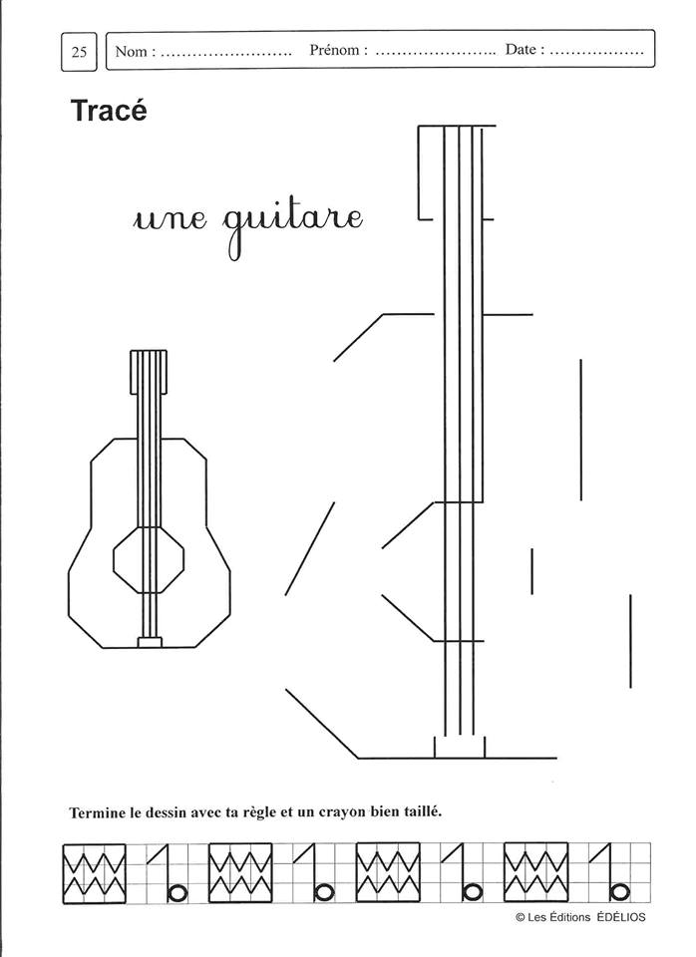

Les activités de géométrie : tracés à la règle

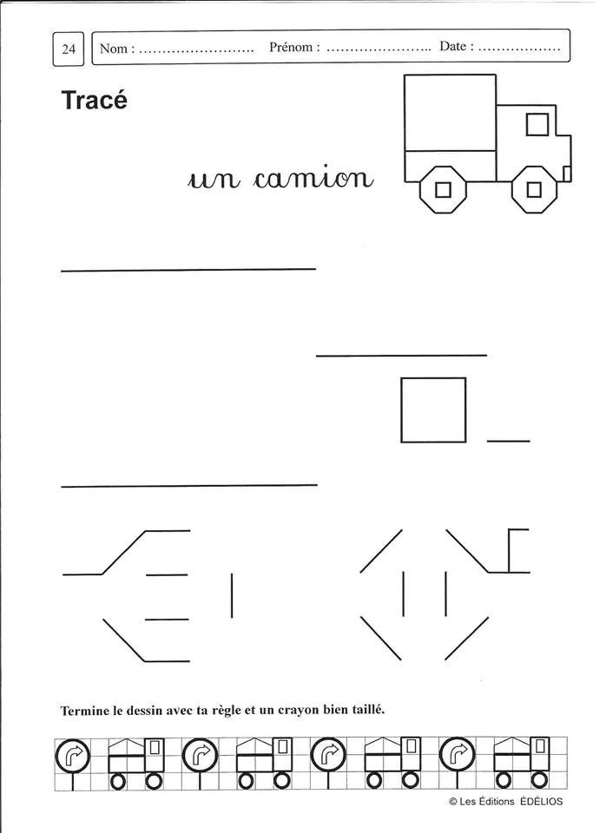

Les activités de géométrie : tracés à la règle

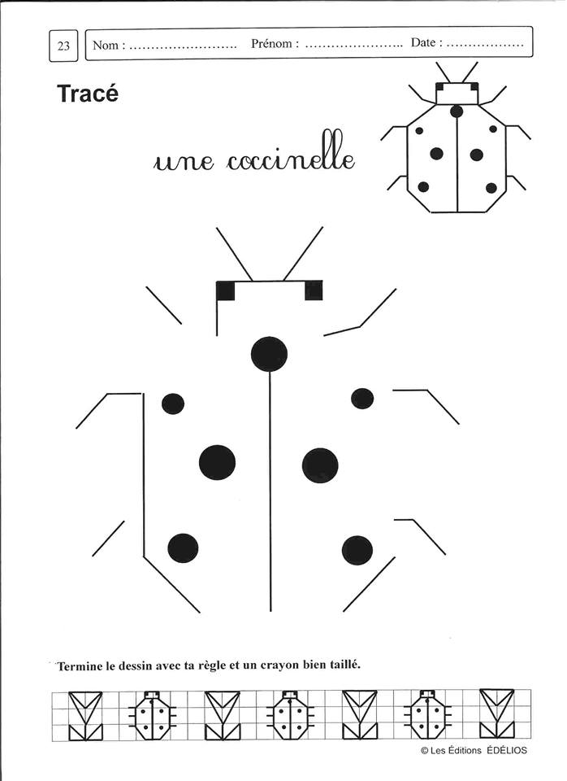

Les activités de géométrie : tracés à la règle

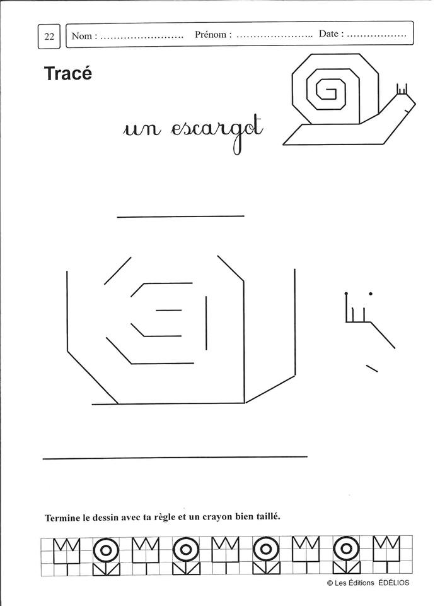

Les activités de géométrie : tracés à la règle

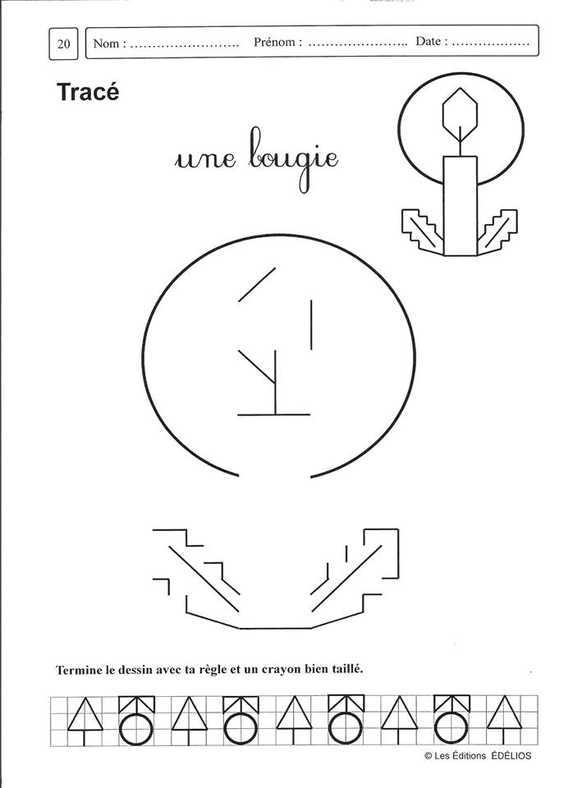

Les activités de géométrie : tracés à la règle

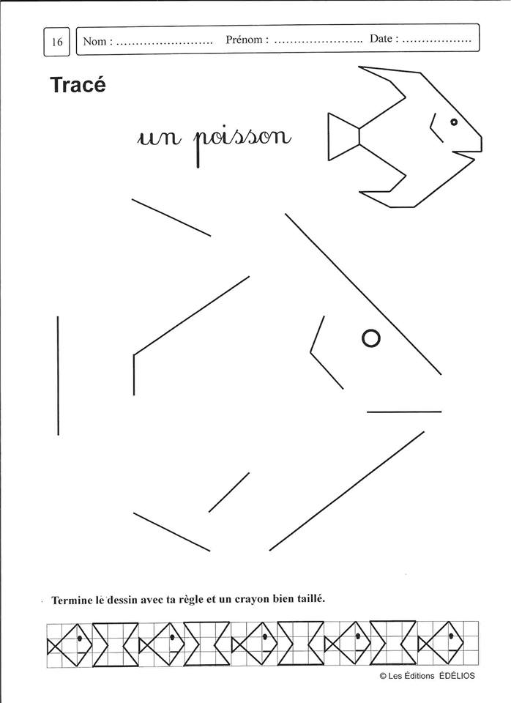

Les activités de géométrie : tracés à la règle

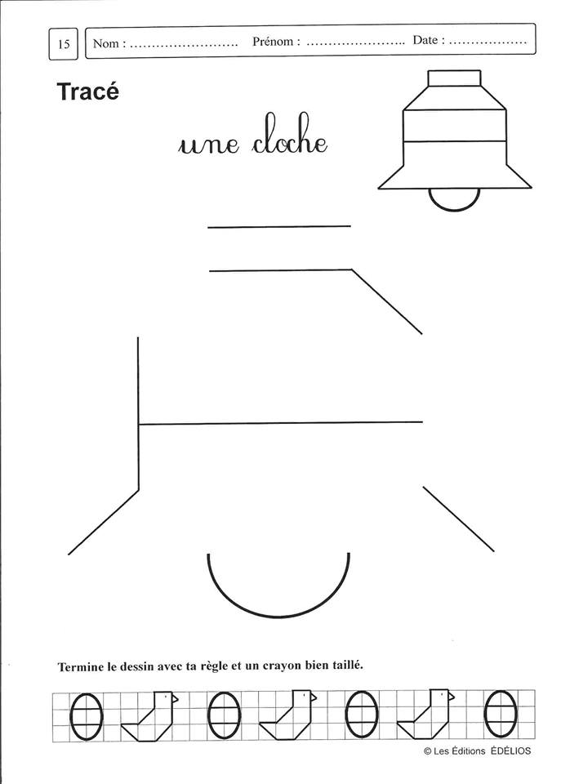

Les jeux de numération et de calcul.

Retrouve le chemin en partant de 5 et en comptant de 5 en 5.

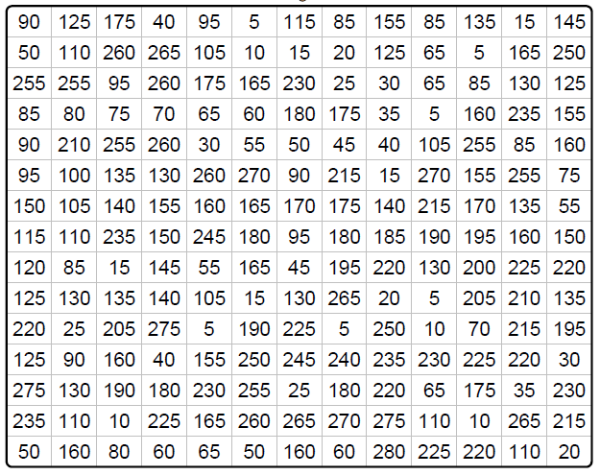

Retrouve le chemin en partant de 10 et en comptant de 10 en 10.

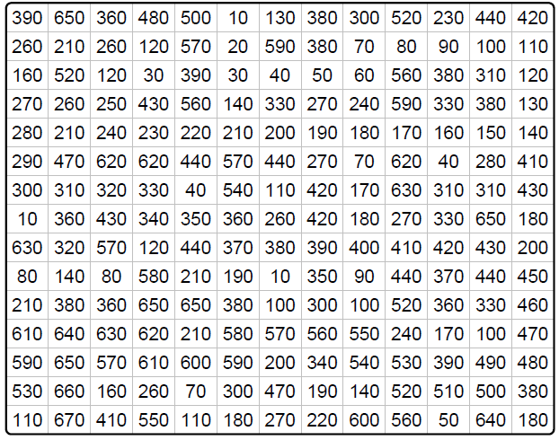

Les jeux de numération et de calcul.

Retrouve le chemin en partant de 3 et en comptant de 3 en 3.

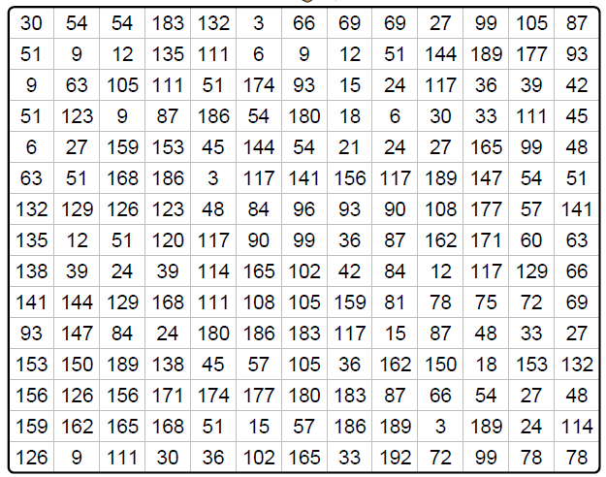

Retrouve le chemin en partant de 4 et en comptant de 4 en 4.

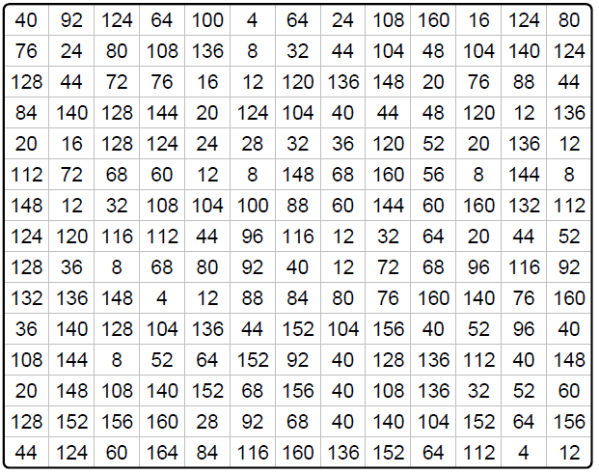

Les jeux de numération et de calcul.

Retrouve le chemin en partant de 2 et en comptant de 2 en 2.

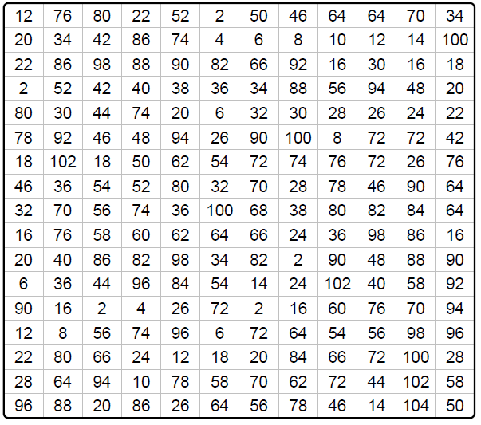

Trouve toutes les opérations qui font 10.

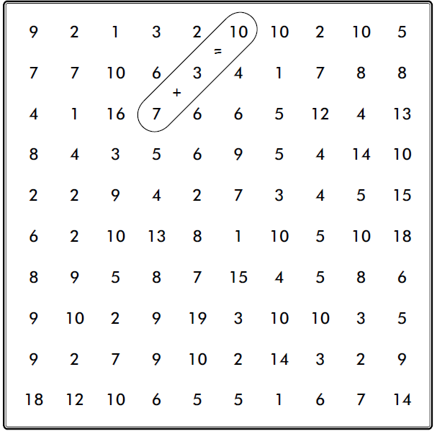

Trouve toutes les opérations possibles.

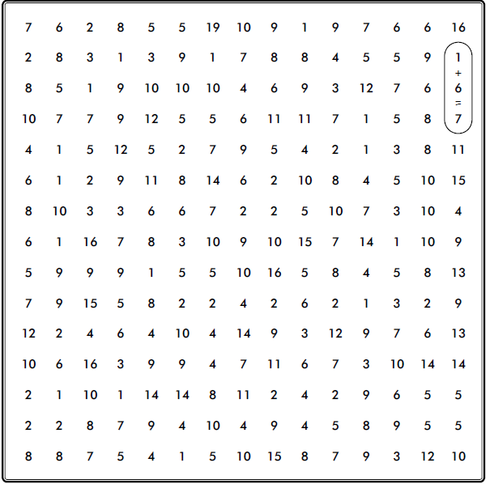

Les coloriages magiques

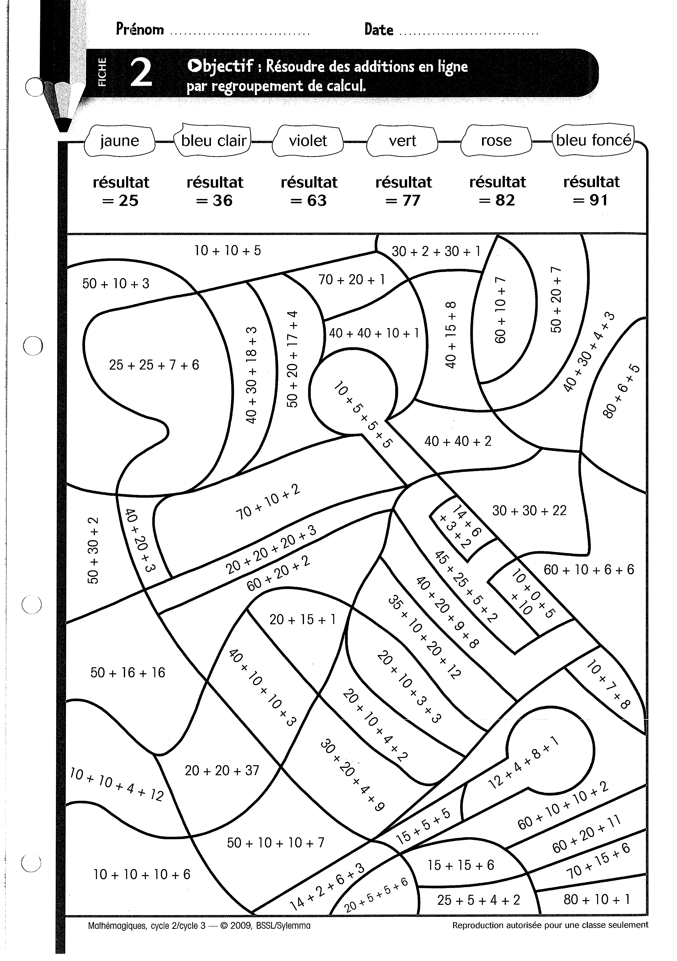

Les coloriages magiques

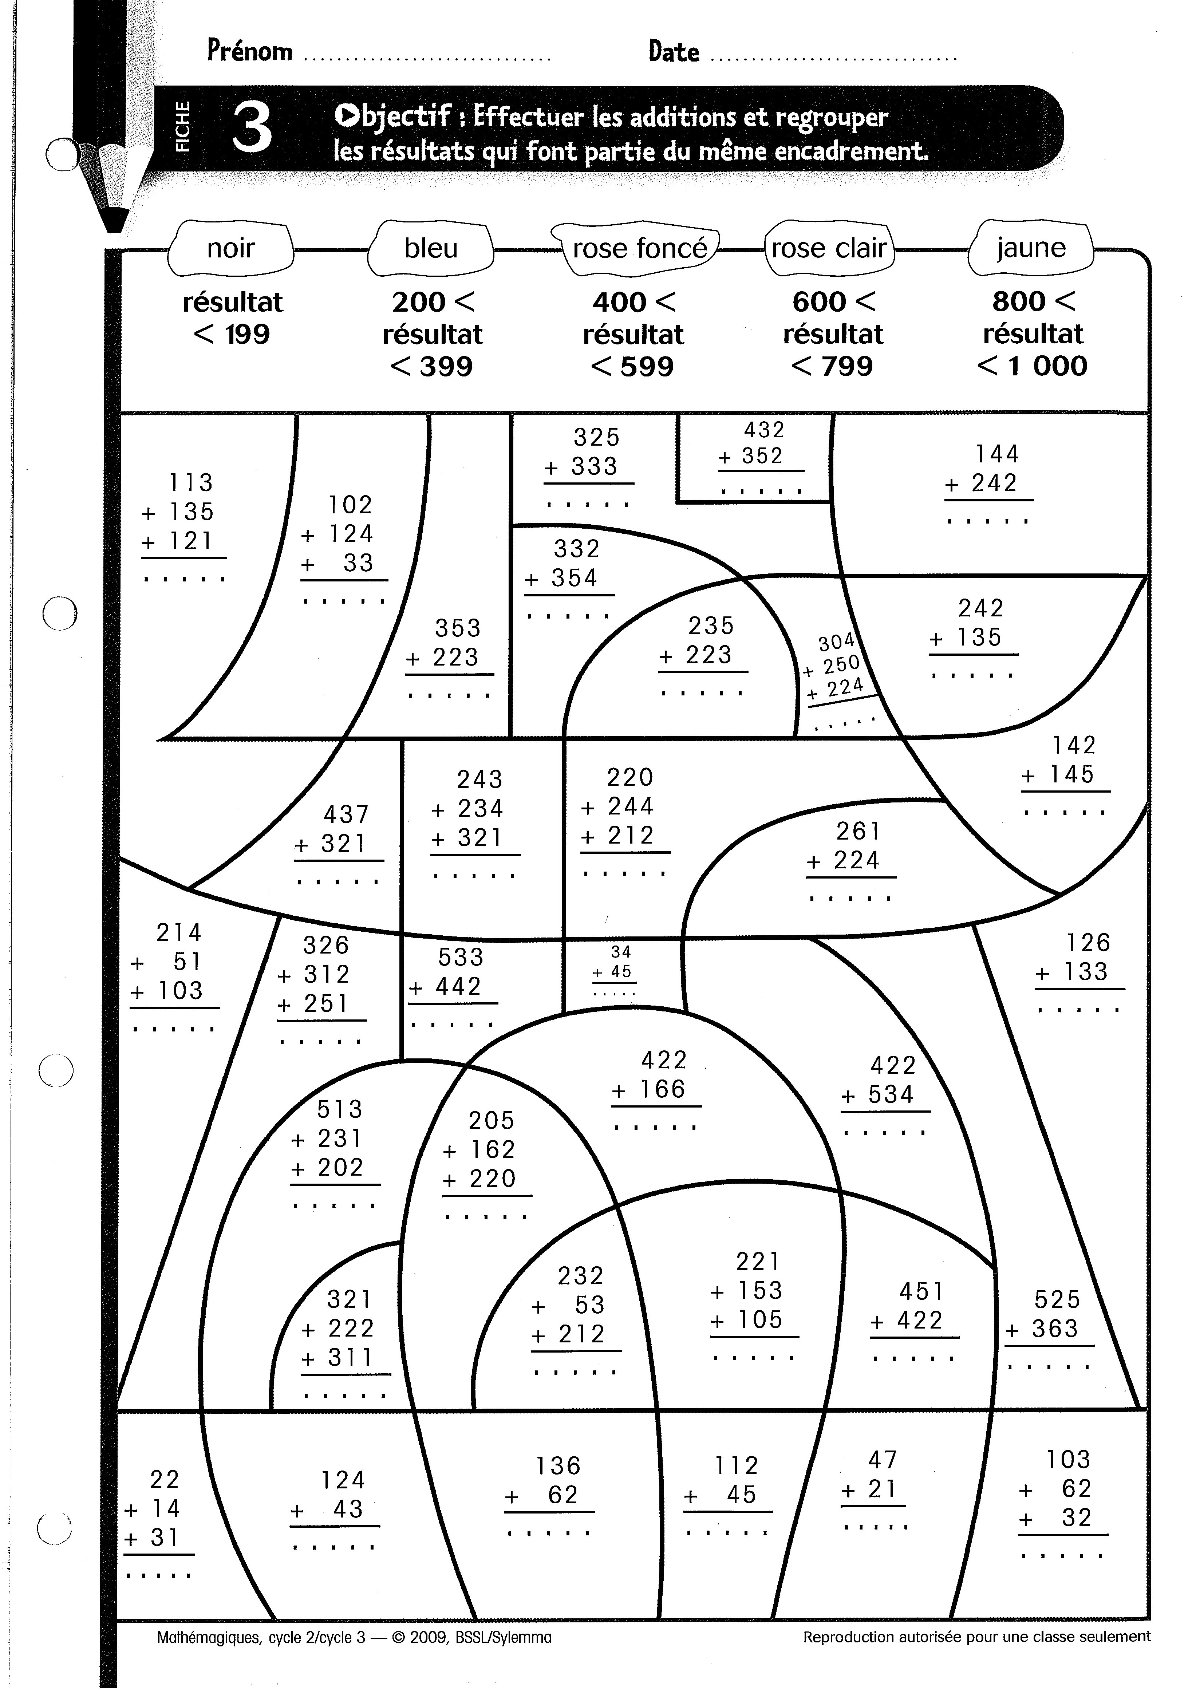

Les coloriages magiques

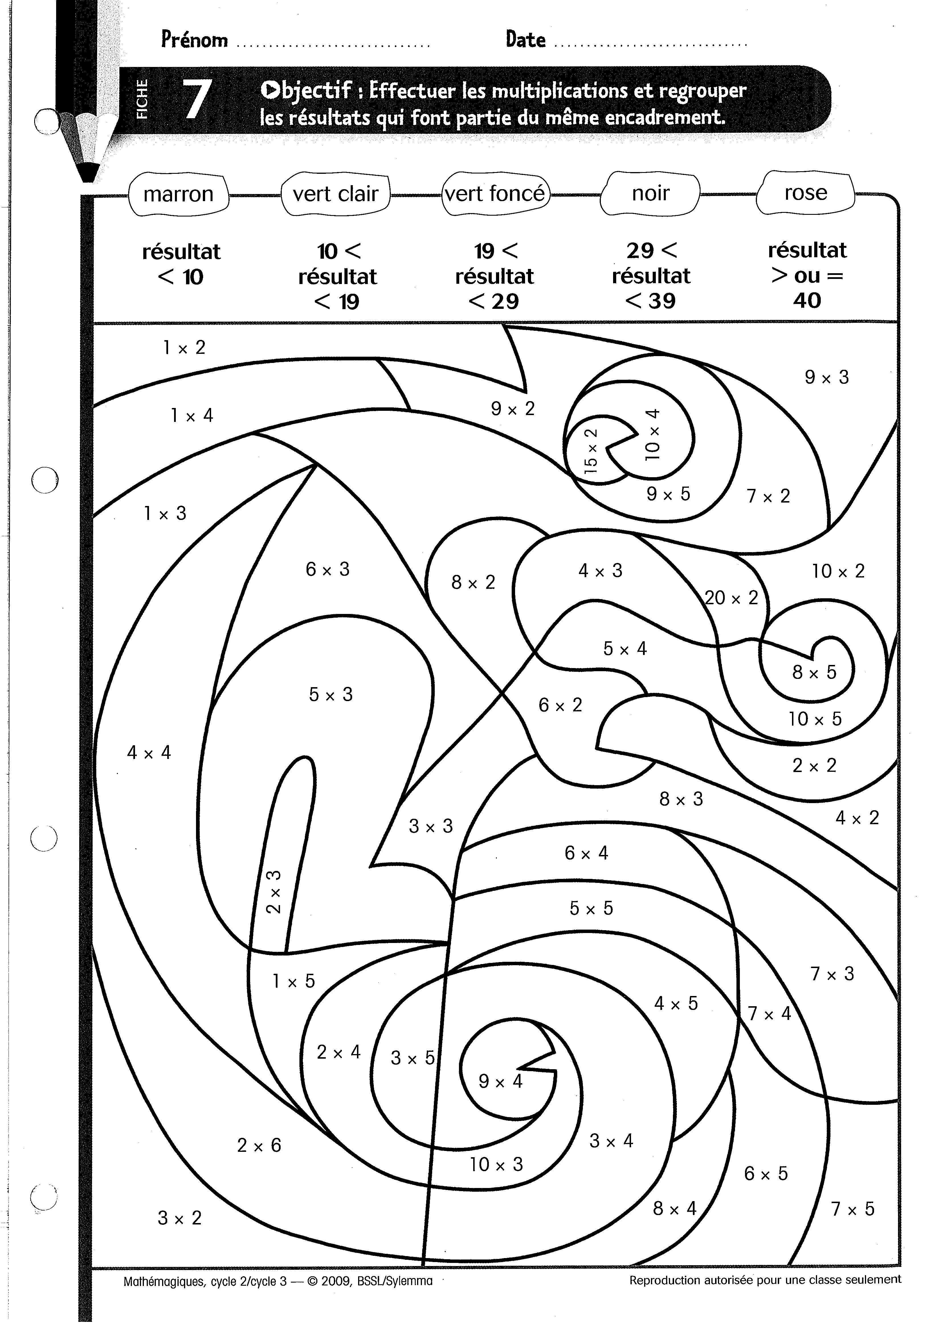

Les coloriages magiques

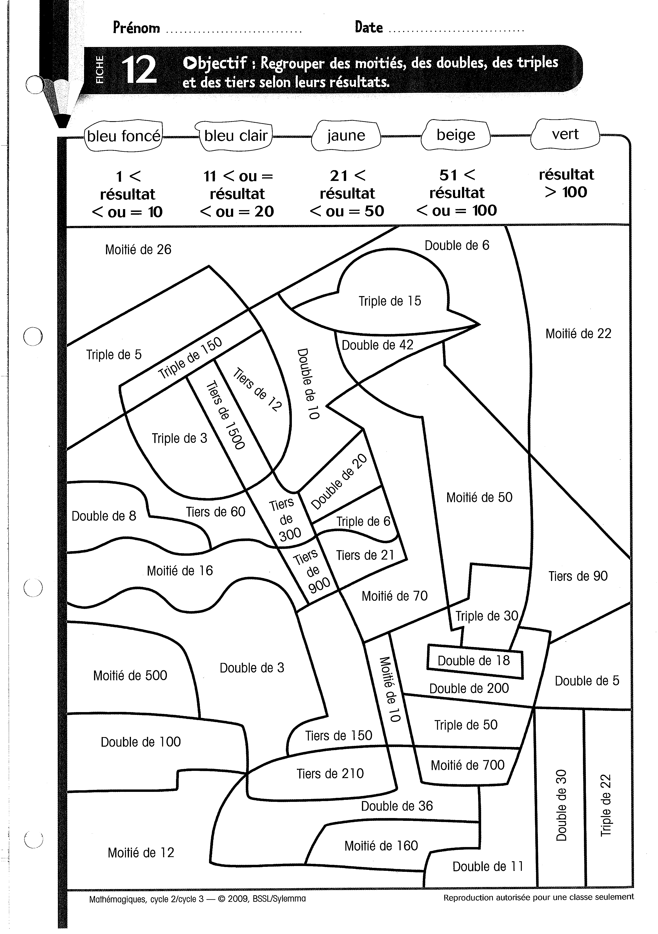

Les coloriages magiques

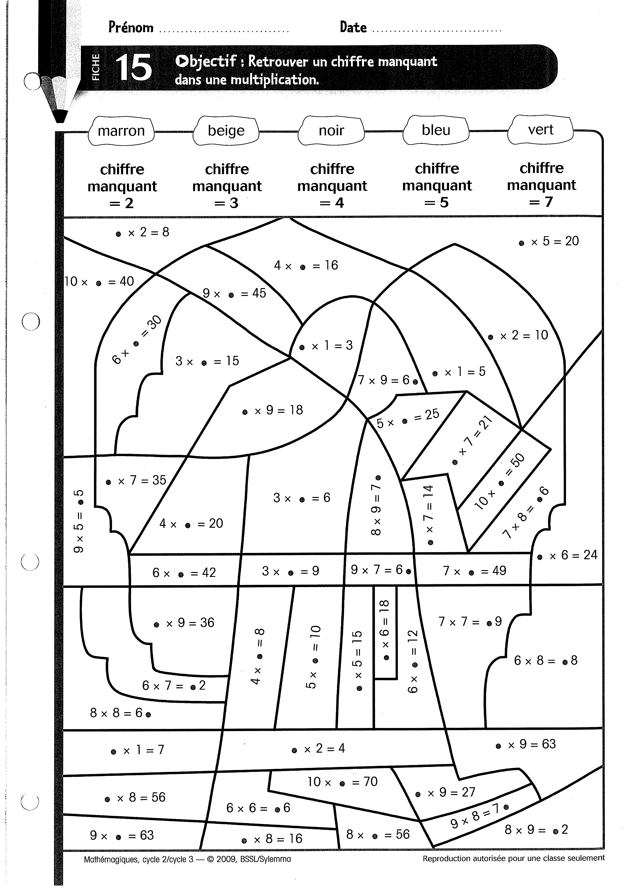

Les coloriages magiques

