|  |  |  |  |  |
| --- | --- | --- | --- | --- |
| x | 3 | 2 | 5 | H:\ecoledesjuliettes\free\serie golo\4a491b1e4acbf21862535e02871ffd08 (1).jpg4 |
| 3 |  |  |  |  |
| 2 |  |  |  |  |
| 6 |  |  |  |  |
| 5 |  |  |  |  |

|  |  |  |  |  |
| --- | --- | --- | --- | --- |
| x | 2 | 4 | 3 | H:\ecoledesjuliettes\free\serie golo\203a160479649f9378acfff520cebd16.jpg5 |
| 4 |  |  |  |  |
| 8 |  |  |  |  |
| 1 |  |  |  |  |
| 7 |  |  |  |  |

|  |  |  |  |  |
| --- | --- | --- | --- | --- |
| x | 4 | 3 | 2 | 5 |
| 9 |  |  |  |  |
| 2 |  |  |  |  |
| 7 |  |  |  |  |
| 5 |  |  |  |  |

|  |  |  |  |  |
| --- | --- | --- | --- | --- |
| x | 4 | 5 | 3 | H:\ecoledesjuliettes\free\serie golo\cef700cf3aeaa84d73d97d5d6d189887 (1).jpg2 |
| 3 |  |  |  |  |
| 8 |  |  |  |  |
| 4 |  |  |  |  |
| 6 |  |  |  |  |

|  |  |  |  |  |  |  |  |
| --- | --- | --- | --- | --- | --- | --- | --- |
| 9 | 6 | 15 | 12 | 6 | 4 | 10 | 8 |
| 18 | 12 | 30 | 24 | 15 | 10 | 25 | 20 |

|  |  |  |  |  |  |  |  |
| --- | --- | --- | --- | --- | --- | --- | --- |
| 8 | 16 | 12 | 20 | 16 | 32 | 24 | 40 |
| 2 | 4 | 3 | 5 | 14 | 28 | 21 | 35 |

|  |  |  |  |  |  |  |  |
| --- | --- | --- | --- | --- | --- | --- | --- |
| 36 | 27 | 18 | 45 | 8 | 6 | 4 | 10 |
| 28 | 21 | 14 | 35 | 20 | 15 | 10 | 25 |

|  |  |  |  |  |  |  |  |
| --- | --- | --- | --- | --- | --- | --- | --- |
| 12 | 15 | 9 | 6 | 32 | 40 | 15 | 16 |
| 16 | 20 | 12 | 8 | 24 | 30 | 18 | 12 |

CORRECTION

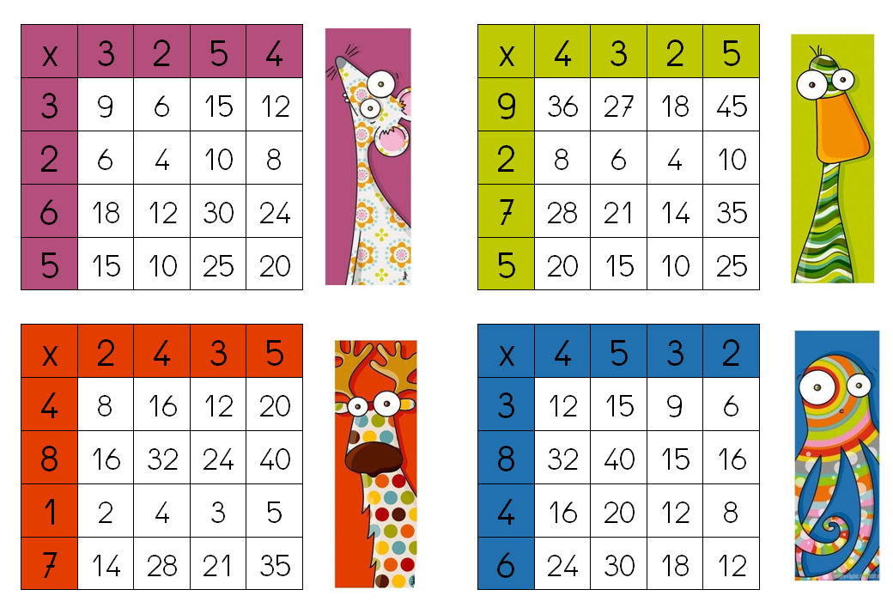

CORRECTION

