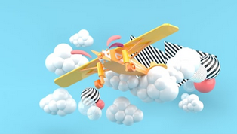

Agrafer ici



90

|  |  |  |
| --- | --- | --- |
| **9** |  |  |
| **8** |  |  |
| **7** |  |  |
| **6** |  |  |
| **5** |  |  |
| **4** |  |  |
| **3** |  |  |
| **2** |  |  |
| **1** |  |  |



80



70



60



50



40



30



20



10



Agrafer ici (sons simples) Agrafer ici (sons complexes)

|  |  |  |
| --- | --- | --- |
| **a** |  | **ou** |
| **e** |  | **on** |
| **i** |  | **an** |
| **o** |  | **oi** |
| **u** |  | **eau** |
| **y** |  | **in** |

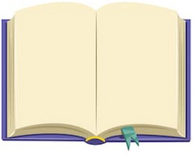

l

r



n

m

t



v



b

d

ch



s

p

j



z

c

